Built Environment Scavenger Hunt

Every community has needs. While the natural environment can provide some of them, we build things to meet the rest. In this investigation, students will:
- Investigate the area around your school to identify elements of the built environment and identify how they work as resources for the community.
- Examine patterns in the locations of these resources.

Video tutorials are available online at https://eli.lehigh.edu/sesi for all instructional materials.

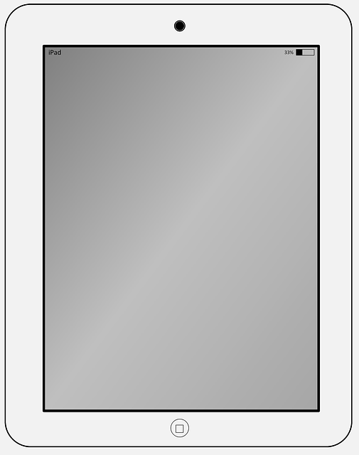
Step 1: Open the Collector App and Your Map

- Collector app and sign in

- Download your class’ Built Environment Scavenger Hunt Map.

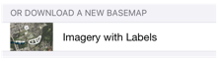
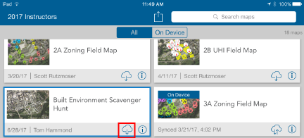

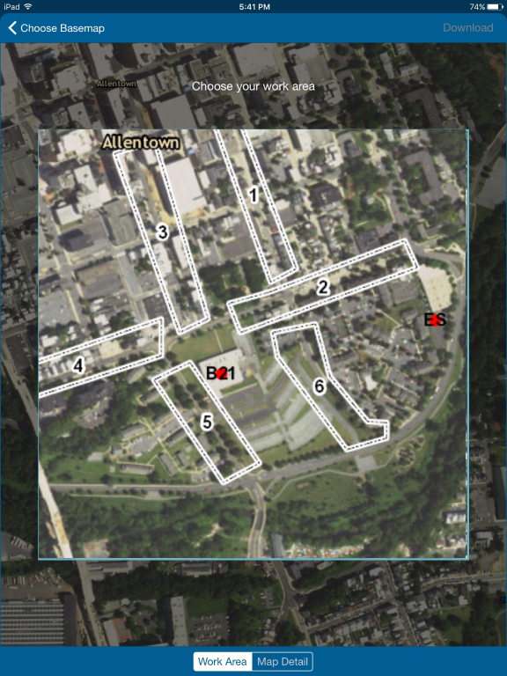
  - Find your sample area on the map. Move and resize the blue square (image on the right).

  - Select the Map Detail button (red box).

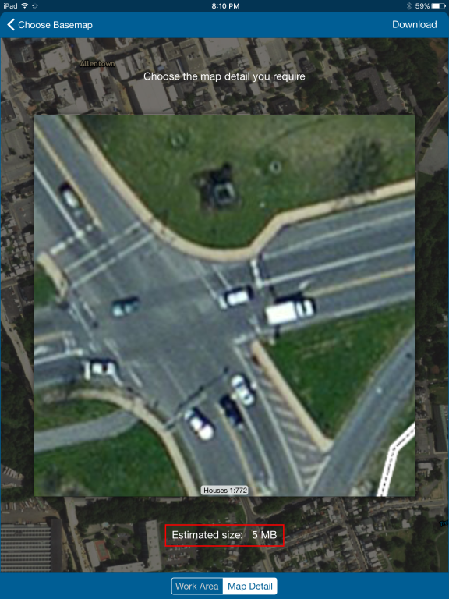
  - Zoom in for detail.

  - Estimated size is not larger than 5 MB.

  - Once you are happy with the detail, select the download button (see arrow) in the upper right of the screen.

- Make sure the blue dot will appear. If it does not, restart the app outside.

Step 2: Start making observations in your area

The environment around you is made up of both natural and human-made objects. You will go to an area around the school to make observations of the human-made objects: the built environment. Always stay with your group when you are outside.

Where to go:  - Go with your teacher or mentor to the area that you will be investigating.  - The Collector app will have north pointed to the top of the screen. The parking lot by the school is south of Building 21 and Lehigh St. is west of Building 21.  What to do:  - In your assigned area, make observations with the Collector app.  - Your goal is to get all 11 community resources categories. Make at least 11 observations, one for each category if possible.  - To enter a new observation, select the plus sign on the upper right of the screen (see arrow).  - Type in a name for the object you are recording.  - Decide which resource the object provides. If you are unsure ask your mentor or teacher for help.  - Write an explanation why this object provides this resource. For example, “A traffic light provides safety.”  - Take a picture of your observation.  - Click Submit. | 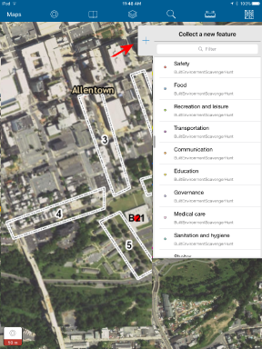

Step 3: Sync your observations

When you return to the school, synchronize your observations.

- Select Maps in the upper left of your screen.  - Select the cloud icon (red box) to start synchronizing your observations. (You should see the number of your observations above the cloud).  - Click on the map again after synchronizing to see all the points your classmates have added.  - After synching, remove the map. On the same screen select the square icon $→$ Manage $→$ Remove $→$ Remove features and basemap  - You can then log out of the iPad. Select the square icon $→$ Sign Out $→$ Sign Out | 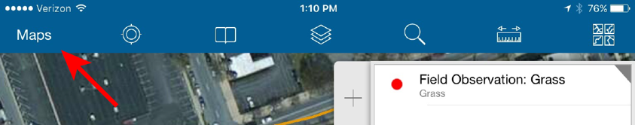

Step 4: Explore your class’ observations in ArcGIS Online

Go to arcgis.com. Login with your username and password at the top right corner of the webpage.
- Click Groups to see your map. Select your class. Click the Built Environment Scavenger Hunt image.  - You should see a screen that looks like the one on the right. North is towards the top of the screen.  - Look at the Legend (blue box). Notice the different colored symbols for each type of observation.  - Select the Contents tab (orange box).  - You can turn on or off any layer by selecting the check mark next to the layer.  - The Observations layer has many symbols below it that can help you look at your data.  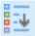  Shows the Legend  Opens a data Table  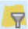  Filters data in Table  - Explore the Legend, Table, and Filter tools to see how you can examine your observations.  - With the Table tool, you can sort observations by column (See center image).  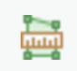  - To measure distances on the map, use the Measure tool at the top of the screen. Select ruler. Change units from miles to kilometers. Click to start a measurement and double click to finish.  - Answer questions # 1-9 below. | 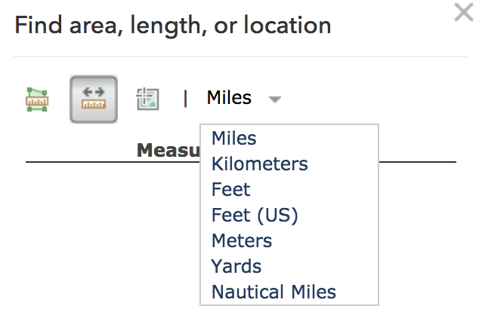  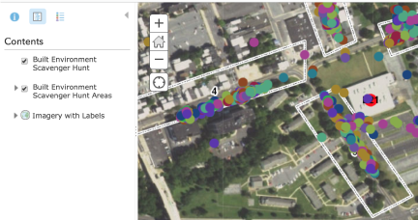  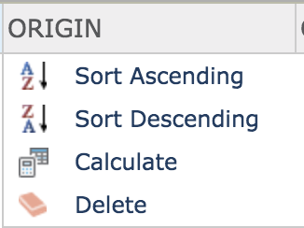

1. Complete the table below.
Teacher / Mentor
Area Assigned
Number of Observations Made

2. Which resource category had the largest number of observations?

3. Which resource category had the fewest number of observations?

4. Did your class find examples of ALL the community resources? (Hint: Look at the data table for the Built Environment Scavenger Hunt layer and sort by category)

5. How many observations did your class make for each resource. Complete the table below.

Resource Category | # of Observations
Communication
Education
Food
Governance
Medical care
Recreation and leisure
Safety
Sanitation and hygiene
Shelter
Transportation
Water

6. Which numbered area has the most types of resources?

7. Which numbered area has the least types of resources?

8. Imagine you lived in an area where some categories of resources were missing. How will you meet your needs?

9. Based on the data, suggest one change that would improve the built environment near Building 21.

Step 5: Editing your map in ArcGIS online

You will now learn how to edit the map by adding Map Notes and how to record your edits by taking screen shots and saving your progress in ArcGIS online.

We will be using the Map Notes tool to draw areas and lines around the school to show where things are located. We will also draw paths to locations of community needs. You will take a screen shot and submit your map images.
- To add Map Notes Select Add in the upper left corner (see arrow).  - Select Add Map Notes and pick a name for your notes (“My name’s” notes).  - You should now see a new Add Features tab.  - The Line tool from the Add Features tab will help you edit the map.  - To draw a line, select the Line tool and click on the map where you want to start (single click). To end the line, double click.  - A pop-up box will now appear. You can change the name of your area in the Title box and add a short note in the Description box. To change the color of your line, select “Change Symbol”. You can then select a new line color.  - To find the latitude and longitude of a location use the Measure tool at the top right of the screen. Select the Location option and change the units to degrees, minutes and seconds (center image).  - Complete questions # 10-13 below. | 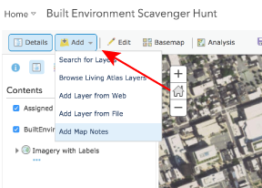  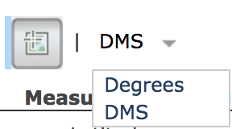

10. The school fire evacuation site is located about 2 blocks east of the school. It is labeled ES on the map.
a. Draw an Area around the residential area next to the school and make it blue.
b. Use the Measure tool to find the shortest path between the high school and evacuation site that does not go through your blue area.
c. Use the Line tool to draw this path. Color your route line red.

Take a screen shot of your new map that shows your path. Submit your map image to Google Classroom as a new document called “Your Name Built Env Scavenger Hunt ES Path”.

Challenge Questions
You will be building a map with 6 locations. You will submit a map image with 6 locations to your teacher.

The questions below will give you specific places to locate near Building 21 High School. You can search for these locations using the search bar in the upper right of the screen (see image).
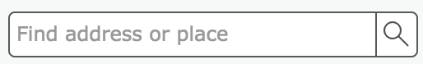

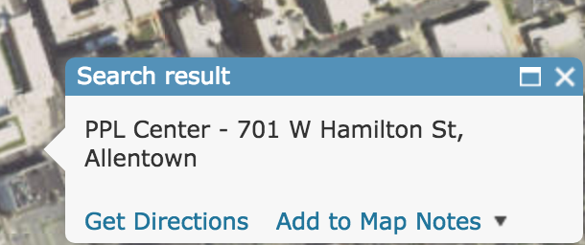

To add a location to your Map Notes find it with the Search bar and use the Add to Map Notes option (image on right).

You may find it easier to answer some questions by changing the basemap displayed on your screen. To do this find the Basemap tool at the top of the screen and change your map to the Streets option. You can change back at any time by selecting the Imagery option from the Basemap tool (see image below).
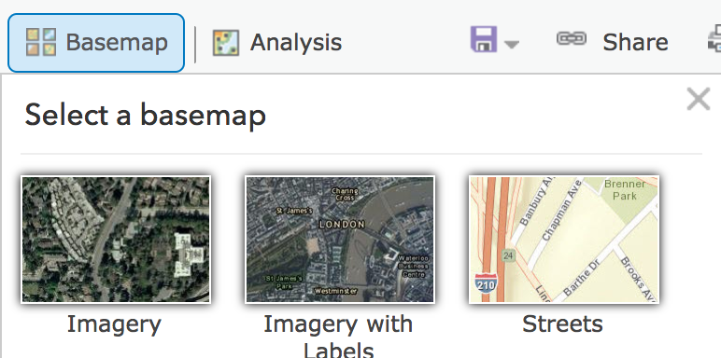

11. Fill out the following table for each location.

Location: | Color of path | Length of path (km) | Direction from school to location | Location in DMS | Resource Category
8th Street Food Market
C Town Super- market, North 4th St.
Sacred Heart Hospital, W Chew St.
Lehigh Valley Hospital, 17th St.
Allen Park, 75 South 4th St.
Baseball field, 890 MLK Jr Drive

12.

a. Why do you think these grocery stores are located where they are?

b. Why do you think these hospitals are located where they are?

c. Why do you think these parks are located where they are?

13. Take a screen shot of your new map that shows the locations of the two grocery stores, two hospitals, two parks, and the school. Submit your map image to Google Classroom as a new document called “Your Name Built Env Scavenger Hunt Challenge”.

