Land Use Change – Explanation Guide

Las Vegas area

Las Vegas – September 13, 1972  Landsat 1 MSS bands 4, 2, 1 | Las Vegas - September 10, 1992  Landsat 5 MSS bands 4, 2, 1
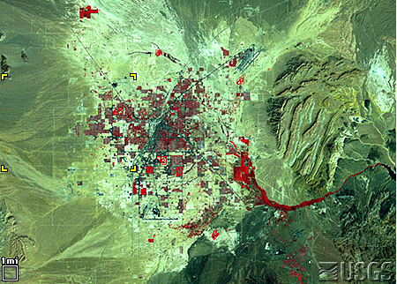 | 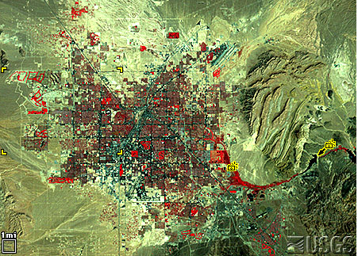

The false-color composite images (TM bands 4, 2 and 1) above show the Las Vegas area in 1972 (left image) and 1992 (right image). Each image is approximately 26 miles wide.

This is one of the fastest-growing areas in the United States.
Population 1972: 273,000
Population 1992: 863,000

The tip of Lake Mead is visible east of the city (black color). Lake Mead is a reservoir created by Hoover Dam. About 96% of the water in Lake Mead is from melted snow that fell in Colorado, Utah, New Mexico and Wyoming and flows down the Colorado River.

Pre-construction land appears medium gray-green in the Landsat image. This color comes from sparse desert vegetation, reddish soils, and stone darkened by an inorganic patina of oxidization.
Construction land appears brighter gray-green. Bulldozed soil, bare of vegetation, is very reflective.
A young neighborhood appears medium green again, perhaps a bit brighter from all the reflective pavement and roofs. The trees are small, and some developments now conserve water by landscaping with rock and desert plants rather than grass.

An old neighborhood appears dark, brownish red from the mature trees and more grass. In these false-color images, photosynthesizing vegetation always adds a red tint.

Golf courses appear bright red because they are the most intense vegetation. New courses tend to be mixed into residential developments while older courses tend to be separate.

Water appears almost black because at this angle it scatters little light back to the Landsat sensor. Like golf courses, water is sometimes integrated into residential developments for recreational purposes.

Lake Mead, Las Vegas’s main water source, is shrinking. Water conservation practices by communities are important for continued development. Community water conservation practices may include water rations, encouraging desert landscaping instead of growing grass in yards, and installing low flow plumbing fixtures.
Dubai, UAE 1973 and 2006

Dubai - January 22,1973  Landsat 1 MSS bands 6, 5, 4 | Dubai - October 11, 2006  Landsat 7 ETM+ bands 4, 3, 2
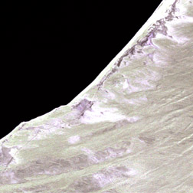 | 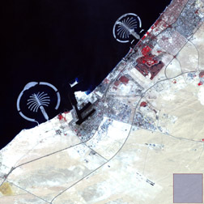

The false-color composite images above shows a section of the city of Dubai in 1973 (left image) and 2006 (right image).

Each image is approximately 13 miles wide.

This is one of the fastest-growing cities in the world.

Population 1985: 183,000
Population 2006: 1,200,000

Dubai is located on the Persian Gulf coast in the northern part of the United Arab Emirates in the Middle East.
It was a small fishing village.

Noticeable features in 2006 image that are absent in the 1973 image are the Palm Islands, the Jebel Ali Harbor, more roads, and an expanded city area.

The Palm Islands are the largest human-made islands in the world. The palm-shaped structure displays 17 huge fronds (leaves) framed by a 12-kilometer protective barrier. When completed, this resort area will include 2000 villas, 40 luxury hotels, shopping centers, cinemas, and other facilities. When completed, the resort is expected to support a population of approximately 500,000 people.
Acheh, Indonesia

Acheh, December 13, 2004  Landsat 7 ETM+ bands 3,2,1 | Acheh, December 29, 2004  Landsat 7 ETM+ bands 3,2,1
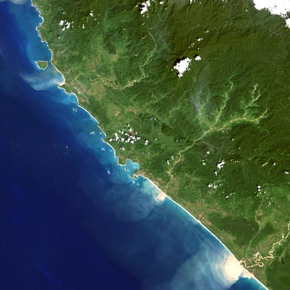 | 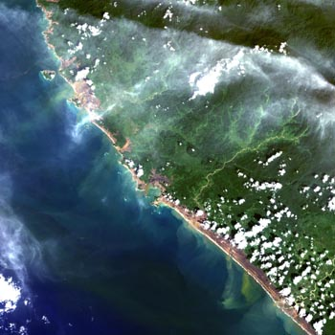

The true-color composite images above show the Acheh Province in Indonesia 13 days prior to a devastating tsunami (left image) that struck on December 26, 2004 and three days after the tsunami struck (right image).

Each image is approximately 37 miles wide.

The Acheh Province is located on the northern end of Sumatra (part of Indonesia).

The image pair shows that the western coastal area of Acheh changed from a green to brown color. This brown area is bare, exposed coastal area. Vegetation and man-made structures on the coast were destroyed by the tsunami.

Clumps of white color appear inland on the December 29 image. These are low-lying cumulus clouds.

New Orleans and Lake Pontchartrain  Apr. 26, 2000  Landsat 7 ETM+ bands 7, 4, 2 | New Orleans and Lake Pontchartrain  August 30, 2005  Landsat 7 ETM+ bands 7, 4, 2
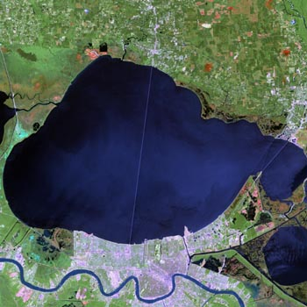 | 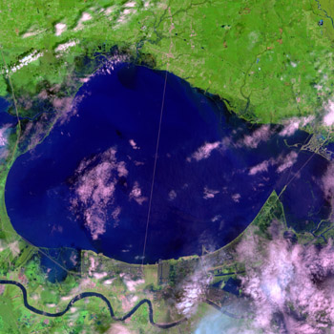

The true-color composite images above show the New Orleans and Lake Pontchartrain area before (left image) and the day after Hurricane Katrina came through the area (right image).

Each image is approximately 37 miles wide.

New Orleans sits between Lake Pontchartrain and the Mississippi River.

The city appears a pinkish shade in the April 2000 image. Severe flooding occurred in the city of New Orleans and in areas near Lake Pontchartrain. These flooded portions of the city appear a dark blue color in the post-Katrina image (right image).

Mt. St. Helens  July 29, 1972  Landsat 1 MSS bands  7, 4, 2 | Mt. St. Helens  September 22, 1990  Landsat 5 TM bands  3, 2, 1 | Mt. St. Helens  September 22, 1999  Landsat 7 EMT+ bands  3, 2, 1
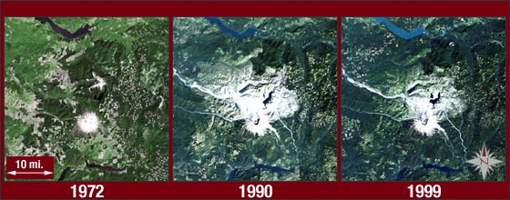

The three true-color composite images above show Mt. St. Helens eight years before its 1980 eruption (left image), ten years after the eruption (middle image), and almost twenty years after the eruption (right image).

Each image is approximately 35 miles wide.

On May 18, 1980 Mt. St. Helens erupted, leveling over 200 square miles of forest. The eruption left the surrounding landscape barren and the mountain 1300 feet shorter. The pumice and ash from the eruption covered everything in a 200 square mile area north of the volcano. The 1990 image shows large regions still covered in ash. In the 1999 image, vegetation regrowth is working its way closer to the volcano's peak.

