ENERGY UNIT CONTENT ASSESSMENT

1. Which of the following statements best DEFINES energy?
A. Potential and kinetic

B. The ability to do work
C. A force that moves something
D. The rate at which work is done

2. Which of the following is NOT a renewable biofuel?
A. Wood chips
B. Petroleum (crude oil)
C. Ethanol made from corn
D. Methane captured from decaying cow manure

3. Petroleum (crude oil) and natural gas come from…
A. dead dinosaur remains.
B. coal fired power plants.
C. swamp remains that are thousands of years old.
D. plankton and sea life that are millions of years old.

4. The term “renewable energy resources” means resources that...
A. are free and easy to use.
B. are very efficient to use for producing energy.
C. can be converted directly into heat and electricity.
D. can be replenished by nature faster than they are consumed.

5. Which energy resource is nonrenewable?
A. Solar
B. Biomass

C. Natural gas
D. Geothermal
6. Which is the most abundant fossil fuel found in the United States?

A. Coal
B. Wood
C. Natural gas
D. Petroleum (crude oil)

7. Stored energy is called ....... energy.
A. kinetic
B. biomass

C. potential
D. electrical

8. Areas with geothermal resources include ….
A. large lakes that flow into rivers.
B. large mountain ranges and forests.
C. high wind velocities and open space areas.
D. geysers, fumaroles, hot springs, and volcanoes.

9. Where would a wind farm generate the most energy?
A. In a coastal area with average wind speed of 20 miles per hour.
B. On a mountaintop with average wind speed of 15 miles per hour.
C. In a desert area with average wind speed of 10 miles per hour.
D. In a farm area with average wind speed of 8 miles per hour.

10. Nuclear energy is considered NONRENEWABLE because ….
A. it produces waste that is very radioactive.
B. the power plant must use a lot of water for the cooling process.
C. the uranium fuel source is found in rocks that can be depleted.
D. fission generates heat in the reactor just as coal generates heat in a boiler.

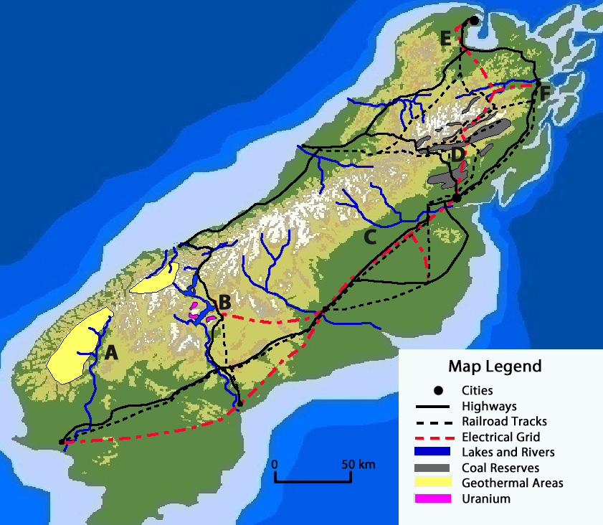
The image above is a map of an island. Use the map to answer questions 11-14.
11. Where is the best location to build a nuclear power plant?

A. Location A
B. Location B
C. Location C
D. Location D

12. Where is the best location to build a coal-fired power plant?

A. Location B
B. Location C
C. Location D
D. Location E

13. Which is a disadvantage of building a geothermal power plant at location A?

A. Fuel would have to be transported to the plant using rivers.
B. Additional highways and railroads would be needed to transport fuel.
C. Water near the location could be developed into a thermal spa area.
D. Additional electrical grid infrastructure would have to be developed.

14. Location C would be a good place to develop a biofuels processing plant if the nearby area has .…
A. a wet climate, a forested area, and a dam.

B. farmland for growing plants and a temperate climate.
C. more railroads, highways, and biodiesel vehicles.
D. pipelines and better access to the electrical grid.

15. In the year 2250, most of the world’s energy will likely come from…
A. coal and oil.
B. natural gas and coal.
C. nuclear power from uranium.
D. a mix of renewable energy sources.

16. Which type of electricity generation has the MOST ENVIRONMENTAL IMPACT?
A. Wind turbines on the top of mountains.
B. A dam on a river to produce hydropower.
C. A coal burning power plant in a rural area.
D. A nuclear power plant on an island in a river.

17. Most electrical energy in the United States is produced from…

A. Coal
B. Natural gas
C. Hydropower (water)
D. Petroleum (crude oil)

18. Photovoltaic cells convert …… directly into electricity.
A. wind power
B. hydropower

C. light energy
D. nuclear energy

19. Which is an advantage that geothermal power plants have over fossil fuel burning power plants? Geothermal power plants…
A. can be built almost anywhere.
B. do not have to transport fuel.
C. generate waste products that can be easily stored.
D. are more efficient to transport electricity to homes and businesses.

20. A network of power transmission lines connected across the entire country is called the…
A. grid.
B. generator.
C. transformer.
D. power surge.

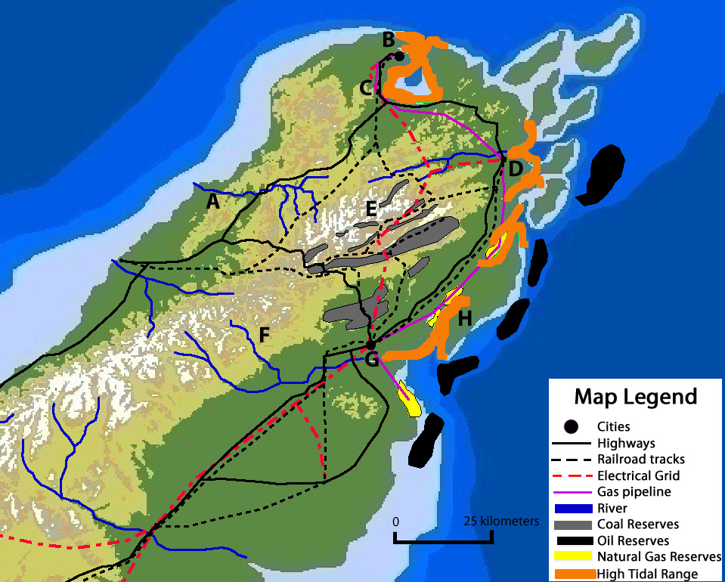
Use the map to answer questions 21-26.
21. Where would be the best location to build both a coal and petroleum (crude oil) power plant?
A. Location A.
B. Location C.
C. Location E.
D. Location F.

22. Where would be the best locations to build tidal power plants?
A. Locations A and F.
B. Locations B and E.
C. Locations E and G.
D. Locations D and H.

23. Where would be the best location to place a dam for a hydroelectric power plant?
A. Location B.
B. Location C.
C. Location F.
D. Location H.

24. Natural gas can be transported to cities near locations…
A. B and D.
B. F and H.
C. A and E.
D. D and E.

25. What is a disadvantage to building a hydroelectric power plant at Location A?
A. A dam at this location could provide recreation opportunities.
B. Hydroelectric power generation does not create water pollution.
C. This location could not be used to build a tidal power plant.
D. Infrastructure is needed to connect to the electrical grid.

26. What should be considered before extracting natural gas from the reserves located near location H?
A. The distance natural gas would have to travel using biodiesel vehicles.
B. The environmental damage that the gas extraction might cause.
C. The current amount of other sources that generate electrical energy.
D. The cost to remove the gas pipeline after all the gas reserves are extracted.

27. Electricity enters the grid at 350,000 volts. How does this voltage get reduced to 120 volts when it reaches your home?
A. Transformers step down the voltage before it reaches your home.
B. Power surges in the grid reduce the voltage before it reaches your home.
C. Transmission lines that carry electricity long distances reduce the voltage.
D. The electrical grid decreases the voltage the further that electricity travels.

28. In a hydroelectric dam facility, water pressure in the reservoir forces water to turn a turbine that generates electricity. This is an example of …
A. a low energy efficient process of a dam.
B. energy transport efficiency of the dam.
C. water gaining potential energy from the reservoir to do work.
D. gravitational potential energy being converted to kinetic energy.

29. The best place to build a new factory is at a location near an electric power plant because…
A. less energy is lost during electrical transmission.
B. fewer miles of pipeline are needed to transport fuel.
C. less kinetic energy is needed for electrical transport.
D. the environmental impact of the factory will be reduced.
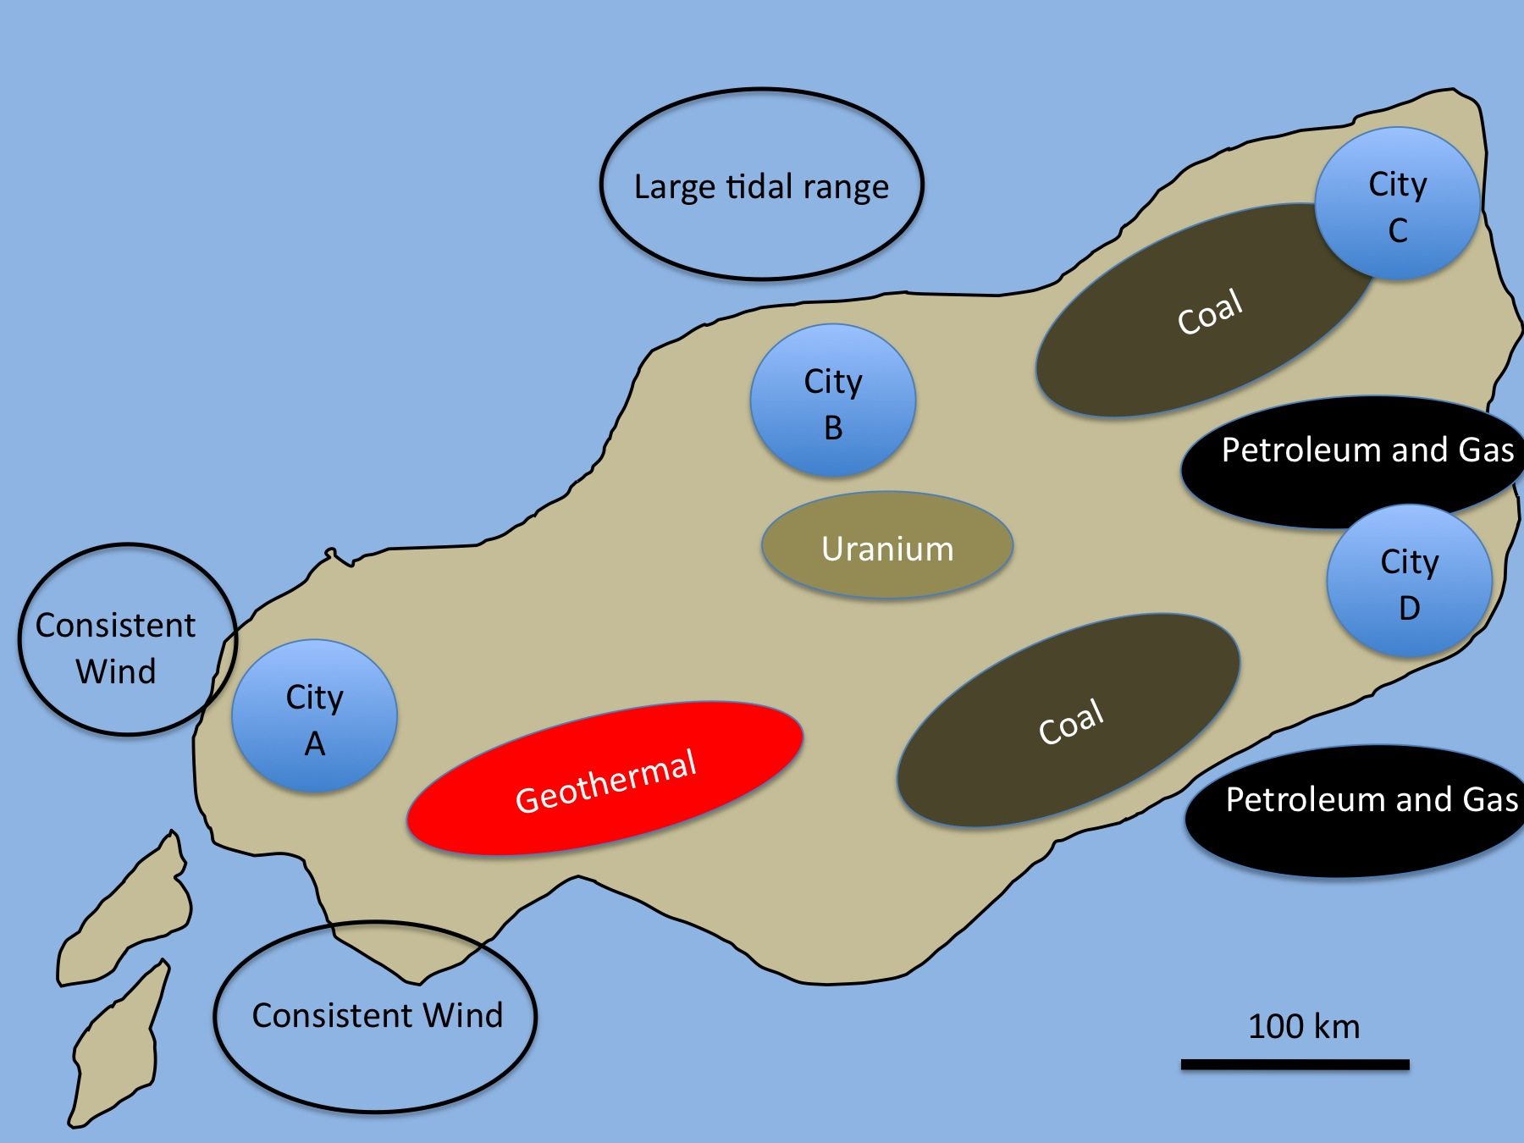
The image above is a map of an island about the size of Pennsylvania. Use the map to answer question 30.
30. Which city is CLOSEST to the most types of renewable energy resources?

A. City A
B. City B
C. City C
D. City D

31. The largest energy source that is used by the United States is…
A. Coal
B. Natural gas
C. Petroleum (crude oil)
D. Hydropower (water)

32. Which uses the MOST ENERGY in the average American home in one year?
A. Lighting the home
B. Cooking and storing food

C. Heating and cooling rooms
D. Entertainment (TV, computer, video games)

33. One advantage to using nuclear power instead of coal or petroleum is that...
A. there is less air pollution.
B. the waste products are easy to store.
C. nuclear power plants are not expensive to build.
D. nobody objects to building new nuclear power plants.

34. Which use consumes the most petroleum in the United States?
A. Electrical

B. Transportation
C. Residential (homes)
D. Industrial (factories)

35. Which energy source is likely to run out first?
A. Coal
B. Geothermal
C. Natural gas
D. Petroleum (crude oil)

36. The amount of ELECTRICAL ENERGY (ELECTRICITY) we use is measured in units called...
A. Volts (V)
B. Kilowatt-hours (kWh)
C. Horsepower (HP)
D. Joule-hours (Jh)

37. Placing your cell phone in the charger when you are not using it…
A. is an energy efficient practice.
B. uses renewable energy from the grid.
C. uses energy when it is not actively charging.
D. uses more energy than heating rooms.

38. In homes, NATURAL GAS is primarily used for….
A. lighting the house.
B. heating, cooling, and cooking on the stove.
C. microwave ovens and toasters.
D. the refrigerator and freezer

