Investigating Weather and Climate with Google Earth

In this activity, you will use Google Earth to explore global temperature changes. You will:
- Use Google Earth to determine how the temperature of the Earth has changed over the last 50 – 58 years.
- Explore, analyze, and interpret climate patterns of 13 different cities.
- Analyze differences between weather and climate patterns.

Read all instructions and answer each question on your field guide.

 Step 1: Download data.

- Open your web browser. Go to www.ei.lehigh.edu/learners/cc/

- Under Investigating Weather and Climate with Google Earth, click on Google Earth file: weatherandclimate.kmz.
Note: If the file download does not automatically launch Google Earth, double-click on the downloaded file weatherandclimate.kmz to launch Google Earth.
- Click the arrow to the left of “Weather and Climate” in the left panel (see red arrow). | 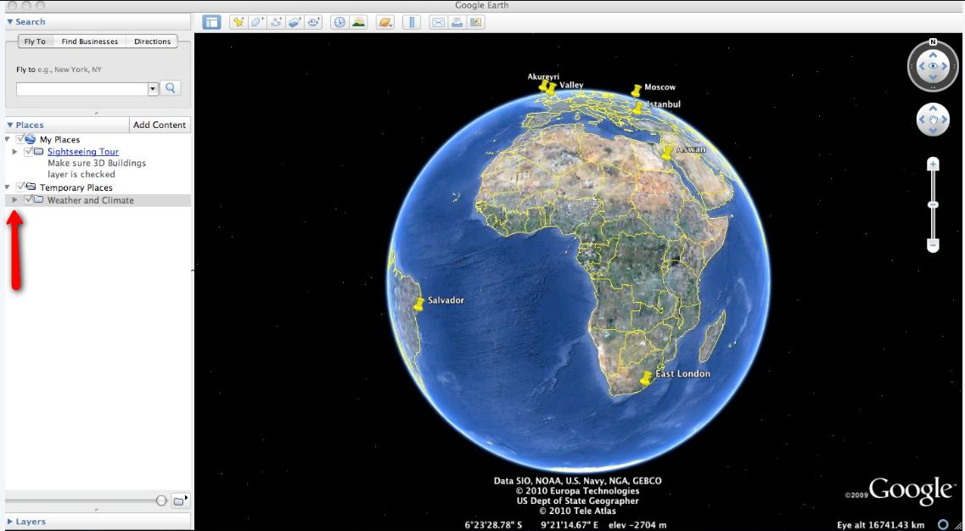
- The Weather and Climate drop-down list will extend. If you cannot see the whole list, scroll down. | 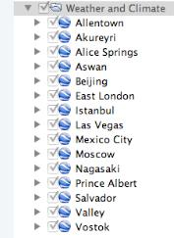
Step 2: Basic features of Google Earth

Note the following Google Earth features, tools, and navigation controls in the figure on the right.  - Search Panel (arrow #1) – Type in the white box to find a location.  - 3-dimensional (3D) Viewer (arrow #2) – This window shows the Earth and its terrain.  - Navigation controls (arrow #3) – Use these controls to zoom, look, and move around. If the navigation controls are not visible click on View>Show Navigation>Always. | 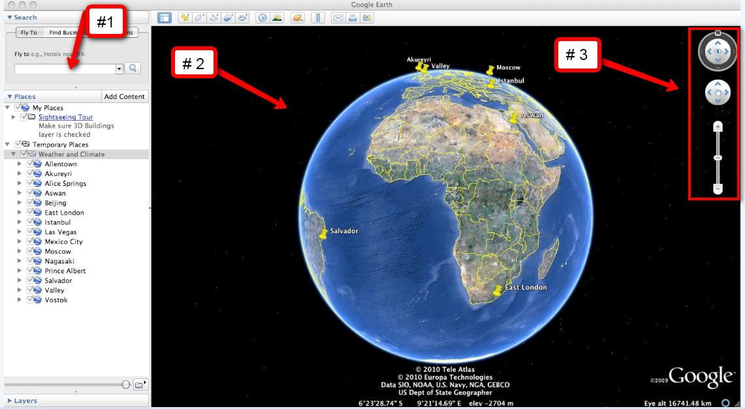

Step 3: Exploring Weather and Climate

You will explore temperature changes over the last 50 - 58 years in 13 global cities using Google Earth. Data will be recorded in the Weather and Climate Student Investigation Sheet.

- Turn on the Gridlines. Click on View. Then select Grid if the gridlines are not activated as shown in the picture to the right. | 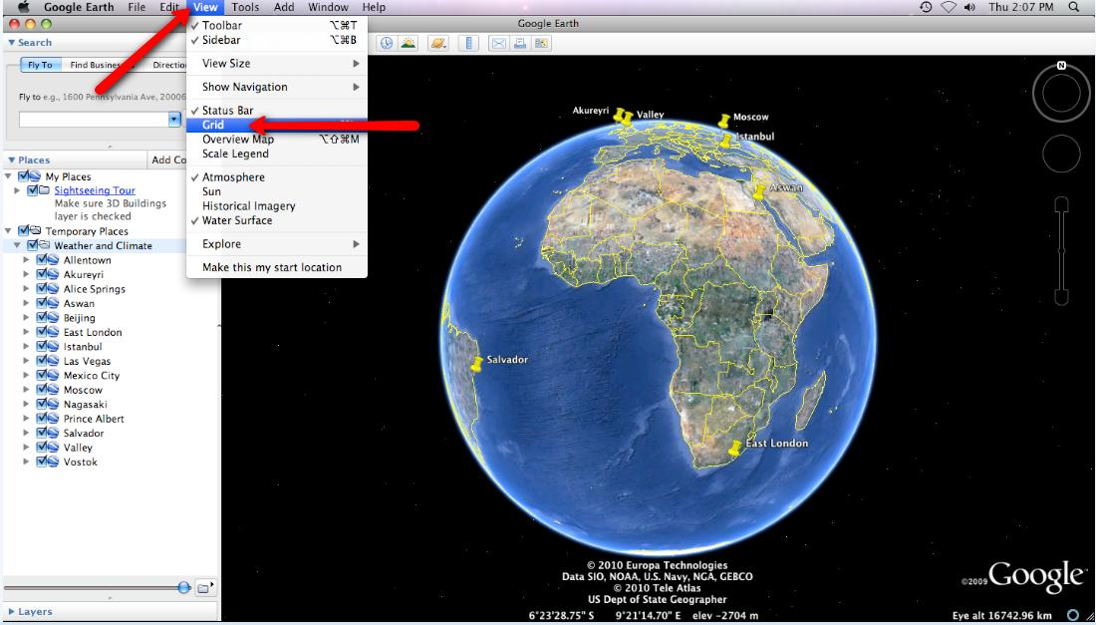

- Double-click on Allentown in the Places window. Google Earth will zoom in to the city of Allentown.  - Click on the underlined word Allentown in the Places window (as shown to the right) or Click on the Yellow Push-Pin in the 3D viewer to view the Allentown climate graph.  Important Note: To make the climate graph appear larger, control-click on the graph (or right mouse click for PC users). Next, select “Open Image”. | 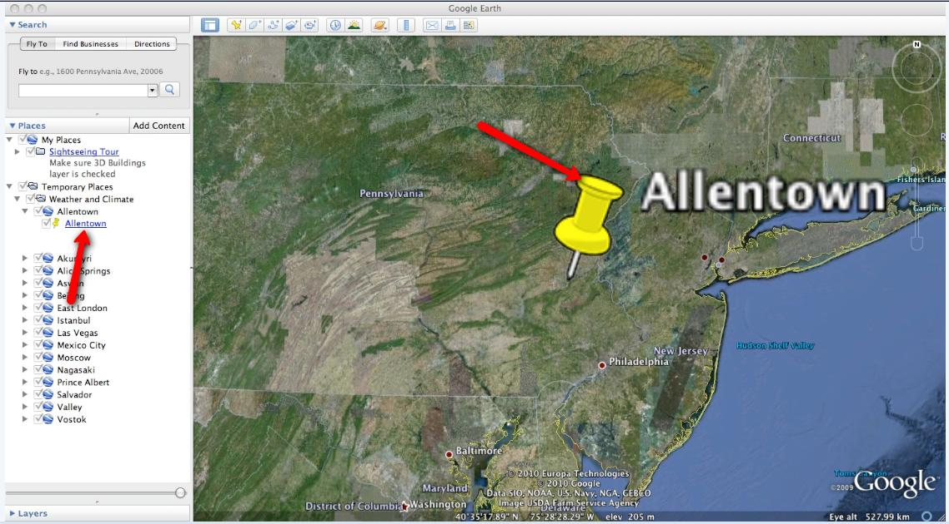
- The red line that passes through the graph is a linear trend line. The linear trend line shows how the climate has changed in the last 58 years. Note the slope of the linear trend line in the Allentown graph. It is a positive slope. A positive slope indicates that average annual temperature has been increasing over a 58-year period.  Note that the temperature difference between the start and end of the linear trend line is about one degree. Therefore, this graph data should be interpreted that the average annual Allentown climate has increased approximately one degree Celsius over a 58-year period. You can determine the change in temperature by observing the temperature at the beginning of the trend line and comparing it to the temperature at the end of the trend line as shown in the picture to the right. | 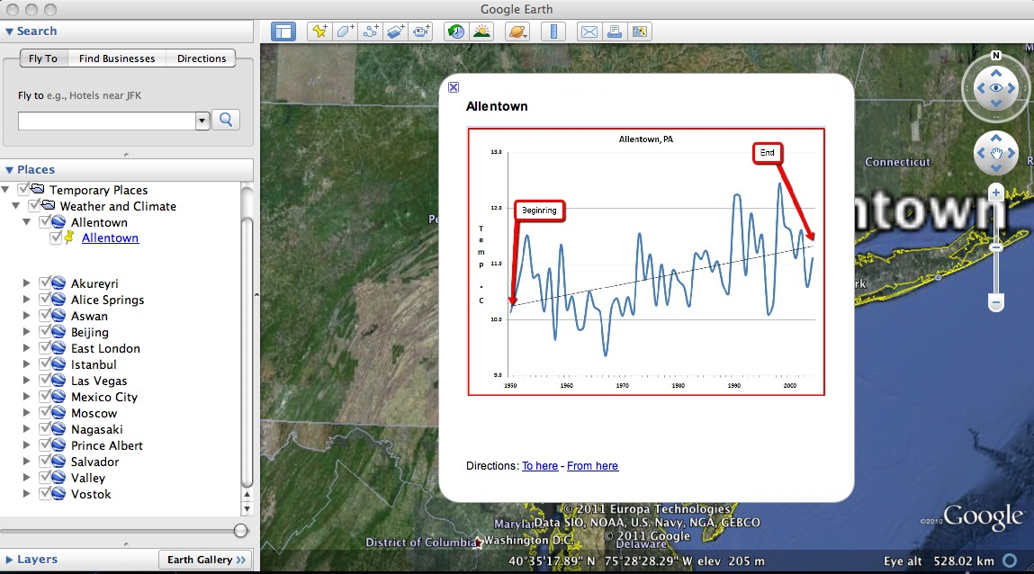

 Look at the data table on the Weather and Climate Student Investigation Sheet. In this investigation, you will analyze climate graphs from 13 different global cities.  For each city, you will record the minimum and maximum average annual temperature (in degrees Celsius) and determine the magnitude of the 50 – 58 year climate pattern.  Allentown is completed for you as an example. The minimum temperature is 9.4 °C (# 1 in the image to the right) and the maximum temperature is 12.4 °C (# 2 in the image).  The 50 – 58 year climate pattern trends may be classified as < 0.5 °C, ~0.5 °C, ~1 °C, ~1.5 °C, or ~2 °C. Examine the linear trend line for Allentown. In Allentown, the temperature has increased about 1 °C in the last 58 years. Therefore, an “X” is placed in the ~1.0 °C column in the data table (see #3 in the image). | 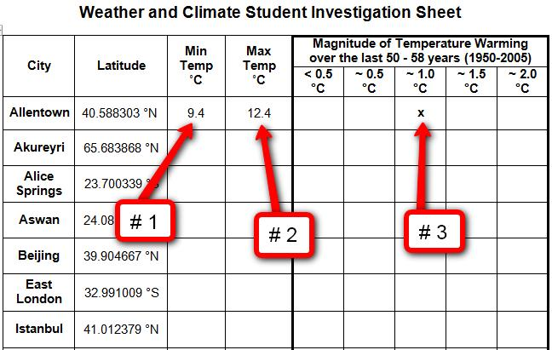

Complete the Weather and Climate Student Investigation Sheet by analyzing the climate graphs from 13 different global cities.

You can navigate from one city to the next by selecting the cities from the drop-down menu in the Places window or by using the Google Earth navigational tools.

Note: If you are zoomed out far enough to view the push-pins for more than one city in the 3D Viewer, you can view the climate graphs by selecting the yellow push-pins.

Answer the analysis questions on your investigation sheet.

