Investigating Weather and Climate with Google Earth Teacher Guide

In this activity, students will use Google Earth to explore global temperature changes. They will:
- Use Google Earth to determine how the temperature of the Earth has changed over the last 50 - 58 years.
- Explore, analyze, and interpret climate patterns of 13 different cities.
- Analyze differences between weather and climate patterns.

Model the following procedural instructions with your students. It is recommended that you display your computer image at the front of the classroom.

 Step 1: Download data

- Open your web browser. Go to https://eli.lehigh.edu/learners/climate-change

- Under Investigating Weather and Climate with Google Earth, click on Google Earth file: weatherandclimate.kmz.

The file is displayed in Google Earth.
Note: If the file download does not automatically launch Google Earth, double-click on the downloaded file weatherandclimate.kmz to launch Google Earth.

- Click the arrow to the left of “Weather and Climate” in the left panel (see red arrow below).

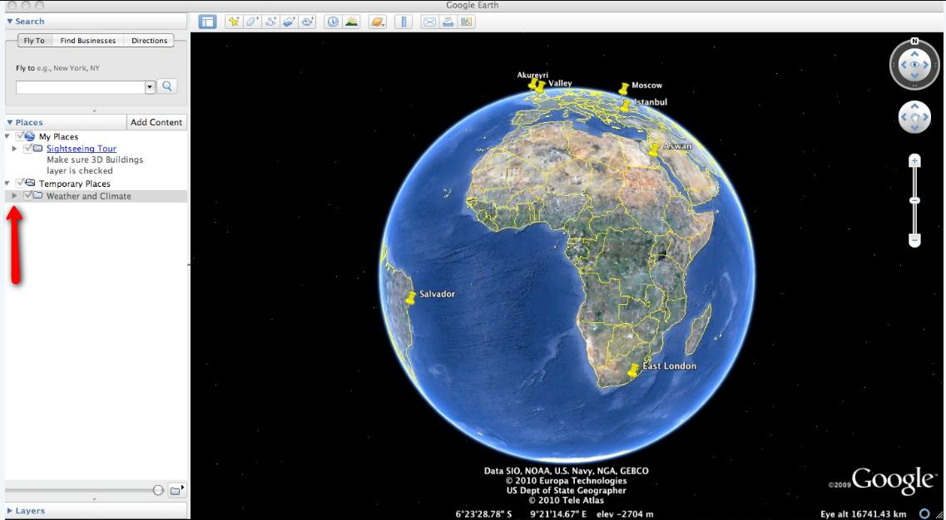

The “Weather and Climate” drop-down list will extend (see below). If you cannot see the whole list, scroll down.

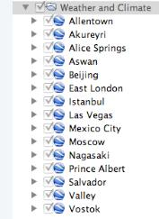

Step 2: Basic features of Google Earth
Note the following Google Earth features, tools, and navigation controls in the figure below.

- Search Panel (arrow #1) – Type in the white box to find a location.

- 3-dimensional (3D) Viewer (arrow #2) – This window shows the Earth and its terrain.

- Navigation controls (arrow #3) – Use these controls to zoom, look, and move around. If the navigation controls are not visible click on View>Show Navigation>Always.

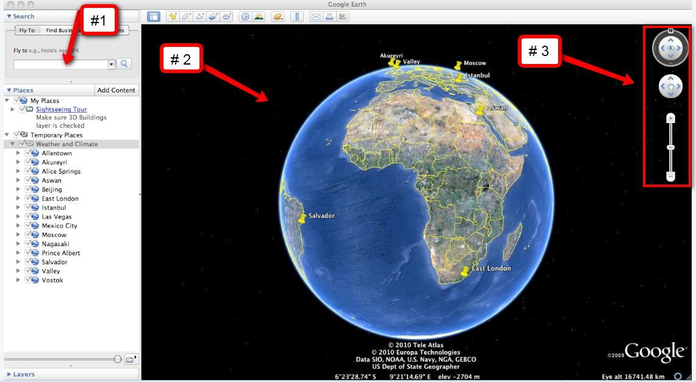

Step 3: Explore Weather and Climate
Your students will explore temperature changes over the last 50 - 58 years in 13 global cities using Google Earth. Data will be recorded in the Weather and Climate Student Investigation Sheet.

 Instruct the students to turn on the Google Earth Gridlines if they are not activated.
Select “View” and then “Grid” as shown below.

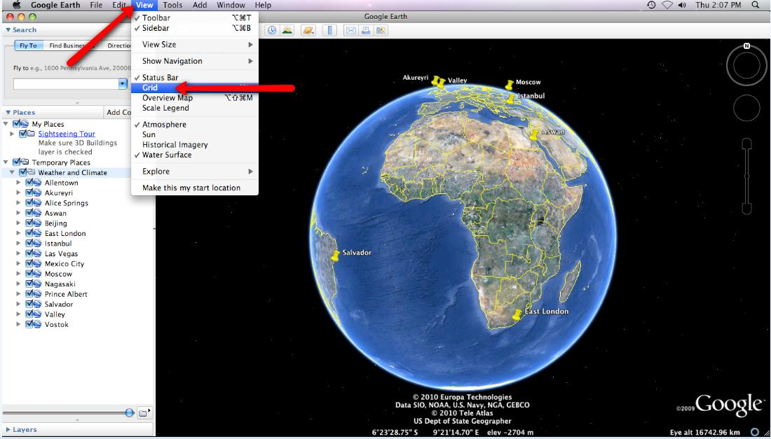

Walk students through the following example to examine climate data from Allentown.

- Double-click on Allentown in the Places window. Google Earth will zoom in to the city of Allentown.

- Click on the underlined word Allentown in the Places window (as shown below) or Click on the Yellow Push-Pin in the 3D viewer to view the Allentown climate graph.

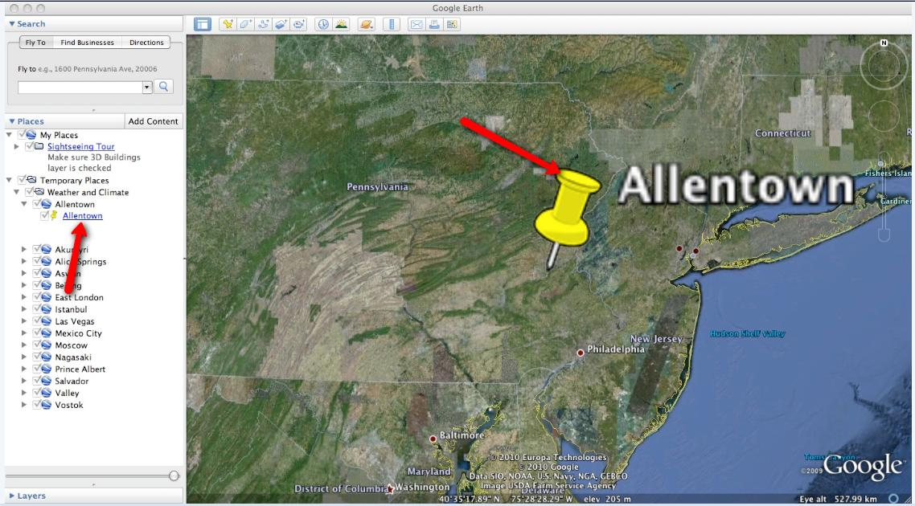

Important Note: We recommend that you show students how to make a climate graph appear larger in Google Earth. To do this, control-click on the graph (or right mouse click for PC users). Next, select “Open Image”. When finished, click “Back to Google Earth” to return to the Google Earth viewer display.

Show the students how to read and interpret a climate graph using Allentown as an example. Note that “years” are located on the x-axis and “temperature in degrees Celsius” is located on the y-axis. All climate graphs display a time period between 50 and 58 years. The temperature data is displayed as the average annual temperature for each year. The red line that passes through the graph is a linear trend line. The linear trend line shows how the climate has changed in the last 58 years. Note the slope of the linear trend line in the Allentown graph. It is a positive slope. A positive slope indicates that average annual temperature has been increasing over a 58-year period.

Note that the temperature difference between the start and end of the linear trend line is about one degree. Students can observe this by looking at the beginning and the end of the trend line for each city in this activity as shown in the picture below. Therefore, this graph data should be interpreted that the average annual Allentown climate has increased approximately one degree Celsius over a 58-year period.

Most climate graphs contain data from 1950 – 2004 (54 years). The Vostok climate graph contains data from 1958 – 2008 (50 years). The Aswan climate graph contains data from 1950 – 2005 (55 years). The Prince Albert climate graph contains data from 1950 – 2000 (50 years).

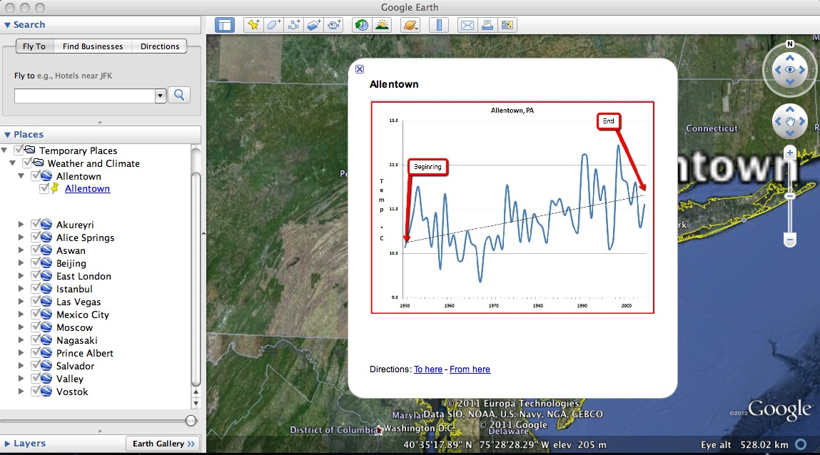

Distribute the Weather and Climate Student Investigation Sheet to each student. Tell students that they will complete the data table by analyzing climate graphs from 13 different global cities. For each city, they will record the minimum and maximum average annual temperature (in degrees Celsius) and determine the 50 – 58 year climate pattern.
The first row of the data table, Allentown, has been completed as an example. Have students view the Allentown climate graph in Google Earth to identify the minimum and maximum temperature. Remind the students that temperature is in degrees Celsius.
For Allentown, the minimum temperature is 9.4 °C (# 1 below) and the maximum temperature is 12.4 °C (# 2 below). The 50- 58 year climate pattern trends may be classified as < 0.5 °C, ~0.5 °C, ~1 °C, ~1.5 °C, or ~2 °C. Inform students that a magnitude of 1 °C is equal to a magnitude of 1.8 °F. Have students examine the linear trend line for Allentown. In Allentown, the temperature has increased about 1 °C in the last 58 years. Therefore, an “X” is placed in the ~1.0 °C column in the data table (see #3 below).

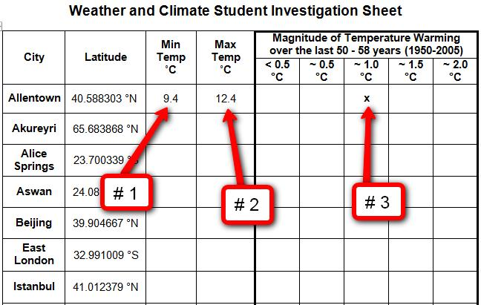

Implementation Suggestion: You may wish to walk students through a second example to highlight a linear trend line that has a very small positive slope to compare with the linear trend line in the Allentown graph. Display the Akureyri climate graph. Akureyri is the second city listed in the Places window. Note that the linear trend line of Akureyri does not increase as much as the Allentown graph (see image below). It is less than 0.5 °C. You may also point out to students that Akureyri has two different periods of 5 years that have weather cooling trends in which the average annual temperature does not exceed the linear trend line.

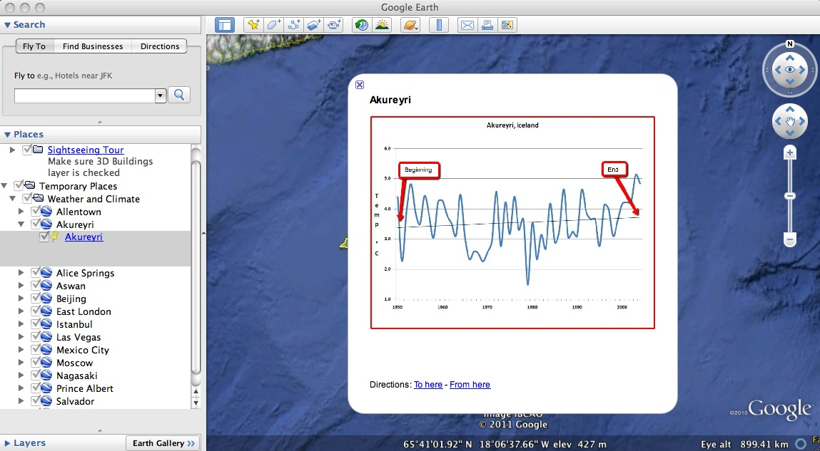

Instruct students to analyze the climate graphs from the other cities and complete the data table. The students can navigate from one city to the next by selecting the cities from the drop-down menu in the Places window or by using the Google Earth navigational tools. Remind students to be sure to examine the linear trend line in each city and to place an “X” in the appropriate column under Magnitude of Temperature Warming over the last 50 - 58 Years (1950 – 2008) on the data table.

Note: If you are zoomed out far enough to view the push-pins for more than one city in the 3D Viewer, you can view the climate graphs by selecting the yellow push-pins.

Implementation Suggestion: Some low-ability students may require additional support for completing this learning task. You may wish to walk through each city one at a time as an entire class using guided questions to analyze each city’s climate graph. This instructional strategy is effective using one computer in the classroom that displays the image to the front of the room.

Instruct students to answer the analysis questions on their investigation sheet.

Note: If your students are not familiar with geographical latitude coordinates, explain that N (north) and S (south) in latitude are geographical positions referenced to the equator. The equator has 0˚ latitude.

