Investigation 2: How do we recognize plate boundaries? Assessment
Answer the questions below in complete sentences.
- What major plate lies west of the North American plate?
The major plate west of the North American plate is the Pacific plate.
- What plate lies northeast of the North American plate?
The plate NE of the North American plate is the Eurasian plate.
- What plate borders the North American plate to the southeast?
The plate that borders the North American plate to the southeast is the African plate.

- Which three plates border the North American plate to the south?
The Caribbean, Cocos, and South American plates border the North American plate to the south.

- What plate borders the North American plate in the U.S. Pacific Northwest?

The plate that borders the North American plate in the U.S. Pacific Northwest is the Juan de Fuca Plate.

- How are earthquakes and volcanoes related to plate boundaries?
Earthquake clusters occur on or very near plate boundaries. Volcanoes occur about 100 kilometers away from a plate boundary in the overriding plate.
- What kind of plate boundary separates the North American and Eurasian plates?

A divergent plate boundary separates the North American and Eurasian plates.
- What kind of plate boundary separates the North American and Pacific plates at 31˚ latitude,
-115˚ longitude?
A transform plate boundary separates the North American and Pacific plates at 31˚ latitude,
-115˚ longitude.
- What kind of plate boundary separates the North American and Pacific plates at 55˚ latitude,
-160˚ longitude?
A convergent plate boundary separates the North American and Pacific plates at 55˚ latitude, -160˚ longitude.

- What type of plate boundary is located between the North American and Juan de Fuca plates?

A convergent plate boundary is located between the North American and Juan de Fuca plates.
- What type of plate boundary is located between the Pacific and Juan de Fuca plates?

A divergent plate boundary is located between the Pacific and Juan de Fuca plates.
- What types of lithosphere make up tectonic plates?

Tectonic plates are made up of continental and oceanic lithosphere.

Assessing the exported map images:
Step 2-3: Trace the North American plate boundaries
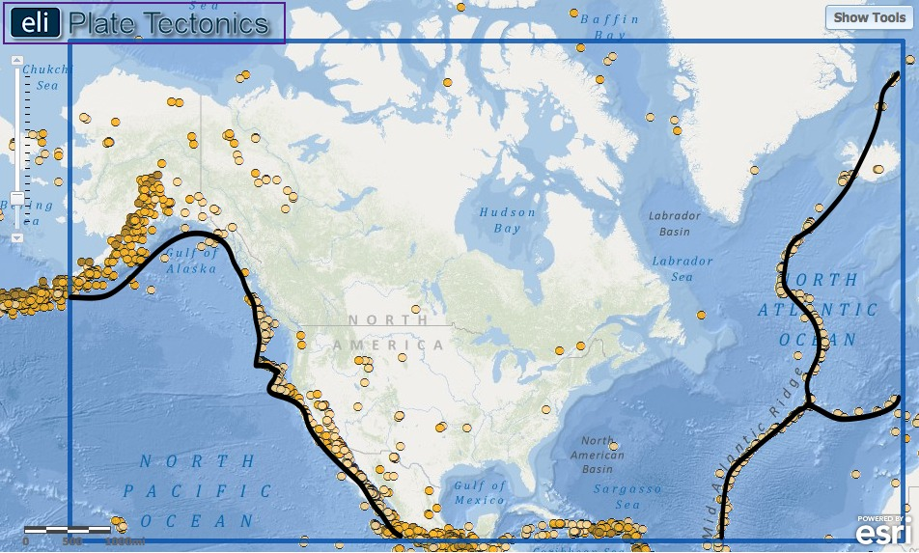
Students’ exported images should include 3 boundaries drawn by tracing the earthquake clusters:
- The western edge of the North American plate boundary.
- The eastern edge of the North American plate boundary.
- The east-west boundary dividing the Eurasia and Africa plates to the east of the North American plate.
Step 4: Revisit the U.S. Pacific Northwest and trace the Juan de Fuca plate using volcanoes
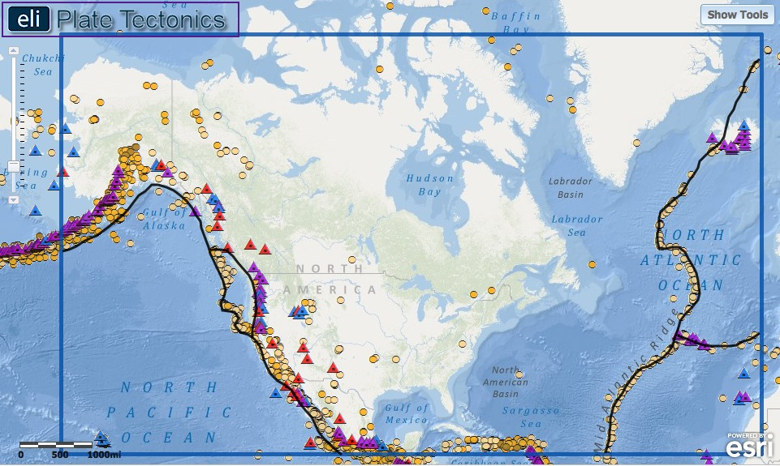
Students’ exported images should include the eastern edge of the Juan de Fuca plate made by tracing the line of volcanoes in the U.S. Pacific Northwest.

