Name____________________________
Investigation 3: How does thermal energy move around in the Earth? Assessment
Read all instructions on your handout and answer each question in complete sentences where appropriate.
- Do continents or oceans have higher surface heat flow?

The highest surface heat flow is located in the oceans.

- Which kind of plate boundary has the highest surface heat flow?
Divergent boundaries have the highest surface heat flow.
- What is occurring at these boundaries?

Divergent boundaries have the highest surface heat flow because they create new crust from molten mantle material.

- Why do oceans have high surface heat flow?

Ocean basins are created by divergent boundaries. At the divergent boundary, hot mantle material reaches the surface and cools to form new oceanic crust.

- In the Atlantic Ocean, where is the youngest ocean floor located?

In the Atlantic Ocean, the youngest ocean floor is located along the divergent boundary at the Mid-Atlantic Ridge.

- How does heat flow relate to age of the ocean floor?

Heat flow is greatest at very young ocean floor. New ocean floor is formed from molten lava from the mantle. It then cools with age. As the plates move apart from each other, the divergent boundary adds new oceanic crust to fill the gap, and the ocean basin and gets bigger

- Use your map to fill in the age of the ocean floor in the spaces below the profile
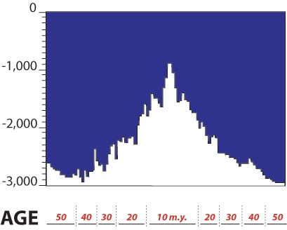

- How does ocean depth relate to age of ocean floor?

Older ocean floor is deeper.

- What is the relationship between ocean age, ocean depth, and surface heat flow?

Older ocean floor is colder and deeper. Younger ocean floor is hotter and shallower.

- How is hotspot volcanism different from other volcanoes?

Hotspots are often located away from plate boundaries.

- Which two plates have the most hotspots? Reminder: click on the map to learn the name of the plate.

The Pacific and African Plates have the most hotspots.

- Why are there more hot spots on the African Plate than on the South American Plate? Hint: look at the length of the plate vectors.

There are more hotspots on the African plate than the South American Plate because it is moving slower. The hotspots forming beneath the African plate have more time for heat to focus in one place and make a volcano on the surface.

- The Pacific Plate is moving fast! Why are there more hot spots in the Pacific Ocean?
Hint: Think about what happens as hot spot travels from the mantle to the surface. Is it faster or easier to go through something thick or thin?

The Pacific Plate lithosphere is relatively thin, and although it is moving fast, a hotspot needs less time get through the crust and form a volcano.

