Name____________________________
Investigation 4: What happens when plates diverge? Assessment
Read all instructions on your handout and answer each question in complete sentences where appropriate.

- What is the name of the feature located at latitude 31º and longitude -41º?

The Mid-Atlantic Ridge is the feature located at is the feature located at latitude 31º and longitude -41º.

- What is the name of the feature located at latitude -29º and longitude -112º?

The East Pacific Rise is the feature located at latitude -29º and longitude -112º.

- Describe the color pattern that occurs as you look from the divergent boundaries towards the continents. What does this tell you about the elevation at divergent boundaries?

The shades of blue are lightest along the divergent boundaries, the Mid-Atlantic Ridge and the East Pacific Rise. The shades of blue get darker as you travel towards the continents. This tells you that the divergent boundaries - the Mid-Atlantic Ridge and East Pacific Rise – are located at a high elevation. The elevation of the ocean floor decreases as you move towards the continents.

- Where are the extensional (normal) earthquake epicenters located?
Helpful Hint: Look at your Map Legend.

Extensional earthquake epicenters are located on divergent plate boundaries.

- a. What is the relative motion between the Eurasian and North American Plate?
Helpful Hint: Click anywhere on the map to locate the plate names.
The North American and Eurasian plates are being pulled apart and moving away from each other.
b. What is occurring as a result of this motion?
Extensional faults result from tension that pulls the rock apart.

- a. At what range of depths do most earthquakes occur along divergent boundaries?
Most earthquakes along divergent boundaries occur at depths <=10 km.
b. Why does this happen?
Helpful Hint: Turn on the Lithosphere Thickness layer and the Surface Heat Flow layer and look at the Map Legend to investigate ‘why?’

Only shallow earthquakes occur at divergent plate boundaries because the lithosphere is thin at this type of plate boundary. Furthermore, it is too hot below the lithosphere for earthquakes to occur in the asthenosphere.

- Calculate the half-spreading rate of the Mid-Atlantic Ridge. The half-spreading rate is the measurement from the divergent plate boundary in one direction towards the continent.

Distance from the Mid-Atlantic Ridge to oldest Atlantic Ocean floor off the east coast of North America | 2,900 km ± 200 km
Age of the oldest Atlantic Ocean floor off the east coast of North America | 180 m.y.
Half-Spreading Rate of the Mid-Atlantic Ridge  (Distance ÷ Time) | 16.1 km/m.y. ± 0.8 km/m.y

- Calculate the half-spreading rate of the East Pacific Rise.

Distance from the East Pacific Rise to the oldest Pacific Ocean floor off the west coast of South America | 4,450 ± 100 km
Age of the oldest Pacific Ocean floor off the west coast of South America | 60 m.y.
Half-Rate of the East Pacific Rise  (Distance ÷ Time) | 74.2 km/m.y ± 1.7 km/m.y

- How many times faster is the East Pacific Rise spreading than the Mid-Atlantic Ridge?
Hint: Divide the rate of the East Pacific Rise spreading by the rate of spreading calculated for the Mid-Atlantic Ridge.

The East Pacific Rise is spreading 4.6 times faster than the Mid-Atlantic Ridge.

- Use your map to fill in the age of the ocean floor in the spaces below the profile. Then, look at the dashed lines on the profile below. The dashed lines mark the average elevation of that part of the ocean floor. Record the average elevations in the spaces below the profile.

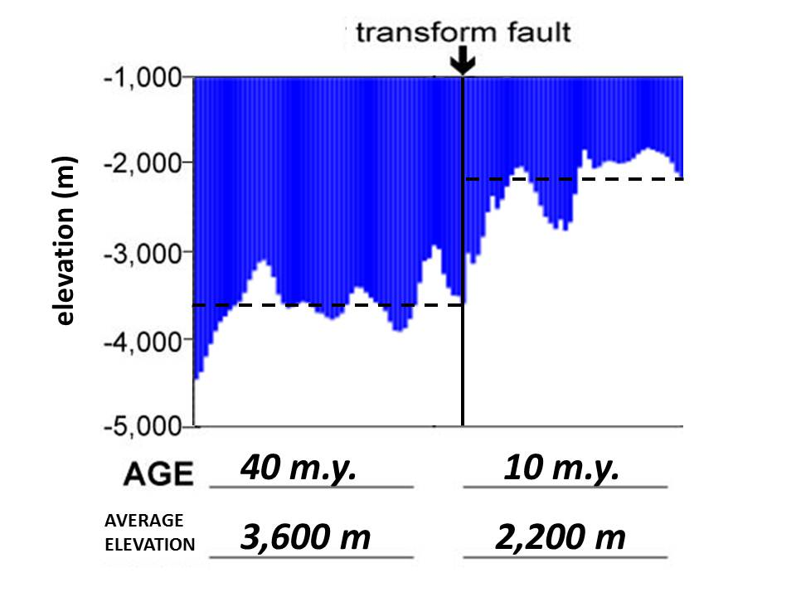

- Why does the elevation change across the transform fault?

The elevation changes across the transform fault because the transform fault puts older ocean floor next to younger ocean floor. The older ocean floor is cooler and denser, so it has a lower elevation.

- Is the eastern edge of the continental shelf of North America on land or under water?

The eastern edge of the continental shelf of North America is located under water.

- What continent rifted away and separated from the East Coast of the United States?

The African Plate rifted away from the east coast of the United States.

- When did North America separate from Africa?

The North American plate separated from Africa 180 million years ago.

Assessing the exported map images:
Map #1: Place the continents where they were located 90 million years ago.

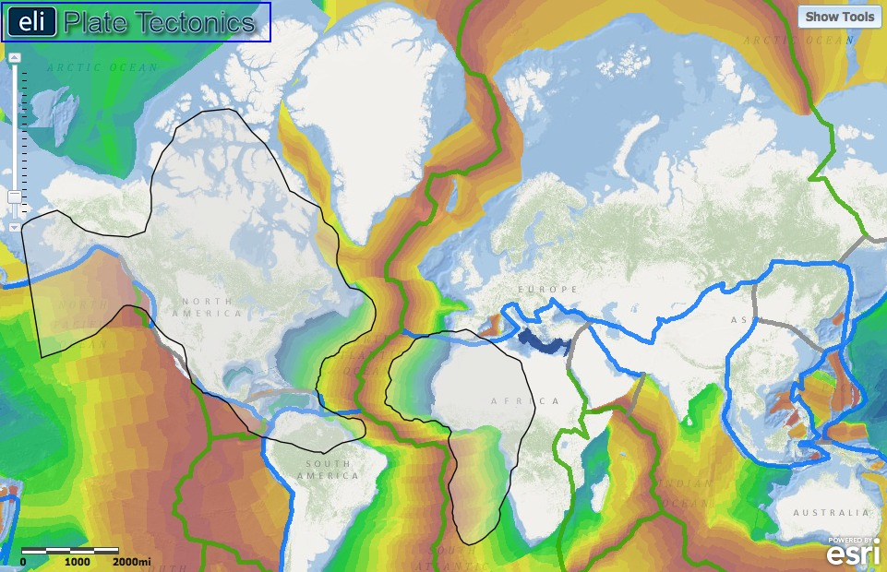

Student’s exported image should show the North America and African continent boundaries aligned with the 90 m.y. age position. This age is represented by a neon yellow-green on the map.

Map #2: Place the continents where they were located when rifting started.

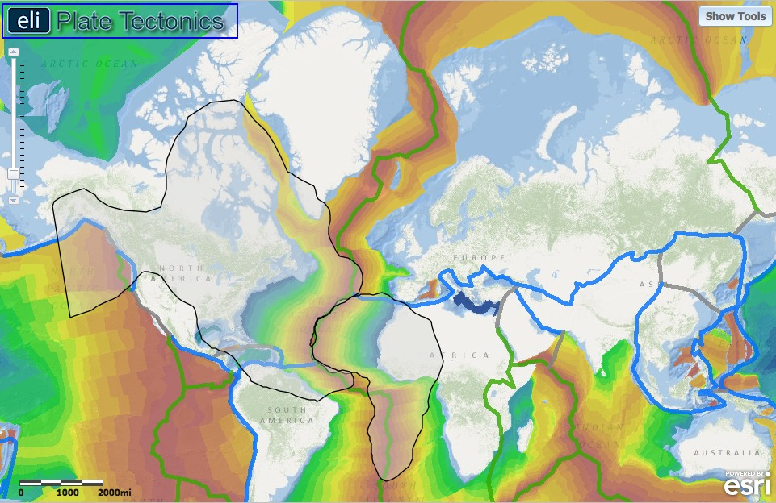

Student’s exported image should show the North America and African continent boundaries aligned with the divergent boundary. North America should be rotated counter-clockwise, and Africa should be rotated clockwise to fit into place.

