Investigation 6: What Happens When Plates Collide? Assessment

Answer the questions below in complete sentences.

Part 1: Subduction Zones

- How deep is the trench in the Aleutian subduction zone?

The trench in the Aleutian subduction zone is approximately 7,000 m below sea level. The deepest point on the elevation profile is 6,921 m below sea level.

- a. What is the height of the volcano along the elevation profile?

The highest volcano along the elevation profile is 2,517 meters in elevation (Shishaldin on Unimak Island). The actual height of the volcanoes is 2,857 meters according to the Web GIS data set. Note: When discussing this answer with students, you may point out that the elevation profile line was not drawn through the volcano’s peak.
b. On which plate is this volcano located?
The Shishaldin volcano is on North American Plate.

- What is the name of the plate immediately north of the Aleutian Trench?

The North American Plate is the plate located immediately north of the Aleutian Trench.

- What is the name of the plate immediately south of the Aleutian Trench?

The Pacific Plate is the plate located immediately south of the Aleutian Trench.

- What type of plate boundary is located along the eastern section of the Aleutian Trench where most volcanoes are located?

The plate boundary is convergent in the eastern section of the Aleutian Trench where most volcanoes are located.
- What type of plate boundary is located along the western section of the Aleutian Trench where volcanoes are absent?

The plate boundary is transform in the western section of the Aleutian Trench where volcanoes are absent.
- Formulate a hypothesis. Which plate is the overriding plate and which is the subducting plate? Support your hypothesis with your knowledge about what occurs in a subduction zone.

Student hypotheses should identify the North American Plate and the Pacific Plate as either the overriding plate or the subducting plate. In a subduction zone, plate collisions at a convergent boundary cause one tectonic plate to move underneath another tectonic plate.

- On your O\O (Atka Island) and O\C (Kodiak Island) profiles, what is the horizontal distance between the volcanoes and the trench? How deep is the deepest earthquake focus on the profile?

 | O\O (Atka Island) | O\C (Kodiak Island)
Distance from volcano to boundary | 160-194 km for the two volcanoes near the profile | 311-342 km for the two volcanoes near the profile
Depth of the deepest earthquake focus | 206 km below sea level | 137 km below sea level

- a. Imagine you are standing on Kodiak Island and feel a deep earthquake which occurs beneath you. On which plate is the epicenter?

This epicenter is on the North American Plate.
b. On which plate is the focus - the place where the deep earthquake originates?

Those earthquakes originate from the Pacific Plate.

- On which profile is the subducting slab steeper?

The subducting slab is at a steeper angle on the O\O profile.
- Look at your hypothesis in question #7. Was your hypothesis correct? Think about how the volcanoes are formed. Restate your hypothesis about which plate is subducting? Support your hypothesis with evidence about processes that occur at a subduction zone.

The Pacific Plate is subducting underneath the North American Plate. The downgoing slab of the Pacific Plate at the subduction zone heats up and partially melts causing magma to rise up through the overriding plate resulting in the formation of volcanoes. This heat rises through the surface going through the overriding plate and results in the formation of volcanoes.

- On the Subducting Slab Depth layer, which colored line is the deepest and which colored line is the shallowest, the red line or green line?

The red line indicates the deepest slab depth. The green line indicates the shallowest slab depth.

- Which direction is the subducting slab sloping (dipping)?

The subducting slab is sloping (dipping) to the north.

  - Imagine the subduction zone profile extended past the Aleutian Trench to the south. What is the age of the ocean floor at the edge of the O\O (Atka Island) Subduction Zone Profile?

The age of the ocean floor at the edge of the Subduction Zone Profile is 70 million years.

  - Imagine the subduction zone profile extended past the Aleutian Trench. What is the age of the ocean floor at the edge of the O\C (Kodiak Island) Subduction Zone Profile?

The age of the ocean floor at the O\C (Kodiak Island) Subduction Zone Profile is 50 million years.

  - What is the relationship between the age of the ocean and the slope (steepness) of the subducting slab?

Ocean floor is older where there is a steeper slope of the subducting slab. The subducting slab is steeper at O\O (Atka Island) where the age of the ocean floor is older.
When discussing this response with your students, you may wish to elaborate that younger crust is warm and shallow. There is warmer, more buoyant ocean being subducted at O\C (Kodiak Island).

Assessing the exported image:
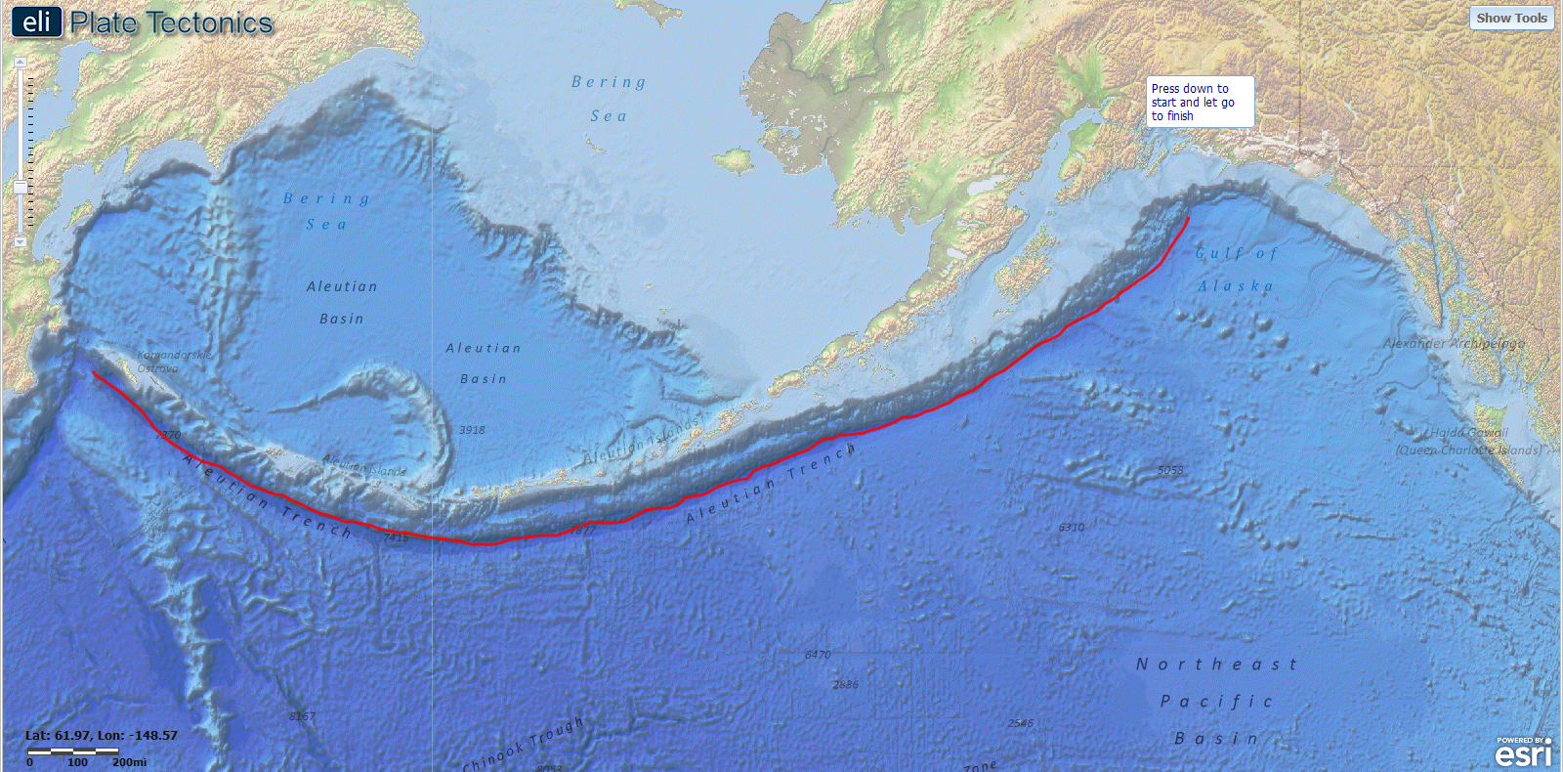
The exported image should include a continuous line that follows the Aleutian Trench at its deepest point indicated by the darkest blue color on the GIS map display.

Part 2: Colliding Creates Landforms
- What type of crust are these plates composed of at this location (oceanic or continental)?

Both plates are composed of oceanic crust at this location.

- What type of landform is formed north of the plate boundary at this location?
Volcanic islands are formed north of the plate boundary at this location.

- What are the names and elevations of the three volcanoes in the Investigation 6 Images layer?

The volcanoes are: Amukta with elevation 1066 m, Koniuji with elevation 273 m, and Great Sitkin with elevation 1740 m.

- Which plate is overriding and which plate is subducting in the U.S. Pacific Northwest at the convergent plate boundary? Support your answer with evidence from the GIS map. (Hint: Where are the volcanoes located?)

The North American Plate is overriding and the Juan de Fuca Plate is subducting in the U.S. Pacific Northwest. This is supported by the fact that the volcanoes are located on the continental North American Plate.

- What type of crust are the plates composed of at the convergent plate boundary in the Cascadia region of the U.S. Pacific Northwest (oceanic or continental)?

The North American Plate is continental crust, and the Juan de Fuca Plate is oceanic crust in the Cascadia region of the U.S. Pacific Northwest.

- What type of landform do volcanoes create at the plate boundary in the U.S. Pacific Northwest?

Volcanoes create volcanic mountains at this plate boundary.

- What are the names and elevations of the three volcanoes in the Investigation 6 Images layer?

The names and elevations of the three volcanoes are: Hood with elevation 3426 m, St. Helens with elevation 2549 m, and Rainier with 4392 m in elevation.

- Compare the three volcano images. Which volcano do you think erupted most recently? Support your answer with evidence from the images. (Hint: Pay close attention to the shape of the top of each volcano.)

St. Helen’s erupted most recently, as evidenced by the absence of the volcanic dome.

- How are the subduction zone areas in the Aleutian Trench and Cascadia similar?
The subduction zone areas in the Aleutian Trench and Cascadia are formed at a convergent boundary that is created by an ocean plate subducting down into the mantle. This subduction results in the formation of volcanoes from magma generated as sinking crust heats up as a result of one tectonic plate sliding underneath another tectonic plate.
- How are the subduction zone areas in the Aleutian Trench near Atka Island and Cascadia different?

The subduction zone in the Aleutian Trench near Atka Island is formed in an ocean/ocean convergent plate boundary that resulted in the formation of volcanic island arc in the ocean. The subduction zone in Cascadia is formed at an ocean/continent convergent boundary and that resulted in the formation of volcanoes on land.

- What is the primary geologic hazard in the U.S Pacific Northwest?

Volcanoes are the primary geologic hazard in the U.S. Pacific Northwest.

- What is the primary hazard in the U.S. Pacific Southwest?

Earthquakes are the primary geologic hazard in the U.S. Pacific Southwest.

- Why do the hazards on the western coast of the United States exist where they are? Support your answer with evidence from the GIS map. (Hint: Look at your GIS layers and legend.)

The plate boundary in the U.S. Pacific northwest is a convergent boundary that results in the formation of volcanoes. The plate boundary in the U.S. Pacific Southwest is a transform plate boundary that characteristically has many earthquakes and no volcanoes.

- What landform was created when Africa collided with North America 300 million years ago?

The Appalachian Mountains were created when Africa collided with North America 300 million years ago.

- The Appalachian Mountains are currently about 2,000 meters tall and 300 million years old. Assuming these mountains have been eroding at a rate of 20 meters per million years, how tall were the Appalachian Mountains when they formed?

The Appalachian Mountains were 8,000 meters high.

- Africa is no longer next to North America. What caused Africa to move to its current location?

North America and Africa drifted apart.

