Tree Ring Exploration Handout

Driving Question: What paleoclimate evidence do tree rings provide?

In this activity you will:
- Understand that trees add rings annually with lighter and darker layers that represent summer and winter growth.
- Understand that the width and shape of the tree ring is dependent on environmental conditions.
- A record of tree ring measurements is a paleoclimate proxy.

Background Information

Tree ring dating, or dendrochronology, is a very accurate indicator of long-term climate change. It is a very accurate indicator of climate change on the decadal (tens of years) to millennial (thousands of years) time scales. Trees grow well when local weather and climate conditions are favorable and grow poorly when they are not. Most trees add one annual growth ring each year. New rings are the result of new growth in the cambium layer just below the bark. The rings in the middle of the tree are oldest and the outer rings nearest the bark are the youngest.

A tree ring is composed of two layers:
• A light colored layer that grows in the spring and early summer.
• A dark colored layer that forms in late summer and the fall.
The cambium produces large cells in the spring when water is abundant and growing conditions are generally good. This is the light part of the tree ring. As the climate becomes drier later in the summer and the growing season ends in the fall, the cambium produces smaller cells that have thicker walls. This is the dark part of the tree ring. In the northern hemisphere, in the late autumn, tree growth stops.

The width of the ring is dependent on the precipitation available to the tree. Trees produce wide rings during wet and cool years. Tree rings are narrow during hot and dry (drought) years.

By combining living and dead tree records, scientists can extend tree-ring paleoclimatology records back hundreds to thousands of years. Scientists cross-reference climate data by matching patterns from several trees. Tree rings can provide evidence of natural disasters including volcanic eruptions, earthquakes, fire, lightning strikes, and insect, fungal or bacterial infestations. Growth patterns can also be altered by human actions that cause damage to the trees.

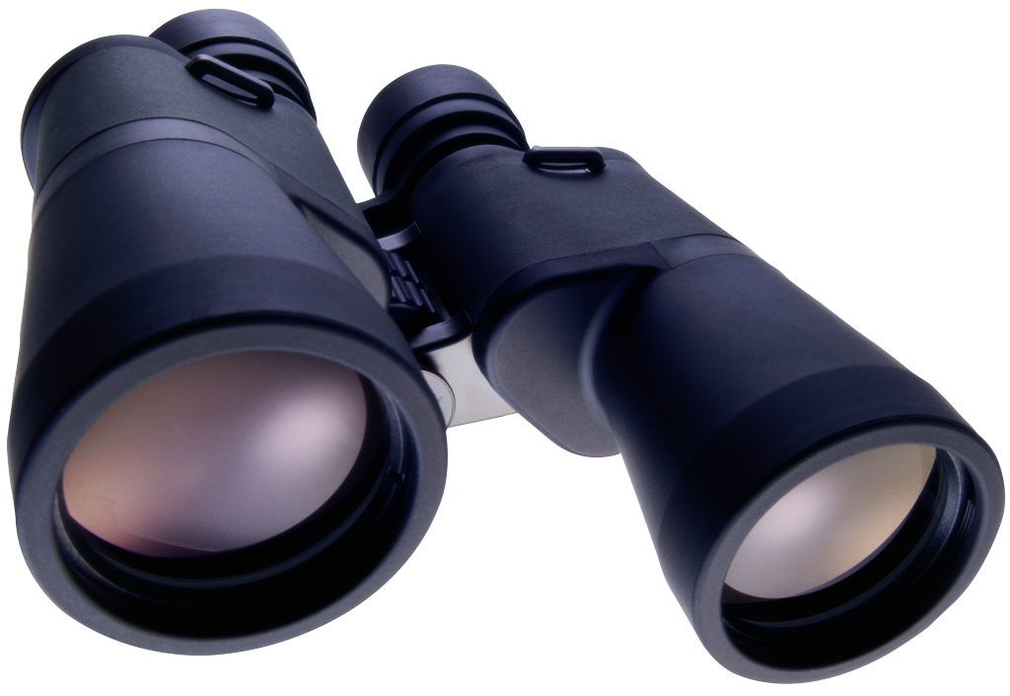Activity Description
- You will examine a tree ring record to explore a tree’s history.
- The image on the next page shows a tree ring record.
Each dark and white layer represents one complete year of growth.
The distance between two dark lines represents one annual layer (or one year) of growth.
- The outer ring of this tree grew in 2011.
- Examine the tree ring record and answer questions #1-5 on the next page.
Tree Ring Activity

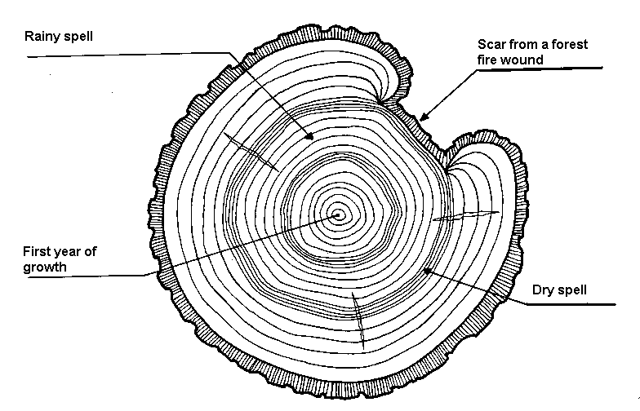

The outer ring of this tree grew in 2011.

- How old is this tree?

- Locate the pointer marked First year of growth.

  - What year did this tree start to grow? (HINT: To calculate the tree’s first year of growth: 2011 - age of the tree = tree’s first year of growth)

- Locate the pointer marked Scar from a forest fire wound.
  - How many years ago did a forest fire wound the tree? (HINT: Count the number of rings between the damage mark and the outer ring.)

- Locate the pointer marked Dry spell.
  - Note the annual layers are very narrow in this part of the tree record.
  - How many years ago did the drought start? (HINT: Count back from the outer ring to the earliest narrow ring that is closest to the First year of growth.) ______
  - How many years were in this dry spell? (HINT: Count the number of narrow rings in this area of the tree record.) ____________________

- Locate the pointer marked Rainy spell. Note that the rings are wider in this area of the tree record.
  - How many years were in this rainy spell? (HINT: Count the number of wider rings in this area of the tree record.) ____________________

