Zoning and Me
What does my local zoning look like? How is city zoning determined near me?

City zoning controls how land is used and what buildings can be constructed within the city limits. The zones define areas that have different uses and building types. You will:
- Investigate the area around your school and identify what type of zone you are in (residential, business, industrial, green space, etc.).
- Determine how zoning areas are distributed around your school and compare your observations with the official zoning map for your city.

Read all instructions and answer each question on your investigation sheet.

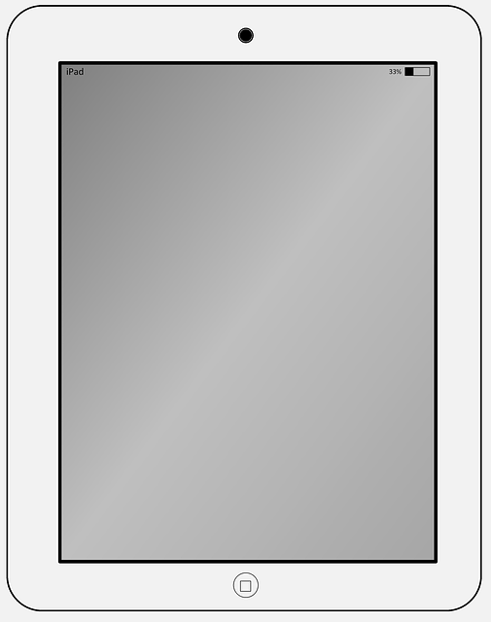
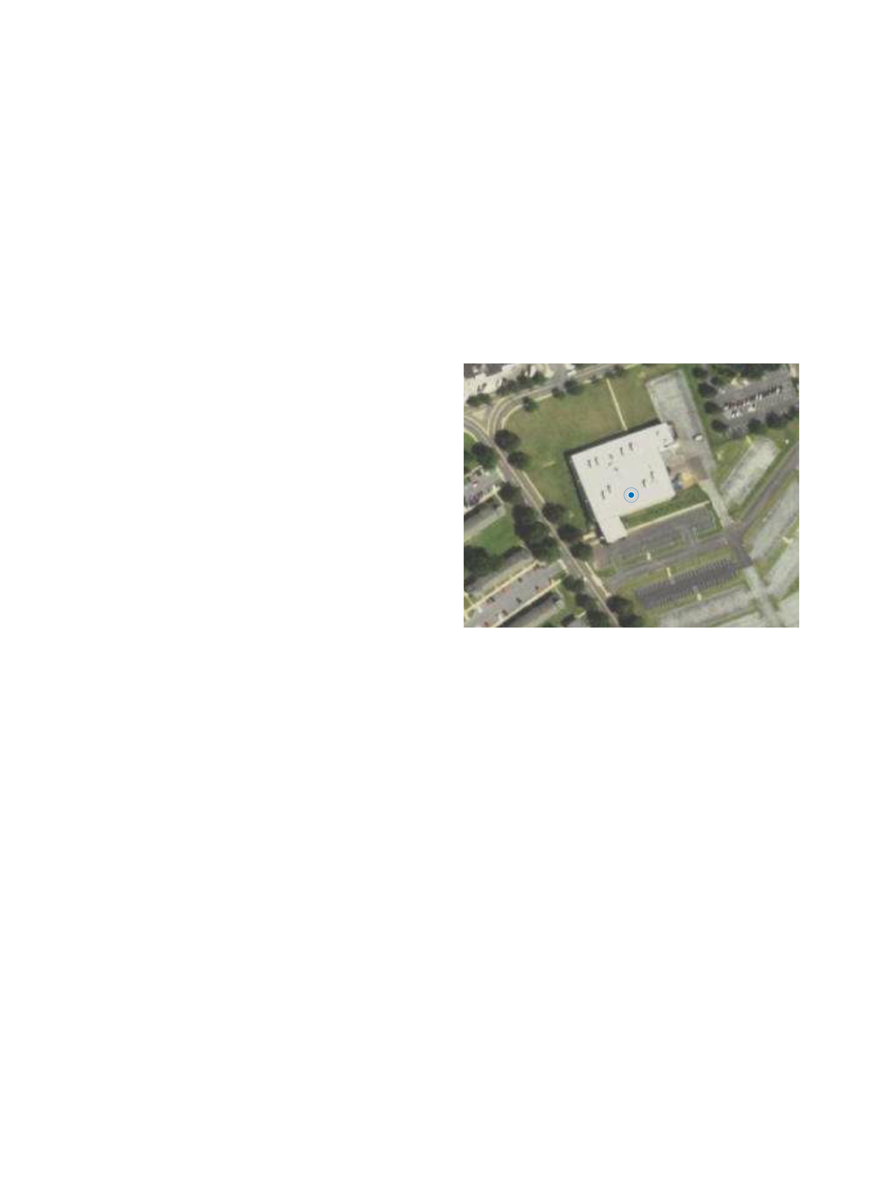
Step 1: Open the Collector App and Your Map

- Collector app and sign in

- Download your class’s map.

- Make sure a blue dot appears. If it doesn’t appear after a few minutes, restart the app outside.

Step 2: Start making observations in your area

Your job is to observe the differences in the areas around your school. Always stay with your partner and adult when you are outside.

Where to go:  - Go to your assigned waypoints (colored circles).  What to do:  - Face in the direction of the arrow.  - Make observations and collect data.  - Take a picture.  - Once you have made all of your observations click Submit. | 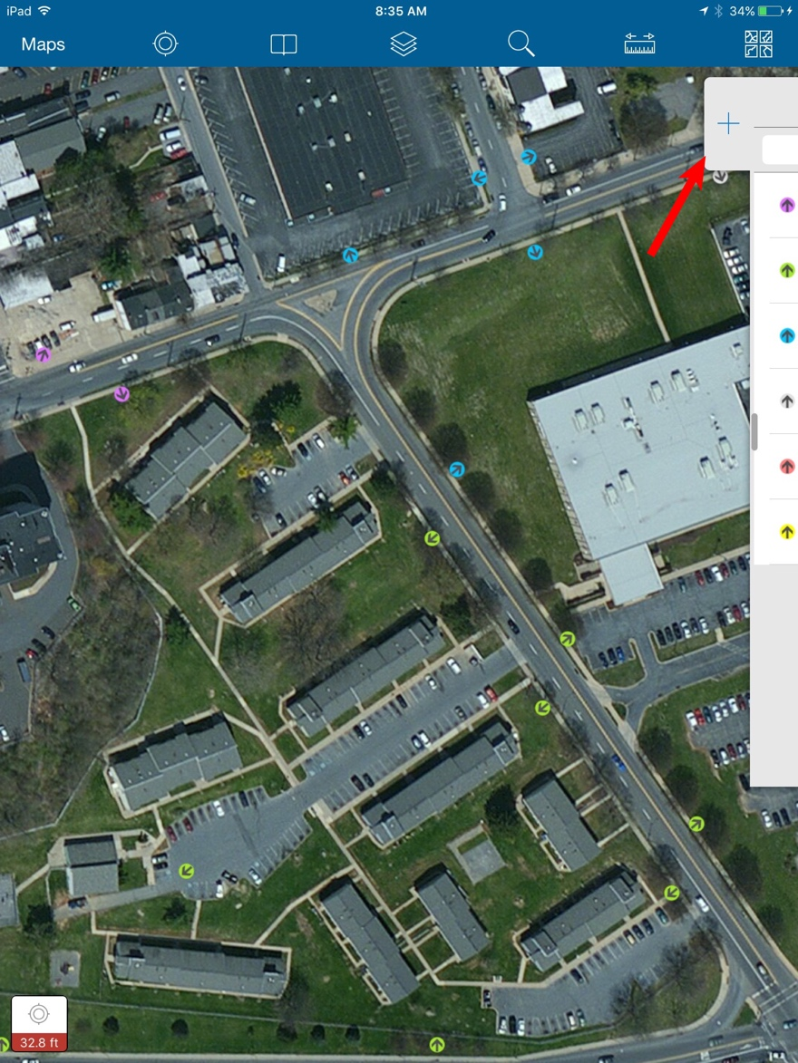

Step 3: Sync your observations with your class

- Select Maps in the upper left of your screen.  - Select the cloud icon (red box) to start synchronizing your observations.  - Click on the map again after synchronizing to see all the points your classmates have added.  - After completing the questions remove the map. On the same screen select the square icon $→$ Manage $→$ Remove $→$ Remove features and basemap  - You can then log out of the iPad. Select the square icon $→$ Sign Out $→$ Sign Out | 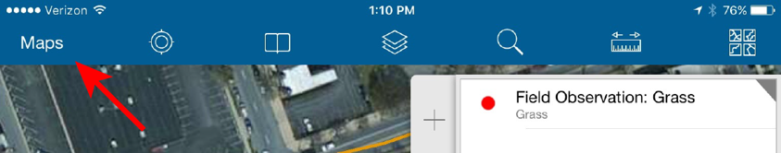

Step 4: Explore your class’ observations in ArcGIS Online

Go to https://b21.maps.arcgis.com/home.html. Login with your username and password in the top right corner of the webpage.

- To bring the map up on your screen you need to click the Groups menu at the top of the screen $→$Your class Students $→$ find and click the All Zoning Classroom Map image  - Field observations are now color-coded.  - Choose the Contents tab (the middle option in the red box in image to the right).  - Explore the entire area.  - Answer questions # 1-6 below. | 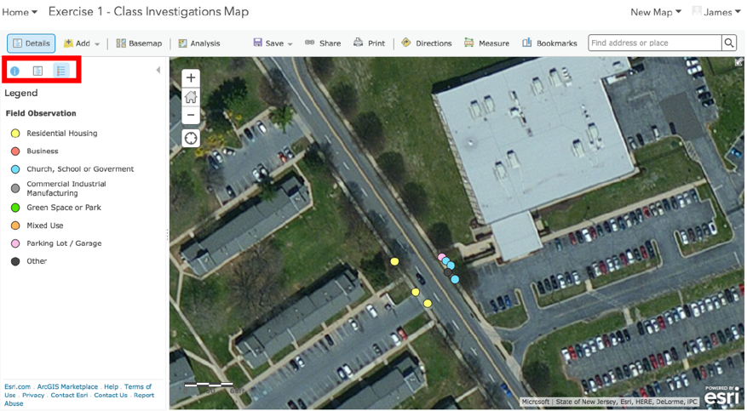

1. Who was in your group and which waypoint were you assigned?
Group Members
Teacher / Mentor
Waypoint Assigned

2. Choose two field observations you collected. Fill out the following table for those 2 observations:
 | Field Observation 1 | Field Observation 2
General Category
Types of Buildings
Any other observations

3. Turn off the Zoning Waypoints layer. Notice the colors on the map. How many different general categories did your class observe? What are the names of the general categories your class observed? (Hint: look at the legend)

4. Turn on the Zoning Observations layers for all classes. Look at the field observations closest to Building 21. What general category does that color represent?

5. Turn on the Zoning Waypoints layer. Find a waypoint for which students made different observations. Click on the waypoint. What is the Waypoint Number?

Why do you think these differences exist?

6. Would you change any general categories that you chose in your field observations? If so, which field observations and why?

Step 5: Identify zoning areas and compare your map to your local zoning map

Compare the similarities and differences of the places marked by the observations in your map. You will identify areas that contain similar features and create a zoning description that classifies those particular areas. You will also determine areas that have different features and mark boundaries between those different areas.
You will draw and label your proposed zoning classifications on your map and submit a screenshot to your teacher with a detailed caption describing your map. You will then compare your zoning classification map to the Allentown government’s official zoning map.

- Select Add (red arrow).  - Select Add Map Notes and pick a name for your notes (“My name’s” notes).  - You should now see a new Edit tab (see lower image).  - Use the Area tool from the Add Features tab to help you make these zones.  - You can change the background color of your area by clicking on the area. A pop-up box will appear. Select “Change Symbol”. You can then select a new fill color (see image).  - You can just Close out of these boxes once you finish editing the color. Click Save to save your changes to your map.  - Continue adding zoning areas to your map until all of your boundaries show up on the map. Click Save each time you make a new change to your map.  - After you have completed your zoning map, take a screenshot of your map and submit it to your teacher using Google Classroom.  - Under your submitted map, write a description of your zoning map. Clearly describe what each color represents.  To take a screenshot, press the ‘Print Screen’ key. | 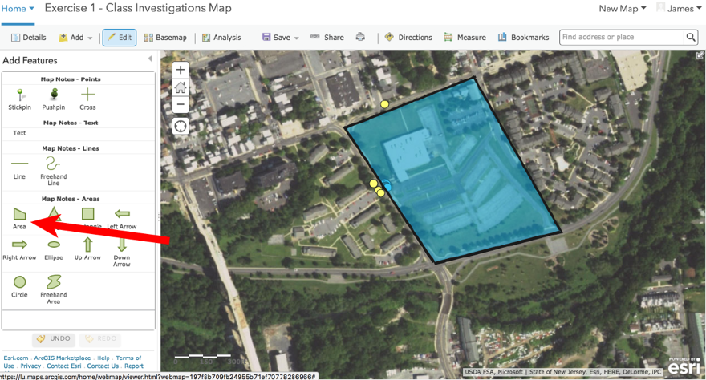  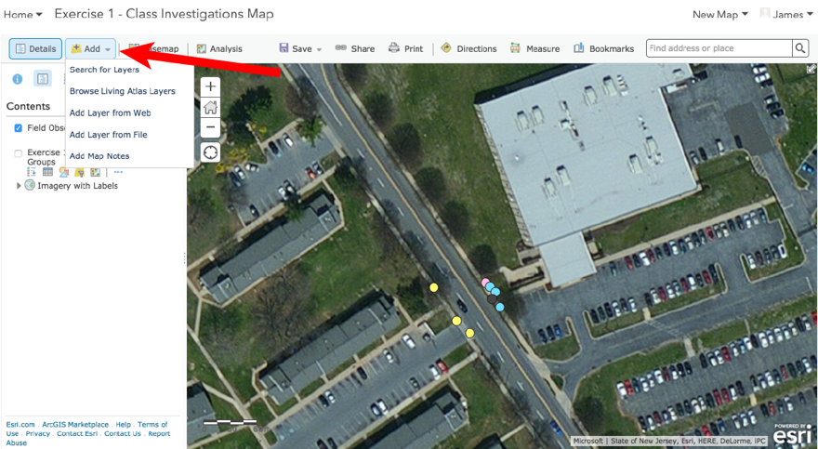
 | 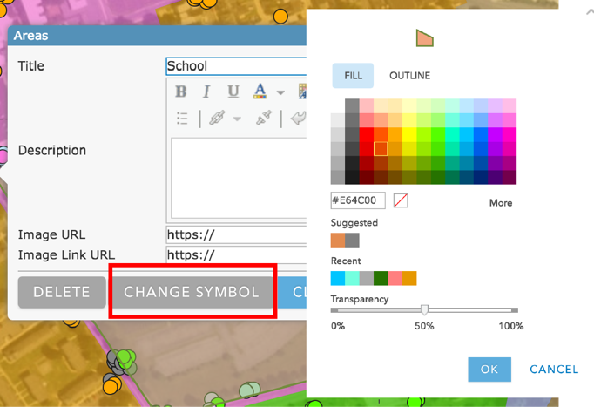
- Next, compare your zones to Allentown’s zoning map.  - Turn on the Allentown Zoning Groups layer (see image to the right).  - A new colored data layer will be added to the GIS map on top of your class’ field observations. Explore the data by clicking on different colors on the map.  - How do your boundaries compare to the boundaries in Allentown’s zoning map? Answer questions  # 7-9 below. | 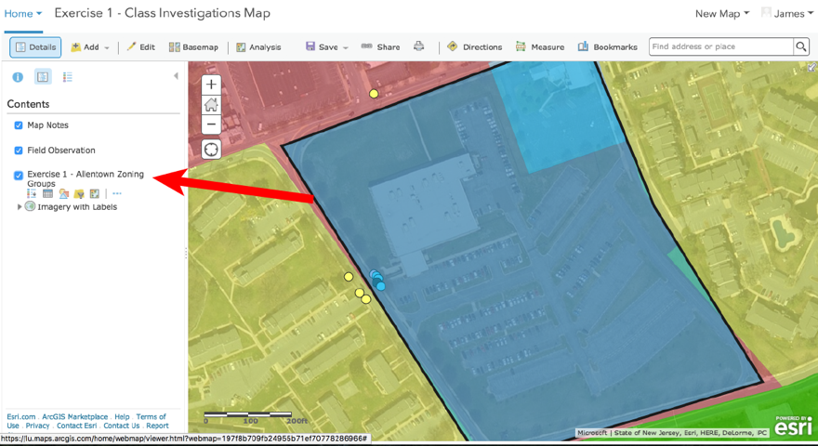

7. List five different zoning classifications from the Allentown Zoning layer.

8a. Compare your class’s observations to Allentown’s zoning map. What differences exist between your class’s observations and the city zoning classifications?

b. Why do you think these differences exist?

9. Why do you think Building 21, a school, is located in a business district?

