Carbon Sequestration Challenge Question

In questions #5 and #6 we assumed that a tree sequesters the same amount of carbon every year. We can test this by comparing the amount of wood added in first 5 years to the amount of wood added in the last 5 years of the tree’s life cycle and deriving the carbon sequestered at each stage.

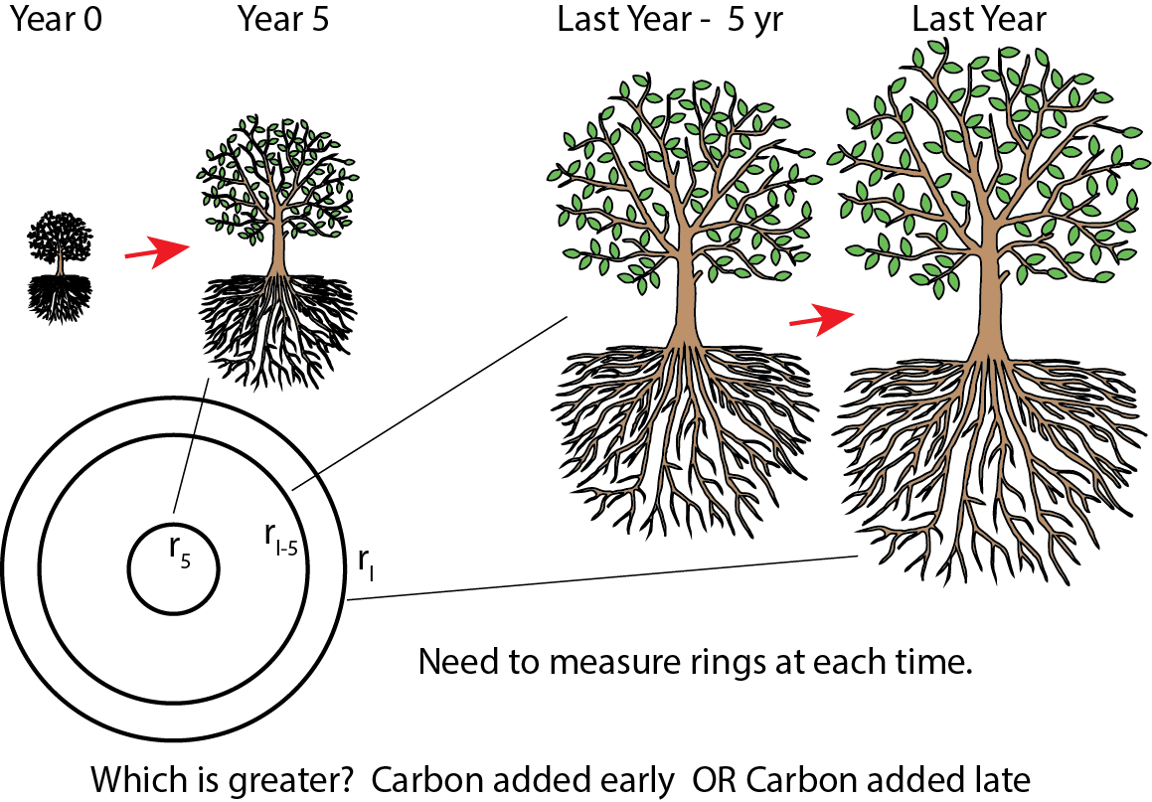
See example image below.

- How much wood was added, and how much carbon was sequestered, in the first 5 years?
 | First 5 years
What is the radius? | r₅ = _________ cm
What is the biomass? | $Total Biomass=33811.8\frac{kg}{m^{2}}•{radius of cookie (m)}^{2}$  IMPORTANT: Convert radius (cm) to meters (m)  = ________________________ kg
What is the carbon sequestered? | $Total Carbon=Total Biomass / 2$ = _____________ kg

- How much wood was added, and how much carbon was sequestered, in the last 5 years?

 | Final size  (starting point to edge) | 5 years before final size | Difference  (additional growth in last 5 years)
What is the radius? | (copy from previous questions)  r_{l} = cm | r_{l-5} = cm | (column 2 – column 1)  = cm
What is the biomass? | (copy from previous questions)  kg | $Total Biomass=33811.8\frac{kg}{m^{2}}•{radius of cookie (m)}^{2}$  IMPORTANT: Convert radius (cm) to meters (m)  kg | (column 2 – column 1)  kg
What is the carbon sequestered? | (copy from previous questions)  kg | $Total Carbon=Total Biomass / 2$  kg | (column 2 – column 1)  kg

- Which was greater the wood added / carbon sequestered in the first 5 years or the last 5 years?

- Why do you think the amount of wood added / carbon sequestered changes over the life of a tree?

