Carbon Sequestration Investigation
How do trees store carbon from the atmosphere?

Trees take up carbon dioxide (CO₂) from the atmosphere for their growth and life. The amount taken up depends on the type of tree and its age. You will:
- Measure the age of a tree.
- Calculate the amount of carbon sequestered (taken up) by that tree during its life.
- Compare the amount of carbon sequestered (taken up) by the tree to a typical American monthly carbon emission.
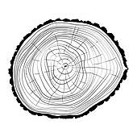

Step 1: Measure the age of a tree

- You will be given a tree “cookie” (slice) which is a cross section of a tree trunk. This tree was cut down in Summer 2017 by PPL to keep power lines clear.  - Count the rings in your tree cookie (slice) to determine the age of your tree. Each year is made up of a thin and thick part of the ring. The thick part (light color) is during the growing season (spring-fall) and the thin part (dark ring) is growth during the winter.  Helpful Hint: Start counting from the center of the cookie to the bark. Count years from dark ring to dark ring.  The bark is not a ring.  Helpful Hint: Your cookie might be asymmetrical. For Step 1 you may use any radius you want, but we suggest you use a longer radius to make counting easier.  - Answer questions #1-3 below | 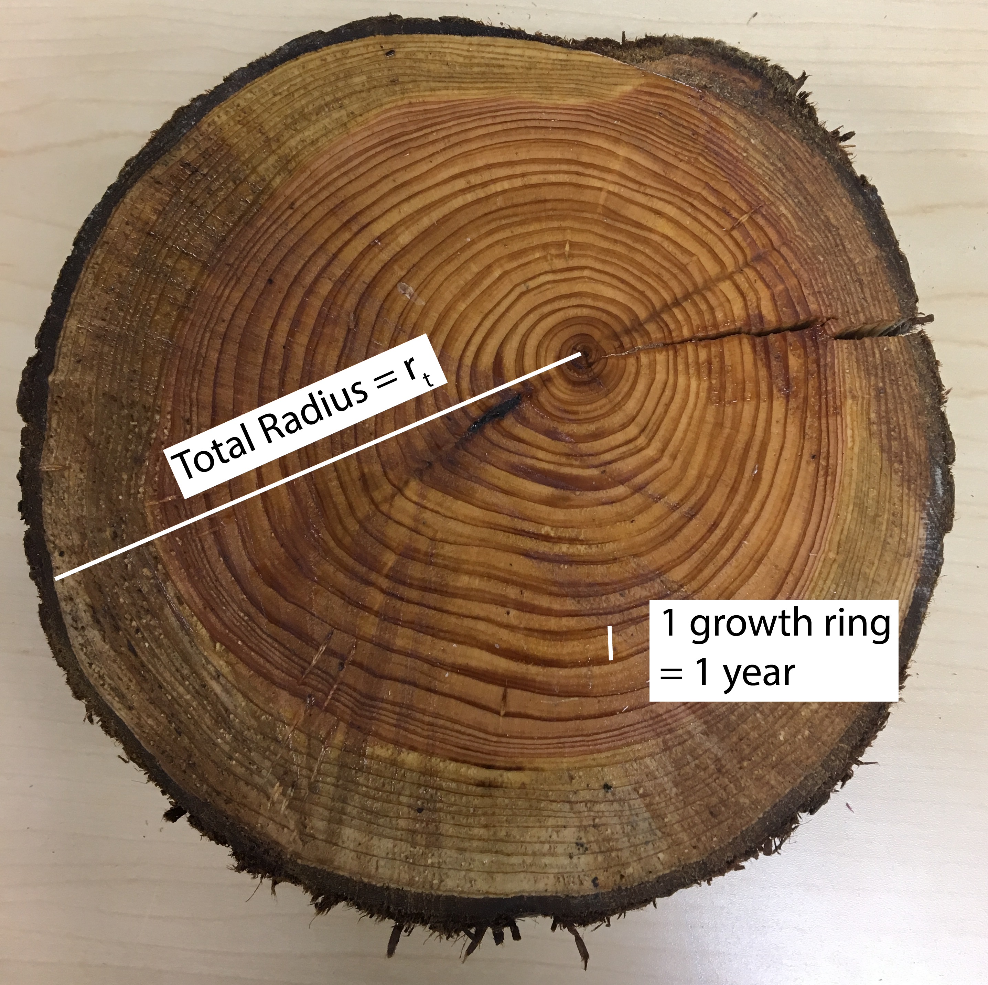

1. a. How many rings did you count?

b. When was this tree planted? (Hint: Subtract the number of rings you counted from the year the tree was cut down - 2017.)

2. Find the thickest tree ring (summer AND winter) in your cookie (slice). What year was this tree ring created?

3. Find the ring for the 10th year of the tree’s life and the ring for 20th year of the tree’s life. How much wood was added during these 10 years? (See image below for how to calculate area of wood added)

To calculate the amount of wood added during these 10 years you need to measure the radius of ring #10 and ring #20 from the center.

***Take your best guess for this radius in centimeters.***
***Be sure to measure both radii in the same direction.***

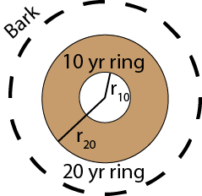
Key:
π=3.14
r₂₀ = radius of ring #20
r₁₀ = radius of ring #10

****Use the equation below****
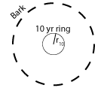
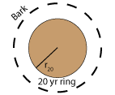
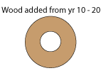

π•r₂₀² – π•r₁₀² = Wood added

r_{20 = _______ cm} r_{10 = ________cm}

Show work here:

Wood material added between year 10 and year 20 : ________cm²

Step 2: Calculate the carbon sequestered by the tree during its life.

- Now that you know the age of your tree you can calculate the amount of carbon sequestered (taken up) in its life.  - Use the equations on the right to calculate the amount of biomass and carbon for an Eastern Red Cedar:  - Answer questions #4-7 below | $Total Biomass=33,811,800,000\frac{kg}{{cm}^{2}}•{radius of cookie (cm)}^{2}$  $Total Carbon=Total Biomass / 2$  Please Note: The total biomass includes the biomass from the trunk and leaves (above ground) and from roots (below ground).  Helpful Hint: If your cookie has different radii (plural of radius), use an “average” radius measure of your cookie. You can calculate the diameter and divide by two. Or, you can find a radius that looks like the average radius of your cookie.
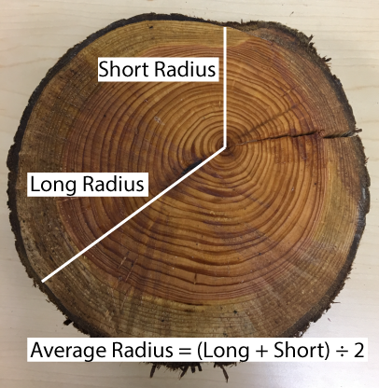

Short radius = ____cm

Long radius = ____cm

4. What are the total biomass and total carbon values for your specific tree cookie (slice)?
$Total Biomass=33811.8\frac{kg}{m^{2}}•{radius of cookie (m)}^{2}$
$Total Carbon=Total Biomass / 2$

Show Work Here:

Total Biomass: ________________ kg

Total Carbon: ________________ kg

Note: About one-half of a tree’s biomass is stored in the root system below the ground. Much of the carbon sequestered by a tree is not at the surface.

5. Using your answer from Question # 1a how much carbon (in kg) does your Eastern Red Cedar tree sequester (take up) each year of its life (Assume it sequesters the same amount every year).

Helpful Hint: Use this equation: Total carbon / Age of the tree

__________kg

6. An Eastern Red Cedar can live up to 150 years. How much carbon would this tree sequester (taken up) over its lifetime if it was not cut down? (Assume the tree sequesters the same amount every year.)

__________kg

Challenge question:

7a. In questions #5 and #6 we assumed that a tree sequesters the same amount of carbon every year. We can test this by comparing the amount of wood added in first 5 years to the amount of wood added in the last 5 years of the tree’s life cycle.
Use the equation in question #3 to calculate the amount of wood added in the first and last 5 years of this tree’s life.

Sample answer based on an 8cm radius cookie with 1.5 cm growth for first 5 years.

First 5 years wood growth: ____ cm²

Last 5 years wood growth = Total cookie wood growth area ____ (cm²) -

Total cookie wood growth area not including the last 5 years ____ cm²

= ______ cm²

b. Use the equation in Step 2 to calculate the amount of carbon added in the first and last 5 years of this tree’s life.

First 5 years of carbon sequestered: _________ kg

Last 5 years carbon sequestered: ___________ kg

c. Why do you think the amount of wood added changes over the life of a tree?

Step 3: Compare the amount of carbon sequestered by a tree to your household’s yearly emissions.

People in Allentown and across America generate CO₂ emissions when they travel, use electricity, heat or cool their home, in addition to other daily activities. Trees can take up this CO₂ to create biomass, but how many trees would you need to offset the typical yearly emissions by someone in Allentown?

Go to https://www3.epa.gov/carbon-footprint-calculator/ and calculate the carbon emissions for your home based on your family’s lifestyle.
Note: Instead of using your own home’s energy values, your teacher might decide to give you a sample data set based on a specific type of energy source in a home and certain energy consumption behaviors.
If this is the case, enter your assigned Family # __________

- Enter then number of people in your household and your home’s zip code.  - Follow the on-screen questions for your simulated home energy, transportation, and waste. Enter required information.  - After answering all questions, select Continue to Report. | 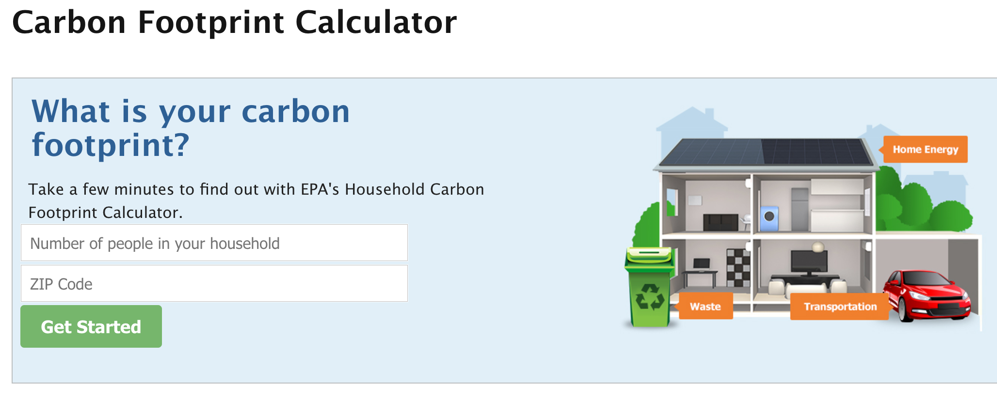

8a. What is your household CO₂ emissions in lbs./year? (Hint: This is what the Website displays)

Home Energy | Transportation | Waste | Total

b. What is your household CO₂ emissions in kg? Show your calculations.
Hint 1: The Website gives the emissions in pounds, not kg. 1 lb. = 0.454 kg
Hint 2: Convert lbs. -> kg
For example, if a household carbon footprint is 30,000 lbs. / year, the total household emissions would be calculated by 30,000 • 0.454 (lbs./kg) = 13620 kg

9a. The average household in Allentown emits 43000 kg of CO₂ per year. How does your household compare to the average?

b. How many Eastern Red Cedar trees would it take to sequester the annual (per year) CO₂ emissions from an average Allentown household? Show your calculations.
(Hint: See answer to #5 to find out how much CO₂ is sequestered by one Eastern Red Cedar tree.)
10a. Compare your household to 3 other kinds of households in your class. You will need to share information with other groups. Use kgs for your units.

Group Name | Home Energy | Transportation | Waste | Total
Your Group

Group 1

Group 2

Group 3

b. Which group had the lowest emissions?

11a. Go to https://www3.epa.gov/carbon-footprint-calculator/.
Change your electricity emissions by:
(1) Use Electricity as your energy source.
(2) Use 800 kWh per month.
(2) Use 100% of the electricity from green power and not from fossil fuels. (See image below)

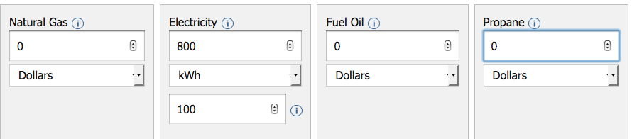

Complete the chart below:

Home Energy Source | Energy Behavior Change | CO₂ Emissions  lbs./year | CO₂ Emissions  kg /year
Starting Energy Source & Amount: | None
Electricity, 800 kWh | 100% renewables

b. How much did this energy source reduce your carbon emissions in kg / year?
12a. Reduce your transportation emissions by not using a car.
- Write your current emissions total in the chart below.
- Go to the Transportation screen.
- Enter “0” for Vehicles.
Complete the chart below:
Transportation Source | Energy Behavior Change | CO₂ Emissions  lbs/year | CO₂ Emissions  kg /year
Starting Car Use | Car use
None | Not using a car

b. How much did not using a car reduce your carbon emissions in kg / year?

13. There are other ways to reduce your household carbon emissions. Examples include changing your thermostat, using EnergyStar lights and products, and drying clothes on a clothes line.
Go to the Home Energy screen.
Go to “Reduce Your Emissions”.
Make one change and record that household change in the chart below and record the resulting CO₂ Emissions.
Repeat for 4 more household changes.
Complete the chart below:
Home Energy Source | Energy Behavior Change  (Be specific) | Estimated Annual Savings ($) | CO₂ Emissions  lbs./year | CO₂ Emissions  kg /year
Starting Home Energy Source: | None | $0
Household Energy
Change 1
Household Energy
Change 2

Household Energy
Change 3

Household Energy
Change 4

Household Energy
Change 5

b. Which household energy change reduced your annual (each year) CO₂ emissions the most?

c. Which household energy change saved you the most money?
HINT: Go to your Household Carbon Footprint Report screen. Look at the Small Actions Add Up section.

14. Take a few screen shots of your Household Carbon Footprint Report that includes:

- Your Household Carbon Footprint.
- What your planned actions are equal to: gas savings, planting trees, or recycling waste.
- All the new actions you have selected.
Submit your screenshot images to Google Classroom as a new Google Doc called: “[LastName]_CarbonOffsetPath”.

15. What changes made the biggest impact to your emissions (changing energy source, changing transportation, or household changes)?

Challenge Question:
16. a. Electricity sources have different CO₂ emissions and cost per kilowatt hour (kWh). Fill out the table below to calculate the amount of CO₂ emitted per $ for each type of power plant.
Type of Power Plant | grams of CO₂/kWh | Cost ($/kWh) | grams of CO₂/$
Coal | 820 g | $0.095
Natural Gas | 490 g | $0.073
Nuclear | 12 g | $0.095
Solar | 45 g | $0.125
Wind | 11 g | $0.074

b. What power source produces the least CO₂ emissions?

c. What power source produces the most CO₂ emissions?

d. What power source produces the least CO₂ emissions per dollar?
e. What power source produces the most CO₂ emissions per dollar?

f. Power sources such as Solar or Wind power do not directly produce CO₂ emissions during power generation. What do you think is responsible for the emissions listed for these power sources?

