***Ecosystem Scavenger Hunt:***

***Find evidence of interactions between plants, animals and humans***

The world you live in contains both natural and artificial objects that interact to form the local environment. In this investigation, you will:

* Investigate the area around your school to identify different types of natural and artificial objects.
* Learn to use the **Collector** app and **ArcGIS Online** tools to collect, visualize and analyze your observations.

Read **all** instructions and answer **each** question on your investigation sheet.

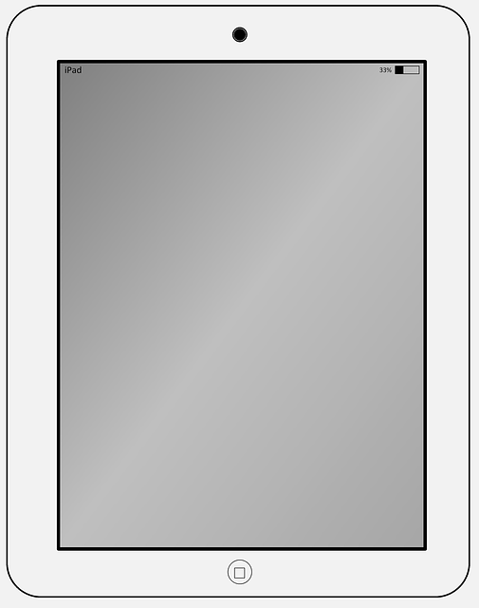

**Step 1: Open the Collector App and Your Map**



1. Collector app and sign in
2. Download your class’ **Ecosystem Scavenger Hunt Map**.   
    

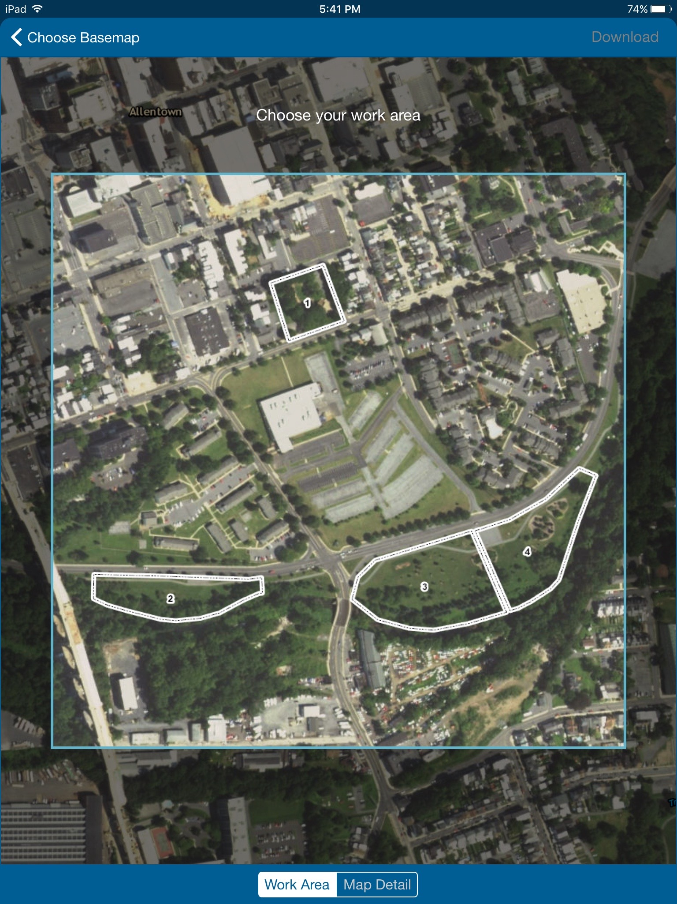

* 1. Find your sample area on the map. Move and resize the blue square (image on right).

* 1. Select the **Map Detail** button (red box).
  2. 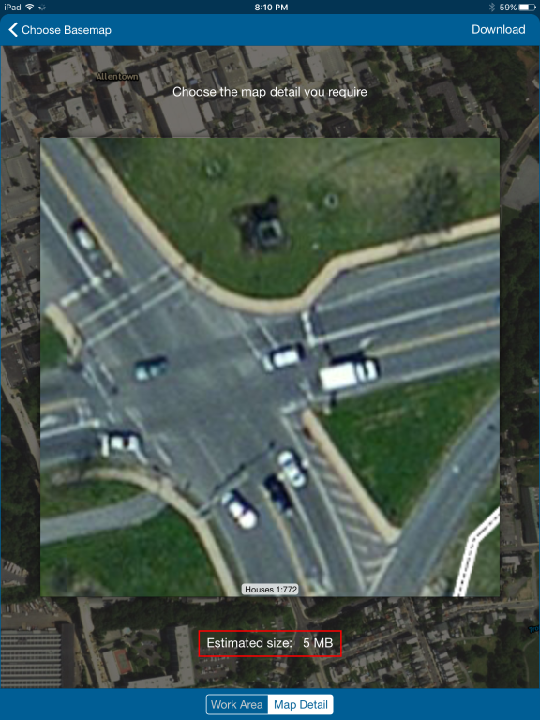Zooming in for detail.
  3. Estimated size **is 5 MB**.
  4. Once you are happy with the detail, select the **download** button (red arrow) in the upper right of the screen.

1. Make sure the blue dot appears. If it does not, restart the app outside.

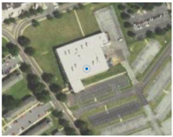



**Step 2: Start making observations in your area**

The environment around you is made up of natural and man-made objects that form the world you live in. Plants and animals create a natural environment that humans can impact.   
  
**Always** **stay with your group when you are outside**.

|  |  |
| --- | --- |
| **Where to go:**   1. Go to your assigned area to make observations.      1. **North** is at the **top** of the screen. The school parking is south of Building 21.  Lehigh St. is west of Building 21.   **What to do:**   1. In your assigned area, make observations and collect data with the **Collector app**. 2. Your goal is to find an example for each **observation category**. Make at least 11 observations. 3. To enter a new observation, select the **plus sign** on the **upper right (red arrow)**. 4. Select observation type. 5. Take a picture of your object. 6. Write a short description of your object. 7. Click **Submit**. |  |



**Step 3: Sync your observations**

|  |  |
| --- | --- |
| 1. Select **Maps** in the upper left of your screen. 2. Select the **cloud icon** (red box) to start synchronizing your observations. (You should see the number of your observations above the cloud). 3. **Click on the map again** **after synchronizing** to see all the points your classmates have added. 4. Answer **questions # 1-6** below. 5. To remove the map, on the same screen select the square icon $→$**Manage $→$** **Remove $→$** **Remove features and basemap** 6. You can then log out of the iPad. Select the square icon $→$**Sign Out $→$** **Sign Out** |  |

1. Complete the table below.

|  |  |
| --- | --- |
| Teacher / Mentor |  |
| Area Assigned |  |
| Number of Observations Made |  |

2. What observation category was easiest to find?

3. What observation category was hardest to find?

4. What evidence of animal habitats did you observe (bird nest, rodent hole (burrow), squirrel nest)?

5. What feature defines the northern boundary of your area (road, stream, sidewalk, etc.)?

6. What feature defines the southern boundary of your area (road, stream, sidewalk, etc.)?

** Step 4: Explore your class’ observations in ArcGIS Online**

Go to **arcgis.com.** Login with your username and password in the top right corner of the webpage.

|  |  |
| --- | --- |
| 1. Click **Groups** to see your map. Select your class. Click the **Ecosystem Scavenger Hunt Map** image. 2. You should see a screen that looks like the one on the right. Field observations are now color-coded.  **North** is still at the **top** of the screen. 3. Click on the **Legend** (blue box). Different colored symbols are for each type of observation.      1. Select the **Contents** tab.      1. You can **turn any layer on or off** by **selecting the check mark** next to the layer. 2. The **Observations** layer has many tools to help you examine your data.     Shows the **Legend**    Opens a data **Table**    **Filters** data in **Table**   1. Select the **Legend**, **Table**, and **Filter** to explore your observations. 2. With the **Table** tool, you can sort observations by column (See center image). 3. With the **Filter** tool, select different fields to sort your observations. (See lower image). 4. To measure distances on the map, use the **Measure** tool at the top of the screen. Select **ruler icon**. Change units from miles to **meters**. Click to start a measurement and double click to finish. 5. Answer **questions #** **7-12** below. |  |

7. What is the length (in meters) of your area north to south?

_______ meters

8. What is the length (in meters) of your area east to west?

_______ meters

9. How many observations were made in you class area for “**natural nonliving thing”?** *Hint*: use the **Table** or **Filter** tools

10. How many observations were made in your class area for “**evidence of water”?** *Hint*: use the **Table** or **Filter** tools.

11. How many observations for **your** class’ area were naturally occurring?

12. What was the largest tree circumference observed for all classes?

** Step 5: Editing your map in ArcGIS online**

You will now learn how to edit the map by adding **Map Notes** and how to record your edits by taking screen shots and saving your progress in ArcGIS online.

We will be using the **Map Notes** tool to draw areas and lines around the school to show where things are located. We will also draw walking paths for when you were outside. You will take a screen shot and submit your map images.

|  |  |
| --- | --- |
| 1. Select **Add** (see arrow). 2. Select **Add Map Notes** and pick a name for your notes (“My name’s” notes). 3. You should now see a new **Edit** tab and **Add Features** window (see lower image). 4. The **Line** (orange box), Freehand and **Area** (blue box) tools from the **Add Features** tab will help you edit the map. 5. To draw a line or path select the **Line** tool and click on the map where you want to start (single click). Move your mouse. A red line appears showing your path. 6. To add a turn to your path, click where you want a turn. At the end of your path, **double click** to end the path. 7. A pop-up box will now appear. Change the name of your path in the **Title** box. Add text in the **Description** box. To change the color of your line, select “**Change Symbol**”. You can then select a new line color. 8. To draw an area, select the **Area** tool and click on the map where you want to start (single click). To close the area, double click. 9. A pop-up box will appear. You can change colors, titles and other features. 10. Complete **questions # 13-15** below. |  |

13. Draw a path using the **Line** or **Freehand Line** tool that shows how you got from the school to your assigned area. Make that path white so you can see it on your screen.

14. Draw an area around Building 21 High School using the **Area** tool. Make the area turn **blue** and make the **outline black** using the **Customize** button.

After you have completed questions 13 and 14, take a screen shot of your map that shows your path and area.

Save this document as “***Your Name* Eco Scavenger Hunt**” and submit to Google Classroom.

Now try the Challenge Question below for additional competency points.

**Challenge Question**:

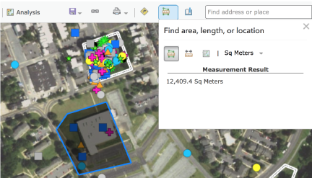15. Calculate the combined area of Areas 3 and 4 in **square meters**. Hint: Use the Measure tool like below.

Area 3: m2

Area 4: m2

Combined Area: m2

Take a screen shot of your area and submit that to Google Classroom as a new document called “***Your Name* Eco Scavenger Hunt Challenge**”