Personal Energy Audit: Revisiting Your Use

In this activity you will:
- Reexamine your energy use habits.
- Review your high-energy consumption activities.
- Compare your current energy use to your energy use at the beginning of the unit.
- Identify energy consumption habits you have changed.
- Reflect on your new energy consumption practices and provide reasons for your behavioral changes.

Let’s analyze your current energy use!

 Step 1: Open your saved Energy Audit Spreadsheet.
Remember it was saved early in the energy unit as Audit_intials.numbers or Audit_intials.xls
For example, if your name is Bruce Wayne, you saved your file as Audit_BW.xls
As you work on your audit, remember to resave your file several times.

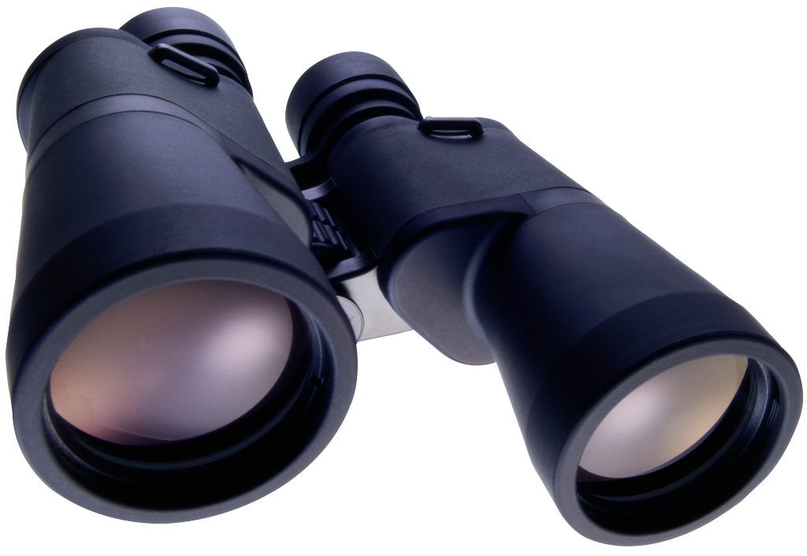 Step 2: Complete the Energy Audit 2 Spreadsheet

For this activity you will complete the sheet labeled Audit 2.

- Be sure you are entering data in the sheet labeled Audit 2. Look at your spreadsheet.

Numbers version:
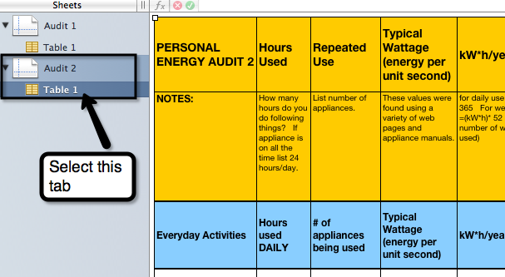

Excel version:
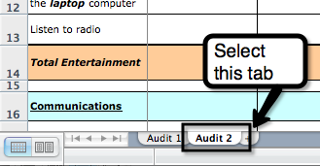

- As you enter the new data, think about the ways you use electricity now.
- Let’s review how to enter data.
  - The spreadsheet lists common activities in Column A that use energy.
You will provide your energy use information in Columns B and C.

  - Look at Column B (Hours Used). You will enter the number of hours you engage in the specific activities that are listed in Column A.
  - Look at Column C (Repeated Use). Think about how many “appliances” you run at a time.
  - If you or your household does not do a particular energy activity, enter 0 in both Columns B and C.

  - Energy Vampire Alert: REMEMBER: Some appliances or chargers use energy when they are not actively charging or are in stand-by mode waiting be activated by a remote or sensor. Please think about your current habits before you fill in your hours used or repeated use values.
  - Daily Average: Some people complete activities in the daily section a few times a week rather than daily. Use the following formula if you do not do an “everyday activity” daily, but a few times during the week.
Daily Average = Hours used / 7 days a week

  - Time Increments: Use the following time increments for Column B if you do not do an activity for a full hour.

Time Increments
Minutes | 2 min. | 5 min. | 10 min. | 15 min. | 20 min. | 30 min. | 45 min.
Hour equivalent | .033 | .083 | .167 | .25 | .33 | .5 | .75

  - Heating and Cooling: Use the Seasonal Use Equivalent Chart below to determine your daily hours used. You will need to multiply your hours used daily when in season by the seasonal use factor below.

Seasonal Use Average = Hours used per day X Seasonal Use Factor

Seasonal Use Equivalent Chart
Months used | 3 months | 4 months | 5 months | 6 months | 9 months | 12 months
Seasonal Use Factor | 1/4 or .25 | 1/3 or .33 | 5/12 or .42 | 1/2 or .5 | 3/4 or .75 | No Change
For example the air conditioner is always on in your house for 24 hours each day during 3 months of summer. Your seasonal use average is
24 hours X .25 = 6
In this example, you would enter 6 in Column B.

- Summary Columns: Notice Audit 2 has 4 new columns.
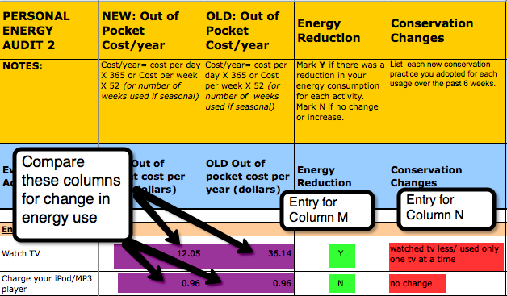

Notice you have 4 new columns:
  - Look at Column K (New: Out of Pocket Cost/ year). This column is labeled “NEW.” These spreadsheet columns calculate the amount of money that your current energy consumption activities cost.

  - Column L (Old: Out of Pocket Cost/ year) displays your original energy use costs from the beginning of the unit.

  - Column M (Energy Reduction) provides a place for you to note if you reduced your energy cost for each activity.
For each row, mark Y in the column if you reduced your energy consumption for that activity.
Mark N if your energy use cost stayed the same or increased.

    - In the example above, look at the Watch TV row. The old usage cost (Column L) is 33.00 and the new cost is 11.00. The energy cost is reduced. In this example, enter Y in Column M.
    - Look at the Charge your iPod/ MP3 player row above. There is no difference in the new and old costs (Columns K and L). In this example, enter N in Column M.

  - In Column N (Conservation Changes), write a description of the conservation practices for each energy activity your family made since the beginning of the energy unit.
    - In the example above, look at Column N in the Watch TV row. This person reduced the amount of time she or he watched TV and also reduced the number of TVs that were turned on at the same time.

