Personal Energy Audit: Sources Teacher Guide
In this activity your students will:
- Examine the ways they use energy.
- Think about how they can use less energy to do many of their activities.
- Make connections between energy use types to energy fuel sources.
- Identify ways to conserve energy resources.

Let’s analyze your energy use!

Instruct students to read all instructions and answer each question.

 Step 1: Instruct students to open their saved Energy Audit Spreadsheet.
Remember: The file was saved as Audit_intials.numbers or Audit_intials.xls. For example, if a student’s name is Clark Kent, he saved his file as Audit_CK.numbers or Audit_CK.xls.

Students will be working on the sheet labeled Audit 1 again.

Numbers version:
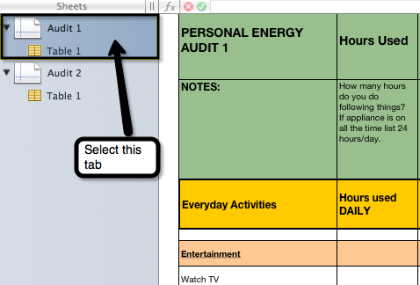

Excel version:
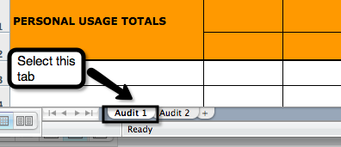

As students work on the audit, remind them to re-save the file several times.

Step 2: Add Columns.

- Instruct students to create two new column titles for columns L and M:
  - In the Column L /Row 1 cell, type Use for Energy
  - In the Column M/Row 1 cell, type Energy Source

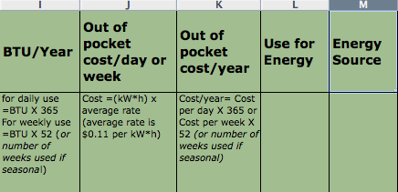

- Remind students to resave the file.
Step 3: Complete the Spreadsheet.
Instruct students to complete the following steps:
- Look at Column L. In this column, list how energy is being used to “power” each activity. The answers may include: electricity source for appliance, heat water to shower, cooling air temperature to reduce heat, etc.
  - Look at Row 6: Watch TV. Enter “Electricity for TV” in Column L.
- Look at Column M – in this column list the main source of the energy for that activity. Common student answers may include: petroleum (crude oil), coal, natural gas, solar, wind, nuclear, hydro, tidal or geothermal. If students write “electricity”, prompt them to think of the source of their electricity. If students are not certain about the fuel source for their electricity, they can list coal since it is the main energy source for electricity generation in the USA.
  - Look at Row 6: Watch TV. Enter “Coal” in Column M.
- Here are some helpful ideas to get students started with completing the Columns L and M in your spreadsheet:
  - Lighting: When you turn on a light switch you are using electricity. Have students enter Electricity for Light in Column L. Since most electricity in the USA is generated using coal as the main energy source, enter Coal in Column M (unless you know your electricity comes from another source).
  - Activities that heat water: If you take a shower or use a dishwasher, you are using energy to heat your water. Have students enter Heat your water in Column L. Water is usually heated by a furnace that uses oil as an energy source or with a water heater that uses natural gas or electricity from coal. The energy source would likely be coal, petroleum (crude oil) or natural gas. Enter Heat Water to shower in Column L and Coal or Petroleum (crude oil) in Column M.
  - Transportation: Each time you ride in the car you are using energy to power the car with gasoline. The source of gasoline is petroleum (crude oil). Have students enter gasoline for transportation in Column L and Petroleum (crude oil) in Column M.
 Step 4: Journal Entry

Ask students to respond to the following 5 questions in their journals.

  - Analyze the energy sources you listed on your spreadsheet. Why are those sources used and not others?
  - How would the energy sources you used be different in another geographic area (such as the South or Northwest)?
  - How can I use less energy in my daily activities?
  - How could our school use less energy?
  - Why do we need to conserve energy?

