Exploring Hydroelectric Dams with Google Earth Teacher Guide

Hydropower is energy that comes from the force of moving water. Most hydroelectric power plants are developed at dams. In this activity, students will use Google Earth to explore hydroelectric dams. They will
- Explore five existing hydroelectric dams around the world.
- Use the Ruler tool to measure the length of dams and distances to populated areas.
- Infer why dams are placed near population centers.

Model the following procedural instructions with your students. It is recommended that you display your computer image at the front of the classroom.

 Step 1: Download data.
- Open your Web browser. Go to www.ei.lehigh.edu/learners/energy/
- Click on Exploring Hydroelectric Dams with Google Earth.

The file is displayed in Google Earth.

- Click the arrow to the left of “Hydroelectric Dams.kml” in the left panel (see arrow below).

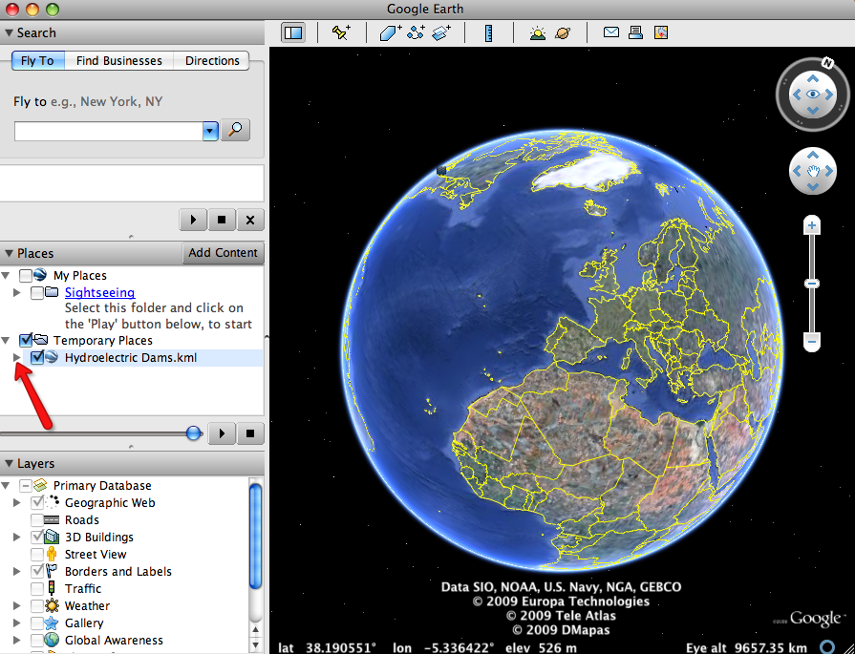

The Hydroelectric Dams drop-down list will extend (see below). If you cannot see the whole list, scroll down.

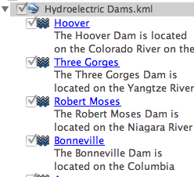

Step 2: Turn on the Populated Places and Terrain layers.
- In the Layers window (lower left panel), click the arrow to the left of Borders and Labels (see arrow #1 below).
- Click the box to the left of Populated Places to place a checkmark in the box (see arrow #2 below).
- Click the box to the left of Terrain to place a checkmark in the box (see arrow #3 below).

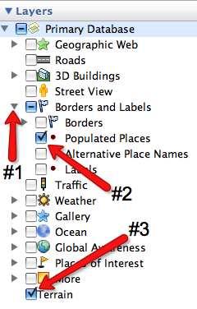

NOTE: Only the Populated Places and Terrain layers should be checked. Have students uncheck all other layers.

Step 3: Explore hydroelectric dams, measure their width, and the distance from each dam to nearby population centers.

- Double-click on Hoover in the Places window.
Google Earth will zoom you to the Hoover dam for you to view it.

- Click on the Hoover icon in the 3D viewer to read information about Hoover dam.

Instruct students to write the river name, location, height, and capacity of Hoover in the Hydroelectric Dams Data Chart on their field guide.

- Click on the Ruler tool on the tools menu at the top of the screen.
The ruler dialog box appears (see below). If the dialog box covers up the dam, move it to a different area on your screen.

- Click on Line (arrow #1 below). Click on the drop-down arrow (arrow #2 below) and select Miles if it is not already selected.

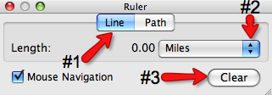

- Click from the left riverbank to the right riverbank of the dam to measure its width.

NOTE: We recommend that you explain and show students how they should measure the width of the dams. For example, have students measure the upstream side of the dam at the widest part (see image on the left below) or across the dam structure (see image on the right below). The assessment information takes into account these variations. Point out that dark area is water.

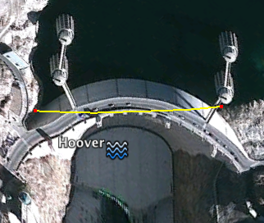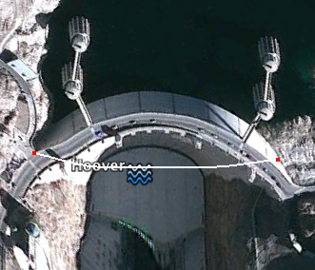

NOTE: Some dams have more than one water release gate. Instruct students to measure each one and add the segments together to determine the width of the dam.

Instruct students to write the width of Hoover in the Hydroelectric Dams Data Chart on their field guide.

NOTE: If you make a mistake, click Clear (arrow #3 above) and measure the width again.

- Click Clear. Do not close the ruler dialog box.

- Use the navigation controls at the top right of the screen to find a nearby population center (city or town) that is located close to Hoover dam.

Helpful hint: Population centers are marked with a small red circle .

- Measure the distance from the Hoover dam to a nearby population center.

Using the Ruler tool, click on the Hoover dam and then drag your line to the nearby population center.

Instruct students to write the name and distance of the nearby population center to the Hoover dam in the Hydroelectric Dams Data Chart on their field guide.

NOTE: Students will need to zoom in or out to view a population center near the dam. Have students look for the nearest population center that is marked with a small red circle . A red circle may not appear at Aswan. The town of Aswan is located just to the right of the dam. If need, prompt students to look for evidence of a population center near the Aswan dam.

- Click Clear. Do not close the ruler dialog box.

- Use the navigation controls to explore the area surrounding the Hoover dam.

What does it look like? Is the Hoover dam area surrounded by a forest, mountains, an urban area, or something else?
What does the water body area behind the Hoover dam look like? Does it appear to be a lake or a river?

Instruct students to write a description of the area surrounding the Hoover dam in the Hydroelectric Dams Data Chart on their field guide.

- Repeat Steps b, e, f, g, h, i, and j to complete the Hydroelectric Dams Data Chart for the remaining 4 dams.

- Click Clear. Close the ruler dialog box when you finish.

Instruct students to answer questions 1 - 7 on their field guide.

