Exploring Water Bodies with Google Earth Teacher Guide

Ocean tides are caused by the gravitational attraction of the moon and to a lesser extent the sun during Earth’s orbital motions. In this activity, students will use Google Earth to analyze the shapes of four water bodies to determine if these would be good places to locate a tidal power plant.

Model the following procedural instructions with your students. It is recommended that you display your computer image at the front of the classroom.

 Step 1: Download data.
a. Open your Web browser. Go to www.ei.lehigh.edu/learners/energy/

b. Click on Exploring Water Bodies with Google Earth.

The file is displayed in Google Earth.

c. Click the arrow to the left of “Water Bodies.kml” in the left panel (see arrow below).

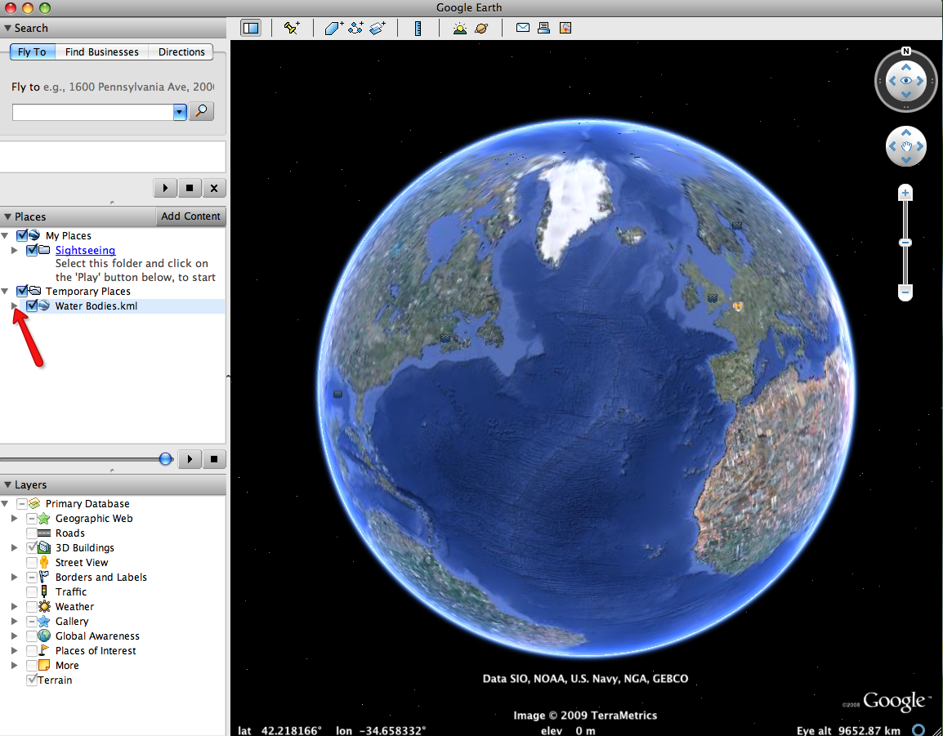

NOTE: If the navigation controls are not visible click on View>Show Navigation>Always.

The Water Bodies drop-down list will extend (see below). If you cannot see the whole list, scroll down.

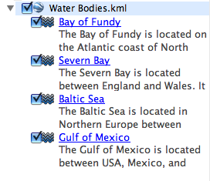

Step 2: Examine the shapes of the water bodies.

- Double-click on Bay of Fundy in the Places window.
Google Earth will zoom you in to the Bay of Fundy for you to view it.
- Click on the Bay of Fundy icon in the 3D viewer to read information about the Bay.

Instruct students to write the tidal range of the Bay of Fundy in the Water Bodies Data Chart on their field guide.

- Look closely at the shape of the Bay of Fundy. Use the Zoom-in and zoom-out tools to view the shape in more detail. What does the shape of the Bay of Fundy look like?

Instruct students to draw and describe the shape of the Bay of Fundy in the Water Bodies Data Chart on their field guide. For example, does it look funnel-like, elongated, hour-glass, circular, large and open, or something else?

- Double-click on Severn Bay, Baltic Sea, and Gulf of Mexico to view them. Click on each of the icons in the 3D viewer to read information about these water bodies.

Instruct students to write the tidal range then to draw and describe the shape of each water body in the Water Bodies Data Chart on their field guide.

Instruct students to answer questions 1-4 on their field guide.

