Land Use Change Unit Assessment Key

1. How does building a shopping mall affect an area?
a. Plant life and wildlife habitat are lost.
b. Building a mall does not affect an area.
c. Urban heat island effects are reduced.
d. Evapotranspiration increases.

2. How does the construction of a mall affect the surrounding environment?
a. A mall near a golf course reduces the carbon footprint of the area.
b. A mall sometimes reduces traffic in the area.
c. Malls always enhance the local landscape.
d. Malls sometimes replace ecosystems such as forests or open fields.

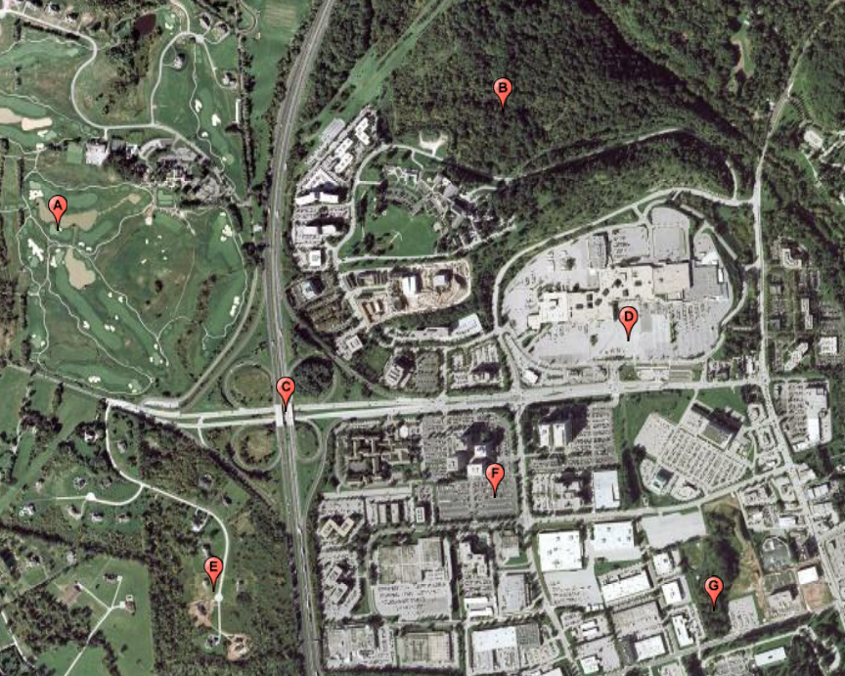

Use the aerial photograph above to answer the following questions.

3. Which location is a natural feature?
a. Location A
b. Location B
c. Location C
d. Location D

4. Which location is a golf course?
a. Location A
b. Location B
c. Location E
d. Location G

5. Which location is an area with houses that have very large yards?
a. Location A
b. Location E
c. Location F
d. Location G

6. The image feature of Location B appears “rough” and the image feature of Location D appears “smooth”. These features are examples of …
a. shadow.
b. texture.
c. site.
d. shape.

7. Which location contributes the most to an urban heat island effect?
a. Location A
b. Location D
c. Location E
d. Location G

8. Which element of aerial photo interpretation can be used to identify location G?
a. The shape of Location G is a specific geometric shape.
b. The shadow of Location G helps determine the size of the object.
c. The tone of Location G is different from the area around it.
d. The association of Location G is common to the objects around it.

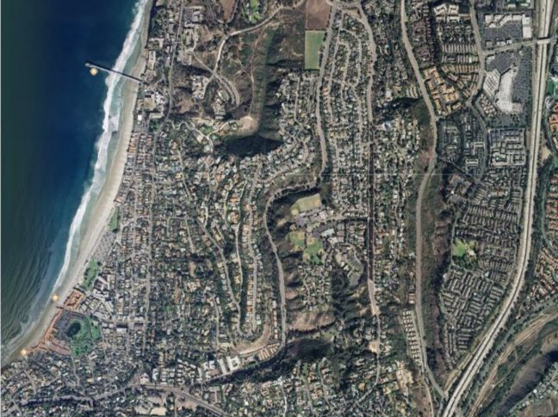

Use the aerial photograph above to answer the following questions.

9. The aerial photo shows features characteristic of a(n) …
a. rural area.
b. dense, urban area.
c. flooded area.
d. agricultural area.

10. The aerial photo shows a…
a. tundra.
b. desert area.
c. mountain area.
d. coastal area.

11. Which contributes to an urban heat island effect?
a. Trees shade areas, preventing a build up of heat.
b. Heat is absorbed and released on pavement and asphalt.
c. Roofs reflect a large portion of the sun's energy.
d. Porous pavements allow water to filter into the ground.

12. Trees release heat over a longer period of time through the process of…
a. photosynthesis.
b. root filtration.
c. tree ring growth.
d. evapotranspiration.

13. What is the best way a city may reduce an urban heat island effect?
a. Build smaller malls and parking lots.
b. Build roofs with low solar reflectance.
c. Plant trees and install vegetated green roofs.
d. Build city plazas with dark colored pavement.

14. A process in which the spread of development across the landscape far outpaces population growth is called...
a. thermal imaging
b. urban heat island.
c. remote sensing.
d. sprawl.

15. Land use changes that often occur with sprawl include…..
a. removing trees to make way for new houses and roads.
b. creating “green spaces” in the community.
c. increasing farmland areas in the community.
d. preventing the development of new shopping malls.

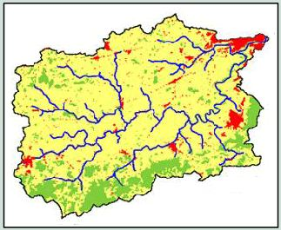 | 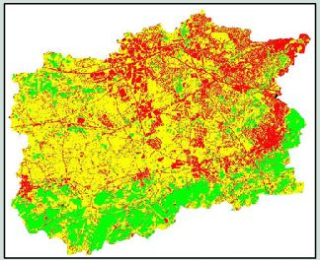
1947 1999

The land use classification maps above show an area that has increased in population from 1947 to 1999.

16. What does the yellow color most likely represent on the maps?
a. Yellow is most likely agricultural areas.
b. Yellow is most likely urban areas.
c. Yellow is most likely suburban areas.
d. Yellow is most likely wetland areas.

17. These classification maps show….
a. land use changes that are associated with “smart growth”.
b. land use changes that are associated with global warming.
c. land use changes that are associated with sprawl.
d. land use changes that are associated with natural disasters.

18. How would building a new shopping mall in the Lehigh Valley area affect the environment?
a. It would promote “smart growth” development.
b. It would change the landscape of the natural environment.
c. It would produce an urban heat island effect with a green roof.
d. It would reduce the greenhouse effect of the area.

19. Where would be the best place to build a new shopping mall in the Lehigh Valley area to have the least impact on the environment?
a. On an abandoned industrial area.
b. Across the street from a golf course.
c. On a wetland area.
d. Next to a strip mall.

20. Satellites are able to use remote sensing to produce images because…
a. the earth has different surfaces that reflect and emit different radiation.
b. satellites can triangulate positions with GPS devices.
c. the earth’s orbit is in constant motion around the sun.
d. land use classification is most valid with ground truthing.

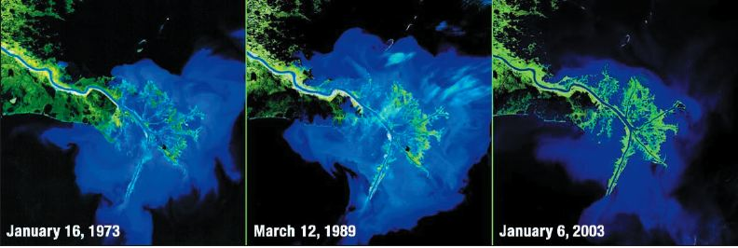

21. What does the Landsat image series above show?
a. The growth of a river delta with mud and sand deposits.
b. The growth of an ecosystem after a volcano eruption.
c. A coastline before and after a tsunami.
d. The development of artificial islands at the edge of a city.

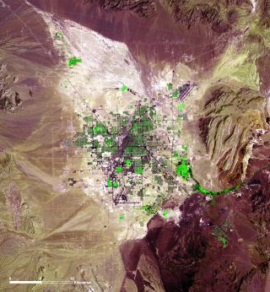 | 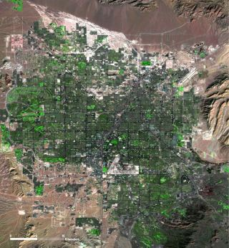

1972 2006

22. What does the Landsat image series above show?
a. The “greening” of a desert area over time.
b. Growth of a forest over time.
c. Urban sprawl as a result of rapid population growth.
d. Growth of agricultural areas.

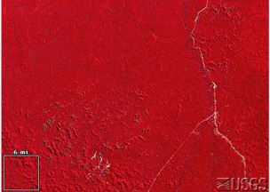 | 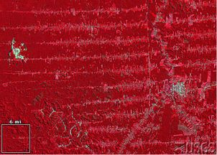

1975 1992

23. The image pair above are …
a. true-color images that shows lava patterns near a volcano.
b. true-color images that shows a red soil area becoming eroded.
c. false-color images that shows the destruction of a forest area.
d. false-color images that shows the growth of an urban area.

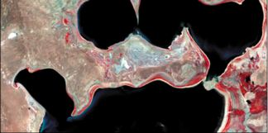 | 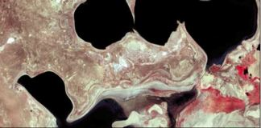

1987 2000

24. The image pair above are ...
a. false-color images that show a bay area after a major earthquake.
b. false-color images that show a shrinking sea.
c. false-color images that show the destruction of a forest area.
d. false-color images that show urban sprawl.

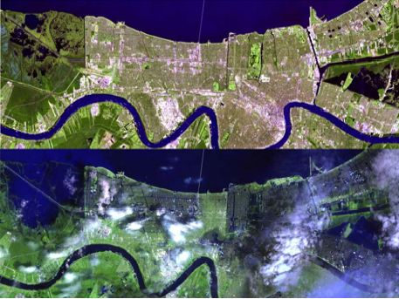

25. The image pair above shows a…
a. city that has been destroyed by a fire.
b. city that has developed an amusement park.
c. city that experienced an earthquake.
d. city that has been flooded.

26. A strategy to develop in the most appropriate areas while protecting our natural resources is called…
a. sprawl.
b. smart growth.
c. land use change.
d. carbon reduction.

27. Which strategy for building a new Wal-Mart Supercenter would have the least impact on the environment?
a. Build a new store on an agricultural area.
b. Build a new store near a highway interchange.
c. Build a new store on a brownfield site.
d. Build a new store near a river.

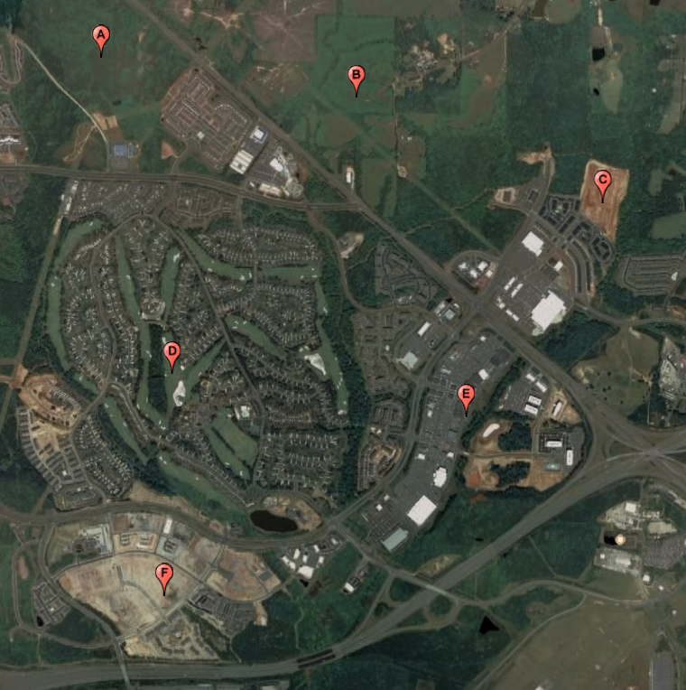

Use the aerial photograph above to answer the following questions.

28. Which location would be the best site to build a Wal-Mart Supercenter that would have the least impact on the environment?
a. Location A
b. Location B
c. Location C
d. Location D

29. Developing a Wal-Mart Supercenter on Location F would be okay since the site location appears to be a(n)…
a. agricultural area for farming.
b. area that has been cleared for development.
c. critical habitat for animals.
d. area faraway from other stores.

30. Developing a Wal-Mart Supercenter would contribute the most to sprawl on …..
a. Location B
b. Location D
c. Location E
d. Location F

31. The land use of Location D appears to be a(n) ….
a. large agricultural area.
b. forested area.
c. amusement park.
d. residential community with a golf course.

32. When heat builds up in a city, it creates a hot spot compared to the nearby suburban and rural areas. This hot spot is called a(n)…
a. greenhouse gas effect.
b. thermal image.
c. solar reflectance effect.
d. urban heat island.

33. It feels very hot when you get out of your car on a hot sunny day at the mall because asphalt in the parking lot…..
a. absorbs heat from the sun and quickly releases it into the surrounding air.
b. reflects heat from the sun into the surrounding air.
c. is made of permeable pavements and allows water to filter into the ground.
d. has a high solar reflectance and absorbs less of the sun’s energy.

