Investigating Energy Resources for the Isle of Navitas with My World GIS

You are the chief energy officer (CEO) of one of three provinces on the Isle of Navitas, an island about the size of Pennsylvania. It has a population of about 7,000,000 people. Your task is to explore the energy resources for your province using My World GIS to recommend an efficient combination of energy sources that will minimize the impact on the environment. You will
- Explore energy resources for the Isle of Navitas.
- Analyze the benefits and costs of each energy source.
- Analyze the environmental impacts of each energy source.
- Recommend an efficient combination of energy sources for your province.

Read all instructions and answer each question on your investigation sheet.

 Step 1: Download data.

- Open your Web browser. Go to www.ei.lehigh.edu/learners/energy/

- Click on Investigating Energy Resources for the Isle of Navitas with My World GIS.

Step 2: Load data in My World GIS.

- Double click on the Navitas_Isle.m3vz icon. | 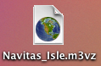
- Check to make sure you are in the visualize mode (see arrow). | 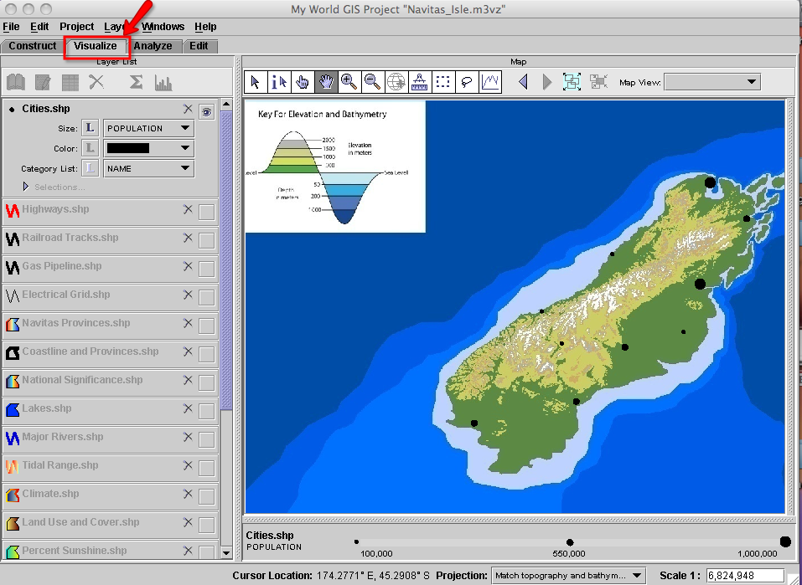

Step 3: Explore energy resources.

The map shows the elevation and bathymetry of the Isle of Navitas. Elevation is how high the ground is above sea level. Bathymetry is how deep the ocean is in a particular area. Topography is a map of elevations and bathymetry.

- Click on the Cities.shp layer to make it active (see arrow #1). The population bar and legend are displayed at the bottom of the map (see arrow #2).  The big black circles on the map represent cities with larger populations and the small black circles represent cities with smaller populations. | 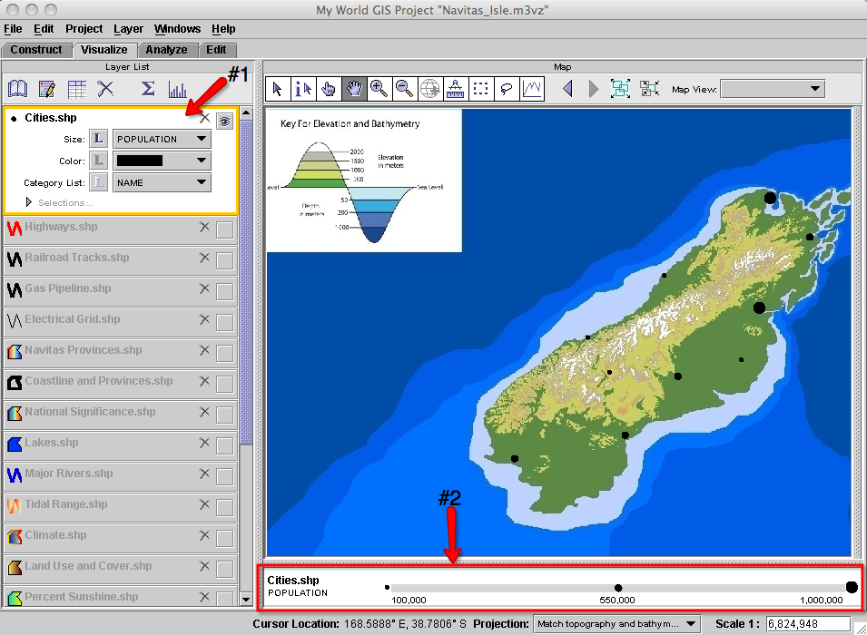
- Click the square to turn the Navitas Provinces.shp layer on. This layer displays the three provinces of the Isle of Navitas: Cambria, Gaul, and Iberia. Click the layer to make it active.  Click on the table icon above the Layer List to view the population and number of households for each province.  Close the Table of Layer “Navitas Provinces.shp” window. | 
Fill in the name of your assigned province on your investigation sheet below question 1.

- Click the eye to turn the Navitas Provinces.shp layer off. | 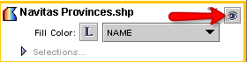
- Click the square to turn the Coastline and Provinces.shp layer on. This layer outlines the coastline and the province boundaries. | 
- Click the square to turn the National Significance.shp layer on. This layer displays locations of biological diversity, historical significance, and natural beauty. These are protected areas. | 
- Zoom in to your assigned province to explore the different energy resources.

Hydroelectric Power
The factors needed to determine the ideal location of a hydroelectric dam include the topography, a canyon that can be dammed, and an area to make a reservoir upstream of the dam. Zoom in to where the streams start in the mountainous areas (light green or white). Hydroelectric power requires a power plant at the dam site and access to the grid for power distribution.
- Click the square to turn the Lakes.shp layer on. This layer displays locations of lakes. | 
- Click the square to turn the Major Rivers.shp layer on. This layer displays locations of major rivers. | 
- Click the square to turn the Electrical Grid.shp layer on. This layer displays the grid that transmits and distributes electricity to the cities. | 
Use the GIS map and your Impacts of Energy Sources Investigation sheet to complete the hydroelectric table on your investigation sheet.

On a scale of 1 - 5 with 1 being poor and 5 being best, rate the use of hydroelectric energy as a possibility for your province. Consider the benefits and environmental impacts. Write your rating in the table on page 7 of your investigation sheet.

- Click the eye in the top right corner of the Lakes.shp and Major Rivers.shp layers to turn them off.

Tidal Energy
The factors needed to determine the ideal shore location of a tidal power plant include a large tidal range and a funnel shaped shoreline pointing inland. Tidal power requires a power plant at the coast and access to the grid for power distribution.
- Click the square to turn the Tidal Range.shp layer on. This layer displays the tidal range.  The tidal range bar and legend are displayed at the bottom of the map. | 
Use the GIS map and your Impacts of Energy Sources Investigation sheet to complete the tidal table on your investigation sheet.

NOTE: if needed, turn the National Significance.shp and Coastline and Provinces layers off to see the tidal range on the map.

On a scale of 1 - 5 with 1 being poor and 5 being best, rate the use of tidal energy as a possibility for your province. Consider the benefits and environmental impacts. Write your rating in the table on page 7 of your investigation sheet.

- Click the eye in the top right corner of the Tidal Range.shp layer to turn it off.

Biofuels/Biomass
The factors needed to determine the ideal location for biomass production include lots of level farm land (may need to fertilize and water) and transportation infrastructure to get the fuel to a processing plant. Biofuels/Biomass production requires a biofuel processing plant. Although biofuels are most commonly used for transportation, they can be used to create electricity. To do this, an energy generating plant with access to the grid is also needed for power distribution.
- Click the square at the right end of the Climate.shp layer to turn it on. This layer displays the different types of climate.  The keys in the panel on the right display the type of climate (see arrow #1) and corresponding precipitation (see arrow #2).  Precipitation is the annual (yearly) amount of rain. | 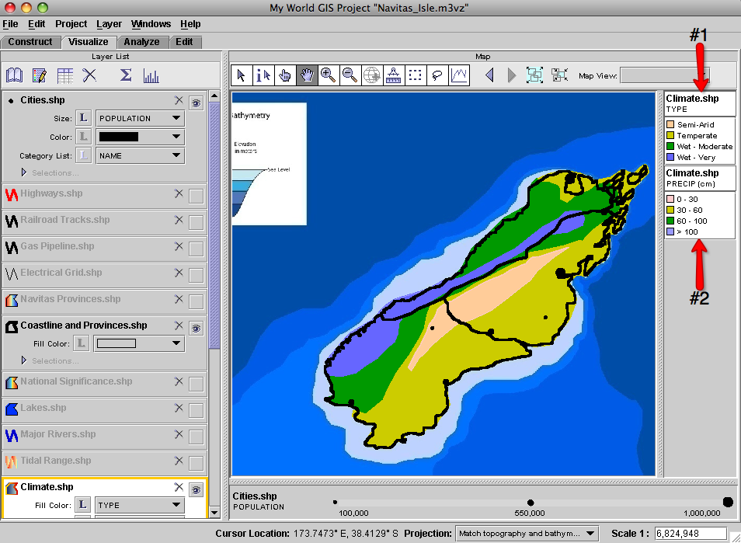
- Click the eye in the top right corner of the Climate.shp layer to turn it off.

- Click the square to turn the Land Use and Cover.shp layer on. This layer displays the different types of land use and ground cover.  The land use and cover key is displayed in the panel on the right. |   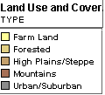
- Click the square to turn the Highways.shp layer on. This layer displays the major highways that are used for transportation. | 
- Click the square to turn the Railroad Tracks.shp layer. This layer displays the railroads used for transportation. | 
Use the GIS map and your Impacts of Energy Sources Investigation sheet to complete the biofuels/biomass table on your investigation sheet.

Helpful hint: Go back and forth between the Climate.shp and Land Use and Cover.shp layers to determine a good location for producing biomass.

On a scale of 1 - 5 with 1 being poor and 5 being best, rate the use of biofuels/biomass as a possibility for your province. Consider the benefits and environmental impacts. Write your rating in the table on page 7 of your investigation sheet.

- Click the eye in the top right corner of the Climate.shp, Land Use and Cover.shp, Highways.shp, and Railroad Tracks.shp layers to turn them off.

Solar Energy
The factors needed to determine the ideal location of a solar power plant include lots of open flat areas, lots of sunshine, and no shadowing trees or buildings. Solar energy requires infrastructure to make power and distribute electricity to the grid.
- Click the square to turn the Percent Sunshine.shp layer on. This layer displays the percent annual average sunshine.  The percent sunshine bar and legend are displayed at the bottom of the map. | 
Use the GIS map and your Impacts of Energy Sources Investigation sheet to complete the solar table on your investigation sheet.

On a scale of 1 - 5 with 1 being poor and 5 being best, rate the use of solar energy as a possibility for your province. Consider the benefits and environmental impacts. Write your rating in the table on page 7 of your investigation sheet.

- Click the eye in the top right corner of the Percent Sunshine.shp layer to turn it off.

Wind Energy
The factors needed to determine the ideal location of a wind farm include enough sustained winds and grid access for power distribution.
- Click the square to turn the Wind Speed.shp layer. This layer displays the wind speeds.  The wind speed key is displayed in the panel on the right. |   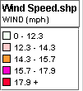
Use the GIS map and your Impacts of Energy Sources Investigation sheet to complete the wind table on your investigation sheet.

On a scale of 1 - 5 with 1 being poor and 5 being best, rate the use of wind as a possibility for your province. Consider the benefits and environmental impacts. Write your rating in the table on page 7 of your investigation sheet.

- Click the eye in top right corner of the Wind Speed.shp layer to turn it off.

Coal
The factors needed to determine the ideal location of a coal-fired power plant include transportation infrastructure for fuel delivery, water for the electrical generation plant, storage of solid waste produced by the plant, and access to the grid for power distribution.
- Click the square to turn the Coal Reserves.shp layer on. This layer displays locations of coal reserves. | 
- Click the square at the right end of the Highways.shp, Railroad Tracks.shp, Lakes.shp, and Major Rivers.shp layers to turn them on.

Use the GIS map and your Impacts of Energy Sources Investigation sheet to complete the coal table on your investigation sheet.

On a scale of 1 - 5 with 1 being poor and 5 being best, rate the use of coal as a possibility for your province. Consider the benefits and environmental impacts. Write your rating in the table on page 7 of your investigation sheet.

- Click the eye in the top right corner of the Coal Reserves.shp, Highways.shp, and Railroad Tracks.shp layers to turn them off.

Natural Gas
The factors needed to determine the ideal location a natural gas power plant include pipelines for fuel delivery, water for the electrical generation plant, and access to the grid for power distribution.
- Click the square to turn the Natural Gas Reserves.shp layer. This layer displays locations of natural gas reserves.
Helpful hint: Click the “Zoom to Active Layer” icon to quickly locate the natural gas reserves.

- Click the square to turn the Gas Pipeline.shp layer on. This layer displays pipelines used for transportation. | 
Use the GIS map and your Impacts of Energy Sources Investigation sheet to complete the natural gas table on your investigation sheet.

On a scale of 1 - 5 with 1 being poor and 5 being best, rate the use of natural gas as a possibility for your province. Consider the benefits and environmental impacts. Write your rating in the table on page 7 of your investigation sheet.

- Click the eye in the top right corner of the Natural Gas Reserves.shp and Gas Pipeline.shp layers to turn them off.

Petroleum (Crude oil)
The factors needed to determine the ideal location a petroleum (crude oil) power plant include a refinery to process the crude oil into fuel, a plant for electrical generation, water for the electrical generation plant, and access to the grid for power distribution.
- Click the square to turn the Oil Reserves.shp layer on. This layer displays locations of oil reserves. | 
- Click the square to turn the Highways.shp layer on.

Use the GIS map and your Impacts of Energy Sources Investigation sheet to complete the petroleum (crude oil) table on your investigation sheet.

On a scale of 1 - 5 with 1 being poor and 5 being best, rate the use of petroleum (crude oil) as a possibility for your province. Consider the benefits and environmental impacts. Write your rating in the table on page 7 of your investigation sheet.

- Click the eye in the top right corner of the Oil Reserves.shp, Highways.shp, Lakes.shp, and Major Rivers.shp layers to turn them off.

Geothermal Energy
The factors needed to determine the ideal location of a geothermal power plant include a hot Earth location and access to the grid to distribute electricity.
- Click the square to turn the Geothermal Areas.shp layer. This layer displays areas where the Earth is hot. | 
Use the GIS map and your Impacts of Energy Sources Investigation sheet to complete the geothermal table on your investigation sheet.

On a scale of 1 - 5 with 1 being poor and 5 being best, rate the use of geothermal energy as a possibility for your province. Consider the benefits and environmental impacts. Write your rating in the table on page 7 of your investigation sheet.

- Click the eye in the top right corner of the Geothermal Areas.shp layer to turn it off.

Nuclear Energy
The factors needed to determine the ideal location of a nuclear power plant include uranium mines, a plant to process the ore into fuel rods, an electrical generation plant, cooling water for power plant, grid to distribute electricity, and a place to store radioactive waste.
- Click the square to turn the Uranium.shp layer on. This layer displays locations of uranium reserves. | 
- Click the square at the right end of the Lakes.shp and Major Rivers.shp layers to turn them on.

Use the GIS map and your Impacts of Energy Sources Investigation sheet to complete the nuclear table on your investigation sheet.

On a scale of 1 - 5 with 1 being poor and 5 being best, rate the use of nuclear energy as a possibility for your province. Consider the benefits and environmental impacts. Write your rating in the table on page 7 of your investigation sheet.

- Click the eye in the top right corner of the Uranium.shp, Lakes.shp, and Major Rivers.shp layers to turn them off.

 Analyze the completed tables on your investigation sheet to answer questions 2 - 7.

