Investigating Energy Resources for the
Isle of Navitas with My World GIS Teacher Guide

IMPORTANT NOTE: Prior to implementing this activity with your students, please refer to Investigating Energy Resources for the Isle of Navitas with My World GIS Assessments for each province and its accompanied Visual Guide to Assess the Isle of Navitas Activity to assist you with additional content knowledge about this activity.

Describe the following scenario to your students:

You are the chief energy officer (CEO) of one of three provinces on the Isle of Navitas, an island about the size of Pennsylvania. It has a population of about 7,000,000 people. Your task is to explore the energy resources for your province using My World GIS to recommend an efficient combination of energy sources that will minimize the impact on the environment. You will
- Explore energy resources for the Isle of Navitas.
- Analyze the benefits and costs of each energy source.
- Analyze the environmental impacts of each energy source.
- Recommend an efficient combination of energy sources for your province.

 Step 1: Download data.

- Open your Web browser. Go to www.ei.lehigh.edu/learners/energy/

- Click on Investigating Energy Resources for the Isle of Navitas with My World GIS.

Step 2: Load data in My World GIS.

- Double click on the Navitas_Isle.m3vz icon.

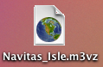

- Check to make sure you are in the visualize mode (see arrow below).

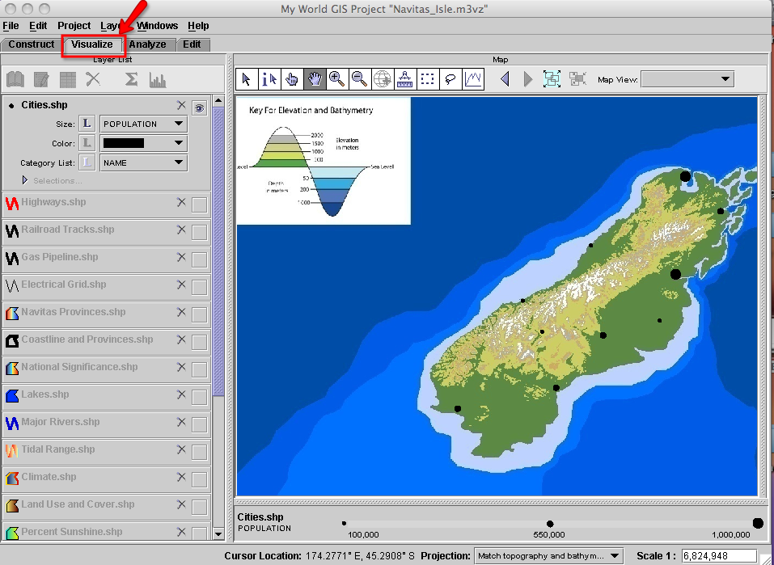

Step 3: Explore energy resources.

The map shows the elevation and bathymetry of the Isle of Navitas. Elevation is how high the ground is above sea level. Bathymetry is how deep the ocean is in a particular area. Topography is a map of elevations and bathymetry.

- Click on the Cities.shp layer to make it active. The population bar and legend are displayed at the bottom of the map.

The big black circles on the map represent cities with larger populations and the small black circles represent cities with smaller populations.

- Turn the Navitas Provinces.shp layer on. This layer displays the three provinces of the Isle of Navitas: Cambria, Gaul, and Iberia. Click the layer to make it active.
Click on the table icon above the Layer List to view the population and number of households for each province. Close the Table of Layer “Navitas Provinces.shp” window.

- Turn the Navitas Provinces.shp layer off.

- Turn the Coastline and Provinces.shp layer on. This layer outlines the coastline and the province boundaries.

- Turn the National Significance.shp layer on. This layer displays locations of biological diversity, historical significance, and natural beauty. These are protected areas.

- Have students zoom in to their assigned province to explore the different energy resources.

Hydroelectric Power: Steps 7 – 9
Thought process: The factors needed to determine the ideal location of a hydroelectric dam include the topography, a canyon that can be dammed, and an area to make a reservoir upstream of the dam. Zoom in to where the streams start in the mountainous areas (light green or white). Hydroelectric power requires a power plant at the dam site and access to the grid for power distribution.
- Click the square to turn the Lakes.shp layer on. This layer displays locations of lakes.  - Click the square to turn the Major Rivers.shp layer on. This layer displays locations of major rivers.  - Click the square to turn the Electrical Grid.shp layer on. This layer displays the grid that transmits and distributes electricity to the cities.  The following layers should now be turned on for hydroelectric energy:  - Coastline and Provinces.shp  - National Significance.shp  - Lakes.shp  - Major Rivers.shp  - Electrical Grid.shp | 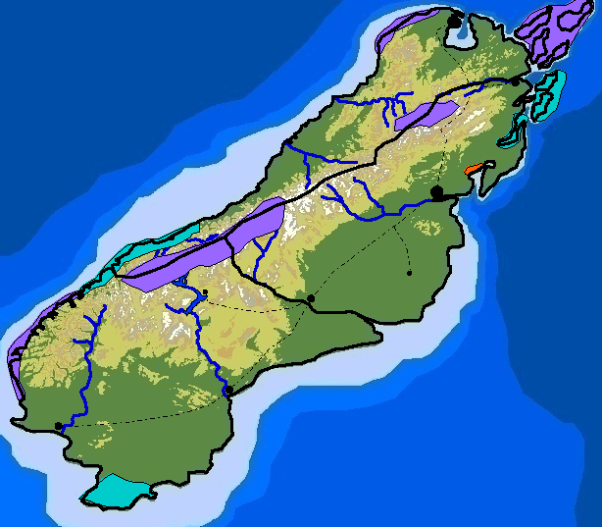

Prompt students to use the GIS map and their Impacts of Energy Sources Investigation sheet to complete the Hydroelectric Power table and the rating on their investigation sheet.

- Click the eye in the top right corner of the Lakes.shp and Major Rivers.shp layers to turn them off.

Tidal Energy: Step 11
Thought process: The factors needed to determine the ideal shore location of a tidal power plant include a large tidal range and a funnel shaped shoreline pointing inland. Tidal power requires a power plant at the coast and access to the grid for power distribution.
- Click the square to turn the Tidal Range.shp layer on. This layer displays the tidal range. The tidal range bar and legend are displayed at the bottom of the map.  The following layers should now be turned on for tidal energy:  - Tidal Range.shp  - Coastline and Provinces.shp  - National Significance.shp  - Electrical Grid.shp  If needed, turn the Coastline and Provinces.shp and National Significance.shp layers off to see the tidal range on the map. | 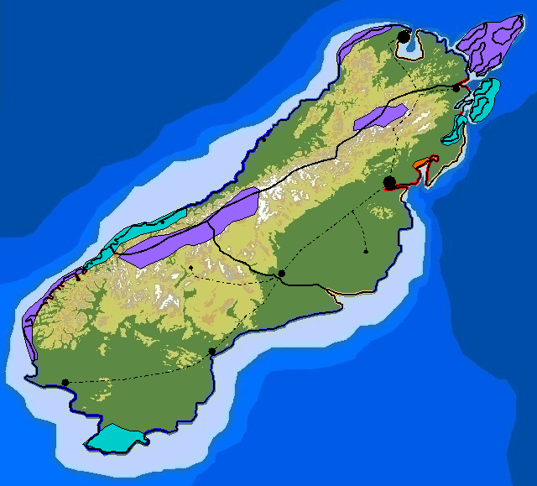

Prompt students to use the GIS map and their Impacts of Energy Sources Investigation sheet to complete the Tidal Energy table and the rating on their investigation sheet.

- Click the eye in the top right corner of the Tidal Range.shp layer to turn it off.

Biofuels/Biomass: Steps 13 – 17
Thought process: The factors needed to determine the ideal location for biomass production include lots of level farm land (may need to fertilize and water) and transportation infrastructure to get the fuel to a processing plant. Biofuels/Biomass production requires a biofuel processing plant. Although biofuels are most commonly used for transportation, they can be used to create electricity. To do this, an energy generating plant with access to the grid is also needed for power distribution.
- Click the square at the right end of the Climate.shp layer to turn it on. This layer displays the different types of climate.

The keys in the panel on the right display the type of climate and corresponding precipitation. Precipitation is the annual (yearly) amount of rain.

- Click the eye in the top right corner of the Climate.shp layer to turn it off.

- Click the square to turn the Land Use and Cover.shp layer on. This layer displays the different types of land use and ground cover.
The land use and cover key is displayed in the panel on the right. | 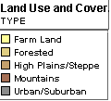

- Click the square to turn the Highways.shp layer on. This layer displays the major highways that are used for transportation.

- Click the square to turn the Railroad Tracks.shp layer. This layer displays the railroads used for transportation.

The following layers should now be turned on for biomass:
- Coastline and Provinces.shp
- National Significance.shp
- Climate.shp
- Land Use and Cover.shp
- Highways.shp
- Railroad Tracks.shp
- Electrical Grid.shp

Go back and forth between the Climate.shp and Land Use and Cover.shp layers to determine a good location for producing biomass.

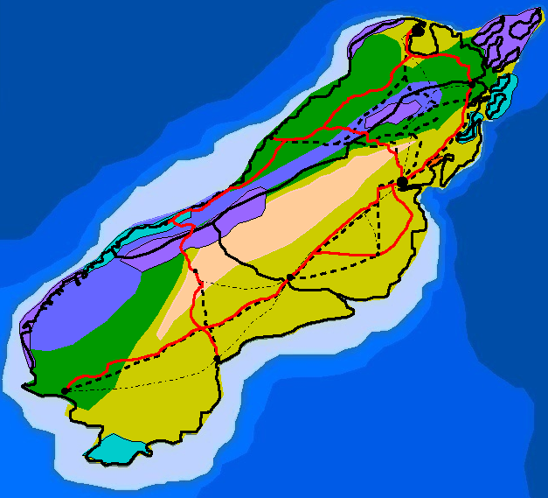 | 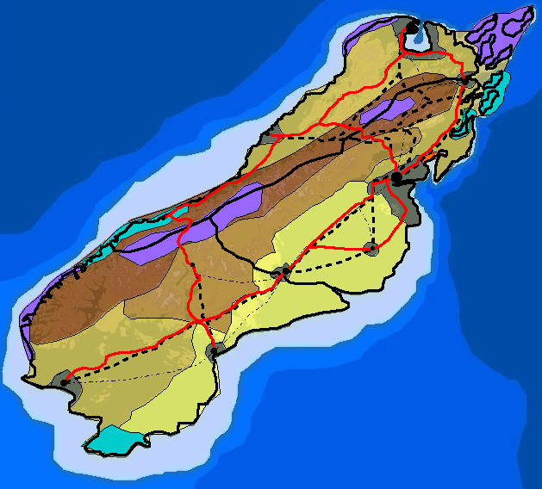

Prompt students to use the GIS map and their Impacts of Energy Sources Investigation sheet to complete the Biofuels/Biomass table and the rating on their investigation sheet.

- Click the eye in the top right corner of the Climate.shp, Land Use and Cover.shp, Highways.shp, and Railroad Tracks.shp layers to turn them off.

Solar Energy: Step 19
Thought process: The factors needed to determine the ideal location of a solar power plant include lots of open flat areas, lots of sunshine, and no shadowing trees or buildings. Solar energy requires infrastructure to make power and distribute electricity to the grid.
- Click the square to turn the Percent Sunshine.shp layer on. This layer displays the percent annual average sunshine.  The percent sunshine bar and legend are displayed at the bottom of the map.  The following layers should now be turned on for solar energy:  - Coastline and Provinces.shp  - National Significance.shp  - Percent Sunshine.shp  - Electrical Grid.shp | 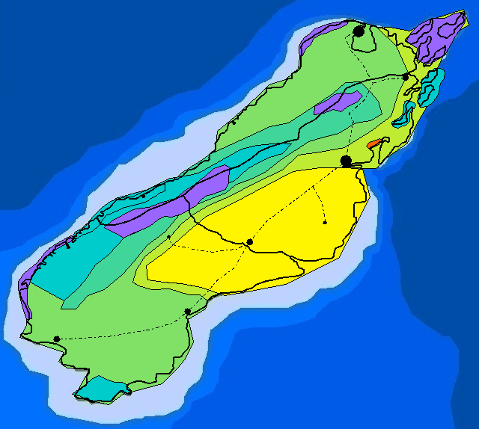

Prompt students to use the GIS map and their Impacts of Energy Sources Investigation sheet to complete the Solar Energy table on and the rating their investigation sheet.

- Click the eye in the top right corner of the Percent Sunshine.shp layer to turn it off.

Wind Energy: Step 21
Thought process: The factors needed to determine the ideal location of a wind farm include enough sustained winds and grid access for power distribution.
- Click the square to turn the Wind Speed.shp layer. This layer displays the wind speeds.  The wind speed key is displayed in the panel on the right.  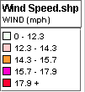  The following layers should now be turned on for wind energy:  - Coastline and Provinces.shp  - National Significance.shp  - Wind Speed.shp  - Electrical Grid.shp | 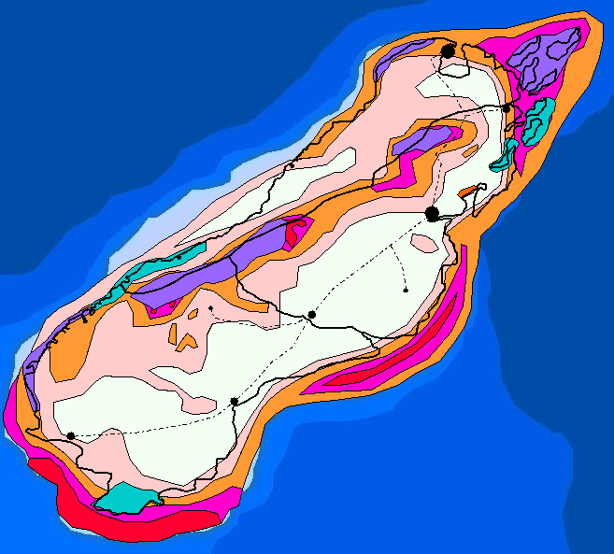

Prompt students to use the GIS map and their Impacts of Energy Sources Investigation sheet to complete the Wind Energy table and the rating on their investigation sheet.

- Click the eye in top right corner of the Wind Speed.shp layer to turn it off.

Coal: Steps 23 – 24
Thought process: The factors needed to determine the ideal location of a coal-fired power plant include transportation infrastructure for fuel delivery, water for the electrical generation plant, storage of solid waste produced by the plant, and access to the grid for power distribution.
- Click the square to turn the Coal Reserves.shp layer on. This layer displays locations of coal reserves.  - Click the square at the right end of the Highways.shp, Railroad Tracks.shp, Lakes.shp and Major Rivers.shp layers to turn them on.  The following layers should now be turned on for coal:  - Coastline and Provinces.shp  - National Significance.shp  - Coal Reserves.shp  - Highways.shp  - Railroad Tracks.shp  - Lakes.shp  - Major Rivers.shp  - Electrical Grid.shp | 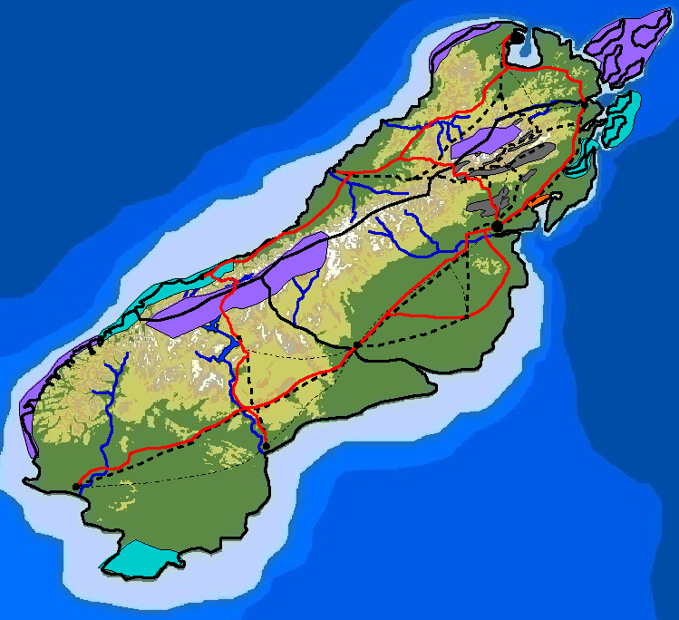

Prompt students to use the GIS map and their Impacts of Energy Sources Investigation sheet to complete the Coal table and the rating on their investigation sheet.

- Click the eye in the top right corner of the Coal Reserves.shp, Highways.shp, Railroad Tracks.shp, and Electrical Grid.shp layers to turn them off.

Natural Gas: Steps 26 – 27
Thought process: The factors needed to determine the ideal location a natural gas power plant include pipelines for fuel delivery, water for the electrical generation plant, and access to the grid for power distribution.
- Click the square to turn the Natural Gas Reserves.shp layer. This layer displays locations of natural gas reserves.  Helpful hint: Click the “Zoom to Active Layer” icon to quickly locate the natural gas reserves.  - Click the square to turn the Gas Pipeline.shp layer on. This layer displays pipelines used for transportation.  The following layers should now be turned on for natural gas:  - Coastline and Provinces.shp  - National Significance.shp  - Natural Gas Reserves  - Gas Pipeline.shp  - Lakes.shp  - Major Rivers.shp  - Electrical Grid.shp | 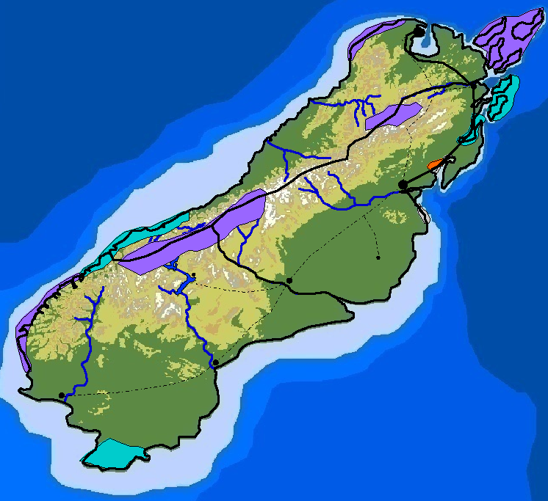

Prompt students to use the GIS map and their Impacts of Energy Sources Investigation sheet to complete the Natural Gas table and the rating on their investigation sheet.

- Click the eye in the top right corner of the Natural Gas Reserves.shp and Gas Pipeline.shp layers to turn them off.

Petroleum (Crude oil): Steps 29 – 30
Thought process: The factors needed to determine the ideal location a petroleum (crude oil) power plant include a refinery to process the crude oil into fuel, a plant for electrical generation, water for the electrical generation plant, and access to the grid for power distribution.
- Click the square to turn the Oil Reserves.shp layer on. This layer displays locations of oil reserves.  - Click the square to turn the Highways.shp layer on.  The following layers should now be turned on for oil:  - Coastline and Provinces.shp  - National Significance.shp  - Oil Reserves.shp  - Highways.shp  - Lakes.shp  - Major Rivers.shp  - Electrical Grid.shp | 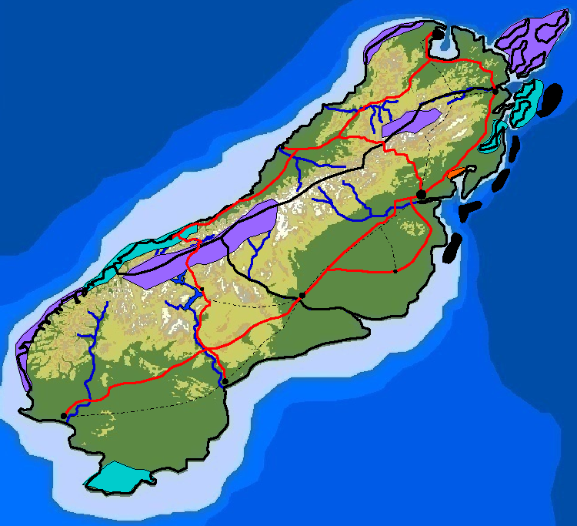

Prompt students to use the GIS map and their Impacts of Energy Sources Investigation sheet to complete the Petroleum (Crude oil) table and the rating on their investigation sheet.

- Click the eye in the top right corner of the Oil Reserves.shp and Highways.shp layers to turn them off.

Geothermal Energy: Step 32
Thought process: The factors needed to determine the ideal location of a geothermal power plant include a hot Earth location and access to the grid to distribute electricity.
- Click the square to turn the Geothermal Areas.shp layer. This layer displays areas where the Earth is hot.  The following layers should now be turned on for geothermal energy:  - Coastline and Provinces.shp  - National Significance.shp  - Geothermal Areas.shp  - Electrical Grid.shp | 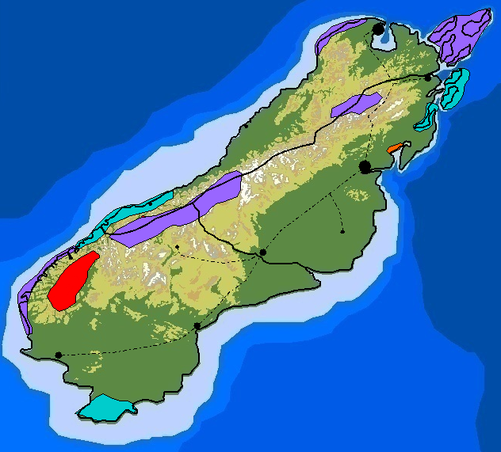

Prompt students to use the GIS map and their Impacts of Energy Sources Investigation sheet to complete the Geothermal Energy table and the rating on their investigation sheet.

- Click the eye in the top right corner of the Geothermal Areas.shp layer to turn it off.

Nuclear Energy: Step 34 - 35
Thought process: The factors needed to determine the ideal location of a nuclear power plant include uranium mines, a plant to process the ore into fuel rods, an electrical generation plant, cooling water for power plant, grid to distribute electricity, and a place to store radioactive waste.
- Click the square to turn the Uranium.shp layer on. This layer displays locations of uranium reserves.  - Click the square at the right end of the Lakes.shp and Major Rivers.shp layers to turn them on.  The following layers should now be turned on for nuclear energy:  - Coastline and Provinces.shp  - National Significance.shp  - Uranium.shp  - Lakes.shp  - Major Rivers.shp  - Electrical Grid.shp | 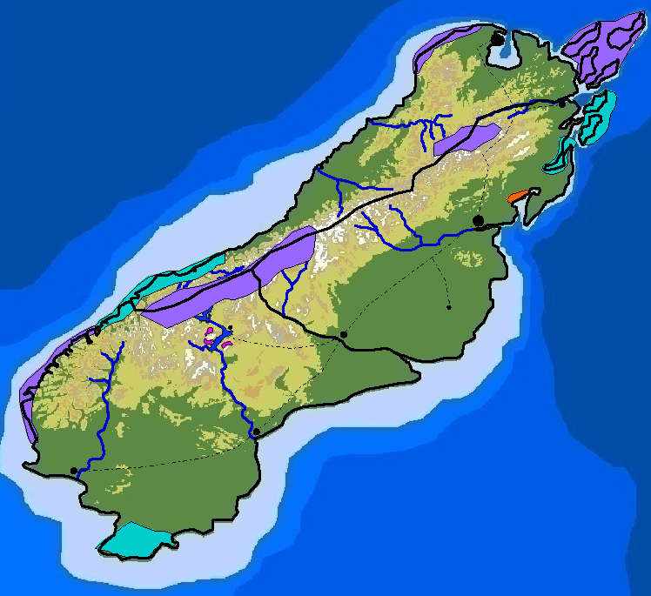

Prompt students to use the GIS map and their Impacts of Energy Sources Investigation sheet to complete the Nuclear Energy table and the rating on their investigation sheet.

- Click the eye in the top right corner of the Uranium.shp, Lakes.shp, and Major Rivers.shp layers to turn them off.

Instruct students to analyze the completed tables on their investigation sheet to answer questions 2 - 7.

