Trees and Ecological Services Investigation
How do trees and vegetation provide ecosystems services to the community?

Different types of vegetation provide ecological services including shade, habitat for wildlife, and nutrient cycling. You will:
- Investigate the area around your school to identify different types of trees.
- Explore the environmental and societal benefits that trees provide in Allentown.
- Investigate the relationship among trees and crime in Allentown.

Read all instructions and answer each question on your investigation sheet.

Preparations Checklist:
Dichotomous Key iBook downloaded _____
Ecological Services Field Map downloaded _____
Measuring Tape _____

Step 1: Open the Collector App and Your Map

- Collector app and sign in

- Download the map.

- Make sure a blue dot appears. If it doesn’t appear after a few minutes, restart the app outside.
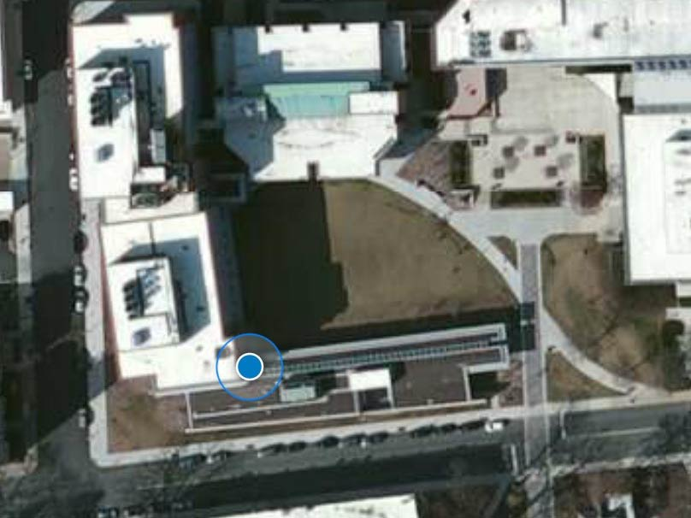

Step 2: Start making observations in your area

Cities have many different types of trees reflecting many years of planting and maintenance. You will gather data on different trees within a few blocks of the school to be used later for analyzing their ecological impact. Always stay with your group when you are outside.

Where to go:  - Go with your teacher or mentor to the area that you will be investigating.  - Go to your assigned locations to make observations of trees.  What to do:  - In your assigned area, make observations with the Collector app.  - You will make observations for a few different trees. Make at least 3 observations.  - To enter a new observation, select the plus sign on the upper right of the screen (red arrow).  - Decide if the tree is deciduous or evergreen. Enter your answer. | 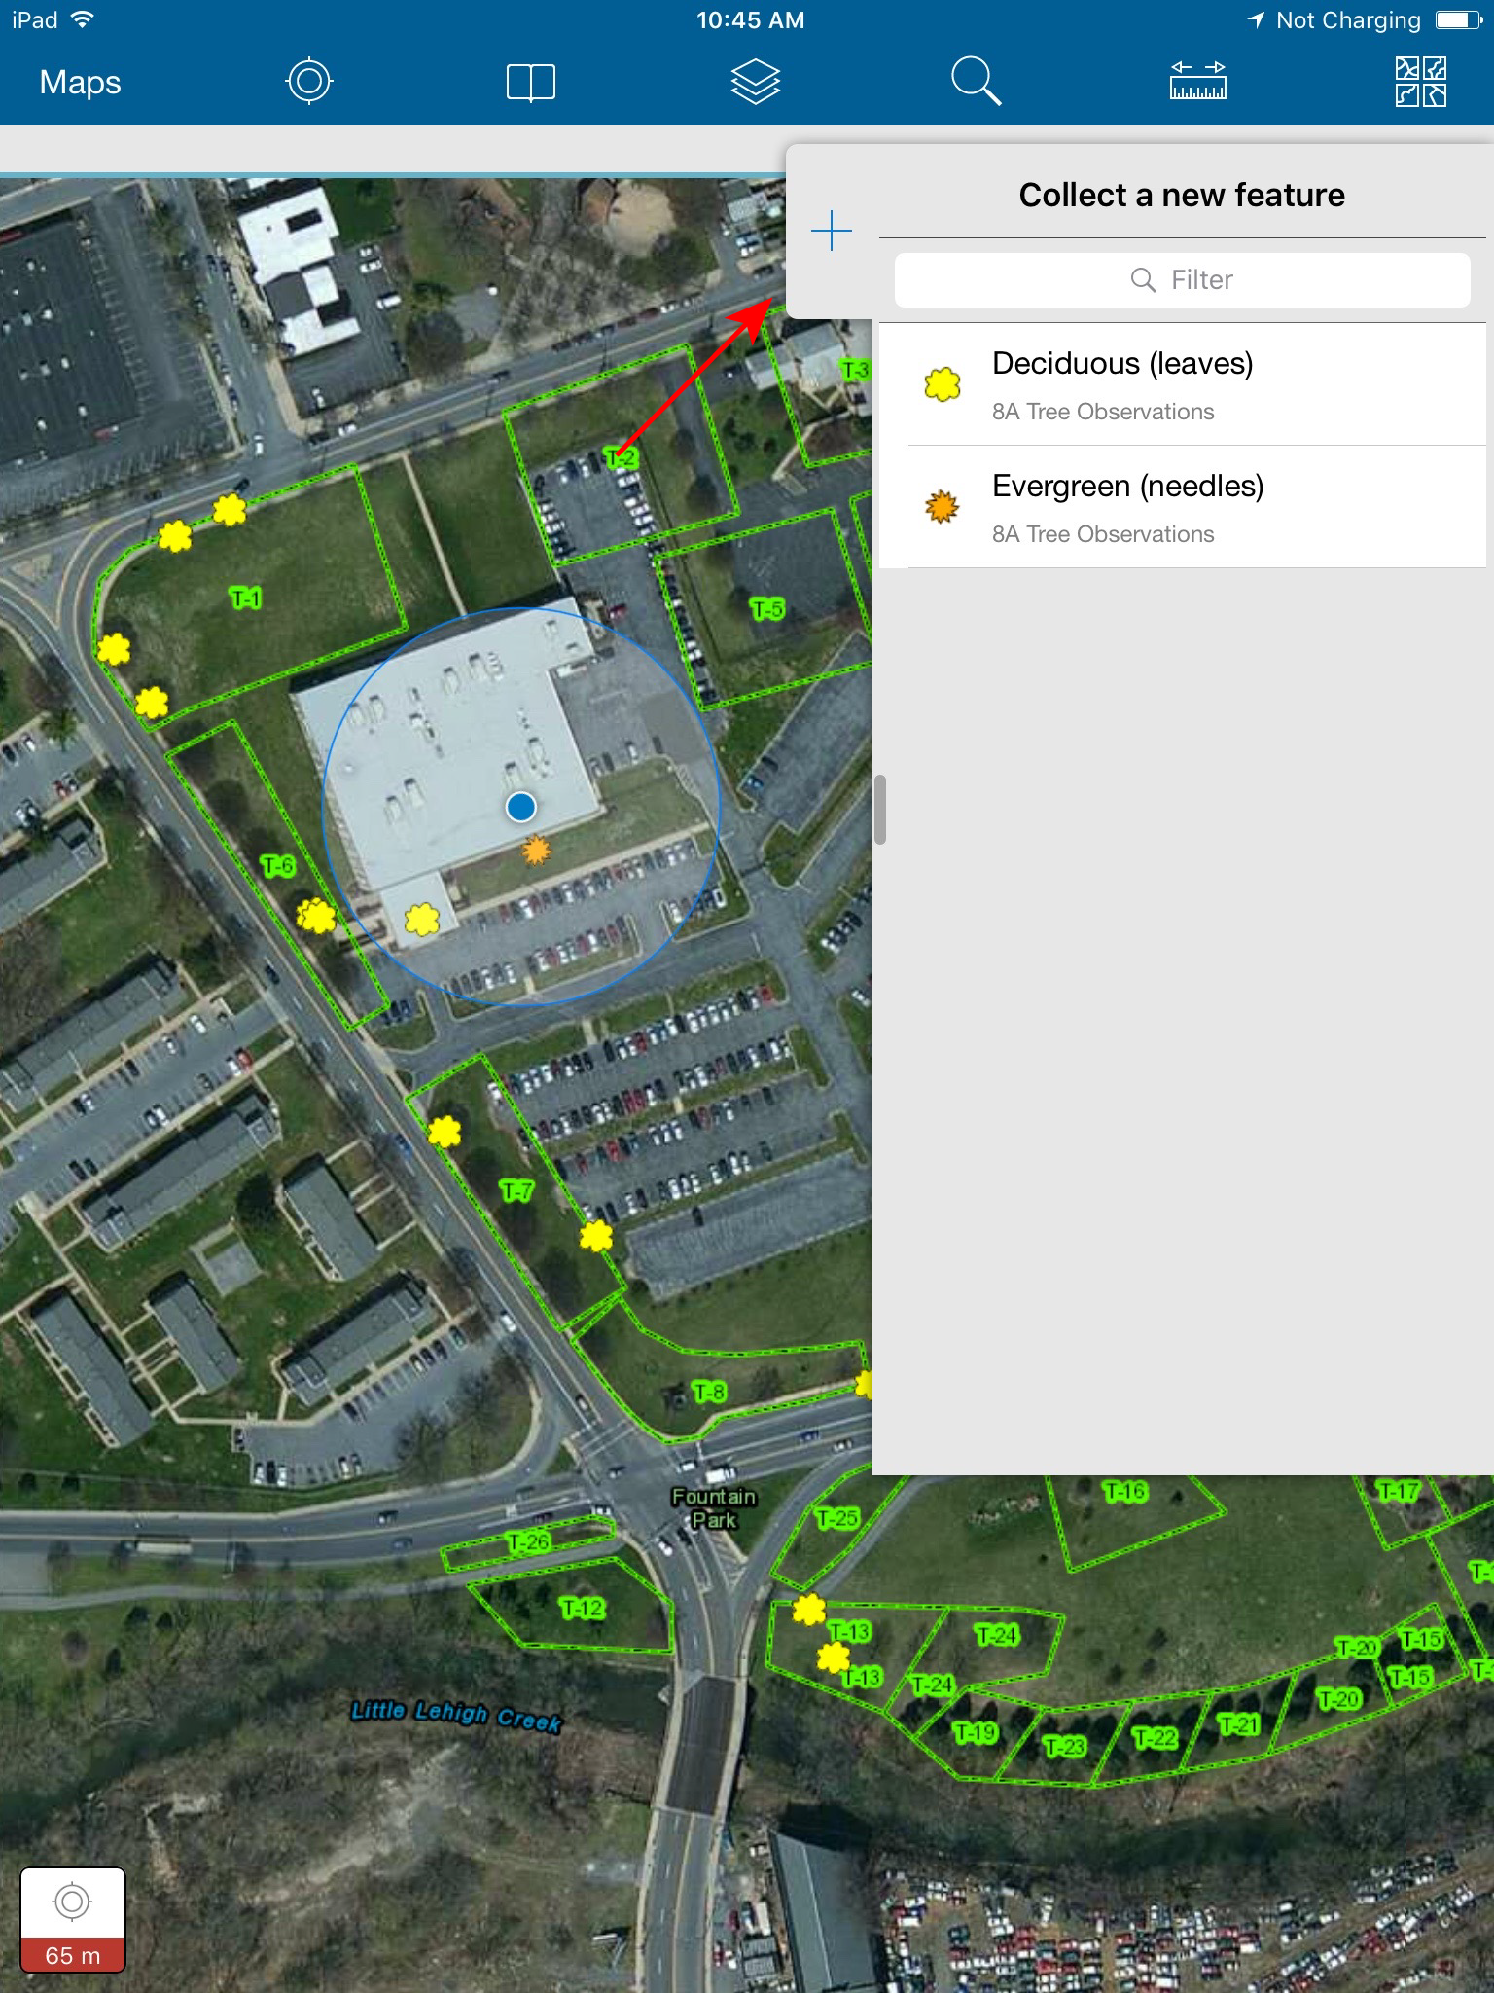
- Open the Dichotomous Key iBook. You will be taken to a directions page that explains how to use this key  - Select Tap to Begin.  - You should see a screen like the one on the right.  - Work through the screens. Select the best answer for each question. You can make the picture bigger by pressing on it.  - Once you have answered all the questions, you will see a bunch of data about the tree you have identified.  - Determine the genus and species of the tree you’re observing (see lower image). The trees listed have both scientific and common names. The genus is the first word of the scientific name (For example, Acer is the genus for all maples).  - In the Collector app, add the genus and common name for the observed tree.  - Measure the circumference of the tree at chest height in centimeters and record it.  - Estimate the height of the tree in meters. Remember, a 6-meter tree is the same height as a two-story building.  - Once you have filled in all the fields, stand next to the tree and hit submit. | 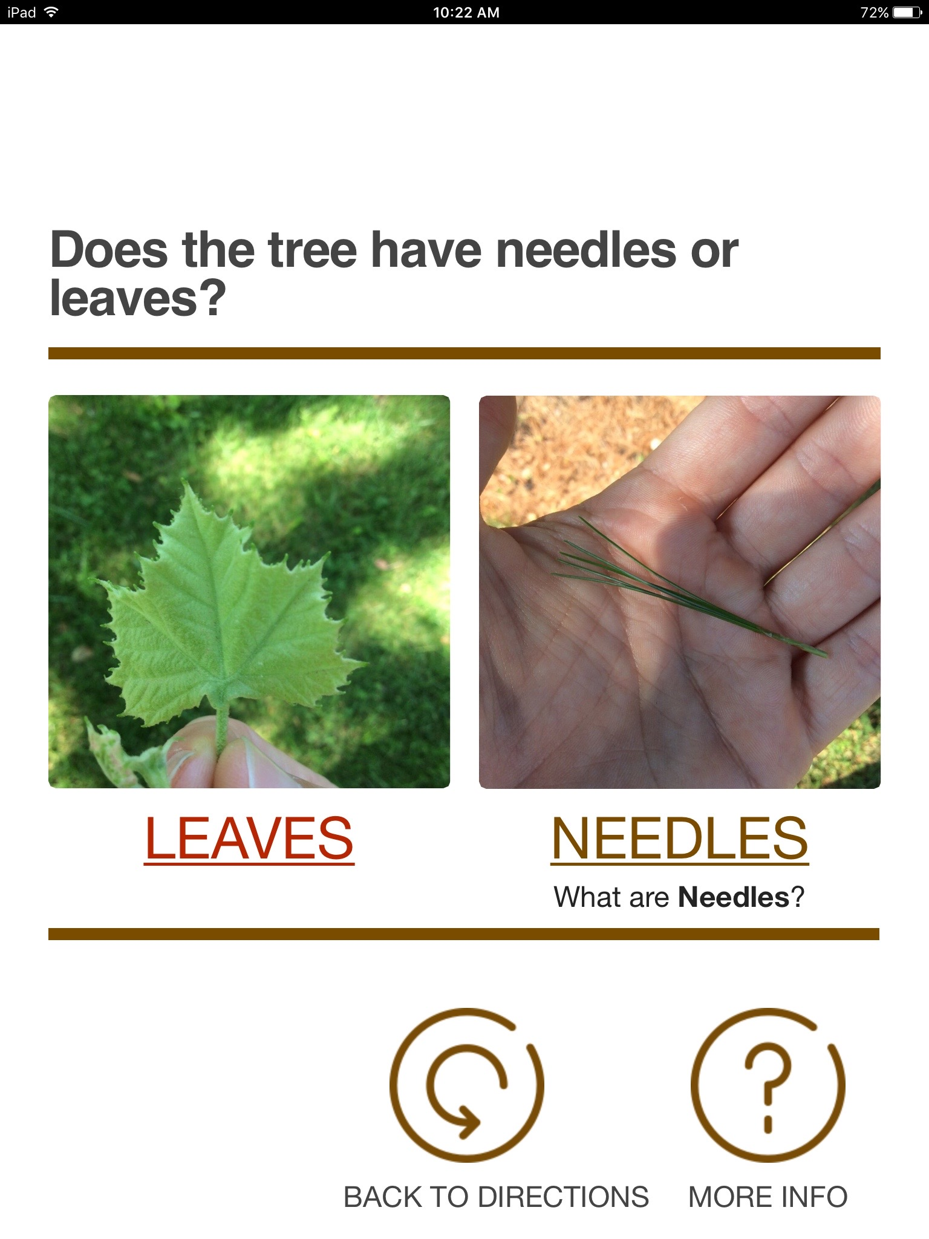  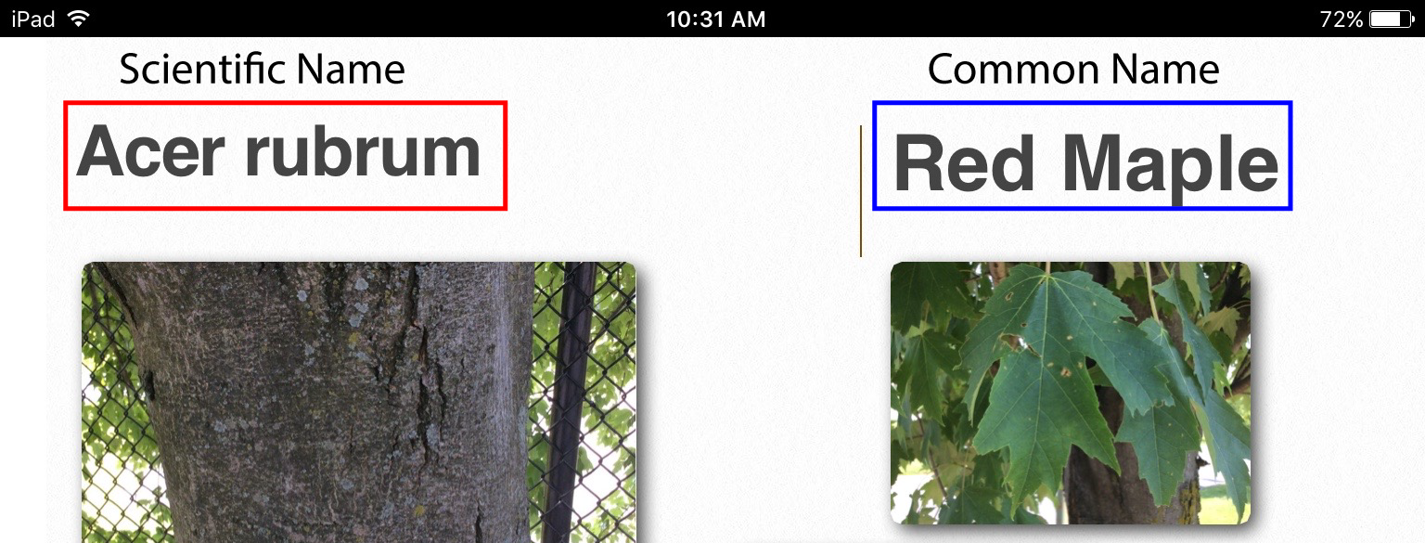

Step 3: Sync your observations with your class

When you have returned to the school, you need to synchronize your observations with the rest of your classmates. This lets you view all class observations including the data from locations you were not able to observe yourself. You can compare your observations with other students’ data and discover if there are locations that have similar or different tree types.

- Select Maps in the upper left of your screen.  - Select the cloud icon (red box) to start synchronizing your observations.  - Click on the map again after synchronizing to see all the points your classmates have added.  - Answer questions # 1-4 below.  - After completing the questions remove the map. On the same screen select the square icon $→$ Manage $→$ Remove $→$ Remove features and basemap  - You can then log out of the iPad. Select the square icon $→$ Sign Out $→$ Sign Out | 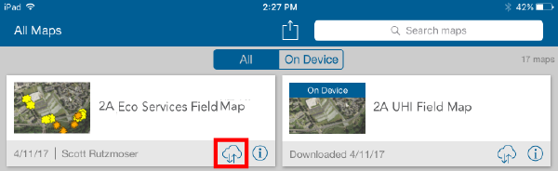  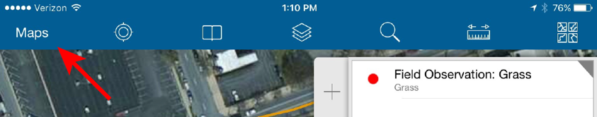

Use you own personal data to answer questions #1-4.
1. Complete the table below.
Teacher / Mentor
Area Assigned
Number of Observations Made

2. List each genus and species of tree you observed.

3. Did you see any evidence of animal habitats in the trees you observed (bird’s nest, rodent hole, squirrels)?

4. a. What was the genus and species of the tallest tree you observed? How tall was it in meters?

b. What was the genus and species of the widest tree you observed? What was the circumference of that tree in centimeters?

Step 4: Explore all class’ observations in ArcGIS Online

Use ArcGIS online on your laptop to analyze your class’ observations.
You can view the data anywhere that has Internet access at https://b21.maps.arcgis.com/home
Sign in with your username and password.

- After logging into your account, select Groups at the top of the screen, select your class, and then find the Trees and Ecological Services Classroom Map – All Blocks and select it.  - You should see a screen that looks like the one on the right.  - Look at the Legend. Notice the different colored symbols for your tree observations for each genus. | 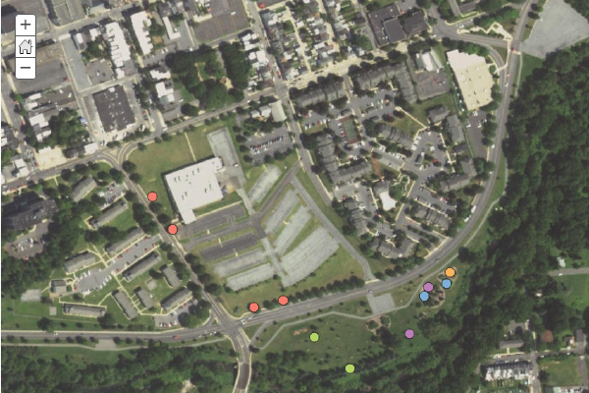
- Select the Contents tab (middle tab).  - Turn on the Allentown City Trees layer. The city of Allentown planted these trees.  - Explore the entire area around the school. Look for patterns in the types of trees that were observed.  - Answer questions # 5-9 below. | 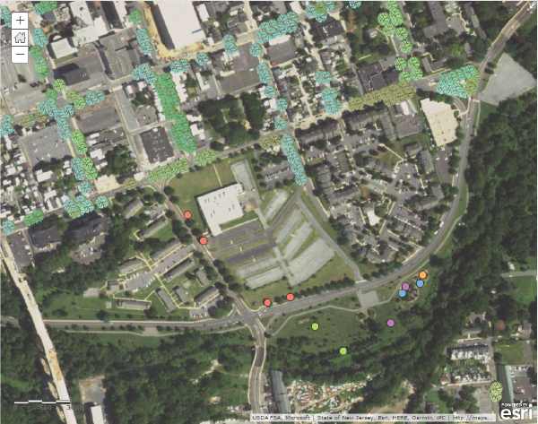
5. What is the most common tree on the Building 21 property?
Provide the genus and species name.
Is this tree native or exotic?

6. Look at all classes’ observations. Notice how tree species differ around the entire observation area. Describe any patterns you see. Where do changes in the species of trees occur? Be specific. HINT: (Look at the color patterns on the map).

7. Why do you think the tree species are different in the different locations around the school?

8. Why would you want shorter trees planted in certain locations?

9. The table below displays ecological services of a tree and corresponding values of those services. Estimate the value of the trees within one block of Building 21 High School.

Estimated number of trees around Building 21: _________
Annual Benefits | Example | Value per tree | Total value for trees around B21
Energy Savings | Reduced cooling costs in summer | $47.63
Air pollution | Removes pollution from the air | $9.02
Storm water catchment | Reduce flooding and erosion | $61.00
Carbon dioxide reduction | Takes up CO₂ | $1.29
Aesthetic/ other | Increase property value | $89.88
Total Value |  | $208.82

Total value of all trees around Building 21 school: _________
Step 5: Investigate the relationship between trees and crime in Allentown

You now have experience making observations about trees and examining the tree diversity around your school. You will now examine different parts of the city to explore how tree canopy is related to crime.

Your teacher will assign you one of the 5 different areas in Allentown to examine how the density of trees changes in different neighborhoods. You will also use observations collected around your neighborhood to compare your home with other students in your class.

- Add the Ecological Services Areas, Allentown Percent Canopy Cover, and Allentown Personal Crime layers to your map. These are census block groups.  - Click Legend. The Allentown Personal Crime Index layer contains statistics about major categories of personal and property crime. 100 is the national average. An example legend is shown on the right.  - Each block on the map is a census block. Click on a block. A pop-up window displays percent canopy cover and personal and property crime data for that block (red boxes in the lower image). Scroll down to see all data and graphs.  - Within your assigned area compare the different census blocks. What are some similarities and differences that exist between these areas?  It may be helpful to turn the Allentown Percent Canopy Cover layer off and on a few times so you can see how trees and crime are related.  - Answer questions # 10-13 below. | 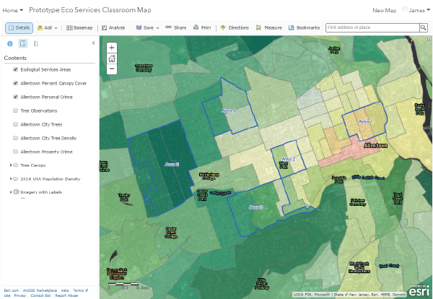  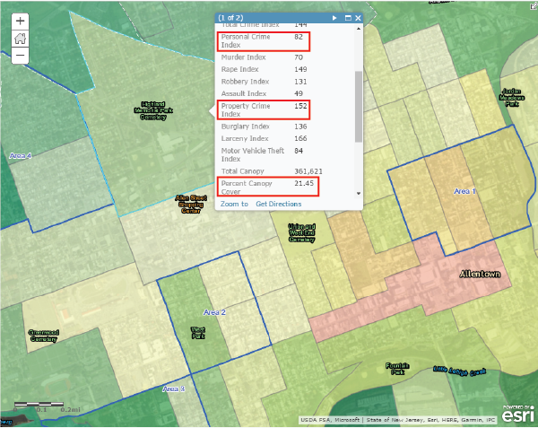  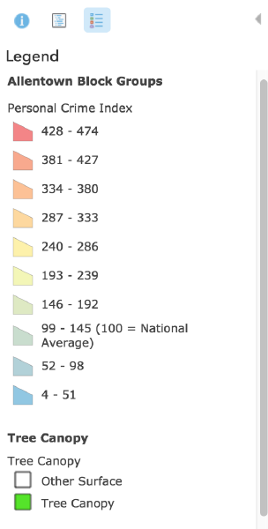

10. Using the table below, how does Allentown’s urban tree cover compare to other cities in the US?
City | Urban Tree Cover
Allentown, PA | 30.0%
Atlanta, GA | 32.9%
Boston, MA | 21.2%
Baltimore, MD | 18.9%
Chicago, IL | 11.0%
New York, NY | 16.6%
Oakland, CA | 21.0%
Philadelphia, PA | 21.6%
Seattle, WA | 23.0%

11. In your assigned area record the personal crime index, property crime index and percent tree canopy.
Click on each census block in your area.

Area Assigned: _______
Census Block ID  Last 5 numbers | Property Crime Index  (USA Average = 100) | Personal Crime Index  (USA Average = 100) | Percent Tree Canopy Cover  (Allentown Average = 30%)
Average Value
Helpful Hint: Average Value = Add up the 3 values in each column and then divide by 3

12. a. Complete the class table below. You will need the data from other groups in the class.
Area | Property Crime Index  (USA Average = 100) | Personal Crime Index  (USA Average = 100) | Percent Tree Canopy Cover  (Allentown Average = 30%)
1
2
3
4
5

b. Complete the graph below using the Personal Crime Index and Percent Tree Canopy Cover data from the table above. Label your axes.

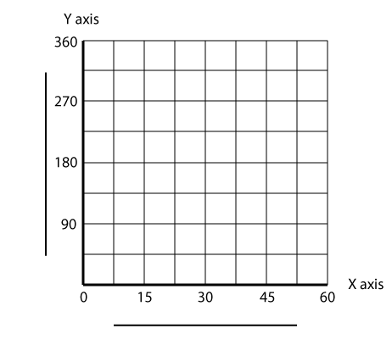

c. Which area has the highest personal and property crime?

d. Which area has the lowest personal and property crime?

e. Which area has the highest percent tree canopy cover?

f. Which area has the lowest percent tree canopy cover?

13. How are crime and tree canopy cover related in the 5 areas in Allentown?
Step 6: Apply what you’ve learned to your neighborhood

- After school, make some observations about your local neighborhood and take some pictures if you can.  - Add your observations to your map using the Map Notes feature (Add > Add Map Notes > Add Features). How does your neighborhood compare to the rest of the city?  - How can you improve your local neighborhood using the information you learned in this investigation?  After you have completed your map, take a screenshot of your map and submit it to your teacher. To take a screenshot, press the ‘Print Screen’  key. You can then Paste the screen shot into Google Docs and submit that to Google Classroom.  - Answer questions # 14-15 below. | 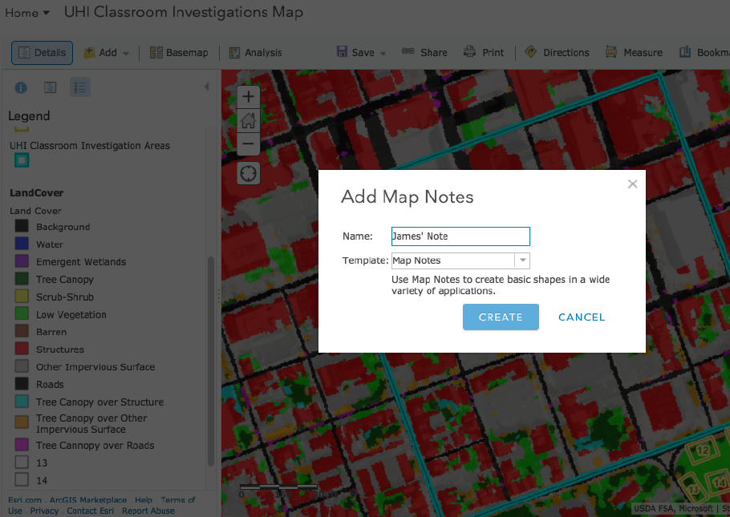

Be sure to submit your screen shot after completing Step 6!

14. How does the tree canopy in your local neighborhood compare to the rest of Allentown? The average tree canopy in Allentown is 30%.
How many trees are within a block of your home?

15. How would you improve your neighborhood to get more value out of trees?
What benefit would be most important to your neighborhood?

