Transportation Modes Investigation

How do people travel around their neighborhood?

Different types of transportation services are available to people that allow them to travel in their daily lives. In this investigation, you will:
- Investigate the environmental impact of different types of transportation.
- Compare time and distance of travel between the same locations with different transportation types.

Answer each question on your investigation sheet.

Video tutorials are available online at https://eli.lehigh.edu/sesi for all instructional materials.

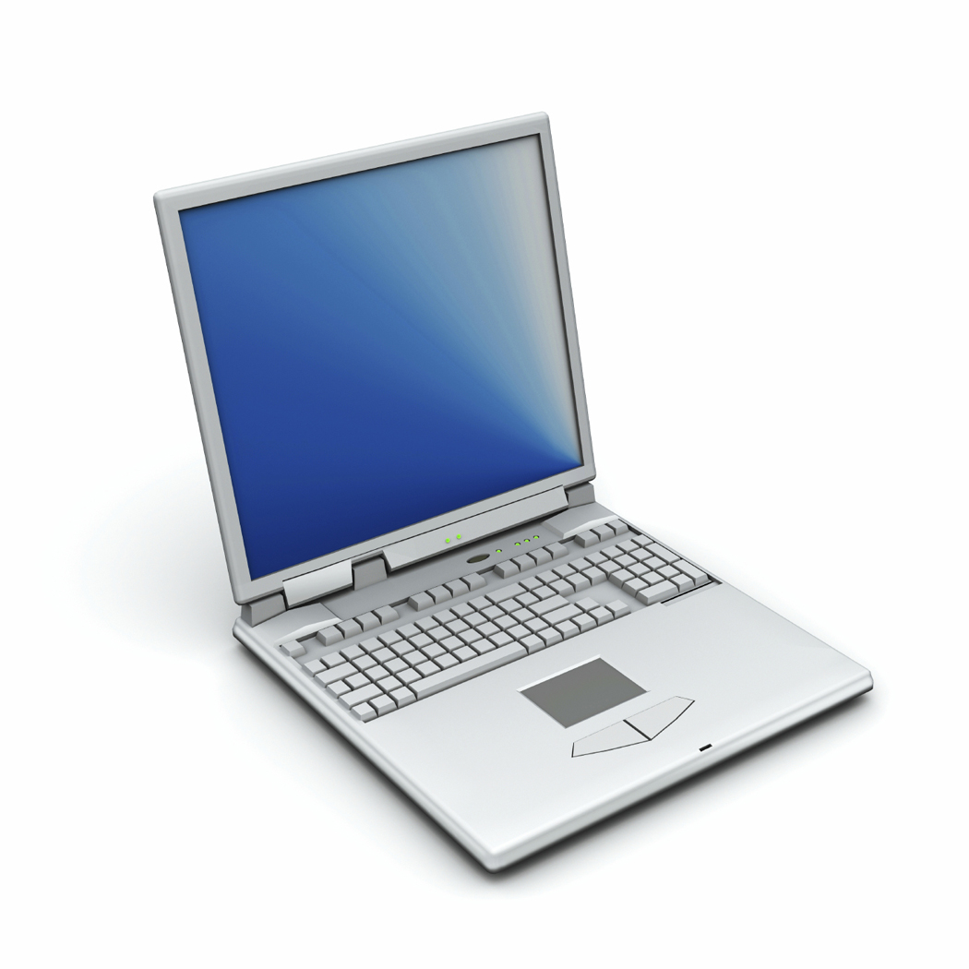

Step 1: Use the Transportation Modes Webpage

- Go to https://gisweb.cc.lehigh.edu/itest/transportation_modes/

- This Webpage allows you to create routes between two locations. You can compare the distance, time, and environmental impacts of different transportation modes (See image below).

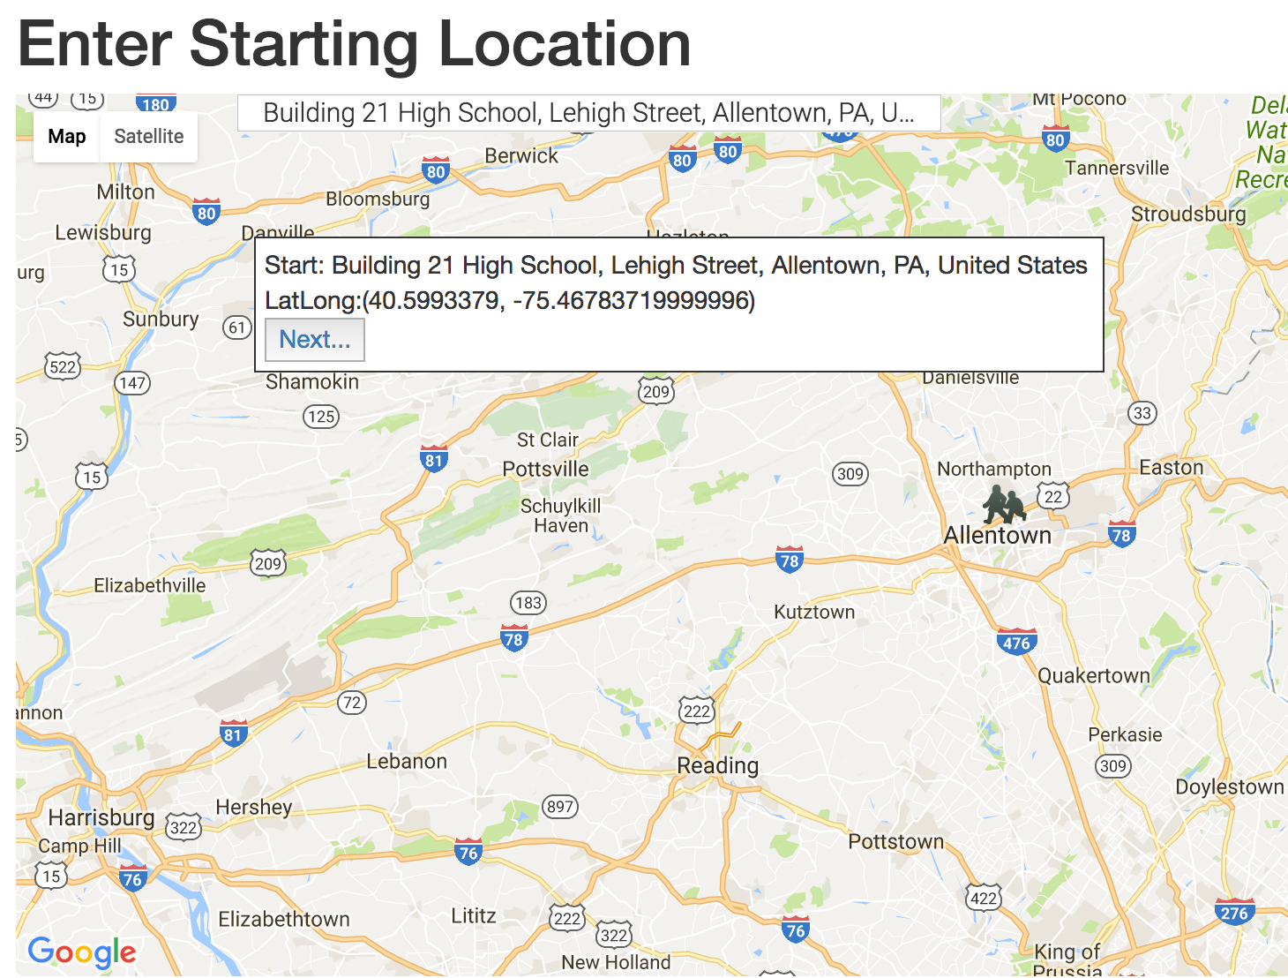

Step 2: Comparing different paths and transportation modes from Building 21

People can travel within cities in different ways. You will explore different routes (paths) and types of transportation modes from Building 21 High School. The choices you make about how to get from one location to another will take different amounts of time and different environmental impacts.

What to do:  - You will explore paths between Building 21 High School and these 5 locations:  - Lehigh Valley Mall  - Dorney Park  - Coca Cola Park  - Allentown Farmers’ Market  - Allentown AMC 16 Movie Theater  - Enter Building 21 as the starting address on the Webpage. Select Building 21 Allentown. Click Next. Then enter your first destination - Lehigh Valley Mall Click Next.  - The Webpage will display a driving path. You should see an image like the one on the right. Data about the trip are displayed to the right of the map. Note that the data is displayed per person, based on two people in a car or thirty people in a bus.  - Click Walk, Bike, or Transit (Bus route) to display routes and data for these transportation modes.  - Complete the data table in #2 below for the Lehigh Valley Mall.  - Select Restart at the top right of the Webpage. Then select the next route on the table. | 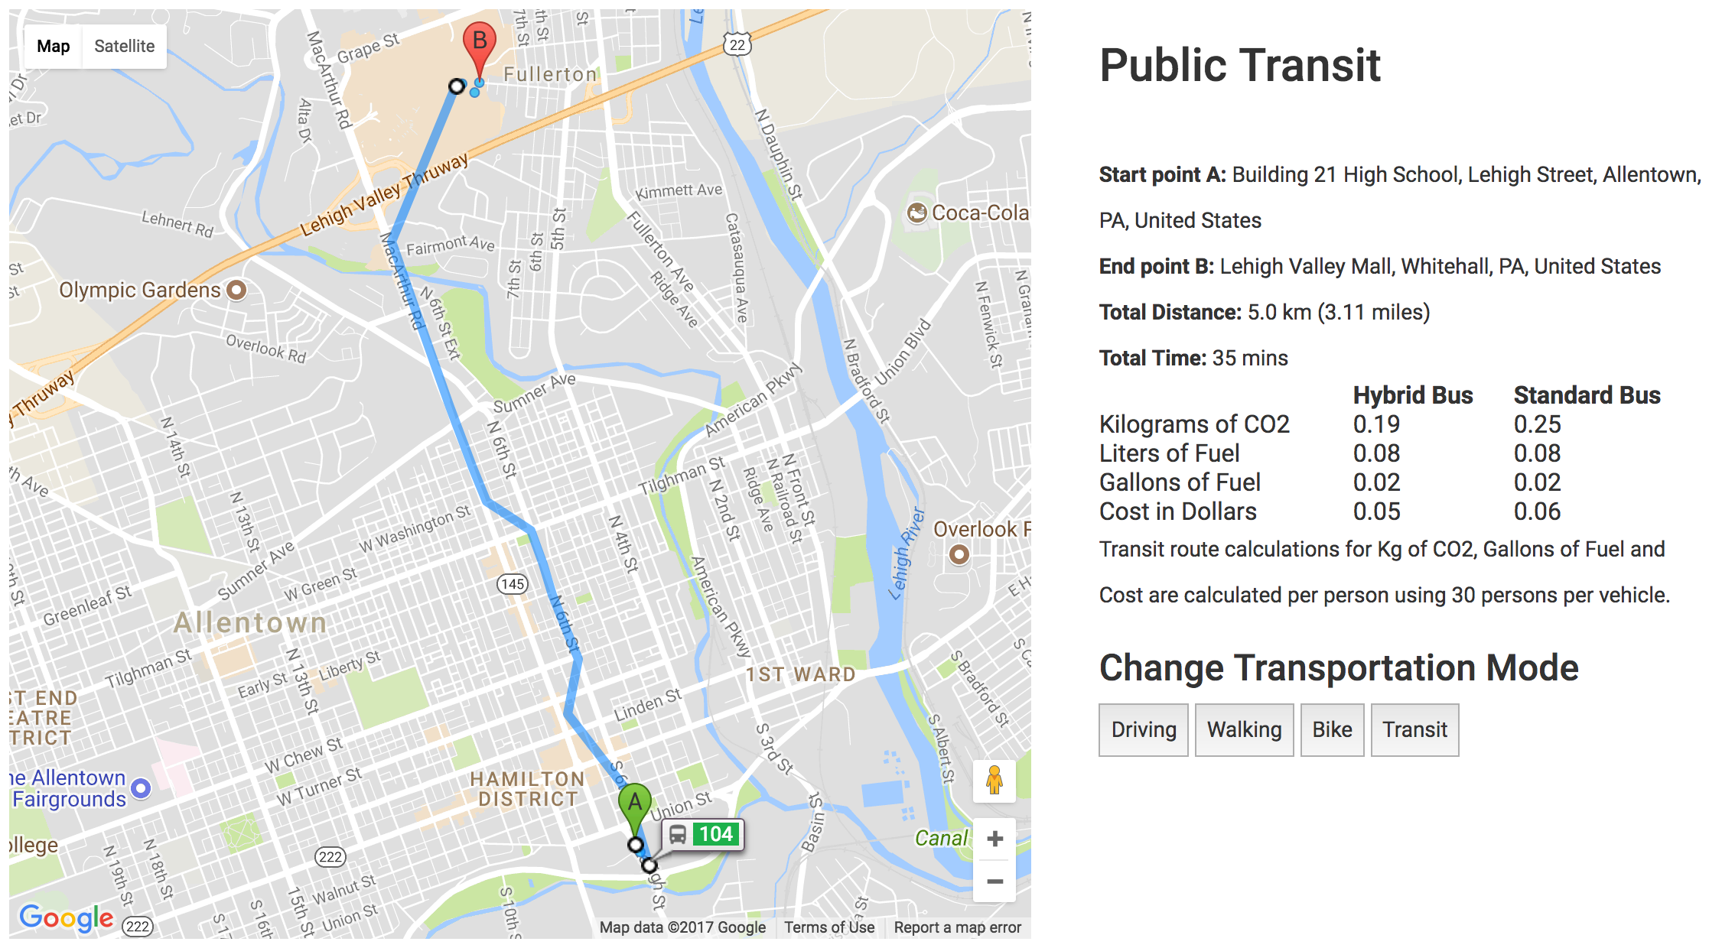  Bus:  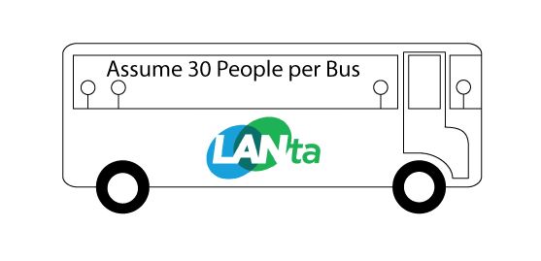  Values are for one person  Car:  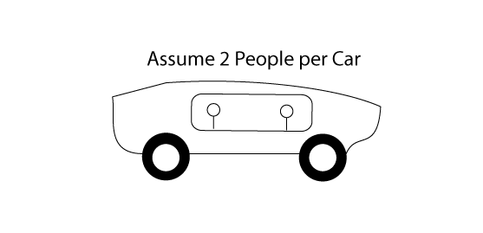  Values are for one person

1. Who is in your group and what is the name of your mentor (if any)?
Group Members
Teacher / Mentor

2. Complete the following table. Because transit (bus) options change during the day, write the day and time: __________________

 |  | Drive |  |  | Walk | Bike | Transit
Destination | Transit  Details | Hybrid Car | Standard  Car | SUV or Small Truck |  |  | Hybrid Bus | Standard Bus
Lehigh Valley Mall | Distance (km)
 | Time (minutes)
CO₂ (kg)
per person
 | Fuel (gal)  per person |  |  |  | 0.00 gal | 0.00 gal
 | Fuel Cost ($)per person |  |  |  | $0.00 | $0.00
Dorney Park | Distance (km)
 | Time (minutes)
CO₂ (kg)
per person
 | Fuel (gal)  per person |  |  |  | 0.00 gal | 0.00 gal
 | Fuel Cost ($) per person |  |  |  | $0.00 | $0.00
Coca-Cola Park | Distance (km)
 | Time (minutes)
CO₂ (kg)
per person
 | Fuel(gal)  per person |  |  |  | 0.00 gal | 0.00 gal
 | Fuel Cost ($)per person |  |  |  | $0.00 | $0.00
Allentown Farmers’ Market | Distance (km)
 | Time (minutes)
CO₂ (kg)
per person
 | Fuel (gal)  per person |  |  |  | 0.00 gal | 0.00 gal
 | Fuel Cost ($)per person |  |  |  | $0.00 | $0.00
Allentown AMC 16 | Distance (km)
 | Time (minutes)
CO₂ (kg)
per person
 | Fuel (gal)  per person |  |  |  | 0.00 gal | 0.00 gal
 | Fuel Cost ($)per person |  |  |  | $0.00 | $0.00

3. a. Pick a destination.
What transportation type produces the most emissions (CO₂) per kilometer per person?
Hint: Try using this formula: CO₂ emitted / distance traveled (in km)

b. What transportation type produces the least emissions (CO₂) per kilometer per person?

4. Rank the 7 transportation mode types from least CO₂ emissions to the most CO₂ emissions per kilometer per person. 1= Lowest CO₂ emissions; 7 = Highest CO₂ emissions

RANK | Transportation Type
1= Lowest CO₂ emissions
2
3
4
5
6
7 = Highest CO₂ emissions

5. a. How do bicycling distances compare to bus route distances? (Are they shorter, longer, or the same?)

b. How do bicycling times compare to using the bus? (Are they shorter, longer, or the same?)

c. How do bicycling distances compare to car routes? (Are they shorter, longer, or the same?)

6. a. The transportation mode values in the table are based on 2 people in the car. Think about ride sharing. Both car passengers contribute to the fuel costs. The values are displayed as per person for 2 people in the car. What would the values be for a single driver?

b. The transportation mode estimates for bus driving is based on 30 people in the bus. Think about the difference between bus with 30 passengers in it and a bus with just the bus driver in it. The values are displayed as per person for 30 people riding in the bus. What would the values be if only the driver was in the bus without any passengers?

Step 3: Compare different routes (paths) and transportation modes in your neighborhood

You will analyze different routes (paths) and types of transportation modes to understand the environmental impacts and time commitments of different transportation modes for these routes from your neighborhood.

What to do:  - You will analyze a route (path) from your neighborhood to your favorite location in Allentown. You will also analyze a route to the Building 21 High School.  - Enter a public location (for example a park, library or school) in your neighborhood as the starting address on the Webpage. Click Next. Then enter your favorite location. Click Next.  - The Webpage will display a Driving path. You should see an image like the one on the right. Data about the trip are displayed to the right of the map. Note that the data is displayed per person, not per vehicle.  - Click Walking, Bike, or Transit (Bus route) to display routes and data for these transportation modes.  Compare the distance, time, CO₂ emissions, fuel use, and fuel costs for this route. Answer questions # 7-10 below. | 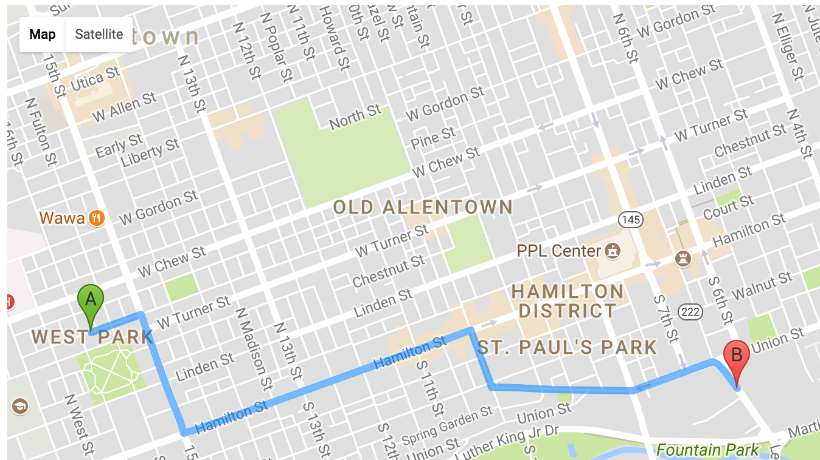

7. What is the address for your starting location in your neighborhood?

8. What is the address for your favorite location in Allentown?

9. a. Complete the following table.

 |  | Driving |  |  | Walking | Bike | Transit
Destination | Transit  Details | Hybrid Car | Typical Car | SUV or Small Truck | Walking | Bicycling | Hybrid Bus | Standard Bus
Building 21 High School | Distance (km)
 | Time (minutes)
CO₂ (kg)
per person
 | Fuel Use (gal) per person |  |  |  | 0.00 gal | 0.00 gal
 | Fuel Cost ($)per person |  |  |  | $0.00 | $0.00
Your Favorite  Location: | Distance (km)
 | Time (minutes)
CO₂ (kg)
per person
 | Fuel Use (gal) per person |  |  |  | 0.00 gal | 0.00 gal
 | Fuel Cost ($)per person |  |  |  | $0.00 | $0.00

Select Restart at the top right of the Webpage. Then create a route from a location in near your home to Building 21 High School

b. For your own transportation mode, what is the carbon footprint (kg of CO₂) of your roundtrip (to and from) Building 21 High School?
Helpful Hint: The map only gives you information for a one-way trip.

c. What is the cost in fuel for this roundtrip?

10a. Compare a bicycling route to your favorite location and a driving route. Which is the shorter distance?

b. Which takes more time?

c. Which releases less CO₂?

Step 4: Create a safe bike route in Allentown
Biking is a great way to get from place to place in a city because it has very little greenhouse gas emissions and is faster than walking. However, biking can be difficult or dangerous if you have to bike on crowded roads and sidewalks. Bike lanes and bike trails help to make traveling by bike safer and more convenient.
You will design a bike lane or trail that will help you get from Building 21 High School to Bucky Boyle Park in Allentown.
Use ArcGIS online to create this path. Go to: https://b21.maps.arcgis.com/home
Sign in with your username and password.
- After logging into your account, select Groups at the top of the screen.  Select your class.  Find the Transportation Modes Map and select it.  Select Save As. Label your map with your first and last name.  - Use the Directions tool to find a driving route from 265 Lehigh St., Allentown to Bucky Boyle Park.  - Click on the icon under  Result Layer Name to Save your route to Bucky Boyle Park.  Give your route a name that you can remember – for example, ‘Driving route to Bucky Boyle’  - Change the route OPTIONS from Driving Time  to Walking Distance  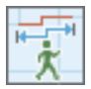  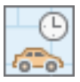  - Save the new route to your map. Give this walking route layer a new name - ‘Walking route to Bucky Boyle’.  Click ‘Save as New’.  - Click on the Directions tool  to exit the route-finding mode.  You should have two new layers on your map: one with a walking route and one with a driving route.  - Turn on your new walking route and driving route layers to view them.  - Click on each route on your map to view information.  - Answer questions # 11-13 below. | 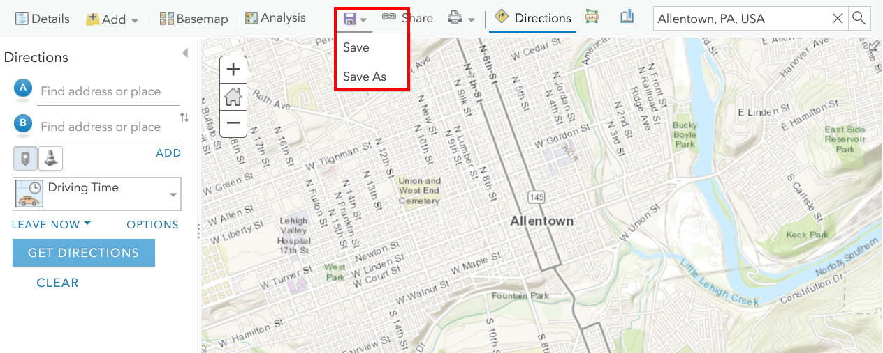  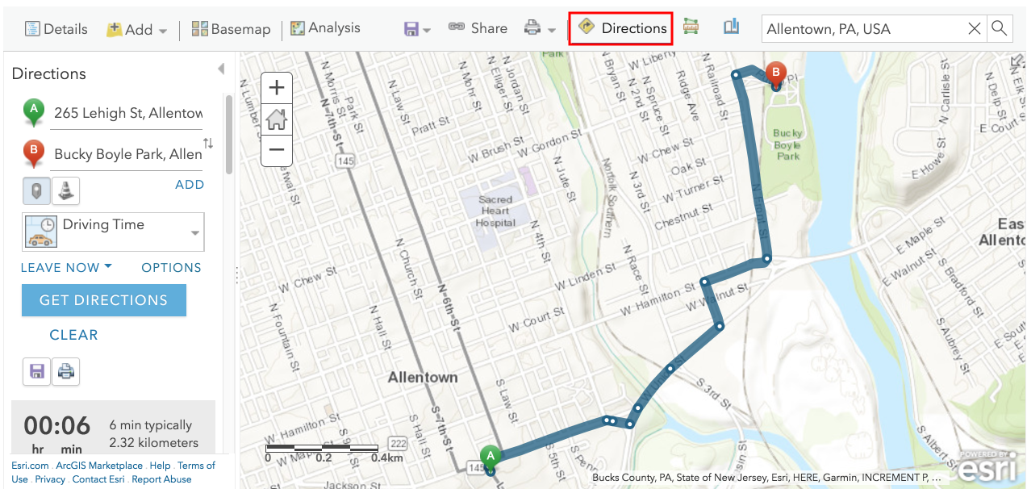  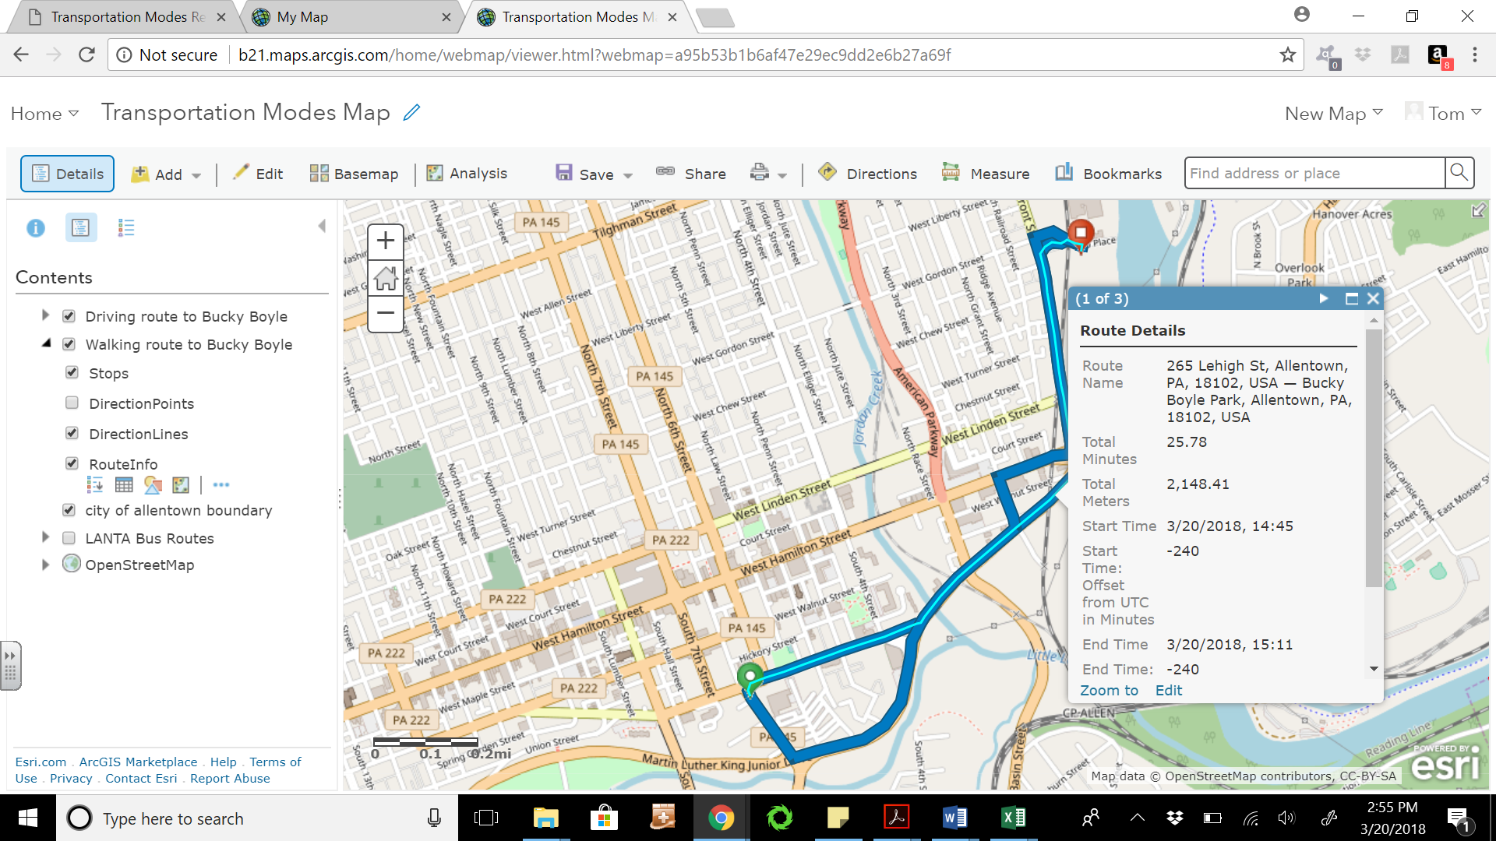

11a. Which route has a shorter distance? The walking route or the driving route?

- Why aren’t the two routes the same distance?

12a. The driving time is obviously shorter (6 minutes versus 25 minutes). What if you rode a bike from the school to Bucky Boyle Park? How long do you think that would take?

b. What route would you choose and why?

13. Use the Add > Add Map Notes feature to draw a bicycle path between Building 21 and Bucky Boyle Park.
a. Draw a bike route to travel safely.
b. Label locations where you would place:
- bike lanes,
- paths and/or tunnels,
- greenways to enhance bicycle safety
- (etc.)
Helpful hint: Look at the satellite view on your map.

Take a screen shot of your new map that shows your path. To do this press the print screen button on the top row of your keyboard. This copies your screen and you can paste the screen shot into a new Google Doc using Control + V on your keyboard, or you can select the Edit menu and then select Paste.

Under your screenshot, write two sentences explaining why you placed the bike path where it is. Include:
- The distance of your route.
- The length of your trip. Assume you bike at a rate of 12 miles/hour.
- Give at least two reasons why you placed the bike path where it is. Consider: Safety considerations, car traffic, and environmental or other hazards.

Submit your map image to Google Classroom as a new document called “Your Name Transport Mode Path”.

Challenge questions:

14. In addition to comparing regular cars and hybrid cars, we can compare specific makes, models, and years of cars. Ask several teachers what vehicles they drive. Then visit http://www.fueleconomy.gov/feg/findacar.shtml and look up that car. Write down the miles per gallon and the annual fuel cost.

Teacher’s Name: ________________________ MPG: _________ Annual Fuel Cost: $___________

Collect information from two more teachers and look up the information for their vehicles. Which teacher has the most efficient vehicle?

Teacher’s Name: ________________________ MPG: _________ Annual Fuel Cost: $___________

Teacher’s Name: ________________________ MPG: _________ Annual Fuel Cost: $___________

Most Efficient Teacher’s Name: ________________________

15. Governments can influence people’s transportation habits through policy decisions. Making a change in policy can impact the choices people make with their transportation.

Consider each of the following suggested policy changes and explain what might happen as a result

a. LANTA decides to make the bus free to everyone – anyone can ride the bus at no cost.

What might happen to the number of people riding the bus?

What would happen to the per person fuel cost and CO2 emission on buses?

What would happen to the number of cars being driven in Allentown?

b. The city of Allentown decides to impose congestion pricing – anyone driving a vehicle into the Central Business District must pay a tax of $1.00.

What might happen to the number of cars being driven in central Allentown?

What might happen to the number of people in each car?

What would happen to the per person fuel cost and CO2 emission of these cars?

