***Urban Heat Island Investigation***

***How do surface properties affect heat?***

Different types of ground surfaces absorb and emit heat differently. You will:

1. Investigate the area around your school to identify different types of ground surfaces (asphalt, concrete, grass, dirt, etc.) and compare the heat radiation of these surfaces.



**Hold the thermometer at knee to waist height and aim down.**

**Try not to take a reading in your own shadow.**

Read **all** instructions and answer **each** question on your investigation sheet.

Preparations Checklist:

UHI Field Map downloaded _____

Infrared Thermometer _____



Video tutorials are available online at **https://eli.lehigh.edu/sesi/support-materials/** for all instructional materials.

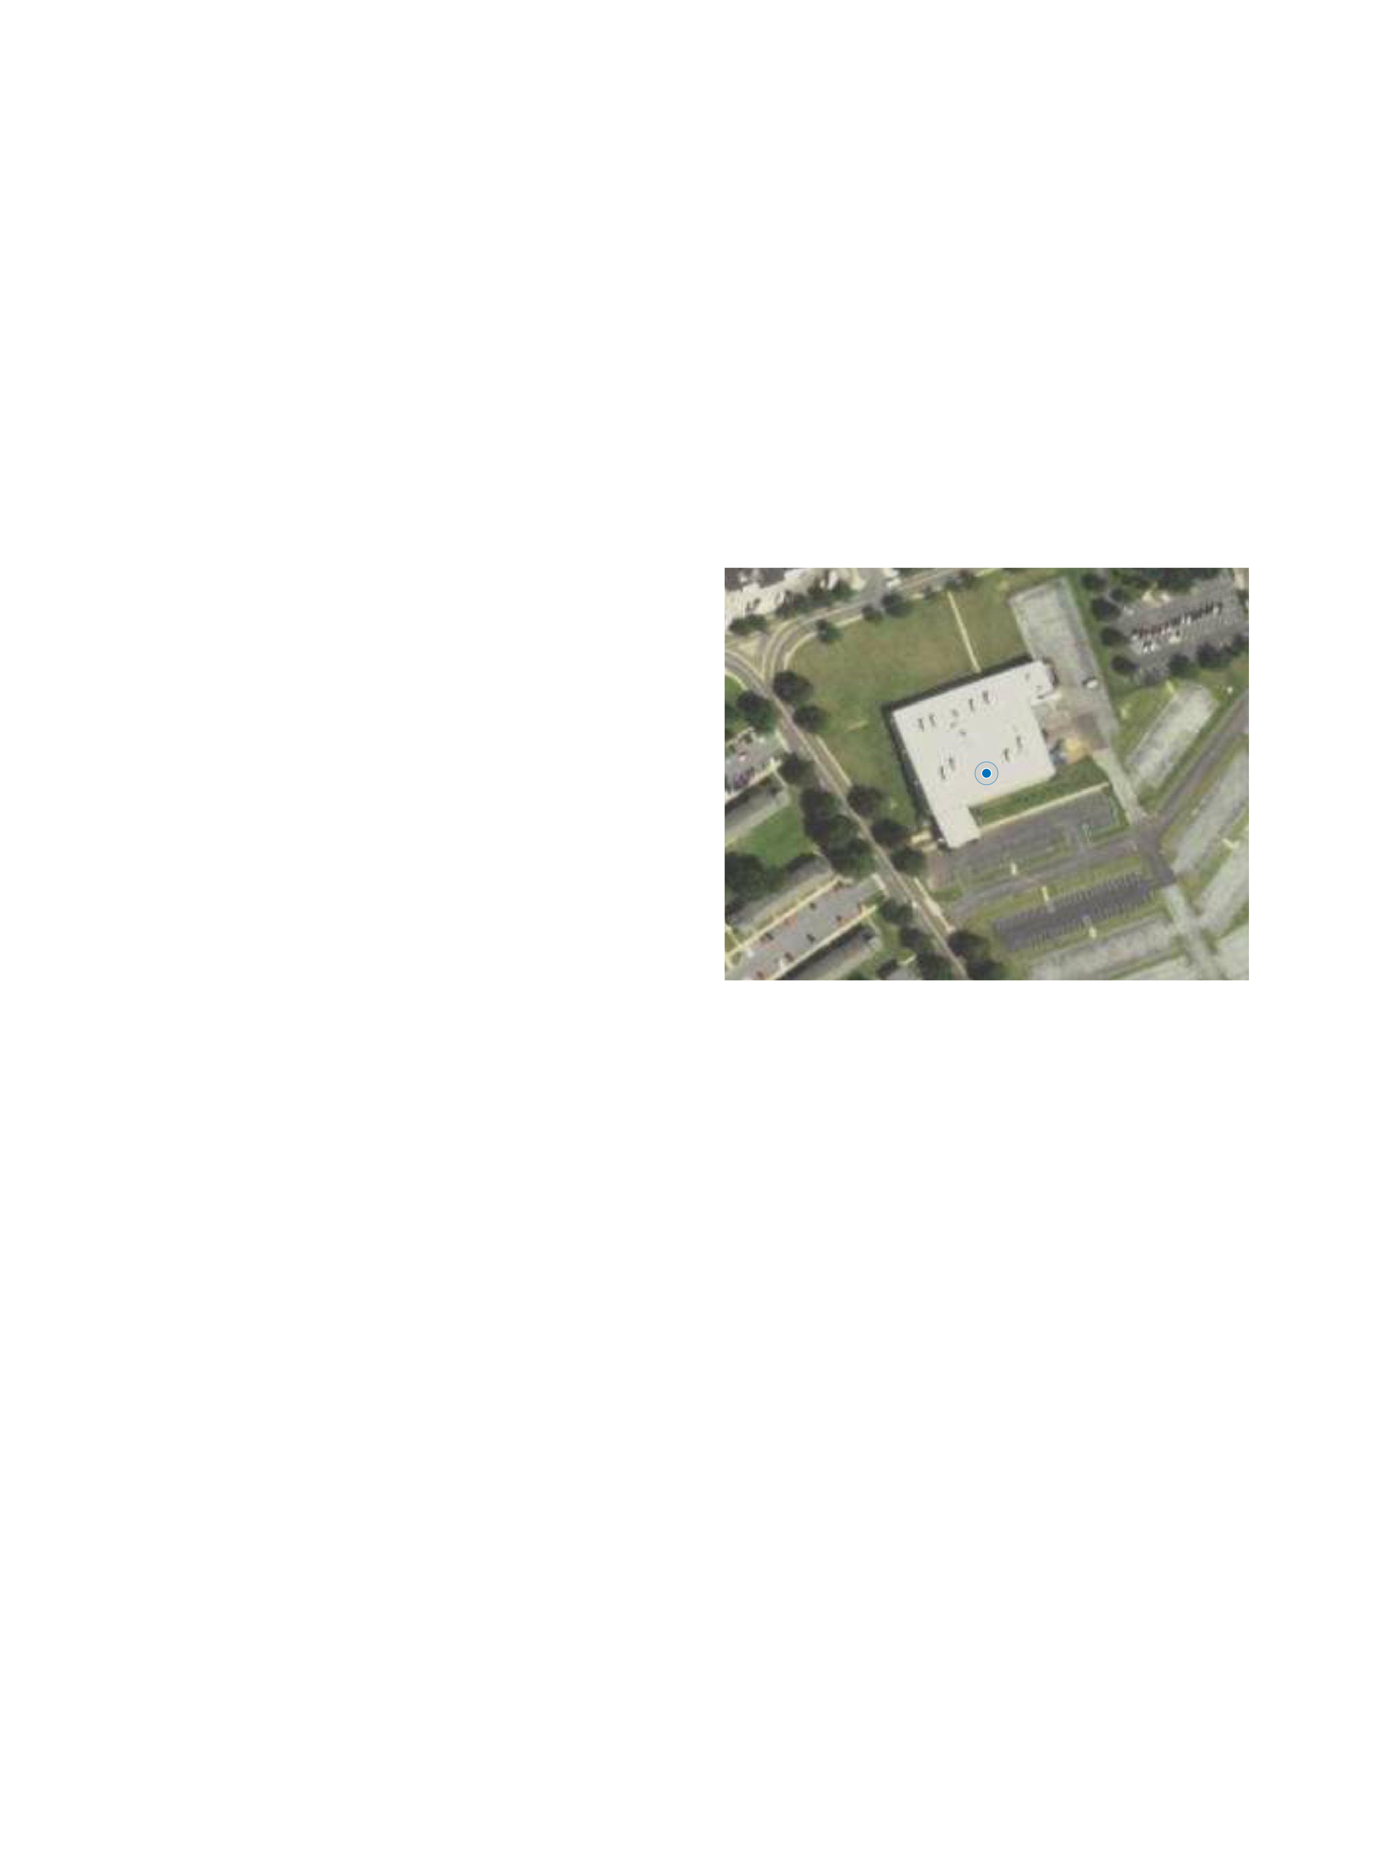



**Step 1: Open the Collector App and Your Map**



1. Collector app and sign in
2. Download the map.

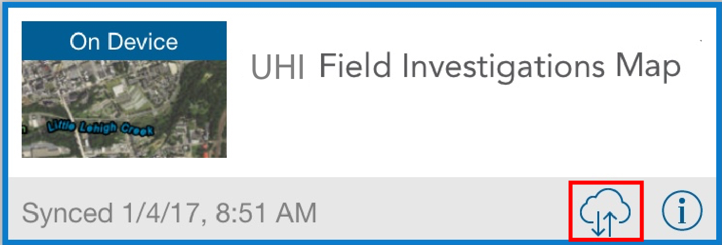

1. Make sure a blue dot appears. If it doesn’t appear after a few minutes, restart the app outside.
2. Record the current outside temperature your teacher tells you: _________ °C



**Step 2: Start making observations in your area**

Your job is to gather data on different surface types within a few blocks of the school and observe the temperature differences of these surfaces. **Always** **stay with your partner when you are outside the school**.

|  |  |
| --- | --- |
| **Where to go:**   1. Go to your assigned area.   **What to do:**   1. Start making temperature observations with the **Collector app**. 2. You will make observations for all the different ground surfaces. Make at least 10 observations in your class period. 3. To enter a new observation, select the **plus sign** on the **upper right of the screen (red arrow)**. 4. You can add other observations by selecting the **Notes** menu and typing your observation. You can also **add photos** by selecting the **camera icon** at the top of the screen. 5. Once you have completed all the data fields, select **Submit**. 6. Partners should take turns entering information into the Collector app. 7. Use the **Details** panel (red square) to edit, copy or delete a point you made. |  |



**Step 3: Sync your observations with your class**

When you have returned to the school, you need to synchronize your observations with the rest of your classmates. This lets you see your class observations and view the information from locations you were not able to observe yourself. You can compare your observations with other students’ data and discover if there are locations that have similar or different temperatures.

|  |  |
| --- | --- |
| 1. Select **Maps** in the upper left of your screen. 2. Select the **cloud icon** (red box) to start synchronizing your observations. 3. **Click on the map again** **after synchronizing** to see all the points your classmates have added. 4. Answer **questions # 1-9** below. 5. After completing the questions remove the map. On the same screen select the square icon $→$**Manage $→$** **Remove $→$** **Remove features and basemap** 6. You can then log out of the iPad. Select the square icon $→$**Sign Out $→$** **Sign Out** |  |

1. Who was in your group and to what area were you assigned?

|  |  |
| --- | --- |
| Group Members |  |
| Teacher / Mentor |  |
| Area Assigned |  |
| Number of Observations Made |  |

2. What was the weather like during your class period (hot/cold, sunny/cloudy, constant/changing, time of day)?

3 a. What surface gave your group the highest temperature reading?

b. What surface gave your group the lowest temperature reading?

4. How did temperatures of the same surface vary between shaded areas and unshaded areas? (Hint: look at **Surface Shade** column in the table)

5. Select two observations for each type of unshaded surface from **your group**. Average these temperatures. Rank the averaged surface in order from hottest to coldest. **1 = the hottest**, **6 = the coldest**

|  |  |  |  |  |
| --- | --- | --- | --- | --- |
| Unshaded Surface | Observation 1 Temperature | Observation 2 Temperature | Average temperature | Rank |
| Grass |  |  |  |  |
| Dark Asphalt |  |  |  |  |
| Light Asphalt |  |  |  |  |
| Concrete |  |  |  |  |
| Dirt |  |  |  |  |
| Other |  |  |  |  |

6. What is the temperature difference between the hottest and coldest surfaces?

7. What was the average air temperature during data collection? How does the air temperature compare to your hottest and coldest surface?

Why do you think this might be? ***Hint***: From where does air get its heat?

8. How would your measurements change if you did this same activity at different times of the year? For example, what might be different if you did this activity during the summer or during the winter?

9. **Challenge Question:** The weather can change very quickly outside. Do you think the ground temperature changes at the same rate as the air temperature? Why or why not?

** Step 4: Explore your class’ observations in ArcGIS Online**

Use ArcGIS online on your laptop to analyze your class’ observations. You can view the data anywhere that has Internet access at **https://b21.maps.arcgis.com/home.html**. Use the same username and password that you used to login to the Collector app on the iPad.

|  |  |
| --- | --- |
| 1. After logging into your account,   select Groups at the top of the screen, select your class, and then find the **UHI Classroom Investigations Map** and select it.   1. Field observations are now color-coded based on your recorded surface temperatures. 2. The **red box** includes tabs that let you display data in different ways and access analysis tools. 3. Choose the **Contents** tab by selecting the middle tab. This allows you to hide or show different types of observations. 4. Answer **questions #** **10-11** below. |  |

10. a. Look at the measurements **your class** made. What surfaces gave the highest and lowest temperature readings?

b. Does this agree with **your group’s** measurements?

11. a. Did you measure a temperature reading that doesn’t agree with the rest of the class (an outlier)? What area did you see this temperature reading?

b. Why do you think this measurement was different from the rest?

** Step 5: Identify ground surfaces and plan to reduce the**

**urban heat island effect of Allentown**

You now have experience making observations about the range of temperatures of different ground surfaces. Now, you will look at different parts of the city to see how temperature changes from the center of the city to the surrounding areas.

Your teacher will assign you one of the 21 different blue areas to examine how the ground surfaces change throughout the city. In your assigned area, you will need to investigate the different types of ground surfaces. Use your field experience to make recommendations for reducing the urban heat island effect.

Draw and label your proposed changes in your area on your map and submit a screenshot to your teacher. Then, compare your map to your classmates’ maps. This guide uses screenshots from area 1 as an example. The instructions below apply to all areas.

|  |  |
| --- | --- |
| 1. Select the **LandCover** option from the menu bar (red arrow). 2. Click on the **Legend** option (red box) to show the legend for all the land cover colors. 3. Part of the legend is also shown in the center image. 4. **In your assigned box you can click to see the area of different land coverages in square meters (see lowest image).** 5. Answer **questions #12-14** below.   It is helpful to turn the **LandCover** layer off and on a few times, so you can see how the satellite image and the land cover are related. |  |

12. How does the land cover of the center of the city compare to the suburbs (areas outside the center of the city)? Using the data your class collected around the high school, do you predict that downtown Allentown would be warmer or cooler than the suburbs?

13. The assigned areas in Allentown are all roughly the same size, but have different amounts of each land cover (buildings, roads, trees, grass, etc.). List two areas that you think would be warmer than average and two areas that would be cooler than average.

14. What is your assigned area in Allentown? Estimate the amount of each land cover type in the table below. In the circle below draw a pie chart based on your table. **Label your pie chart**.

**Assigned Area**:

|  |  |
| --- | --- |
| Surface | Percentage (%) |
| Structure |  |
| Roads |  |
| Other Impervious Surface |  |
| Tree Canopy (all kinds) |  |
| Water |  |
| Low Vegetation |  |
| Barren |  |

|  |  |
| --- | --- |
| 1. In your group, use your answers to **questions #1-14** to think about ways you can reduce the urban heat island effect in your assigned area. 2. Draw boxes on the map to show areas that you want to improve by using the **Map Notes** (Add Menu>Add Map Notes> Add Features). 3. For example, if you want to add trees, add a green box to your area. You can change the background color of your area by clicking on it. A pop-up box will appear. Select “**Change Symbol**”. You can then select a new fill color. 4. After you have completed your map, take a screenshot of it, and **submit to your teacher**. To take a screenshot, press the ‘Print Screen’ key and paste the image into a google doc. 5. Submit your document to google classroom. 6. Now, answer **questions # 15-18** below. |  |

15. Some surfaces such as dark asphalt increase the urban heat island effect, but they also are used for vehicle traffic. How can you reduce the effect of asphalt on urban heating while still having roads for people to travel?

16. What changes would you make within your selected area to reduce the urban heat island effect without altering land use?

17. If you were allowed to alter land use, what changes would you make within your selected area to reduce the urban heat island effect?

18. How would you change the school’s property to reduce its urban heat island effect?