Watershed Unit Curriculum Integration Supplement
Virtual Reality (VR) & Field Trip Learning Experience

Welcome to the teacher resource page. Virtual reality games and excursions are intended to enhance a school’s curriculum and fit neatly into a watershed unit. This supplemental resource page is designed to assist teachers with incorporating the VR learning experiences into the watershed unit and extend the learning. The curriculum enhancement learning activities suggested here are intended to be incorporated into a watershed unit, but many of the ideas branch off into new areas of science and other content areas beyond the watershed unit. These ideas are intended to enable teachers to spark classroom conversations, both before and after the visit, to help students to get excited about learning more about the world around them.

For using the desktop VR experiences:
Hardware Requirements
The minimum requirements:
2.5 GHz Intel Core i3 processor, 2 GB RAM, at least 2 GB of free hard drive space

Notes:
- This content is not currently supported on mobile devices.
- Depending on your network connection, it may take a minute or so to load on your computer.
- For best performance, we recommend using the Mozilla Firefox web browser.
- Please, disable any pop-up window blocker

⚠️ ATTENTION Mac users:
You need to use the MOZILLA FIREFOX web browser to run a lag-free experience.

Need help?
- How to download and install Firefox on Windows
- How to download and install Firefox on Mac

Big Ideas for Watershed Literacy
- Watersheds are land areas from which streams get their water.
- Watersheds are complex and interconnected systems that include physical, biological, and chemical components.
- A watershed can be nested within another watershed.
- Every place on earth is located within a watershed, so everyone lives in a watershed.
- It is important for us to identify our own and neighboring watersheds, recognizing how they connect to each other and to the ocean.
- The boundaries of a watershed are called drainage divides and are determined by topography. Political, governing, and /or management boundaries may not correspond to these natural delineations.
- Watersheds include running water, still water, groundwater, and surface water.
- Groundwater soaks into the ground rather than running quickly into a stream.
- Some water may flow easily underground and is called an aquifer.
- Human activities affect and change our watershed.
- Watersheds can be contaminated by pollutants as well as by invasive species.
Virtual reality experiences are engaging and helpful, but taking a field trip to a location in your own watershed provides powerful learning opportunities that work together with the VR explorations for a superior educational experience. The Lehigh River watershed has several great options for field trips.
- The Lehigh Gap Nature Center (www.lgnc.org) is a restored Superfund site located near Slatington.
- Jacobsburg Environmental Education Center (www.dcnr.pa.gov) offers a watershed education program and is located near Nazareth.
- The Delaware & Lehigh National Canal Museum (www.canals.org) highlights a locktender’s house on the Lehigh Canal located in Easton.
Your visit to any of these places is sure to spark some interesting discussions. The questions below are simply suggestions to help teachers and other educators prepare for and follow up after a field trip.

Suggested Discussion Questions

Pre-Trip Questions (possible answers in parentheses)
- What are rivers useful for? (Farming, trade, travel, recreation). Where along a river are these activities likely to be found? (Rafting in the upper part of the river; fishing at the side of a river, a tributary, or a dam; towns where two tributaries meet, etc.)
- What is a watershed? (An area of land that drains water into a common place, such as a river) Why do watersheds matter? (They store water for communities and ecosystems, so flooding, biodiversity, pollution, etc. are all dependent on actions affecting the watershed)
- What is the difference between surface water and groundwater? (Surface water is freshwater above ground like runoff and rivers, while groundwater is underground)
- What is an aquifer? (Permeable and porous rocks that allow water to slowly pass through them)
- How might human activities affect a river? (Damming, littering or other pollution, bringing invasive species, overfishing, erosion)
- Why might people build a dam? (Flood control, recreation, deeper water for fish)
- Why release water regularly, instead of just during storms to control flooding? (Cooler deep-water temps, better fish spawning, recreation)
- What is a fish ladder and what does it do? (Allows fish such as shad to migrate so they can get to their spawning areas.)
- Where might we find a fish ladder? (At a dam)
- Name as many river fish as you know. (Bass, perch, catfish, salmon, trout, carp, etc) Have you ever heard of shad? (A migrating fish that anglers fish for in rivers near the coast)
- What do fly fishermen try to catch? (Trout, salmon, bass, carp, etc)
- How has transportation changed over time? (Progression: animals, carts pulled by animals, boats, trains, bicycles, cars, airplanes) (Routes: paths, paved roads, rivers, tracks, canals, airstrips)
- Why was coal needed? (The Industrial Revolution demanded coal to turn iron ore into iron and as a heating source.)
- Why was iron needed? (Needed to make trains, tracks, and steam engines for mining)
- Why was zinc needed? (For batteries and die casting, for galvanizing metal, for batteries, and so many other products) (Coal was used to get zinc out of ore.)
- Why was cement also produced in the Lehigh Valley? (Because the limestone needed for making cement was there)
- If humans pollute a river at one location, where in the watershed will the biggest effects be seen? (At the nearest downstream region)
- What are the dangers of lead, mercury, or other heavy metals in the water? (Kidney failure, damage to digestive and immune systems, nervous system disorders, birth defects, cancer, etc)

If you are planning a trip to the Lehigh Gap Nature Center, consider these as well:
- What is a Superfund site? (A location identified by the EPA as polluted with hazardous materials that must be cleaned up through long-term efforts)
- What is a “green” building? (A building designed to have minimal to no negative impact on the environment)
- Once a natural area has been contaminated (the ground, etc), what can be done to restore it? Planting grasses helps stop erosion and trap the contaminants)
- What proof of success can we see? (Vegetation growing where the land was barren, minimized erosion, improved water quality)
- Why are migratory species important? (These species are a vital part of food webs in multiple ecosystems; to maintain species diversity)
- What is a wildlife corridor? (A safe passage created or conserved to facilitate migration of a species through a region)
- What species could benefit from a wildlife corridor? (Monarch butterflies, raptors, songbirds)

If you are planning a trip to the Jacobsburg Environmental Education Center, consider these:
- Why did people choose to settle near a freshwater stream? (Freshwater source for drinking)
- What impact did these settlements have on the watershed? (Agricultural runoff impacts, changes to the natural landscape)
- Why are migratory species important? (These species are a vital part of food webs in multiple ecosystems; to maintain species diversity)
- What is a wildlife corridor? (A safe passage created or conserved to facilitate migration of a species through a region)
- What species could benefit from a wildlife corridor? (Monarch butterflies, raptors, songbirds)
- How can humans impact our natural environment? (pollution, deforestation, soil erosion, establishing preserves, reintroducing species, reforestation)

If you are planning a trip to the D&L National Canal Museum, consider these as well:
- How are historic transportation routes linked to waterways? (A road has to be cleared and maintained, but a river is naturally clear for travel, so early transportation depended on waterways)
- How could a coal company most efficiently return upriver or up the mountain without spending all the profits gained by the sale of their load of coal? (Mules can pull boats back upstream in a canal, trains going downhill can pull up empty trains through a pulley system)
- How did historic transportation routes affect the Lehigh River watershed? (Dredging the river bottom or damming up the river affects the ecosystem, creating a canal brings animal and human waste to the river, and other forms of transportation bring pollution)
- How has the Lehigh River changed over time? (Became polluted and filthy, locks and dams built that prevented flooding, has become cleaner)

Post-Trip Questions
- What are benthic macroinvertebrates? (They are what fly fisherman are trying to mimic; they reveal the health of the water)
- How does grass help control erosion? (Roots keep the soil from washing away; grass stems break up the water so it has less force)
- What is a riparian zone? (Ecosystem by a river)
- What effect could covering the ground with impervious substances, such as paving a parking lot, have on runoff, groundwater, and the watershed? (Cause much more runoff and pollution as the soil cannot filter and absorb the water)
- Can zinc be mined in an environmentally friendly way? (Possibility of volcanic/geothermal mines)
- Why is it better to keep our natural water sources from being polluted rather than purifying it when you’re ready to drink it? (Better for farming, animals, plants, businesses, etc)

If you took a trip to the Lehigh Gap Nature Center, consider these as well:
- What makes Lehigh Gap Nature Center unique? (It is the only environmental education center in the U.S. on a Superfund site.)
- What did the New Jersey Zinc Company bring to Palmerton? (Job creation, economic boost, security during the Great Depression, schools, increased property values, harmful pollutants, contaminated soil and water, barren hillside)
- How did the Kittatinny Ridge (Blue Mountain) near Palmerton become a Superfund site? (Zinc smelting caused pollutants such as sulfur dioxide and heavy metals to be released in the air, causing acid rain and heavy metal deposition on the surrounding land. These pollutants killed the trees and prevented vegetation from growing back. Without tree roots in the ground, water was able to erode the soil and contaminate runoff. Lead in blood samples from children helped raise awareness of the problem.)
- Why were hemlock trees necessary for the tannery business? (Tannins in the bark would tan the hides) What would have happened if they used the hemlocks faster than they grew back? (Go out of business)
- How can you tell the rocks were deposited by frost wedging rather than by moving glaciers (Sharp, angular edges on the rocks)

If you took a trip to the Jacobsburg Environmental Education Center, consider these as well:
- What family produced the long rifle at this location in Pennsylvania during the Revolutionary War? (The Pennsylvania Long Rifles were custom manufactured by the Henry family, used by Jacob Aster and the fur trade company during expansion, and used in every armed engagement until Civil War, but ultimately displaced by technological advancements when guns became mass produced)
- What effects did the making of the rifle have on the watershed? (They built a water wheel for hydro-power, caused thermal pollution, and ran a tannery and other industries)
- How are the hemlock trees necessary for the tannery business that was run? (Tannins in the bark would tan the hides) What would have happened if they used the hemlocks faster than they grew back? (They would go out of business)

If you took a trip to the D&L National Canal Museum, consider these as well:
- What are the benefits of building a dam? (Flood control and recreation)
- What unintended consequence for shad has been fixed at the Hamilton Street Dam? (The dam has a fish ladder to allow fish to migrate upstream to their spawning areas)
- What does Walnutport have in common with Easton? (Canal boats were pulled by mules up and down the canal towpath)
- What is the historical importance of Cementon? (In the early 1900s, the majority of cement in our country came from the quarries in this area)
- What is the historical importance of Thomas Iron Works? (A furnace for the production of iron was built here in the 1800s, starting the profitable anthracite iron industry along the canal.)
- What is the historical importance of Bethlehem Steel? (Bethlehem Steel was the United States’ second-largest steel producer and its largest shipbuilder)
- Why would a cement company, an iron furnace, and a steel producer all build their production facilities near the same geographic location? (They all need limestone, and two also need coal, both of which are naturally present in this region of the world, and the canal offered a means to transport the goods)
- What role did the canal play in these industries? (Carry resources and products faster)
- Why are you likely to find canals and dams near each other? (Dams help control the water for the canal; canals provide a means to get around the dam)
- Why build a canal rather than simply taking the boat on the river? (The rapids are dangerous, the river might be too shallow at places, or the canal might provide a shortcut faster than a winding river)
- What impact might an invasive species have? (Crowd out the native species, even to the point of extinction, reducing biodiversity) How can people be responsible for introducing invasive species? (Thought the flower was pretty, released a pet, hitched a ride)

The VR learning experiences and the field trips provide opportunities for classroom teachers to springboard into other areas of science. The following ideas are intended for middle school science teachers to incorporate into their classrooms as supplemental to the curriculum. The applicable middle school science standards codes are listed for each idea, both Next Generation Science Standards and PA State Middle School Science Standards for 6th, 7th, and 8th grades. The standards themselves are listed in the glossary at the end. Larger project ideas that incorporate science, social studies, math, and language arts as well can be found in the Interdisciplinary/Cross-Curricular Project section.

Learning Extension Ideas:
Science Activity Ideas:
- Identify what zinc is used for, where it is on the periodic table, and what its properties are.
NGSS standards: MS-PS1-1, MS-ESS3-3, MS-ETS1-2
PA Science Standards: S6.B.3.2, S6.C.1.1.1, S7.A.1.2, S7.A.3.3, S7.B.3.3, S7.C.1.1.1, S8.A.1.2, S8.A.3.3, S8.B.3.3, S8.C.1.1.2

- Learn how to tell the difference between zinc, anthracite, quartzite, coal, sphalerite and how each type was formed.
NGSS standards: MS-PS1-1, MS-ESS2-1, MS-ESS3-1
PA Science Standards: S6.C.1.1.1, S6.D.1.1, S7.C.1.1.1, S7.D.1.1, S8.C.1.1.2, S8.D.1.1

- Explore the characteristics of the types of rock found in the Lehigh Valley (limestone, dolomite, slate, shale, sandstone, siltstone) and the geoscience processes that formed them or exposed them.
NGSS standards: MS-PS1-1, MS-ESS2-1, MS-ESS3-1
PA Science Standards: S6.C.1.1.1, S6.D.1.1, S7.C.1.1.1, S7.D.1.1, S8.C.1.1.2, S8.D.1.1

- Create a food web for some of the producers, decomposers, and consumers in your local ecosystem and explore the effect on the ecosystem if one part of the food web was suddenly removed.
NGSS standards: MS-LS2-1, MS-LS2-4, MS-LS2-5, MS-ESS3-3
PA Science Standards: S6.A.3.1, S6.A.3.2, S6.B.3.1, S7.A.3.1, S7.A.3.2, S7.B.3.1, S7.B.3.2, S8.A.3.1, S8.A.3.2, S8.B.3.2

- Investigate acid rain and the interaction between land use and watershed quality
NGSS standards: MS-LS2-1, MS-LS2-4, MS-ESS2-2, MS-ESS3-3, MS-ESS3-4, MS-ETS1-2
PA Science Standards: S6.B.3.1, S6.B.3.2, S7.A.1.2, S7.B.3.1, S7.B.3.2, S7.B.3.3, S8.A.1.2, S8.B.3.2, S8.B.3.3, S8.D.1.2

- Collect water from local water source and test it
NGSS standards:MS-ESS3-3,MS-ESS3-4
PA Science Standards: S6.A.1.2, S6.A.2.2, S6.A.3.2, S7.A.1.3, S7.A.2.2, S7.A.3.2, S7.D.1.2, S8.A.1.3, S8.A.2.2, S8.A.3.2, S8.D.1.2, S8.D.1.3
- Find what pollutants the EPA has identified in your watershed
NGSS standards: MS-ESS3-3, MS-ESS3-4
PA Science Standards: S6.A.1.1, S6.A.1.2, S7.A.1.1, S7.A.1.3, S7.D.1.2, S8.A.1.1, S8.A.1.3, S8.D.1.2, S8.D.1.3

- Make a digital poster showing the importance of watersheds, how they can be damaged and how they can be preserved.
NGSS standards: MS-ESS2-2, MS-ESS3-1
PA Science Standards: S6.A.1.2, S7.A.1.3, S7.D.1.2, S8.A.1.3, S8.D.1.3

- Choose a local stream and pond and investigate the changes over time and/or the seasonal variations in that water source.
NGSS standards: MS-ESS2-2, MS-ESS2-4, MS-ESS3-1
PA Science Standards: S6.A.1.2, S6.A.2.2, S6.A.3.2, S7.A.1.3, S7.A.2.2, S7.A.3.2, S7.A.3.3, S8.A.1.3, S8.A.2.2, S8.A.3.2, S8.A.3.3

- Investigate water-related careers (like fluvial geomorphology) and the path to attaining those careers.
NGSS standards: MS-ETS1-2
PA Science Standards: S7.A.1.2, S8.A.1.2

- Give students a bottle of polluted water and let them attempt to purify it
NGSS standards: MS-ETS1-3, MS-ETS1-4
PA Science Standards: S6.A.2.1, S6.A.2.2, S6.A.3.2, S7.A.2.1, S7.A.2.2, S7.A.3.2, S7.D.1.2, S8.A.2.1, S8.A.2.2, S8.A.3.2, S8.D.1.3

- Explore one of the activities at this website: https://ei.lehigh.edu/envirosci/guide/index.html#middle

Interdisciplinary/Cross-Curricular Project Ideas:
(incorporating 6th, 7th, and 8th grade science, social studies, math, and language arts)

My Happy Place Project
Have students do a watershed project. Pick their dream spot to live in the USA. Write a report that includes the following elements. Identify its watershed with Model My Watershed. Calculate the cost of living there. Identify which people settled there and why, what geographic features influenced these decisions, as well as why people currently want to move there. Identify native species that wouldn’t stay/survive if the watershed became polluted. Map the watershed and the sources of water for residents. Identify the impact on the environment that their moving there would have. Suggest ways to ensure they won’t have a net negative impact (things like solar roof, etc). Calculate unit rate (cost/month) to make those environmentally friendly changes. Identify geological features and typical weather for that region.

NGSS standards: MS-ESS2-4, MS-ETS1-1, MS-ETS1-2, MS-ETS1-4
PA Science Standards:S6.A.1.1, S6.A.1.2, S6.A.2.1, S6.A.2.2, S6.A.3.1, S6.A.3.2, S7.A.1.1, S7.A.1.2, S7.A.1.3, S7.A.2.1, S7.A.2.2, S7.A.3.1, S7.A.3.2, S7.D.1.2, S8.A.1.1, S8.A.1.2, S8.A.1.3, S8.A.2.1, S8.A.2.2, S8.A.3.1, S8.A.3.2 S8.D.1.3
National and PA social studies standards: 6.1.6.A, 6.1.6.B.a, 6.1.6.D, 6.2.6.E, 6.5.6.D, 7.1.6.A, ​​7.1.6.B, 7.2.6.A, 7.2.6.B, 8.1.6.A, 8.2.6.C, 6.1.7.A, 6.1.7.B, 6.1.7.D, 6.2.7.E, 6.5.7.D, 7.1.7.A, 7.1.7.B, 7.2.7.A, 7.2.7.B, 8.1.7.A, 8.2.7.C, 6.1.8.A, 6.1.8.B, 6.1.8.D, 6.5.8.D, 7.1.8.A, 7.1.8.B, 7.2.8.A, 7.2.8.B, 8.1.8.A, 8.2.8.C
National and PA math standards: CC.2.1.6.D.1, M06.A-R.1.1.2, M06.A-R.1.1.4, CC.2.4.6.B.1, M06.D-S.1.1.1, CC.2.1.7.D.1, M07.A-R.1.1.1, M07.A-R.1.1.6, CC.2.4.7.B.2, M07.D-S.2.1.1, CC.2.4.8.B.1
National and PA ELA standards: CC.1.2.6.J, E06.B-V.4.1.1, CC.1.4.6.A , CC.1.4.6.C, E06.C.1.2.2, CC.1.4.6.V, CC.1.4.6.X, CC.1.5.6.A, CC.1.2.7.J, E07.B-V.4.1.1, CC.1.4.7.A, CC.1.4.7.C, E07.C.1.2.2, CC.1.4.7.V, CC.1.4.7.X, CC.1.5.7.A, CC.1.2.8.J, E08.B-V.4.1.1, CC.1.4.8.A, CC.1.4.8.C, E08.C.1.2.2, CC.1.4.8.V, CC.1.4.8.X, CC.1.5.8.A

Model My Watershed Project
Collect soil samples from your school or the local neighborhood and examine the soils. Predict the type of ground there. Check your prediction with Model My Watershed. Graph the variations between the soil samples to visualize the differences between locations. Discuss the mean, median, mode, (i.e. what does “average” mean?) and variability in the samples. Identify the type of ground and the geographical features at your school or in the students’ neighborhood using Model My Watershed and predict whether water will seep in or run off the ground. Use the runoff simulation to test your prediction. Identify conservation practices that could be incorporated at the school or in the neighborhood that would have maximum positive environmental impact with minimal expense. Calculate the overall cost to implement and the cost per resident/student. Award a prize to the idea that has maximum impact for minimal expense. Craft a written proposal and present it to administration for implementation of the prize-winning idea. (detailed instructions with screenshots for using modelmywatershed.org and more in-depth lesson plan ideas at this site).

In addition, have students go to the River Runner Website at https://river-runner.samlearner.com/ to trace the flow of a raindrop.

NGSS standards: MS-ESS2-2, MS-ESS2-4, MS-ESS3-1, MS-ETS1-1, MS-ETS1-2, MS-ETS1-3, MS-ETS1-4
PA Science Standards: S6.A.1.1, S6.A.1.2, S6.A.2.1, S6.A.2.2, S6.A.3.2, S7.A.1.1, S7.A.1.2, S7.A.1.3, S7.A.2.1, S7.A.2.2, S7.A.3.2, S7.D.1.2, S8.A.1.1, S8.A.1.2, S8.A.1.3, S8.A.2.1, S8.A.2.2, S8.A.3.2 , S8.D.1.3
National and PA social studies standards: 6.1.6.B.a, 6.5.6.D, 7.1.6.A, ​​7.1.6.B, 7.2.6.A, 7.2.6.B, 6.1.7.B, 6.5.7.D, 7.1.7.A, 7.1.7.B, 7.2.7.A, 7.2.7.B, 6.1.8.B, 6.5.8.D, 7.1.8.A, 7.1.8.B, 7.2.8.A, 7.2.8.B,
National and PA math standards: CC.2.1.6.D.1, M06.A-R.1.1.2, M06.A-R.1.1.4, CC.2.4.6.B.1, M06.D-S.1.1.1, M06.D-S.1.1.2, M06.D-S.1.1.3, M06.D-S.1.1.4, CC.2.1.7.D.1, M07.A-R.1.1.1, M07.A-R.1.1.6, CC.2.4.7.B.2, M07.D-S.2.1.1, CC.2.4.8.B.1, M08.D-S.1.1.1, M08.D-S.1.1.2, M08.D-S.1.1.3
National and PA ELA standards: CC.1.2.6.J, E06.B-V.4.1.1, E06.E.1.1.2, CC.1.4.6.G, CC.1.4.6.I, E06.C.1.1.2, CC.1.4.6.X, CC.1.5.6.A, CC.1.5.6.D, CC.1.5.6.E, CC.1.2.7.J, E07.B-V.4.1.1, E07.E.1.1.2, CC.1.4.7.G, CC.1.4.7.I, E07.C.1.1.2, CC.1.4.7.X, CC.1.5.7.A, CC.1.5.7.D, CC.1.5.7.E, CC.1.2.8.J, E08.B-V.4.1.1, E08.E.1.1.2, CC.1.4.8.G, CC.1.4.8.I, E08.C.1.1.2, CC.1.4.8.X, CC.1.5.8.A, CC.1.5.8.D, CC.1.5.8.E

The Power of Change Project
Track the historical progression of the importance of various transportation modes and/or fuel sources, exploring how their use changes human behavior and the environment. For example, Native Americans in the Lehigh Valley primarily used muscle power (their own bodies), fueled by food, and water power (building small dams to aid in catching fish). After colonization, carriage animals were introduced (horses, oxen) fueled by food to pull wagons over roads. Later, canals are built, powered by mules, and then railroads, using coal to power steam engines. Each of these changes in transportation modes and fuel source create new patterns of activity and new impacts on the environment: building canals, digging coal mines, and so forth. Describe the process to turn each fuel source into usable energy. Examine how thermal energy is gained from each fuel source and how those sources change (chemical reactions, byproducts) as a result. Based upon this information, compare the environmental impact of utilizing each fuel source. Investigate why each fuel source gained or lost popularity over time. Using the data chart at https://www.eia.gov/todayinenergy/detail.php?id=11951, predict what the chart will look like in 60 years and what percent of our energy will come from hydroelectric sources. Write a story set in the future 60 years and include the prediction about fuel sources as well as predictions about the environmental impact of today’s decisions. Create a way to harness renewable energy, possibly using a project from sciencebuddies.org.
NGSS standards: MS-PS1-4, MS-PS1-6, MS-LS2-5, MS-ESS3-3, MS-ESS3-4, MS-ETS1-2, MS-ETS1-3, MS-ETS1-4
PA Science Standards: S6.A.1.2, S6.A.2.1, S6.C.1.2, S6.C.2.1.3, S7.A.1.2, S7.A.1.3, S7.A.2.1, S7.A.3.3, S7.C.1.2, S7.C.2.1.3,, S8.A.1.2, S8.A.1.3, S8.A.2.1, S8.A.3.3, S8.C.2.2, S8.D.1.2
National and PA social studies standards: 6.1.6.A, 6.1.6.B.a, 6.1.6.D, 6.2.6.E, 6.5.6.D, 8.1.6.A, 8.2.6.C, 6.1.7.A, 6.1.7.B, 6.1.7.D, 6.2.7.E, 6.5.7.D, 8.1.7.A, 8.2.7.C, 6.1.8.A, 6.1.8.B, 6.1.8.D, 6.5.8.D, 8.1.8.A, 8.2.8.C
National and PA math standards: CC.2.1.6.D.1, M06.A-R.1.1.5, CC.2.4.6.B.1, M06.D-S.1.1.1, CC.2.1.7.D.1, M07.A-R.1.1.6, CC.2.4.7.B.2, M07.D-S.2.1.1, CC.2.4.8.B.1
National and PA ELA standards: CC.1.2.6.J, E06.B-V.4.1.1, CC.1.4.6.A, CC.1.4.6.C, E06.C.1.2.2, E06.E.1.1.2, CC.1.4.6.G, CC.1.4.6.I, E06.C.1.1.2, CC.1.4.6.M, CC.1.4.6.V, CC.1.4.6.X, CC.1.5.6.A, CC.1.2.7.J, E07.B-V.4.1.1, CC.1.4.7.A, CC.1.4.7.C, E07.C.1.2.2, E07.E.1.1.2, CC.1.4.7.G, CC.1.4.7.I, E07.C.1.1.2, CC.1.4.7.M, CC.1.4.7.V, CC.1.4.7.X, CC.1.5.7.A, CC.1.2.8.J, E08.B-V.4.1.1, CC.1.4.8.A, CC.1.4.8.C, E08.C.1.2.2, E08.E.1.1.2, CC.1.4.8.G, CC.1.4.8.I, E08.C.1.1.2, CC.1.4.8.M, CC.1.4.8.V, CC.1.4.8.X, CC.1.5.8.A

River Expedition Project
Have students plan a boat trip down the Lehigh River, stopping at a minimum of three strategic sites to get out and learn. Students should write a paper describing how they would like to travel down the river, where they would like to stop along the river and why, and what wildlife or vegetation they hope to see along the way. They must explain the environmental or historical significance of one of their stopping points.

Step 1: They need to pick a starting point and ending point and calculate the total distance and time it will take them to travel that distance so they can pack adequate supplies and plan accordingly. Using the unit conversions of 1 mi = 1.60934km, 1 mi = 1760 yards, 1 mi = 5280 feet, and 1 km = 1000 m, give the students these measurements and have them convert so that the total distance is in miles or in kilometers: Whitehaven to Rockport is 15.3 miles. Rockport to Lehigh Gap/Palmerton (zinc smelters, superfund site) is 42.9 km. Palmerton to Walnutport is 12,144 ft. Walnutport to Northampton (Lafarge Whitehall Cement plant) is 9.5 mi. Northampton to Catasauqua (Thomas Iron Works) is 3,600 m. Catasauqua to Hamilton Street dam (Allentown) is 7,920 yards. Allentown to Bethlehem Steel (formerly Bethlehem Iron, a brownfield site) is 9.4 km. Bethlehem to Easton is 10.9 mi. (Answers: 15.3 mi/24.6 km, 26.7/42.9 km, 2.3 mi/3.7 km, 9.5 mi/15.3 km, 2.2 mi/3.6 km, 4.5/7.3 km, 5.9 mi/9.4 km, 10.9 mi/17.6 km, for a grand total of 77.3 mi/124.4 km from Whitehaven to Easton)

Step 2: From Glen Onoko to East Penn, Bowmanstown is 11 miles. On average, the river runs 5.7 mph over this stretch. If the dam releases water, the speed increases 2.5 mph. A typical person can paddle 1 mile in 30 minutes. Calculate the time it would take to drift, to paddle without water release from the dam, and to drift with water release from the dam. Use this information to calculate the length of the overall trip they are planning. Include in the paper whether they prefer to drift or paddle and prefer with or without water release and why. (Answers: drifting 11 miles takes 1.9 hours, or 1 hr 56 min. Paddling (faster by 2 mph) without water release takes 1.4 hrs or 1 hr 26 min. Drifting with water release takes 1.3 hrs or 1 hr 20 min. Note, water release makes the trip too dangerous for most boaters.)

Step 3: Based on this total length, students should plan what supplies to bring and how to minimize the environmental impact of their trip. They should also prioritize where to stop and explore and describe the environmental or historical significance of these stops as well as the wildlife and vegetation they expect to see.

Possible bonus option: Make a scale model of the Lehigh River from the Francis E. Walter Dam to the Forks of the Delaware, completely out of recycled materials.

NGSS standards: MS-ESS3-3 , MS-ETS1-1 ,
PA Science Standards: S6.A.1.1, S6.A.2.1, S6.A.3.2, S7.D.1.2, S7.A.1.1, S7.A.2.1, S7.A.3.2, S8.D.1.2, S8.D.1.3, S8.A.1.1, S8.A.2.1, S8.A.3.2
National and PA social studies standards: 7.1.6.A, ​​7.1.6.B, 7.2.6.A, 7.2.6.B, 8.1.6.A, 8.2.6.C, 7.1.7.A, 7.1.7.B, 7.2.7.A, 7.2.7.B, 8.1.7.A, 8.2.7.C, 7.1.8.A, 7.1.8.B, 7.2.8.A, 7.2.8.B, 8.1.8.A, 8.2.8.C
National and PA math standards: CC.2.1.6.D.1, M06.A-R.1.1.2, M06.A-R.1.1.4, CC.2.1.7.D.1, M07.A-R.1.1.1, M07.A-R.1.1.6
National and PA ELA standards: CC.1.2.6.J, E06.B-V.4.1.1, CC.1.4.6.A , CC.1.4.6.C, E06.C.1.2.2, CC.1.4.6.V, CC.1.4.6.X, CC.1.5.6.A, CC.1.2.7.J, E07.B-V.4.1.1, CC.1.4.7.A, CC.1.4.7.C, E07.C.1.2.2, CC.1.4.7.V, CC.1.4.7.X, CC.1.5.7.A, CC.1.2.8.J, E08.B-V.4.1.1, CC.1.4.8.A, CC.1.4.8.C, E08.C.1.2.2, CC.1.4.8.V, CC.1.4.8.X, CC.1.5.8.A

Glossary of Middle School Science Standards Used
Organized according to Next Generation Science Standards
Includes PA State Middle School Science Standards for 6th, 7th, and 8th grades

- Physical Science
MS-PS1-1 Develop models to describe the atomic composition of simple molecules and extended structures.
MS-PS1-4 Develop a model that predicts and describes changes in particle motion, temperature, and state of a pure substance when thermal energy is added or removed.
MS-PS1-6 Undertake a design project to construct, test, and modify a device that either releases or absorbs thermal energy by chemical processes.
S6.C.1.1.1 S7.C.1.1.1 S8.C.1.1.2 Use characteristic physical or chemical properties of matter to distinguish one substance from another (e.g., density, thermal expansion/contraction, boiling/freezing/melting points, solubility, streak test, ability to rust).
S6.C.1.2 S7.C.1.2 Describe and compare chemical and physical changes of matter.
S6.C.2.1.3 S7.C.2.1.3 S8.C.2.2 Compare the environmental impact of various energy sources (i.e., oil, coal, natural gas, solar, wind, and moving water) and describe how these energy sources are transformed into useful forms of energy.
- Life Science
MS-LS2-1 Analyze and interpret data to provide evidence for the effects of resource availability on organisms and populations of organisms in an ecosystem
MS-LS2-4 Construct an argument supported by empirical evidence that changes to physical or biological components of an ecosystem affect populations.
MS-LS2-5 Evaluate competing design solutions for maintaining biodiversity and ecosystem services.
S6.B.3.1 S7.B.3.1 S7.B.3.2 S8.B.3.2 Identify evidence of change to infer and explain the ways different biotic and abiotic variables may cause and/or influence change in natural or human-made systems.
S6.B.3.2 S7.B.3.3 S8.B.3.3 Explain how renewable and nonrenewable resources provide for human needs and how these needs impact the environment.
- Earth and Space Sciences
MS-ESS2-1 Develop a model to describe the cycling of Earth’s materials and the flow of energy that drives this process.
MS-ESS2-2 Construct an explanation based on evidence for how geoscience processes have changed Earth’s surface at varying time and spatial scales.
MS-ESS2-4 Develop a model to describe the cycling of water through Earth’s systems driven by energy from the sun and the force of gravity.
MS-ESS3-1 Construct a scientific explanation based on evidence for how the uneven distributions of Earth’s mineral, energy, and groundwater resources are the result of past and current geoscience processes.
MS-ESS3-3 Apply scientific principles to design a method for monitoring and minimizing a human impact on the environment.
MS-ESS3-4 Construct an argument supported by evidence for how increases in human population and per-capita consumption of natural resources impact Earth’s systems.
S6.A.3.1 S7.A.3.1 S8.A.3.1 Explain the parts of a simple system, their roles, and their relationships to the system as a whole.
S6.D.1.1 S7.D.1.1 S8.D.1.1 Describe constructive and destructive natural processes that characterize and form different geologic structures (i.e., igneous [granite, basalt, obsidian, and pumice]; sedimentary [limestone, sandstone, shale, and coal]; and metamorphic [slate, quartzite, marble, and gneiss]), biomes, and resources (soil fertility, composition, resistance to erosion, and texture).
S8.D.1.2 Describe the potential impact of human-made processes on changes to Earth’s resources and how they affect everyday life.
S7.D.1.2 S8.D.1.3 Describe characteristic features and significance of Earth’s water systems or their impact on resources.
- Engineering Design
MS-ETS1-1 Define the criteria and constraints of a design problem with sufficient precision to ensure a successful solution, taking into account relevant scientific principles and potential impacts on people and the natural environment that may limit possible solutions.
MS-ETS1-2 Evaluate competing design solutions using a systematic process to determine how well they meet the criteria and constraints of the problem.
MS-ETS1-3 Analyze data from tests to determine similarities and differences among several design solutions to identify the best characteristics of each that can be combined into a new solution to better meet the criteria for success.
MS-ETS1-4 Develop a model to generate data for iterative testing and modification of a proposed object, tool, or process such that an optimal design can be achieved.
S6.A.1.1, S7.A.1.1, S8.A.1.1 Explain, interpret, and apply scientific, environmental, or technological knowledge presented in a variety of formats (visuals, scenarios, graphs).
S7.A.1.2 S8.A.1.2 Identify and explain the (positive and negative, intended and unintended) impacts (including standard of living and health effects) of applying scientific, environmental, or technological knowledge to address solutions to practical problems.
S6.A.1.2 S7.A.1.3 S8.A.1.3 Identify and analyze evidence that certain variables may have caused measurable changes in natural or human-made systems.
S6.A.2.1 S7.A.2.1 S8.A.2.1 Apply knowledge of scientific investigation or technological design in different contexts to make inferences, solve problems, and/or answer questions.
S6.A.2.2 S7.A.2.2 S8.A.2.2 Select and safely use appropriate tools and instruments for a specific purpose and describe the information provided by each tool.
S6.A.3.2 S7.A.3.2 S8.A.3.2 Apply knowledge of models to make predictions, draw inferences, or explain technological concepts.
S7.A.3.3 S8.A.3.3 Describe repeated processes or recurring elements in natural, scientific, and technological patterns.

Glossary of Non-Science Middle School Standards Used
Includes Common Core Standards as well as PA State Standards for grades 6, 7, and 8

- Social Studies Standards
6.1.6.A 6.1.7.A 6.1.8.A Explain how limited resources and unlimited wants cause scarcity.

6.1.6.B.a 6.1.7.B 6.1.8.B Compare ways that people meet their needs with how they meet their wants and decisions made because of limited resources and unlimited wants. Describe and analyze how resources are combined to produce different goods and services
6.1.6.D 6.1.7.D 6.1.8.D Explain how positive and negative incentives affect personal choices and behavior.
6.2.6.E 6.2.7.E Explain the causes and effects of expansion and contraction of businesses.
6.5.6.D 6.5.7.D 6.5.8.D Explain how profits and losses serve as incentives and the relationship between risk and reward for specific business actions.
7.1.6.A ​​7.1.7.A 7.1.8.A Describe and illustrate how common geographic tools are used to organize and interpret information about people, places, and environment.
7.1.6.B 7.1.7.B 7.1.8.B Describe and locate places and regions as defined by physical and human features.
7.2.6.A 7.2.7.A 7.2.8.A Describe the characteristics of places and regions.
7.2.6.B 7.2.7.B 7.2.8.B Describe the physical processes that shape patterns on Earth’s surface.
8.1.6.A 8.1.7.A 8.1.8.A Explain continuity and change over time using sequential order and context of events. Compare and contrast these events and how continuity and change influenced those events.
8.2.6.C 8.2.7.C 8.2.8.C Compare and contrast how continuity and change have impacted Pennsylvania history as related to local communities in these areas: belief systems and religions, commerce and industry, technology, politics and government, physical and human geography, and social organizations.

- Mathematics Standards
CC.2.1.6.D.1 Understand ratio concepts and use ratio reasoning to solve problems.
M06.A-R.1.1.2 Find the unit rate a/b associated with a ratio a:b (with b ≠ 0) and use rate language in the context of a ratio relationship.
M06.A-R.1.1.4 Solve unit rate problems including those involving unit pricing and constant speed.
M06.A-R.1.1.5 Find a percent of a quantity as a rate per 100 (e.g., 30% of a quantity means 30/100 times the quantity); solve problems involving finding the whole, given a part and the percentage.
CC.2.1.7.D.1 Analyze proportional relationships and use them to model and solve real-world and mathematical problems.
M07.A-R.1.1.1 Compute unit rates associated with ratios of fractions, including ratios of lengths, areas, and other quantities measured in like or different units.
M07.A-R.1.1.6 Use proportional relationships to solve multi-step ratio and percent problems.
CC.2.4.6.B.1 Demonstrate an understanding of statistical variability by displaying, analyzing, and summarizing distributions.
M06.D-S.1.1.1 Display numerical data in plots on a number line, including line plots, histograms, and box-and-whisker plots.
M06.D-S.1.1.2 Determine quantitative measures of center (e.g., median, mean, mode) and variability (e.g., range, interquartile range, mean absolute deviation).
M06.D-S.1.1.3 Describe any overall pattern and any deviations from the overall pattern with reference to the context in which the data were gathered.
M06.D-S.1.1.4 Relate the choice of measures of center and variability to the shape of the data distribution and the context in which the data were gathered.
CC.2.4.7.B.2 Draw informal comparative inferences about two populations.
M07.D-S.2.1.1 Compare two numerical data distributions using measures of center and variability.
CC.2.4.8.B.1 Analyze and/or interpret bivariate data displayed in multiple representations.
M08.D-S.1.1.1 Construct and interpret scatter plots for bivariate measurement data to investigate patterns of association between two quantities. Describe patterns such as clustering, outliers, positive or negative correlation, linear association, and nonlinear association.
M08.D-S.1.1.2 For scatter plots that suggest a linear association, identify a line of best fit by judging the closeness of the data points to the line.
M08.D-S.1.1.3 Use the equation of a linear model to solve problems in the context of bivariate measurement data, interpreting the slope and intercept.

- English Language Arts Standards
CC.1.2.6.J CC.1.2.7.J CC.1.2.8.J Acquire and use accurately grade-appropriate general academic and domain-specific words and phrases; gather vocabulary knowledge when considering a word or phrase important to comprehension or expression.
E06.B-V.4.1.1 E07.B-V.4.1.1 E08.B-V.4.1.1 Determine or clarify the meaning of unknown and multiple-meaning words and phrases based on grade level reading and content, choosing flexibly from a range of strategies. a. Use context (e.g., the overall meaning of a sentence or paragraph, a word’s position or function in a sentence) as a clue to the meaning of a word or phrase. b. Use common, grade-appropriate Greek or Latin affixes and roots as clues to the meaning of a word (e.g., audience, auditory, audible). c. Determine the meaning of technical words and phrases used in a text.
CC.1.4.6.A CC.1.4.7.A CC.1.4.8.A Write informative/explanatory texts to examine a topic and convey ideas, concepts, and information clearly.
CC.1.4.6.C CC.1.4.7.C CC.1.4.8.C Develop and analyze the topic with relevant facts, definitions, concrete details, quotations, or other information and examples; include graphics and multimedia when useful to aiding comprehension.
E06.C.1.2.2 E07.C.1.2.2 E08.C.1.2.2 Develop the topic with relevant facts, definitions, concrete details, quotations, or other information and examples.
E06.E.1.1.2 E07.E.1.1.2 E08.E.1.1.2 Develop the analysis using relevant evidence from text(s) to support claims, opinions, ideas, and inferences and demonstrating an understanding of the text(s).
CC.1.4.6.G CC.1.4.7.G CC.1.4.8.G Write arguments to support claims.
CC.1.4.6.I CC.1.4.7.I CC.1.4.8.I Acknowledge alternate or opposing claims and support claim with logical reasoning and relevant evidence, using accurate, credible sources and demonstrating an understanding of the topic.
E06.C.1.1.2 E07.C.1.1.2 E08.C.1.1.2 Support claim(s) with clear, logical reasoning and relevant evidence, using accurate, credible sources and demonstrating an understanding of the topic or text.
CC.1.4.6.M CC.1.4.7.M CC.1.4.8.M Write narratives to develop real or imagined experiences or events.
CC.1.4.6.V CC.1.4.7.V CC.1.4.8.V Conduct short research projects to answer a question, drawing on several sources and generating additional related, focused questions for further research and investigation.
CC.1.4.6.X CC.1.4.7.X CC.1.4.8.X Write routinely over extended time frames (time for research, reflection, and revision) and shorter time frames (a single sitting or a day or two) for a range of discipline-specific tasks, purposes, and audiences.
CC.1.5.6.A CC.1.5.7.A CC.1.5.8.A Engage effectively in a range of collaborative discussions, on grade-level topics, texts, and issues, building on others’ ideas and expressing their own clearly.
CC.1.5.6.D CC.1.5.7.D CC.1.5.8.D Present claims and findings, emphasizing salient points in a focused, coherent manner with pertinent descriptions, facts, details, and examples; use appropriate eye contact, adequate volume, and clear pronunciation.
CC.1.5.6.E CC.1.5.7.E CC.1.5.8.E Adapt speech to a variety of contexts and tasks.

Standardized Test Prep
- Who lives in a watershed?
(A) everyone on Earth
(B) people near oceans
(C) everyone except those who live in a desert
(D) everyone except those who live in the arctic circles
Answer: A
- Natural watershed boundaries can be caused or defined by which of the following:
(A) fences
(B) rivers
(C) mountain ridge
(D) state governments
Answer: C
- What can change a watershed?
(A) only natural processes
(B) natural processes and hurricanes
(C) natural processes and human activity
(D) human activity and industrialization
Answer: C
- What is a watershed?
(A) a storm drain
(B) a land area from which a stream gets its water
(C) a shed that stores groundwater for pumping out city water
(D) a place to store water for use in an emergency or a drought
Answer: B
- What does a watershed consist of?
(A) biological and physical components
(B) only the water elements (river, etc.)
(C) only the water and soil components
(D) only the water, land, and plants in it
Answer: A
- Watersheds include which of the following?
(A) only groundwater
(B) only surface water
(C) groundwater and tap water
(D) groundwater and surface water
Answer: D
- Which is the most accurate description of smaller vs. larger watersheds?
(A) smaller ones overlap each other, forming bodies of water
(B) smaller ones connect to each other, forming larger ones
(C) smaller ones occur in villages, while larger ones occur in cities
(D) smaller ones are bounded by creeks, while larger ones are bounded by streams
Answer: B

- Which town is most affected by the pollution of the abandoned mine?
A B C D E
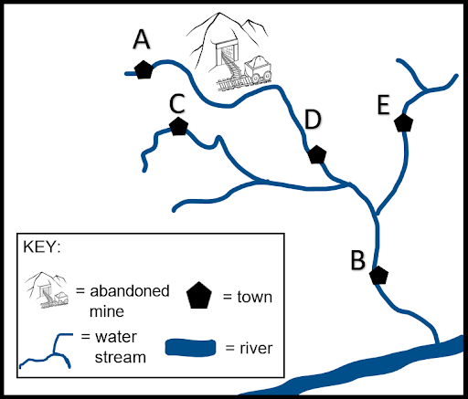

Answer: D
- Which number corresponds to the Lehigh River watershed?
1 2 3 4 5
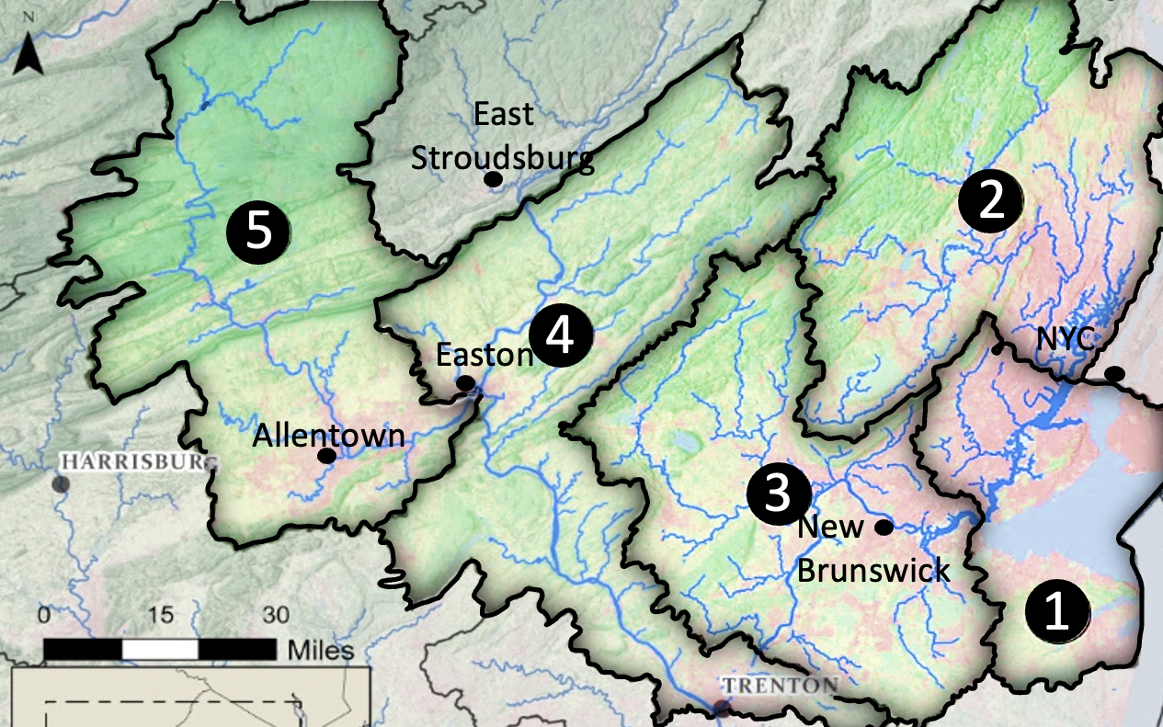
Answer: 5

- The New Jersey Zinc Company smelted zinc near Palmerton from 1898 to 1980, polluting the area. Lehigh Gap Nature Center’s restoration began in 2006. Assuming restoring a site takes 50% of the time it took to pollute it, what year would you expect the restoration to be completed?
(A) 2021
(B) 2047
(C) 2056
(D) 2088
Answer: B

- The entire East Coast of the United States drains into which body of water:
(A) Pacific Ocean
(B) Atlantic Ocean
(C) Arctic Ocean
(D) Indian Ocean
Answer: B

- The Francis Walter Dam coordinates water releases to both prevent floods and facilitate whitewater rafting and fishing. A local company advertises a four-hour rafting trip on the Lehigh River for $66.95 at dam release times. The company offers a discounted rate of $64.95 per person for large groups, but the additional $5.50 river access fee would still be charged. Nora is helping plan the school marching band trip and must pay $350 to reserve and use the school bus. Which equation could Nora use to calculate the total cost of the school trip if n students go on the trip?
(A) C(n) = 66.95n + 64.95n - 5.50 + 350
(B) C(n) = 64.95n + 5.50n + 350n
(C) C(n) = 64.95n + 5.50n + 350
(D) C(n) = 64.95n + 5.50 + 350/n
Answer: C

- When examining the health of the local watershed, we look for variety, complexity, and abundance of species in the local ecosystem. This refers to ________.
(A) fish
(B) variation ecology
(C) biological diversity
(D) biochemical evolution
Answer: C

- Where in the groundwater is it easiest to access fresh water?
(A) rivers
(B) lakes
(C) glaciers
(D) aquifers
Answer: D

- All of these are nonrenewable except ___.
(A) oil
(B) coal
(C) nuclear
(D) geothermal
Answer: D

- Match each term in the hydrologic cycle with the correct arrow:
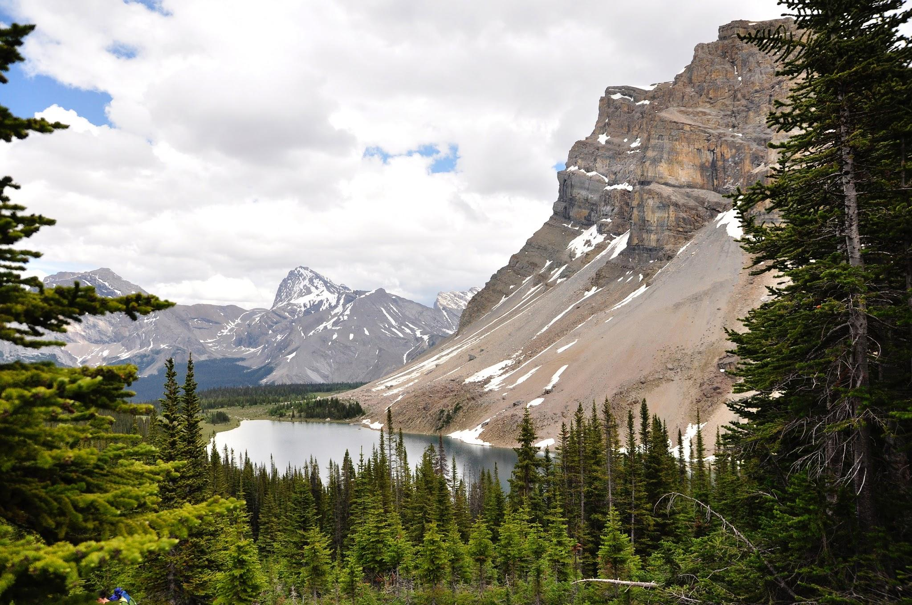

(1) water falls
from the clouds
(2) water flows downhill
(3) water seeps into the ground
(7) water vapor forms clouds
(5) vapor forms from open surfaces of water
(4) water vapor comes from vegetation
(6) water vapor comes from snow or ice
(a) sublimation
(b) precipitation
(c) runoff
(d) infiltration
(e) evaporation
(f) condensation
(g) transpiration

Answers:
1 b 2 c 3 d
4 g 5 e 6 a 7 f

Photo by clement fusil on Unsplash

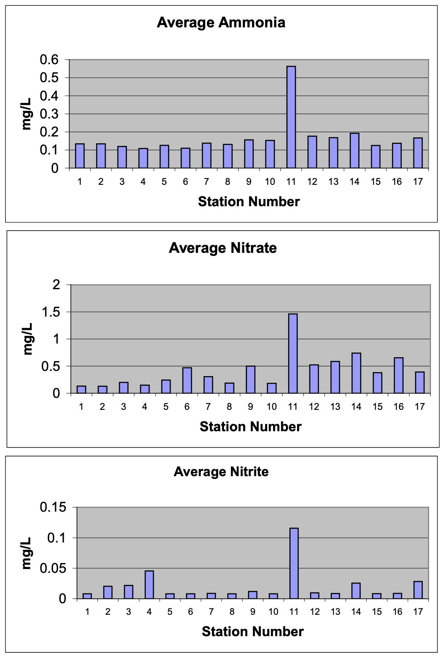
- The following graphs show average ammonia, nitrate, and nitrite concentrations observed at stations along the Lehigh River between May and November 2001.
What conclusion can be drawn from these observations?
(A) No conclusion can be drawn from the given information.
(B) The average concentration of each compound is higher further downstream (increasing station number).
(C) The average concentration of each compound is at its highest during November, the 11th month, when water level is lowest.
(D) The average concentration of each compound was consistently higher at station 11 (Mahoning Creek), just downstream of the Lehighton sewage treatment facility.
Answer: D

(observed at stations LH1 to LH17 during the Lehigh River water quality monitoring study, from the report prepared for the U.S. Army Corps of Engineers, February 2002)

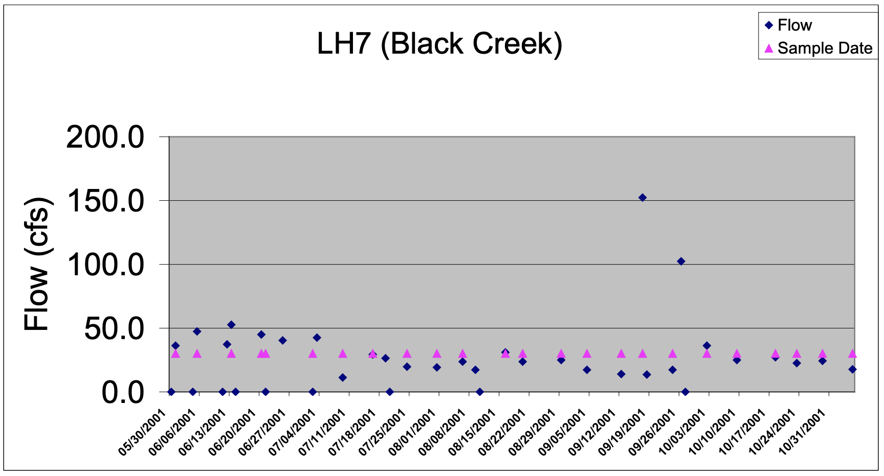
- The above graph shows flow (cfs) monitored at Black Creek (LH7) based on gauge readings along the Lehigh River between May and November 2001. Water sampling dates are indicated with the triangular points. Flows plotted on the x-axis were not recorded or indeterminate for that date. What can we conclude about the data point marked with the arrow? (observed at station LH7 during the Lehigh River water quality monitoring study, from the report prepared for the U.S. Army Corps of Engineers, February 2002)

(A) The flow at Black Creek for that day was an outlier.
(B) No conclusion can be drawn from the given information.
(C) The dam had a regularly scheduled dam release for that day.
(D) A company upstream of Black Creek had a spill that flooded the area.
Answer: A

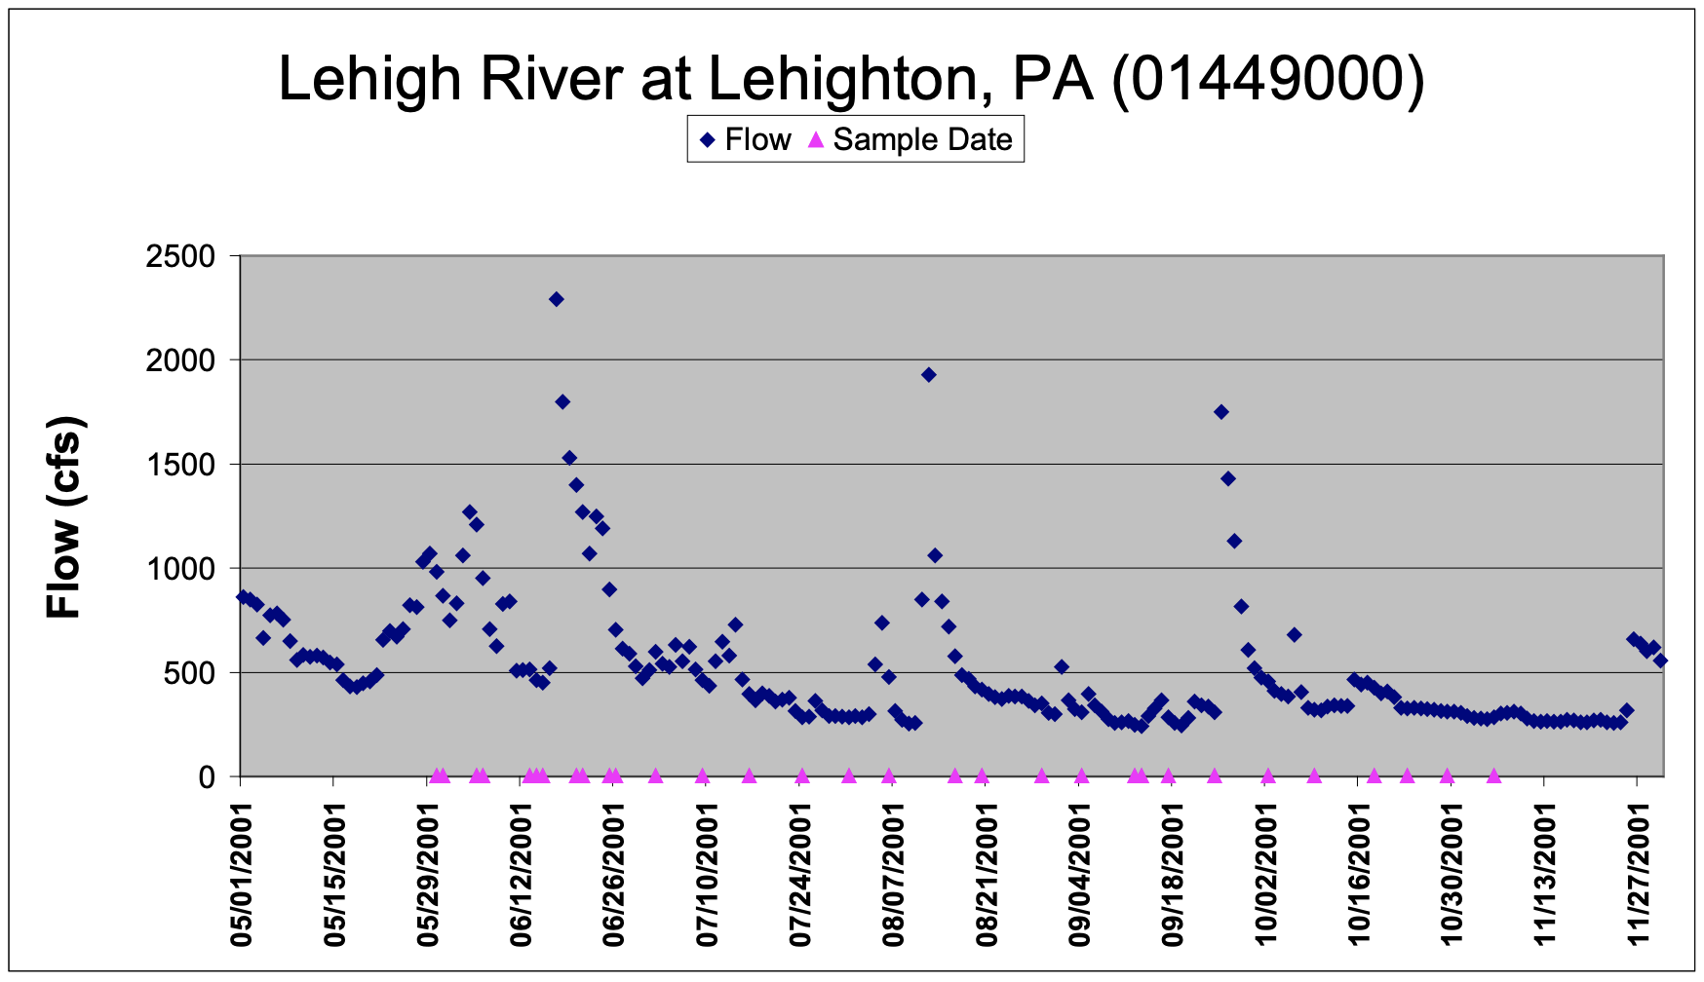
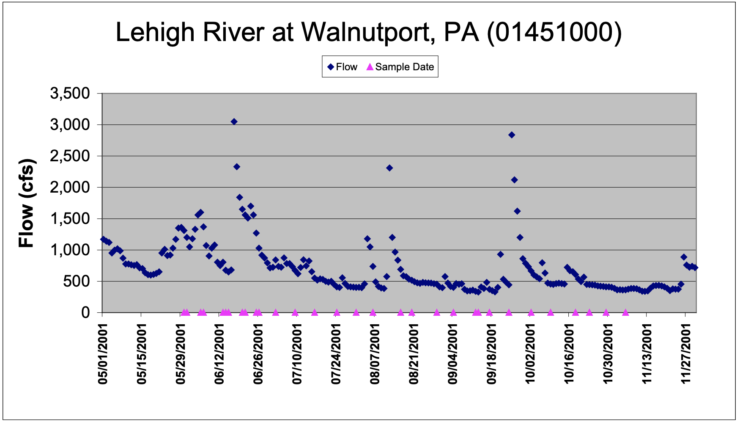
- The above graphs show flows (cfs) monitored at Lehighton and Walnutport based on gauge reading conducted during the Lehigh River water quality monitoring study between May and November 2001. What can we conclude about these two locations? (observed at stations LH10 and LH15 during the Lehigh River water quality monitoring study, from the report prepared for the U.S. Army Corps of Engineers, February 2002)
(A) Lehighton and Walnutport have nearly identical amounts of flow.
(B) Lehighton and Walnutport have similar patterns of flow, but Walnutport has more flow.
(C) Lehighton and Walnutport have similar patterns of flow, but Walnutport has lower flow.
(D) The data has too many outliers to make any valid conclusions.
Answer: B

- The above graph shows flows (cubic feet of water per second, cfs) monitored at Walnutport based on gauge readings conducted on the Lehigh River. The line indicates the 75-year average flow. What can be inferred about the flow of the Lehigh River at Walnutport? (2001 flows observed at station LH15 during the Lehigh River water quality monitoring study, from the report prepared for the U.S. Army Corps of Engineers, February 2002. 75-year mean of daily values from usgs.gov)
(A) The flow follows the average pattern, but at about 50% of its typical level, possibly indicating a drought.
(B) The flow is random and doesn’t follow a discernible pattern until October when it levels off like July and September.
(C) The Francis Walter Dam releases water for whitewater rafting three times every year: May, August, and October.
(D) Due to the outliers of May, August, and October, no inference can be made.
Answer: A

- Using the above graph, how much lower was the flow on September 18 than on June 20, its highest point?
(A) 2,400 cfs
(B) 2,600 cfs
(C) 3,000cfs
(D) 3,500 cfs
Answer: B
- Scientists monitoring the Lehigh River near Walnutport noticed a rise in acidic water containing heavy metals. Which of these is likely the cause of a lower pH or more acidic water?
(A) Trees had died off recently, most likely due to acid rain.
(B) A fisherman had spilled a bottle of acidic apple cider vinegar.
(C) A battery company downstream uses acid to make most of their batteries.
(D) Recently a large amount of soil was eroded from an abandoned mine upstream.
Answer: D

- Ornithologists count nests of common birds to determine the effects of acid rain and other pollutants and the impact of rejuvenation efforts. Use the table of nests below to answer the question. (2015-2021 data from NestWatch Digest, The Cornell Lab of Ornithology)

 | Original Population | 2015 | 2018 | 2021
Eastern Bluebird | 16,812 | 2,684 | 4,614 | 5,604
American Robin | 1,496 | 257 | 340 | 432
House Wren | 8,515 | 1,288 | 1,051 | 2,505
Tree Swallow | 16,880 | 3,434 | 4,614 | 5,060

Which species is most likely to return to its original population size by the year 2040?
(A) Eastern Bluebird
(B) American Robin
(C) House Wren
(D) Tree Swallow
Answer: A

- The population of shad in the Lehigh River declined by 50% in one year. Which of the following could explain this occurrence?
(A) The amount of male shad outnumbered the female shad by 50% the previous year.
(B) Researchers documented an increase in population for its natural predator, the invasive catfish.
(C) Fisheries stocked the river with excess plankton and small shrimp, things that shad often feed upon.
(D) The dam in Easton constructed a fish ladder the previous year, permitting 500 shad to travel upstream.
Answer: B

