Investigating Natural Gas Production and Consumption with Web GIS

Natural gas is made up of remains of dead plants and animals that lived millions of years ago. In this activity, you will use Web GIS to investigate patterns of natural gas production and consumption. You will

- Examine countries with natural gas reserves.
- Compare natural gas production and consumption of countries in 1980 and 2008.

Read all instructions and answer each question on your investigation sheet.

 Step 1: Download Data

Open your Web browser. Go to www.ei.lehigh.edu/learners/energy/

Under Natural Gas, select “Investigating Natural Gas Production and Consumption with Web GIS.”

Step 2: Basic Features of Web GIS

- Your screen should open to a global view as shown in the picture to the right.  - To navigate in Web GIS you can use the navigational tools (# 1) or the hand (# 2). You can move around the map by selecting different areas or scrolling to them.  - You can zoom into an area by using the zoom options (# 3) or by double clicking on a location.  - You can find your exact location on the map using the latitude and longitude tool located in the bottom left corner of the map (# 4). | 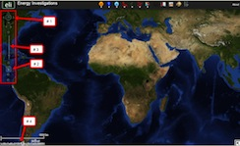
- You can also get back to the main view by using the Bookmark icon in the toolbar at the top of the screen (# 2). In the window that appears, select World View.  - The data for each activity can be activated using the Map Legend Tool (# 1). Click on the Map Legend Tool. The Map Legend window will appear. In the Map Legend window, activate a data layer you wish to display by clicking the checkbox. You can expand or shrink a legend item by clicking on the globe icon next to each data layer label.  - To observe the legend for a specific data layer, select the globe icon next to that item in the list (# 3).  - You can also activate portions of the data layers by selecting options from the top toolbar menus. | 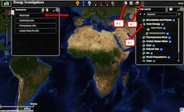

 Step 3: Examine countries with natural gas reserves. (Questions 1)

Let’s investigate which countries have large amounts of natural gas reserves.

- Activate the Natural Gas Reserves data layer. In the Map Legend window, select Natural Gas, as shown to the right. Click on the globe next to Natural Gas. Then click on the globe next to Gas Reserves to view the legend for that data layer. | 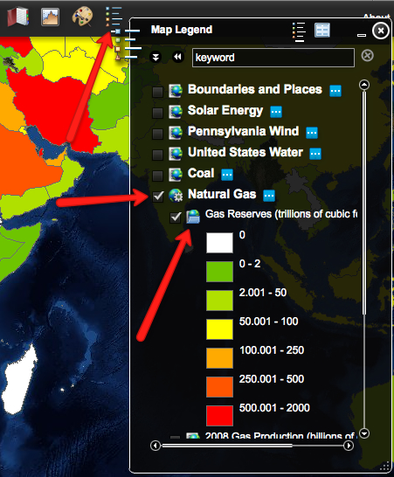
- Query the Gas Database as shown to the right (# 1). In the window that opens, select to Sort By: Gas Reserves and click Select Sort.  - In the Reserve Query window that appears select to Sort By: Country and Ascending. When finished, click Submit Query.  - In the data chart that appears sort the columns based on Reserves (Trillions of Cubic Feet). To sort a column in descending order click the top of this column twice. | 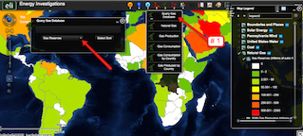
 Answer questions 1 on your investigation sheet.

Gas reserves are listed in amounts of trillions of cubic feet. 1 trillion = 1,000,000,000,000.
1 cubic foot = 28.32 liters

- Close the Query Gas Database window by selecting the “x” in the top right corner.

Step 4: Analyze natural gas production. (Questions 2 - 4)

Let’s investigate…
- Which countries produced large amounts of natural gas in both 1980 and in 2008?
- Which countries produced more natural gas in 2008 than in 1980?
- Which countries produced less natural gas in 2008 than in 1980?

- In the Map Legend activate the 2008 Gas Production and the 1980 Gas Production layers. Deactivate the Gas Reserves Layer.  - You should toggle back and forth between the 1980 and 2008 layers to see which countries changed their production. | 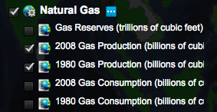
- Open the Query Gas Database using the Natural Gas dropdown tool at the top of the page.  - Choose to Sort By: Gas Production. Click Select Sort.  - In the window that appears, select to sort by: Country and Ascending. When finished click Submit Query. | 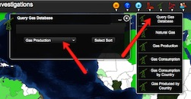
- In the Production Query results, locate the Billions of Cubic Feet, 2008 column. If you can not see the entire data set, you can widen the columns by placing the mouse between two columns. Click and drag your mouse to make a column wider or smaller.  - Sort the column in Ascending and Descending order by clicking on the top of the column. | 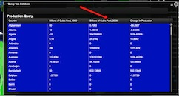
Answer question 2 on your investigation sheet.
List the 4 countries that produced the largest amounts of natural gas in the 2008 Natural Gas Production Data Charts on your investigation sheet.

- Sort the Billions of Cubic Feet, 1980 column in descending order.
Helpful hint: Click the column twice.

List the 4 countries that produced largest amounts of natural gas in the 1980 Natural Gas Production Data Chart on your investigation sheet.
- In the Query Gas Database, locate the Change in Production column. If you can not see the entire data use you can widen the columns by placing the mouse between two columns. Click and drag your mouse to make a column wider or smaller.  - Sort the column in Ascending and Descending order by clicking on the top of the column.  Numbers that are positive represent countries that produced more natural gas in 2008 than in 1980.  Numbers that are negative represent countries that produced less natural gas in 2008 than in 1980. | 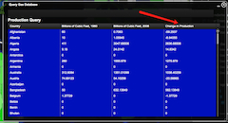
Important Note for Questions 3-6: In 1980, Russia and other countries in Eastern Europe belonged to the Soviet Union. No natural gas production and consumption amounts were reported for Russia in 1980. Therefore you should not include Russia in your responses to Questions 3-6 on your investigation sheet.

Use the Change in Production column to answer questions 3 and 4 on your investigation sheet.

- Close the Query Gas Database window by selecting the “x” in the top right corner.

Step 5: Examine natural gas consumption. (Questions 5 - 6)

Let’s investigate,
- Which countries consumed more natural gas in 2008 than in 1980?
- Which countries consumed less natural gas in 2008 than in 1980?

- In the Map Legend Tool activate the 2008 Gas Consumption and the 1980 Gas Consumption layers. Deactivate the 2008 and 1980 Gas Production Layers.  - You should toggle back and forth between the 1980 and 2008 layers to see which countries changed their consumption. | 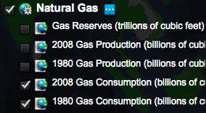
- Open the Query Gas Database using the Natural Gas top toolbar menu.  - Choose to Sort By: Gas Consumption. Click Select Sort.  - In the window that appears, select to sort by: Country and Ascending. When finished click Submit Query. | 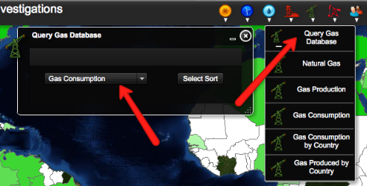
- In the Query Gas Database, locate the Change in Consumption column. If you can not see the entire data use you can widen the columns by placing the mouse between two columns. Click and drag your mouse to make a column wider or smaller.  - Sort the column in Ascending and Descending order by clicking on the top of the column.  Numbers that are positive represent countries that consumed more natural gas in 2008 than in 1980.  Numbers that are negative represent countries that consumed less natural gas in 2008 than in 1980. | 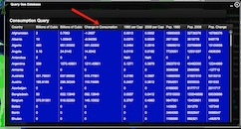
Use the Change in Consumption column to answer questions 5 and 6 on your investigation sheet.
In 1980, Germany was two separate countries: East Germany and West Germany. No natural gas production and consumption amounts were reported for Germany in 1980. Therefore you should not include Germany in your responses to Questions 5-6 below.

  - In the Gas Consumption table that is open sort the column Billions of Cubic Feet, 2008 in descending order. You need to record the amount of natural gas consumed in 2008 for each of the countries listed in Question 7. The countries in the Natural Gas Data Chart should be near the top. If they are not you can scroll through the list until you find them. Record the amount of natural gas consumed in 2008 by each contry in the Natural Gas Consumed in 2008 (Billion Cubic Feet) column of your data chart.

  - When you are finished close the Query Gas Database by selecting the “x” in the top right corner.

  - Open the Query Gas Database using the Natural Gas top toolbar.

  - Choose to Sort By: Gas Production. Click Select Sort.

  - In the window that appears, select to sort by: Country and Ascending. When finished select Submit Query.

- In the Query Gas Database window, locate the Billions of Cubic Feet, 2008 column. If you can not see the entire data set, you can widen the columns by placing the mouse between two columns. Click and drag your mouse to make a column wider or smaller.  - Sort the column in Descending order by clicking on the top of the column. | 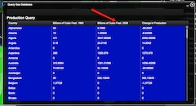
- Record the amount of natural gas produced by the 5 countries listed in the Natural Gas Data Chart on your investigation sheet. These countries should be near the top of the list. If they are not you can scroll through the list to find them.  - Record the Billions of Cubic Feet Produced in 2008 for each of the countries on your Natural Gas Data Chart. | 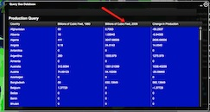
 Answer questions 8 - 10 on your investigation sheet.

