Investigating Hydroelectric Power Dams with Web GIS

Hydropower is energy that comes from the force of moving water. Most hydroelectric power plants are developed at dams. In this activity, you will use Web GIS to study and analyze hydroelectric power dams. You will
- Query and analyze features of US hydroelectric power dams.
- Query and analyze features of the 10 most powerful US hydroelectric power dams.
- Create a new layer containing Pennsylvania hydroelectric power dams.
- Query and analyze features of Pennsylvania hydroelectric power dams.

Read all instructions and answer each question on your investigation sheet.

 Step 1: Download data.

- Open your Web browser. Go to www.ei.lehigh.edu/learners/energy/

- Click on Investigating Hydroelectric Power Dams with Web GIS.

Step 2: Basic Features of Web GIS

- Your screen should open to a global view as shown in the picture to the right.  - To navigate in Web GIS you can use the navigational tools (# 1) or the hand (# 2). You can move around the map by selecting different areas or scrolling to them.  - You can zoom in on an area by using the zoom in tool options (# 3).  - You can find your exact location on the map by viewing the latitude and longitude location of your cursor in the bottom left corner of the map (# 4). | 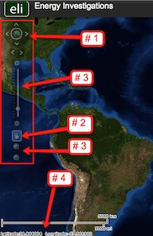
- You can also get back to the main view by using the Bookmark icon in the toolbar at the top of the screen (# 2). In the box that appears, select World View.  - The data for each activity can be activated using the Map Legend Tool (# 1). Place your mouse over this box and click on it. The Map Legend box will appear. In the Map Legend box, activate the data layer you wish to display by clicking in the checkbox. You can expand or shrink a legend item by clicking on the globe icon next to each data layer label.  - To observe the legend for a specific data layer, select the globe icon next to that item in the list (# 3)  - You can also activate portions of the data layers by selecting options from the top toolbar menus. | 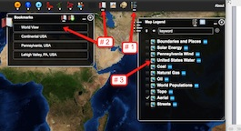

Step 3: Query and analyze US hydroelectric dams. (Questions 1 - 5)

- Use the Bookmarks tool (# 1) at the top of the page to navigate to the Continental United States. In the box that appears select Continental United States.  - In the Data Layers box activate the United States Water layer and the Boundaries and Places layer (# 2). | 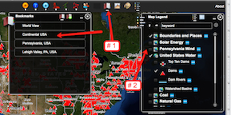
- In the toolbar menu at the top of the screen select Water Power. In the drop down box select Query Hydro Database.  - The box that pops up allows you sort through Hydro Database. If you can not see the entire box, use your mouse to move it into the viewing screen.  - In the pop up box use the drop down box (Sort By). Select River Names and then click Select Sort as shown in the middle picture.  - In the new window that appears use the drop down boxes to select the following features to search by. In the first box, select Search All Rivers. In the second box select State. In the third box select Ascending. When finished click Submit Query. | 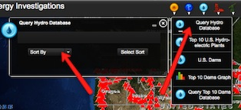  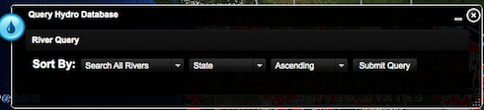
- The data table that appears contains 1,184 records. You can use the scroll bars to navigate through the data. If you can not view the scroll bars, expand the window using the expand option in the bottom right corner (# 1).  - You can sort through the data by columns. To do this you will need to click the label at the top of the column (# 2). This sorts the table by the data in that column.  Note: When you first open the table, the data is sorted by State Name. You can resort the data by clicking the label at the top of a column. One click will sort the data in a descending manner. A second click will sort that data in an ascending manner.  If you can not read the entire name in a column, Select that column and place your mouse between that column of data and the next column of data. A “line” icon” should appear that allows you change the column width. | 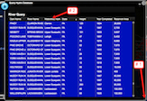
The information on the data table includes the location of the dam, the height of the dam (in feet), and the area of the reservoir behind the dam. The area behind the dam is measured in units of acre feet. One acre is about the area size of a football field. The figure on the left shows the area of one acre overlaid on an American football field.
One acre foot is about the volume size of a football field that is one foot deep. The figure on the right shows the volume of one acre foot. It is a volume that would hold 325,851 gallons of water.
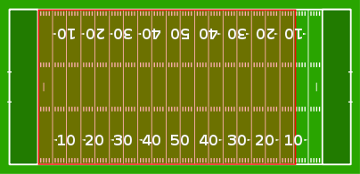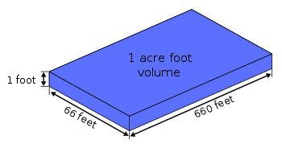

- Click on the YEAR COMPLETED column once. What happens to the column?

You should notice that the years are sorted in descending order. The dam completed at the latest date is at the top of the list.

Scroll down the bottom of the table. Note that these 37 dams do not have a year listed. The completion date of these dams are not in the data table.

- Click on the YEAR COMPLETED column a second time. What happens to the coulmn?

You should notice that the years are sorted in ascending order. The oldest completed dam is at the top of the list.

 Use the Query Hydro Database to answer questions 1 - 5 on your investigation sheet.

When finished keep the data table open.

Step 4: Looking at specific dams in the United States. (Questions 6 - 9)
Let’s investigate
- How many hydroelectric power dams are between 300 and 500 feet tall?
- How many dams on the Columbia River generate electricity?

- In the open Query Hydro Database, sort the data by dam height. You will want the tallest dams to be at the top of the list.  - Scroll down the list. Count the number of dams that have a height between 500 and 800 feet.  - When you are finished, select the “x” in the top right corner to close the data table.  - Answer questions 6 on your investigation sheet. | 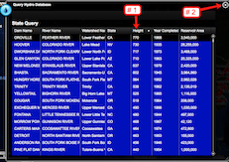
- To determine how many dams generate electricity on the Columbia River, open the Query Hydro Database.

- In the window that opens, select Sort by River Name.

- In the new window that appears select to sort the data by Columbia River, Resevoir Area, and Ascending. If you can not find an item on the list use the scroll bars in each drop down box to find those items. When finished you should select Submit Query.

- Click on the labels of each column to sort the data according to each column lable. If you need to expand the column width, click the top of that column and use your cursor to expand each column.

The displayed table will help you to answer questions # 7-9 on your Student Investigation Sheet.

Step 5: Query and analyze the 10 most powerful US hydroelectric dams.
(Questions 10 - 15)

- In the Data Layers box, deactive the Boundaries and Places layer and the Dams layer. Activate the Top Ten Dams layer by selecting the check box next to that layer (Shown to the right). | 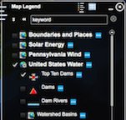
- In the toolbar menu at the top of the screen select Water Power. In the drop down box select Query Top 10 Dams Database (# 1 in the top picture).  - The box that pops up allows you sort through the Top 10 Dams Database. If you can not see the entire box, use your mouse to move it into the viewing screen.  Sort the columns in the chart to answer questions 10-14 on your investigation sheet. When finished select the “x” in the top right corner to close the Query Database.  - Navigate to the Top 10 Dams Graph (# 1 in the lower picture). Use this to answer question 15.  - When finished select the “x” in the top right corner to close the graph display. | 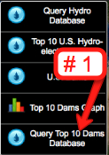  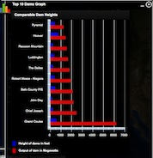

Step 6: Analysis of Pennsylvania dams. (Questions 16 - 23)

- Navigate to Pennsylvania on the map using the Bookmarks tool.  - Deactivate the Top 10 Dams layer and activate the Dams layer, the Boundaries and Places layer, and the Dam Rivers layer using the Data Layers menu as shown to the right (# 1). | 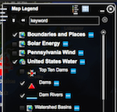
- In the water power drop down menu, select Query Hydro Database.

- In the box that appears select State in the drop down box and then click Select Sort.

- In the next box that appears Sort By: Pennsylvania, Year Completed, and Ascending, as shown to the right. Select Submit Query. If you cannot view an item use the scroll bars in the drop down box to navigate to that item.

- Use the data table that appears to answer Questions #16-23.

- Use the helpful hints on your Student Investigation Sheet to help you answer the above questions.

