Investigating Oil Production and Consumption with Web GIS

Crude oil (petroleum) was formed from the remains of tiny sea animals and plants that lived millions of years ago in marine (water) environment. In this activity, you will use Web GIS to investigate patterns of crude oil (petroleum) production and consumption. You will

- Examine countries with oil reserves.
- Analyze crude oil production and consumption of countries in 1980 and 2008.
- Investigate the relationship among countries’ crude oil consumption and their populations.

Read all instructions and answer each question on your investigation sheet.

 Step 1: Download data.

  - Open your Web browser. Go to www.ei.lehigh.edu/learners/energy/

  - Click on Investigating Oil Production and Consumption with Web GIS.

 Step 2: Basic Features of Web GIS

- Your screen should open to a global view.  - To navigate in Web GIS you can use the navigational tools (# 1) or the hand (# 2). You can move around the map by selecting different areas or scrolling to them.  - You can zoom in on an area by using the zoom in tool options (# 3).  - You can find your exact location on the map by viewing the latitude and longitude location of your cursor in the bottom left corner of the map (# 4). | 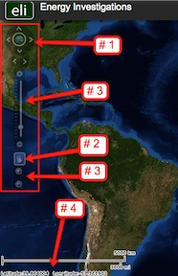
- You can also get back to the main view by using the Bookmark icon in the toolbar at the top of the screen (# 2). In the box that appears, select World View.  - The data for each activity can be activated using the Map Legend Tool (# 1). Click on the Map Legend Tool. The Map Legend window will appear. In the Map Legend window, activate a data layer you wish to display by clicking the checkbox. You can expand or shrink a legend item by clicking on the globe icon next to each data layer label.  - To observe the legend for a specific data layer, select the globe icon next to that item in the list (# 3)  - You can also activate portions of the data layers by selecting options from the top toolbar menus. | 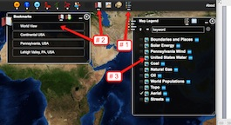

Step 3: Examine countries with oil reserves. (Question 1)

Let’s investigate which countries have large amounts of oil reserves.

- Activate the Oil Reserves data layer. In the Map Legend window, select Oil Reserves, as shown to the right. Click on the globe next to Oil. Then select the globe next to Oil Reserves to view the legend for that data layer. | 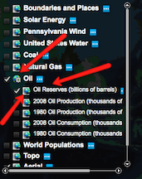
- Open the Query Oil Database using the top toolbar menu as shown to the right  (# 1). In the box that opens Sort By: Oil Reserves.  - In the Reserve Query box that appears select to Sort By: Country and Ascending. When finished click Submit Query.  - In the data chart that appears sort the columns based on Reserves (Trillions of Cubic Feet). To sort a column in descending order click the top of this column twice. | 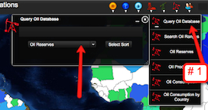
 Answer question 1 on your investigation sheet.

Oil reserves are the amount of oil that can be economically taken from crude oil reservoirs.
Oil reserves are listed in amounts of billions of barrels. 1 barrel = 42 gallons.
1 billion = 1,000,000,000.

e. Close the Query Oil Database window by selecting the “x” in the top right corner.

Step 4: Analyze oil production. (Questions 2 - 3)

Let’s investigate,
- Which countries produced more oil in 2008 than in 1980?
- Which countries produced less oil in 2008 than in 1980?

- In the Map Legend activate the 2008 Oil Production and the 1980 Oil Production layers. Click on the globe next to these layers to view the legend. Deactivate the Oil Reserves Layer.  - You should toggle back and forth between the 1980 and 2008 layers to see which countries changed their production. | 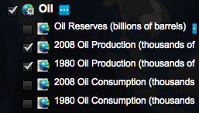
- Select the Query Oil Database using the Oil top toolbar menu.  - Choose to Sort By: Oil Production. Use the drop down box to select this feature. Click Select Sort.  - In the box that appears Sort by: Country and Ascending. When finished click Submit Query. | 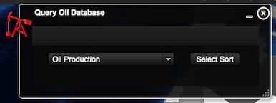  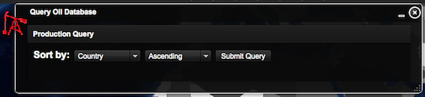
- In the Query Oil Database, navigate to the Change in Production column. If you can not see the entire data set, you can widen the columns by placing the mouse between two columns. Click and drag your mouse to make a column wider or smaller.  Sort the column in Ascending and Descending order by clicking on the top of the column. | 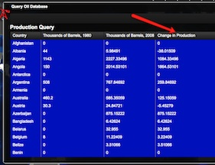
Use the Change in Production column to answer questions 2 and 3 on your investigation sheet.

- When finished close the Query Oil Database by selecting the “x” in the top right corner.

Step 5: Examine oil consumption. (Questions 4 - 5)

Let’s investigate,
- Which countries consumed more oil in 2008 than in 1980?
- Which countries consumed less oil in 2008 than in 1980?

- In the Map Legend Tool activate the 2008 Oil Consumption and the 1980 Oil Consumption layers. Click on the globe next to these layers to view the legend. Deactivate the 2008 and 1980 Oil Production Layers.  - You should toggle back and forth between the 1980 and 2008 layers to see which countries changed their consumption. | 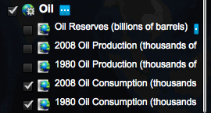
- Open the Query Oil Database using the Oil top menu toolbar.  - Sort By: Oil Consumption. Use the drop down box to select this feature. Click Select Sort.  - In the box that appears select to sort by: Country and Ascending. When finished select Submit Query. | 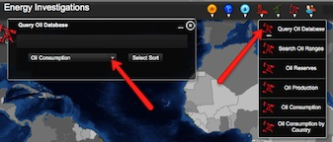
- In the Query Oil Database, navigate to the Change in Consumption column. If you can not see the entire data column, you can widen the columns by placing the mouse between two columns. Click and drag your mouse to make a column wider or smaller.  - Sort the column in Ascending and Descending order by clicking on the top column label.  Numbers that are positive represent countries that consumed more oil in 2008 than in 1980.  Numbers that are negative represent countries that consumed less oil in 2008 than in 1980. | 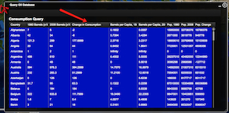
Use the Change in Consumption column to answer questions 4 and 5 on your investigation sheet.

h. When finished keep the Query Oil Database open.

Step 6: Examine populations of countries. (Questions 6)

Let’s investigate which countries have the largest population differences between 1980 and 2008.

- In the Query Oil Database navigate to the Pop. Change column. If you can not see the entire data use you can widen the columns by placing the mouse between two columns. Click and drag your mouse to make a column wider or smaller.  Note: Use the scroll bars and expand the window from the bottom right corner if you can not view all of the data columns. | 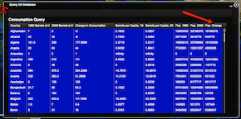
 Use the Pop. Change column to answer question 6 on your investigation sheet.

Step 7: Examine per capita oil consumption. (Questions 7 - 13)

Let’s investigate each country’s per capita oil consumption. Per capita oil consumption means the average amount of oil each person consumed.

- In the open Query Oil Database, navigate to the Barrels per Capita, 2008 column. | 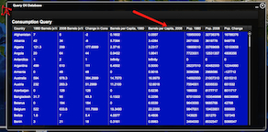
Use the Barrels per Capita, 2008 column to complete the Oil Data Chart on your investigation sheet.

Navigate through the list to find the countries in the data table. You can sort the countries by clicking the top of the column country.

Answer questions 7 - 13 on your investigation sheet.

