Investigating Oil Production and Consumption with Web GIS Teacher Guide

Crude oil (petroleum) was formed from the remains of tiny sea animals and plants that lived millions of years ago in marine (water) environment. In this activity, your students will use Web GIS to investigate patterns of crude oil (petroleum) production and consumption. They will

- Examine countries with oil reserves.
- Analyze crude oil production and consumption of countries in 1980 and 2008.
- Investigate the relationship among countries’ crude oil consumption and their populations.

Instruct students to read all instructions and answer each question on their investigation sheet.

 Step 1: Download data.

  - Open your Web browser. Go to www.ei.lehigh.edu/learners/energy/

  - Click on Investigating Oil Production and Consumption with Web GIS.

 Step 2: Basic Features of Web GIS

- The screen should open to a global view as shown in the picture below.

- To navigate in Web GIS, students can use the navigational tools (# 1) or the hand (# 2). They can move around the map by selecting different areas or scrolling to them.

- Students can zoom in on an area by using the zoom in tool options (# 3).

- They can find their exact location on the map by viewing the latitude and longitude location of the cursor in the bottom left corner of the map (# 4).

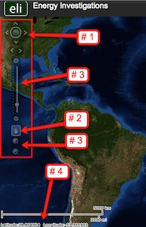

- Students can get back to the main view by using the Bookmark icon in the toolbar at the top of the screen (# 2 below). In the box that appears, select World View.

- The data for each activity can be activated using the Map Legend Tool (# 1 below). Click on the Map Legend Tool. The Map Legend window will appear. In the Map Legend box, activate a data layer you wish to display by clicking the checkbox. You can expand or shrink a legend item by clicking on the globe icon next to each data layer label.

- To observe the legend for a specific data layer, select the globe icon next to that item in the list
(# 3). The legend can be closed by clicking the globe icon a second time.

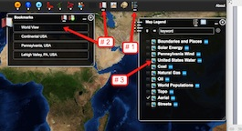

- Students can also activate portions of the data layers by selecting options from the top toolbar menus.

Step 3: Examine countries with oil reserves. (Question 1)

Let’s investigate which countries have large amounts of oil reserves.

- Activate the Oil Reserves data layer. In the Map Legend window, select Oil Reserves, as shown to the right. Click on the globe next to Oil. Then select the globe next to Oil Reserves to view the legend for that data layer.
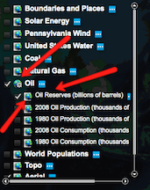

- Open the Query Oil Database using the top toolbar menu as shown to the right
(# 1 below). In the box that opens Sort By: Oil Reserves.

- In the Reserve Query box that appears select to Sort By: Country and Ascending. When finished click Submit Query.

- In the data chart that appears sort the columns based on Reserves (Trillions of Cubic Feet). To sort a column in descending order click the top of this column twice.
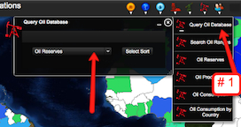

 Have students answer question 1 on their investigation sheet.

Oil reserves are the amount of oil that can be economically taken from crude oil reservoirs.
Oil reserves are listed in amounts of billions of barrels. 1 barrel = 42 gallons.
1 billion = 1,000,000,000.

- Close the Query Oil Database window by selecting the “x” in the top right corner.

Step 4: Analyze oil production. (Questions 2 - 3)

Let’s investigate,
- Which countries produced more oil in 2008 than in 1980?
- Which countries produced less oil in 2008 than in 1980?

- In the Map Legend activate the 2008 Oil Production and the 1980 Oil Production layers. Click on the globe next to these layers to view the legend. Deactivate the Oil Reserves Layer.

- Students should toggle back and forth between the 1980 and 2008 layers to see which countries changed their production.
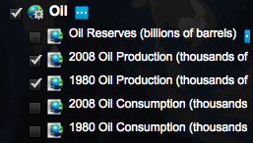

- Select the Query Oil Database using the Oil top toolbar menu.

- Choose to Sort By: Oil Production. Use the drop down box to select this feature. Click Select Sort.

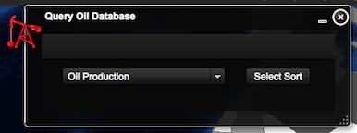

- In the box that appears Sort by: Country and Ascending. When finished click Submit Query.
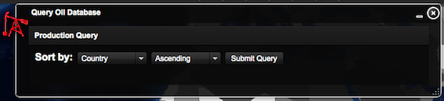

- In the Query Oil Database, navigate to the Change in Production column. If students can not see the entire data set, they can widen the columns by placing the mouse between two columns. Click and drag the mouse to make a column wider or smaller.

- Sort the column in Ascending and Descending order by clicking on the top of the column.

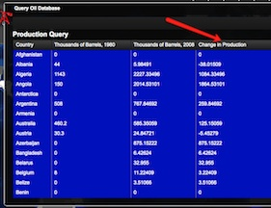

Students should use the Change in Production column to answer questions 2 and 3 on their investigation sheet.

- When finished have the students close the Query Oil Database by selecting the “x” in the top right corner.

Step 5: Examine oil consumption. (Questions 4 - 5)

Let’s investigate,
- Which countries consumed more oil in 2008 than in 1980?
- Which countries consumed less oil in 2008 than in 1980?

  - In the Map Legend Tool activate the 2008 Oil Consumption and the 1980 Oil Consumption layers. Click on the globe next to these layers to view the legend. Deactivate the 2008 and 1980 Oil Production Layers.

  - You should toggle back and forth between the 1980 and 2008 layers to see which countries changed their consumption.
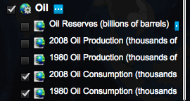

  - Open the Query Oil Database using the Oil top menu toolbar.

  - Sort By: Oil Consumption. Use the drop down box to select this feature. Click Select Sort.

  - In the box that appears select to sort by: Country and Ascending. When finished select Submit Query.
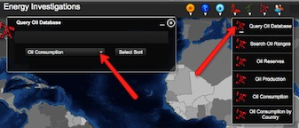

  - In the Query Oil Database, navigate to the Change in Consumption column. If you can not see the entire data column, you can widen the columns by placing the mouse between two columns. Click and drag your mouse to make a column wider or smaller.

  - Sort the column in Ascending and Descending order by clicking on the top column label.

Numbers that are positive represent countries that consumed more oil in 2008 than in 1980.
Numbers that are negative represent countries that consumed less oil in 2008 than in 1980.

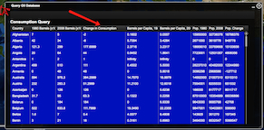

Instruct students to use the Change in Consumption column to answer questions 4 and 5 on their investigation sheet.

  - When finished keep the Query Oil Database open.

Step 6: Examine populations of countries. (Questions 6)

Let’s investigate which countries have the largest population differences between 1980 and 2008.

- In the Query Oil Database navigate to the Pop. Change column. If you can not see the entire data use you can widen the columns by placing the mouse between two columns. Click and drag your mouse to make a column wider or smaller.

Note: Use the scroll bars and expand the window from the bottom right corner if you can not view all of the data columns.

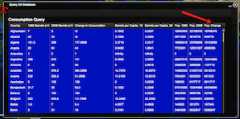

 Instruct students to use the Pop. Change column to answer question 6 on your investigation sheet.

Step 7: Examine per capita oil consumption. (Questions 7 - 13)

Let’s investigate each country’s per capita oil consumption. Per capita oil consumption means the average amount of oil each person consumed.

- In the open Query Oil Database, navigate to the Barrels per Capita, 2008 column.

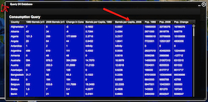

Use the Barrels per Capita, 2008 column to complete the Oil Data Chart on your investigation sheet.

Navigate through the list to find the countries in the data table. You can sort the countries by clicking the top of the column country.
Instruct students to answer questions 7 - 13 on your investigation sheet.

