Where is the Best Place to Locate a New Solar Power Plant? Teacher Guide

Solar energy comes from the sun. In this activity, students will use Web GIS to determine the best place to locate a new solar power plant. They will
- Learn some basic features of Web GIS to visualize data and obtain information.
- Analyze annual average sunshine data to determine good locations for solar plants.

Model the following procedural instructions with your students. It is recommended that you display your computer image to the front of the classroom.

 Step 1: Download Data

Have students open their Web browser. Go to www.ei.lehigh.edu/learners/energy/

Under Solar Energy, select “Where is the Best Place to Locate a New Solar Power Plant with Web GIS?”

Step 2: Basic Features of Web GIS

- Your screen should open to a global view as shown in the picture below.

- To navigate in Web GIS students can use the navigational tools (# 1) or the hand (# 2). They can move around the map by selecting different areas or scrolling to them.

- Students can zoom in on an area by using the zoom in tool options (# 3).

- They can find your exact location on the map by viewing the latitude and longitude location of the cursor in the bottom left corner of the map (# 4).

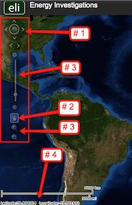

- Students can get back to the main view by using the Bookmark icon in the toolbar at the top of the screen (# 2 below). In the box that appears, select World View.

- The data for each activity can be activated using the Map Legend Tool (# 1 below). Click on the Map Legend Tool. The Map Legend window will appear. In the Map Legend window, activate a data layer that you wish to display by clicking in the checkbox. You can expand or shrink a legend item by clicking on the globe icon next to each data layer label.

- To observe the legend for a specific data layer, select the globe icon next to that item in the list (# 3). The legend can be closed by clicking the globe icon a second time.

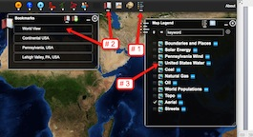

- Students can also activate portions of the data layers by selecting options from the top toolbar menus.

Step 3: Web GIS Tools
  - Have students click on the Bookmark 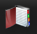 tool.
In the drop down box, select one of the options (World View, Continental USA, Pennsylvania, Lehigh Valley).
What happens to the map?
Students should notice that the map zooms out to display the entire world when World View is selected and displays other specific geographic locations when selected.
Click the “x” in the top right corner to close the Bookmark window.

  - Click on the Zoom In tool. Drag and draw a small rectangle over any area on the map. What happens to the map?
Students should notice that the map zooms in to the rectangular area.

  - Click on the Move Map tool.
Click and drag the map to the left.
Click and drag the map to the right.
Click and drag the map upward.
Click and drag the map downward.
What happens to the map?
Students should notice that the map displays are re-centered at a new location.
Look at the bottom left corner of your map display. The latitude and the longitude of the hand’s location is displayed here.

  - Click on the Zoom Out tool . Drag and draw a small rectangle over any area on the map.
What happens to the map?
Students should notice that the map displays a larger area.

  - Click on the the Map Legend tool. In the drop down box that appears select the check box next to Boundaries and Places.

  - Students can also query and analyze the data layers using the options in the toolbar menu.
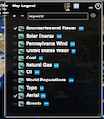

  - Activate the Solar Data in the Map Legend by selecting the Solar Energy check box.
What happens when students click on this layer?
To display the Legend layers, select the Legend icon from the toolbar at the top. Each legend can be displayed by selecting the globe icon next to each data layer (# 1 below). If the entire legend is not displayed, use the scroll bars to move up and down the list (# 2 below).
This data layer displays the average annual percentage of sunshine an area receives.

Note: When students are done using a window they can close it by clicking the “x” in the top right corner.
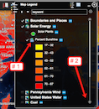

Step 4: Analyze data related to solar power plants

  - Have students activate the Solar Energy layer in the Map Legend Tool.

- They should select the Legend in the toolbars menu as shown in the picture above.

Using the legend, instruct students to observe the color differences on their GIS map display. These colors indicate the average annual percentage of sunshine that an area receives.

Instruct students to use the Web GIS map to answer questions 1 - 5 on their investigation sheet.

Part 1: Have student’s use the Bookmarks tool to navigate to the state of Pennsylvania.

Activate the Solar Plants layer in the Map Legend tool.

In the top toolbar, select the Solar icon. Click on Solar Power Plants. The location of a solar plant in Pennsylvania is displayed. Place your mouse over the Pennsylvania solar plant and click on it to display information about that solar power plant.

In the drop down menu select, Percentage Sunshine (Range). In the box that appears, select the Draw Point tool as shown in the picture below. Click to add a point on top of the Pennsylvania Solar Plant that you are viewing. The percent average annual sunshine is displayed.

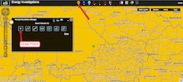

Instruct students to answer question 6 and 7 on their investigation sheet.

Part 2: Select World View from the Bookmark tool. In the top toolbars menu, have students select the Solar icon (# 1 below). In the drop down menu, they should select Solar Power Plants.

A new display box (# 2 below) appears with a list of plants and their locations. Instruct students to use this information to complete the Solar Power Plants Data Chart on the Student Investigation Sheet. Students can click on a specific solar power plant in this chart to navigate directly to that location in the GIS.

The latitude and longitude can be determined by holding the mouse over each Solar Plant and recording the geographic locations that are displayed in the bottom left corner of the screen (# 3 below).

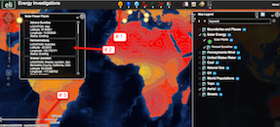

Make sure students record all of the information for each of 13 Solar Plants. The Pennsylvania Solar Park solar plant is completed as an example.

To determine the Annual Average Sunshine for each solar plant, students will need to reactivate the Percent Sunshine layer in the Data Layers.

Have students navigate to individual solar plants using the zoom-in tool options or by double-clicking on each plant.

Instruct students to select the Solar icon in the top toolbar. In the drop down menu they should select Percentage Sunshine (Range). In the box that appears, have them select the Draw Point tool as shown in the bottom left picture. Instruct students to click to add a point on top of the Solar Plant that they are viewing. The percent average annual sunshine is displayed. Instruct students to record the displayed value in the box (# 1 in the bottom right picture) on their Student Investigation sheet in the appropriate column.

When students are ready to move to the next Solar plant, they should click on Select Features (# 2) and begin the process again.
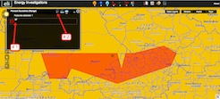

Helpful hint: Use the Bookmarks tool to return to the World View that displays the entire data set.

Instruct students to use their Solar Power Plants Data Chart and the Web GIS map to answer questions 8 – 15 on their investigation sheet.

