Where is the Best Place to Locate a New Wind Farm?

Wind is moving air and is a locally plentiful source of energy. In this activity, the students will use Web GIS to examine wind speed patterns and land use in Pennsylvania to determine the best place to locate a new wind farm. They will
- Examine wind speed patterns in Pennsylvania.
- Examine land use patterns in Pennsylvania and in the Lehigh Valley.
- Determine the best place to locate a new wind farm in the Lehigh Valley and in Pennsylvania.

Read all instructions and answer each question on your investigation sheet.

 Step 1: Download data.

  - Have the students open their Web browser and go to www.ei.lehigh.edu/learners/energy/

  - Click on Where is the Best Place to Locate a New Wind Farm with Web GIS?

 Step 2: Basic Features of Web GIS

- Your screen should open to a global view as shown in the picture below.

- To navigate in Web GIS students can use the navigational tools (# 1) or the hand (# 2). They can move around the map by selecting different areas or scrolling to them.

- Students can zoom in on an area by using the zoom in tool options (# 3).

- They can find your exact location on the map by viewing the latitude and longitude location of the cursor in the bottom left corner of the map (# 4).
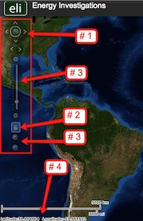

- Students can get back to the main view by using the Bookmark icon in the toolbar at the top of the screen (# 2 below). In the box that appears, select World View.

- The data for each activity can be activated using the Map Legend Tool (# 1 below). Click on the Map Legend Tool. The Map Legend window will appear. In the Map Legend window, activate a data layer that you wish to display by clicking in the checkbox. You can expand or shrink a legend item by clicking on the globe icon next to each data layer label.

- To observe the legend for a specific data layer, select the globe icon next to that item in the list (# 3 below)

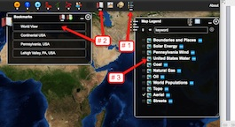

- Students can also activate portions of the data layers by selecting options from the top toolbar menus.

Step 3: Examine Patterns of Wind Speeds in Pennsylvania.

The Web GIS map displays average wind speeds at 50 meters above the ground. In assessing optimal locations for a wind farm, it is better to examine wind speeds at 50 meters above the ground since surface wind speed and direction is influenced by surface roughness (ground, trees, buildings) or friction with the ground.

- Have the students zoom to Pennsylvania using the Navigation Tools or the Bookmark tool at the top of the page (# 1 below).

- They should activate the Boundaries and Places layer, the Pennsylvania Wind layer, the Pennsylvania Wind Farms layer, and the Wind Speed MPH layer as shown in the image below (# 2).

- Activate the map legend by clicking on the globe icon next to the data layer (# 3 below). Look at the different wind speeds on the map of Pennsylvania.
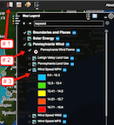
 The students should answer question 1 on their investigation sheet.

Step 3: Explore Wind Farm Sites.
Let’s examine the wind speed and land use at the wind farm sites.

To determine the Wind Speed and Land Use of wind farm sites 2, 8, and 15, follow the directions below.

16 sites on the map are displayed (with red numbers) where you could place a wind farm. Eleven sites are in the Lehigh Valley (see arrow) and 5 sites are in other locations in Pennsylvania.
NOTE: There are no actual wind farms located at these sites today.
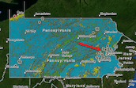
  - Zoom in closely to wind farm site 2. Alternatively, students can click on the Pennsylvania Wind Farms Widget on the top tool bar and select Wind Farm 2 from the drop-down list.

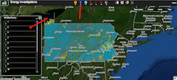

  - Make sure that the Wind Speed MPH layer is activated in the Map Legend Tool.

  - Make sure that the legend is displayed by selecting the glob icon next to the data layer (# 1 below). If you cannot view everything on the legend, use the scroll bars to move up and down.

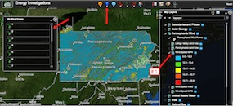

Students should record the wind speed of wind farm sites 2, 8, and 15 on the Wind Farm Sites Data Chart on their investigation sheet. Match the color surrounding the wind farm location with the wind speed color in the legend.

Students can use the Pennsylvania Wind Farm Widget to navigate to each wind farm.

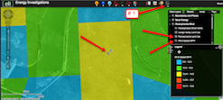

  - Use the Bookmark tool to navigate back to the state of Pennsylvania. When finished select the “x” in the bookmarks pop-up box to close the window.

  - Turn the Wind Speed MPH layer off in the Map Legend tool.
Turn the Pennsylvania Land Use layer on in the Map Legend tool.

  - Zoom in closely to wind farm site 2. Alternatively, click on the Pennsylvania Wind Farms Widget on the top tool bar and select Wind Farm 2 from the drop-down list.

Have the students record the land use type at wind farm 2, 8 and 15 on the Wind Farm Sites Data Chart on your investigation sheet. Match the color surrounding the wind farms location with the land use color in the legend.

Students should use the Wind Farm Sites Data Chart and the Web GIS map to answer questions 3 – 8 on their investigation sheet.

