Climate Hotspots with Google Earth Student Guide

In this activity, you will use Google Earth to explore several locations where rapid climate change is occurring. You will:
- Use Google Earth to explore 5 hotspot locations indicating recent changes in climate patterns.
- Understand that climate change is not restricted to North America and is happening on a global scale.
- Understand that climate warming has already caused changes in landscape features (glaciers) and organisms’ habitats.

 Step 1: Download Data

- Open your Web browser. Go to www.ei.lehigh.edu/learners/cc/.

- Under Climate Hotspots, click on Google Earth file: climatehotspots.kmz.

The file is displayed in Google Earth.
Note: If the file download does not automatically launch Google Earth, double-click on the downloaded file climatehotspots.kmz to launch Google Earth.

- Click the arrow to the left of “Climate Hotspots” in the left panel (see red arrow below).

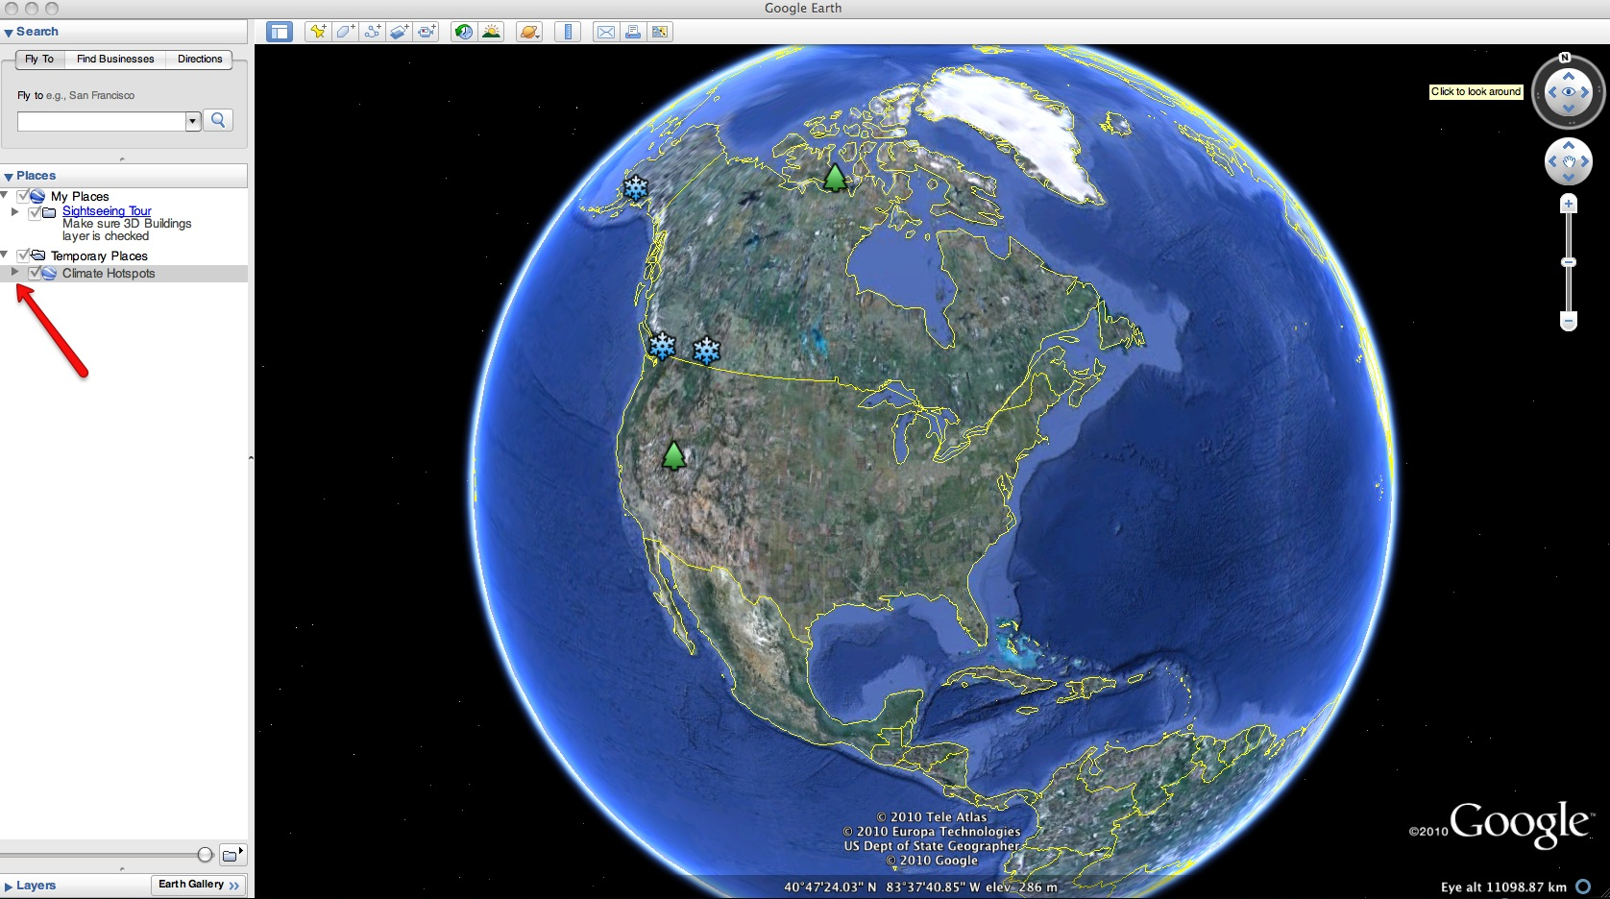
d. The “Climate Hotspots” drop-down list will extend (see below). If you cannot see the whole list, scroll down.

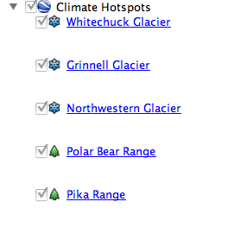

Step 2: Basic Features of Google Earth
Note the following Google Earth features, tools, and navigation controls in the figure below.

- Search Panel (arrow #1) – Type in the white box to find a location.

- 3-dimensional (3D) Viewer (arrow #2) – This window shows the Earth and its terrain.

- Navigation Controls (arrow #3) – Use these controls to zoom, look, and move around. If the navigation controls are not visible, click on View>Show Navigation>Always.

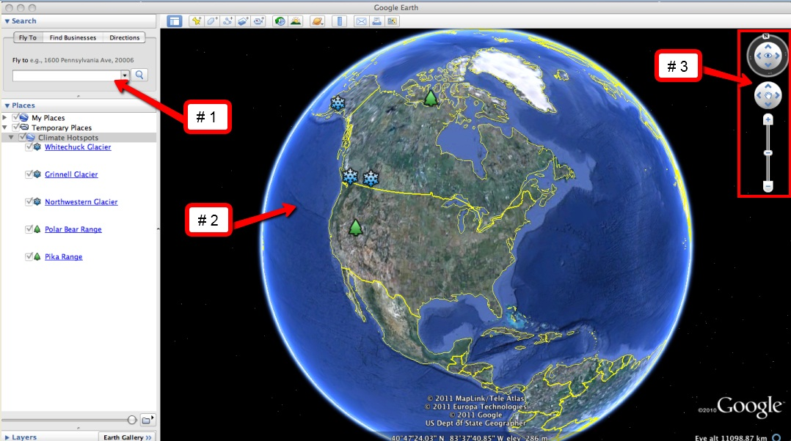

Step 3: Climate Hotspots Activity
- You will explore 5 different climate hotspot locations in Google Earth to better understand the effects of climate change. You will analyze evidence of global climate change and answer analysis questions on the Climate Hotspots with Google Earth Investigation Sheet.

- At each location, read the text, observe changes in time-sequence images of glaciers, and observe changes in the habitat range maps of polar bears and pikas.

- The glacial images were taken at similar locations during two different time periods. This type of photographic evidence helps scientists observe large changes in a landscape over time.
- Start by investigating changes in glacial features. These locations are indicated by “snowflake” push-pins.  - Begin by examining the time-sequence images of the Whitechuck Glacier. This is shown in the picture to the right. In these Google Earth displays, the older image of the time-sequence pair will be on the left and a more recent image will be on the right.  - Read the displayed text and observe the differences in the land cover between the two pictures. Take note of the years associated with each picture and record these in the data table on your Investigation Sheet. | 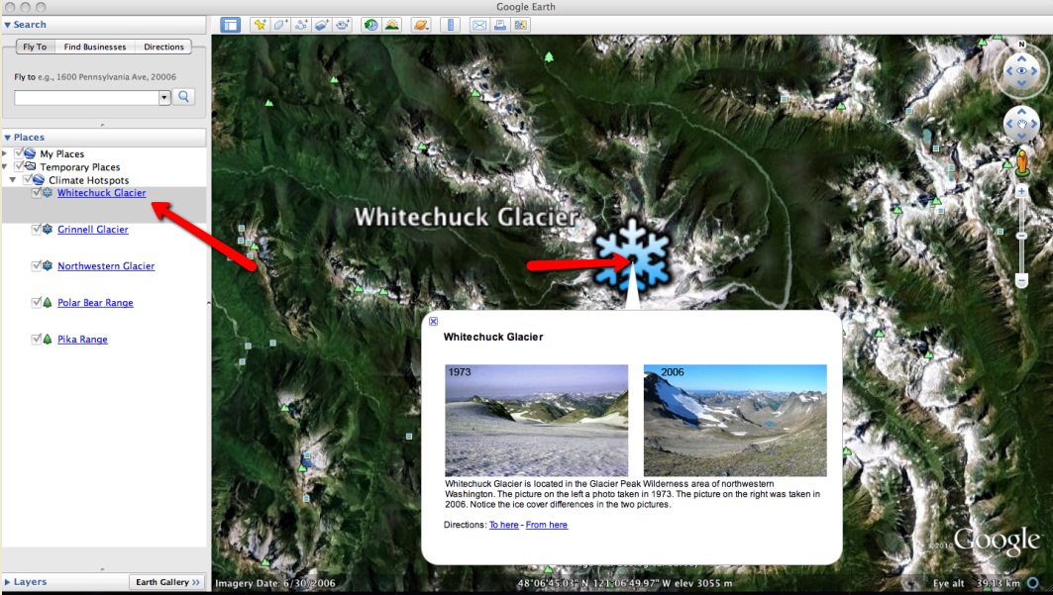
- Navigate to the Grinnell Glacier location and analyze the differences in the land cover of the two images.  - Navigate to the Northwestern Glacier location and observe the land cover changes at that location.  - Fill in the associated table for the 3 glacier locations (shown to the right) on your Investigation Sheet.  - Complete Analysis Questions #1-2 on the Investigation Sheet. | 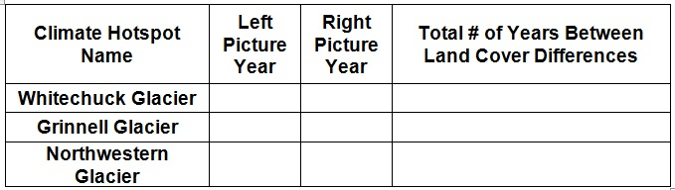
- Proceed to the Polar Bear Range location and follow the instructions below.

- Observe changes in polar bear habitat range that have occurred over the last century in North America using the navigation tools in Google Earth.

- The blue outline indicates the extent of the polar bear habitat range in 1900. The red outline indicates the extent of the polar bear habitat range in 2005. The red color is overlaid on top of the blue color.

Note: Polar bears spend most of their time on sea ice.

- Proceed to the Pika Range location and observe changes in pika habitats that have occurred over the last century using the navigation tools in Google Earth. You may need to use the scroll bars to view the text underneath the picture.

- Complete Analysis Questions #3-5 on the Investigation Sheet.

You can navigate from one location to the next by selecting the hotspot location from the drop-down menu in the Places window or by using the Google Earth navigational tools.
Note: If you are zoomed out far enough to view multiple push-pins in the 3D Viewer, you can view the data by selecting the snowflake or tree push-pins.

