Energy Efficiency Lab Teacher Guide

Driving Question: What does it mean to be energy efficient?

Following completion of this activity your students will understand:
- Different light bulb types use different amounts of electricity to produce similar amounts of light.
- When energy is converted from electricity to light, energy is “lost” primarily in the form of heat.
- Heat production is a form of energy conversion. Excessive heat is the result of an inefficient electrical conversion.
- High efficiency light bulbs help reduce energy consumption.

Background information:

An energy efficient appliance is one that is manufactured using alternative technology yet produces equivalent or improved results while consuming less electricity. Some people think when one selects an energy efficient product over a standard product, that they must sacrifice quality. For example, some people think a CFL light bulb may not be as bright as an incandescent bulb. Some people also complain that energy efficient products are too expensive to purchase and to use. This is not the case in most instances. Energy efficient appliances usually require an immediate initial investment that pays off over time.

The benefits of using energy efficient appliances include a reduction in energy bills and a reduction in fossil fuel use and greenhouse gas emissions. Energy efficient products such as CFL light bulbs often have extended life use and reduced replacement costs.

This laboratory is designed to investigate the meaning of energy efficiency. During this lab, students explore the energy efficiency of different light bulb types by measuring their heat output. Students may think that wattage is directly related to heat output. This is not the case. For example, in this lab activity, the 40 watt appliance bulb will have an equivalent or greater heat output than a 60 watt incandescent bulb.

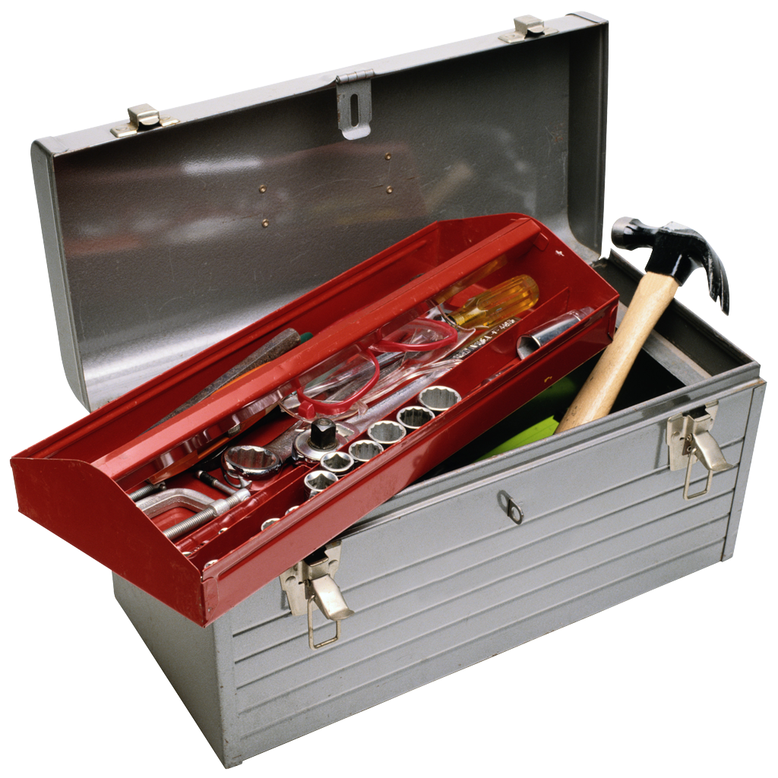 Equipment List
For 8 light bulb stations
- 40 or 60 watt equivalent light bulbs
  - 2 - Incandescent
  - 2- Compact Florescent Bulb (CFL)
  - 2- LED
  - 2- Appliance Bulb
  - 2- Halogen (optional)
- 8 Gooseneck lamps
- 8 Temperature probes (if probes are not available use thermometers)
- 8 Stop watches or clock
- Optional - Light probes (lumens)
- Observation Sheet

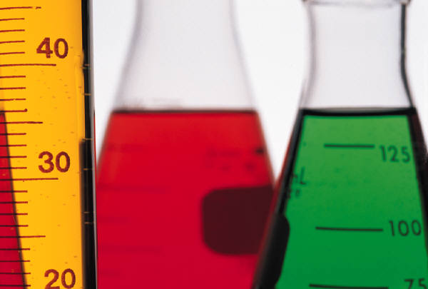 Step 1: Laboratory Preparation

  - Insert the appropriate light bulb into the gooseneck lamp at each light bulb station.
    - Station 1 – Incandescent
    - Station 2 – Appliance
    - Station 3 – CFL
    - Station 4 – LED
  - Place a copy of the appropriate station label in front of the lamp at each station. These labels identify the type of bulb and the wattage rating. Sample labels are provided at the end of this document.
  - Plug in lights but do not turn on the lights.
 Step 2: Lab Procedure

Divide the class into groups of 4. Assign each group to a light bulb station. Rotate students to a new light bulb station every 5-7 minutes.

Each group will complete observations for one light bulb station at a time. For example: Group 1 will gather data at the first light bulb station for 5 minutes. After 5 minutes, students will move to the next station. It is recommended that students spend no more than 7 minutes at each bulb station. You will determine whether your students will measure temperature in Fahrenheit or Celsius. If your students use probeware for their measurements, instruct them to make sure their probes are set to measure temperature in the appropriate units.

- Assign students in each group the following tasks:
  - Temperature monitor. The temperature monitor holds the temperature probe 1-inch away from the bulb. Some bulbs heat over time. Tell students to be sure to record the temperature both before and after the light is turned on.

  - Light bulb observer. The light bulb observer watches how quickly the light turns on. Some bulbs turn on immediately with full brightness. With other types of bulbs there may be a delay between turning on the switch and the appearance of light. Some bulbs slowly brighten. Some light bulbs have slightly different colors.

  - Timekeeper. The timekeeper keeps track of the measurement intervals and tells the other group members when to take measurements.

  - Recorder. The recorder writes the observations and temperature measurements provided by the group.
      - Each group member is responsible for copying the measurements from the master investigation sheet and completing their own investigation sheet.
      - You may rotate jobs between light bulb stations.

  - Direct students to their first light bulb station.

  - Instruct students to read the light bulb type label that is placed in front of the lamp. They should identify the light bulb type on the appropriate row on their investigation sheet. Students record data for this station in that row.

- Observation Schedule
  - BEFORE: Instruct students to measure temperature output prior to turning on the light bulb. Tell students to hold the probe or thermometer 1 inch away from the bulb. Prompt students to record the temperature in the BEFORE column.
    - Emphasize to your students that it is important to know the temperature both before and after the light is turned on. Less change in the heat output (as measured by the temperature difference) means the bulb is more efficient.

  - TURNING THE BULB ON: Remind groups they need to prepare for a set of measurements that must be taken as soon as the bulb is switched on. Remind students that temperature measurement and light bulb observations are taken during this step. Students will:
    - Measure and record temperature in the 1 sec column on the investigation sheet.
    - Write their observations (see student job description for details) in the observations column on the investigation sheet.

  - THIRTY SECOND INTERVALS: Students will repeat the temperature measurement every thirty seconds. Remind students that the time labels at the top of the data chart are elapsed time. Students will:
    - Measure and record temperature. Prompt students to record the temperature in the correct time column as needed.

  - OFF: After the final thirty-second interval observation turn the bulb off. Students will:
    - Measure the temperature after 30 seconds.
    - Note the speed in which the light turns off. Some turn off immediately; others fade slowly. Prompt students to write their observations in the Observations column.
    - Wait 30 seconds. Prompt students to measure and record temperature in the 1 min. OFF column.
    - Wait another 30 seconds. Prompt students to measure and record temperature in the 1.5 min. OFF column.

  - Instruct students to repeat this procedure at each light bulb station.

- After students complete all light bulb stations, instruct them to complete the Light Bulb Lab Analysis section on their investigation sheet.

 Step 3: Group Discussions
Review and discuss question responses from the students’ investigation sheets. See Energy Efficiency Lab Assessment for sample answers.

Sample Light Bulb Labels

Incandescent
Light Bulb

60 Watts

Appliance Bulb

40 Watts
Compact Florescent Light (CFL)
Bulb

13 Watts

LED Bulb

1.5 Watts

