Investigating Future Worlds with Google Earth (Part 1) Student Guide

In this activity, you will use Google Earth to explore evidence of climate change during a recent 30-year period. You will…
- Use Google Earth to explore changes in Arctic Sea ice extent over the last four decades.
- Use Google Earth to explore changes in the distribution of coral reefs in the Caribbean Sea.
- Understand that climate change will continue to affect our planet into the future.

 Step 1: Download Data

- Open your Web browser. Go to www.ei.lehigh.edu/learners/cc/.

- Under Future Worlds, click on Google Earth file: Future Worlds Part1.kmz.

The file is displayed in Google Earth.
Note: If the file download does not automatically launch Google Earth, double-click on the downloaded file futureworldspart1.kmz to launch Google Earth.

- Click the arrow to the left of “Future Worlds Part 1” in the left panel (see red arrow below).
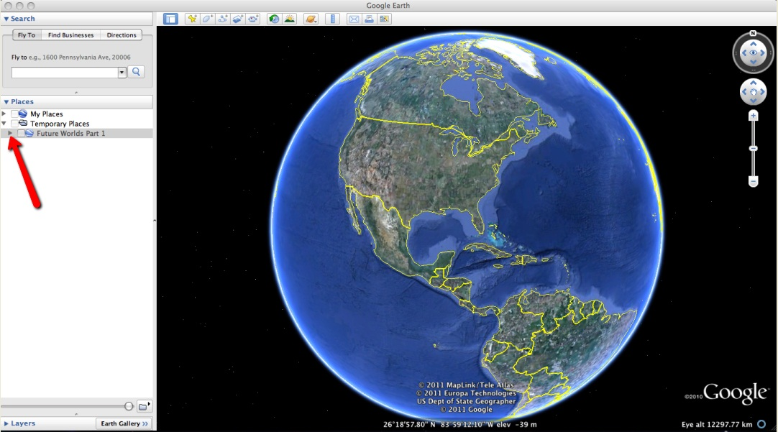

d. The “Future Worlds Part 1” drop-down list will extend (see below). If you cannot see the whole list, scroll down.

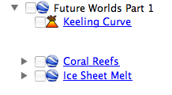

Step 2: Basic Features of Google Earth
Note the following Google Earth features, tools, and navigation controls in the figure below.

- Search Panel (arrow #1) – Type in the white box to find a location.

- 3-dimensional (3D) Viewer (arrow #2) – This window shows the Earth and its terrain.

- Navigation Controls (arrow #3) – Use these controls to zoom, look, and move around. If the navigation controls are not visible, click on View>Show Navigation>Always.

 Turn on the Google Earth Gridlines if they are not activated. Select “View” and then “Grid” as shown below (#4).

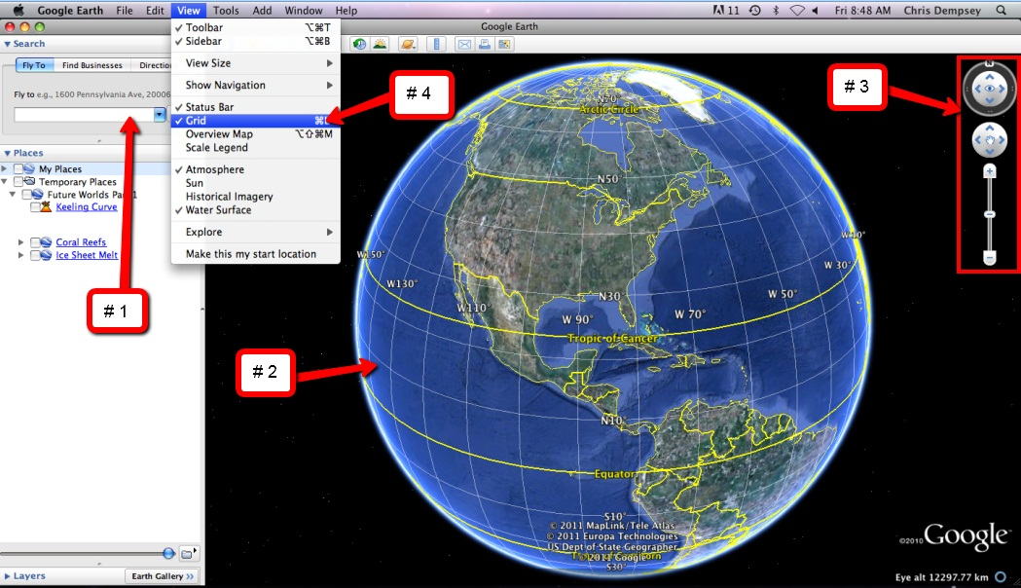

Step 3: Future Worlds Part 1 Activity

You will explore climate change during the last four decades. This investigation will help you to understand how changes in climate over the next 100 years could affect your future.

- In the Google Earth drop down menu, check the Keeling Curve box in the Places window and double click the Keeling Curve underlined text to display the image shown to the right. Read the associated text in the box that appears.  - Answer analysis questions # 1-2 on the Investigation Sheet. When finished, close the box by selecting the “x” at the top of the box. | 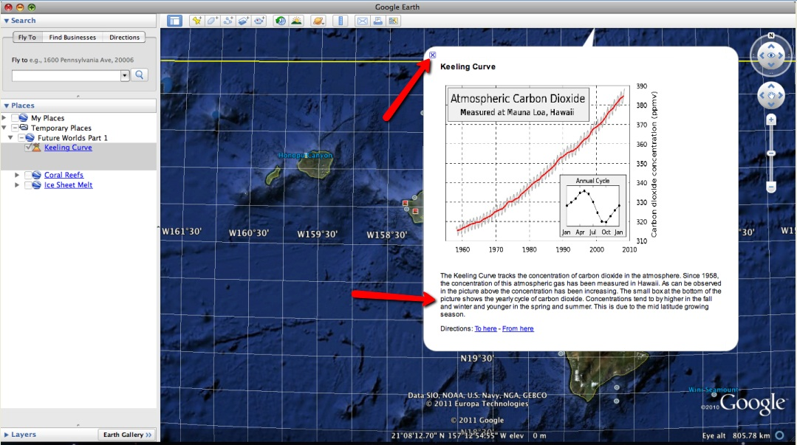
- Navigate to Coral Reefs. Double click the Coral Reefs underlined text in the Places window to display the image shown to the right (1). Read the associated text shown below the picture. When finished, close the box by selecting the “x” at the top of the box.  - Display the Coral Reefs 2001 layer and the Jamaica layer as shown to the right (2). These layers are displayed by checking the box to the left of each layer. Pay particular attention to the area between longitude W 77° and 83°.  - Observe the locations where coral reefs were present in 2001. These are indicated by the purple color on the screen. Activate the Coral Reefs 2010 layer to observe where coral reefs were found in 2010. This is indicated by the yellow color. Focus on the area to the southwest of Jamaica. This is one location where coral reefs were present in 2001, but are not found anymore in 2010. For reference, please see the image to the right (3).  - Answer analysis question # 3 on the Investigation Sheet. | - 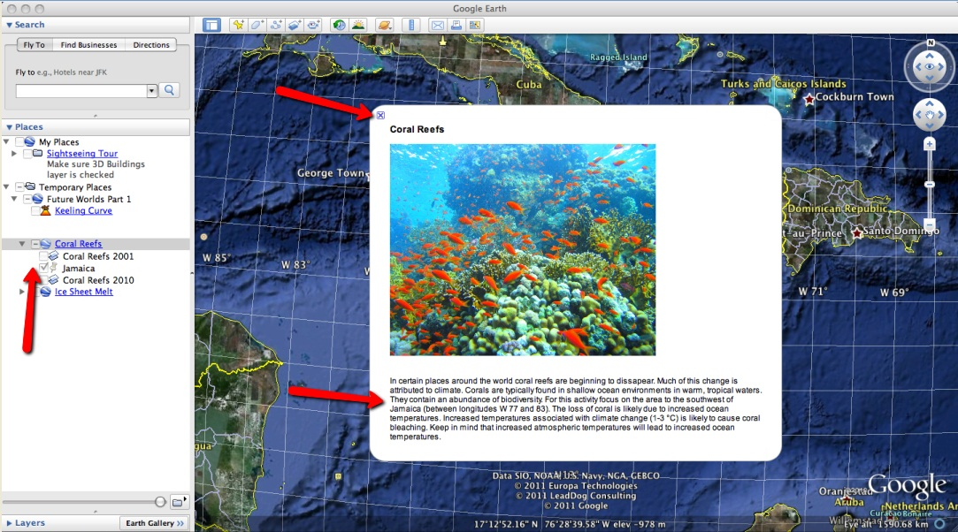  - 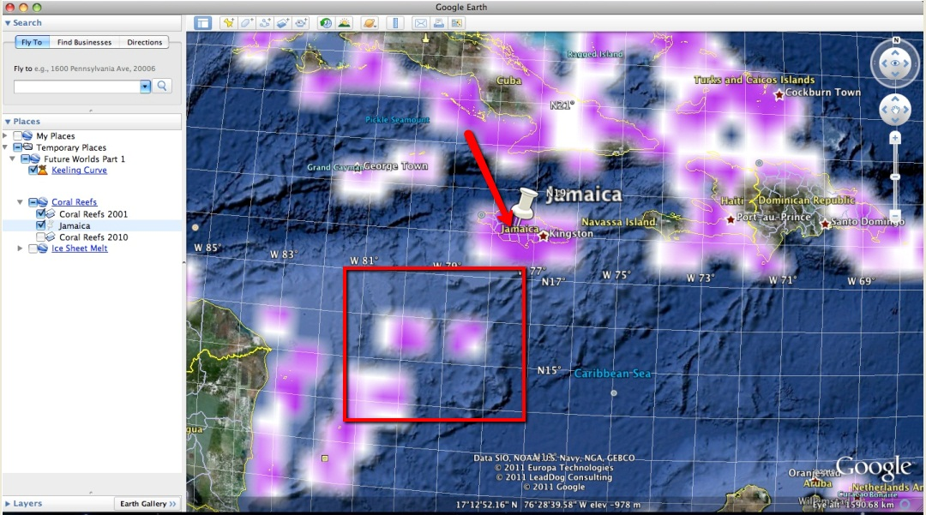  - 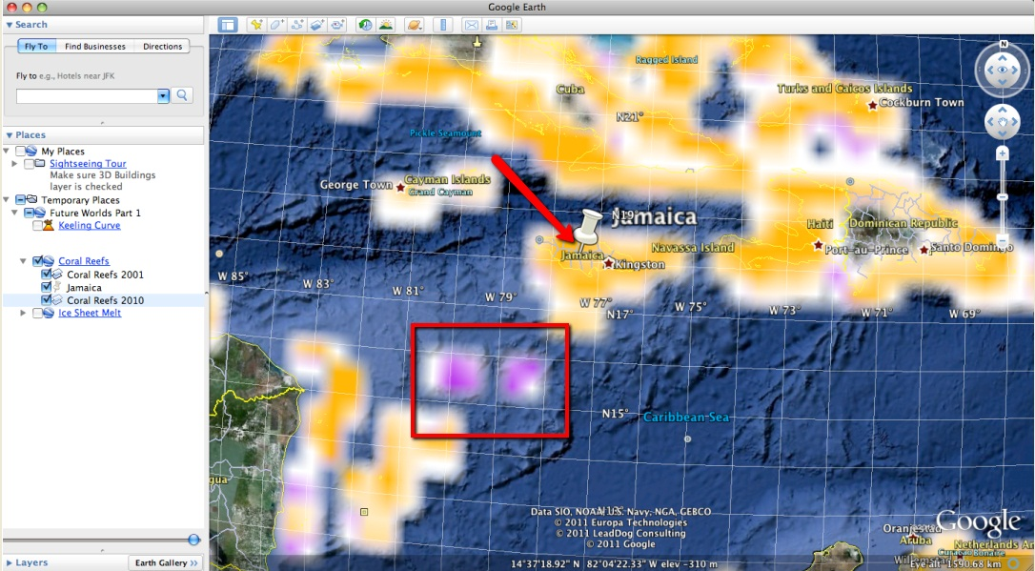
- Double click the Ice Sheet Melt underlined text in the Places window to display the image shown to the right. Read the associated text. When finished, close the box by selecting the “x” at the top of the box.  - Observe the ice layers in order from 1979, 1990, and 2010 by selecting each yearly data layer. | 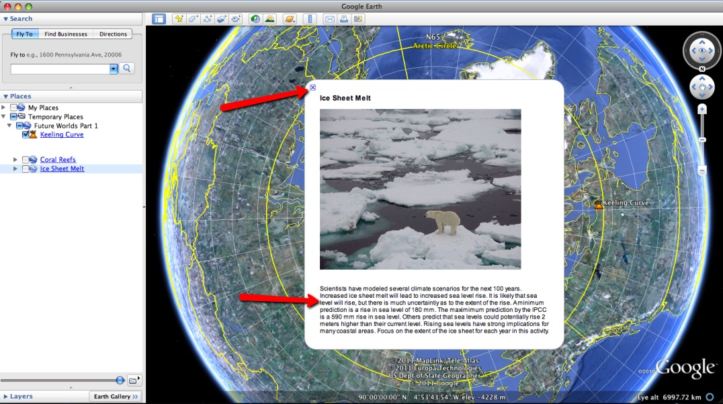  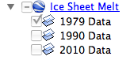
- You will need to become familiar with the measuring tool in Google Earth for this activity.  - Click on the Ruler tool on the tools menu at the top of the screen. The ruler dialog box appears (see the image to the right). If the dialog box covers up the ice sheet, move it to a different area on your screen.  - Click on Path (arrow #1). Click on the drop-down arrow (arrow #2) and select Kilometers if it is not already selected.  NOTE: Measure the continuous ice sheet displayed in the Google Earth viewer. Do NOT include Greenland in your area measurements. This is shown in the picture to the right. Do not take into account the ice islands that are found in the 1990 and 2010 images.  The continuous ice sheet area should be measured in a manner similar to that shown in the images below. Make sure you are consistent when measuring the individual continuous ice sheet layers. Be sure that the Gridlines are activated in order to follow the instructions below. |  | 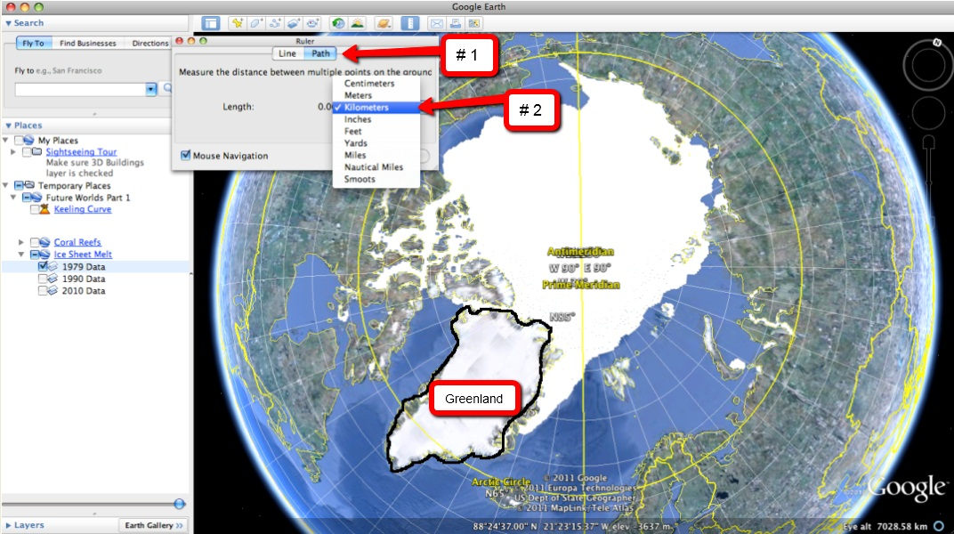
- Activate the 1979 Data layer by selecting the check box next to that layer. Make sure that the 1990 Data and the 2010 Data are left unchecked. After selecting the check box, an ice sheet will appear. If it does not immediately appear, uncheck the 1979 Data box and then recheck it.  - Use the Ruler tool to determine the length of the ice sheet. Measure the length of the continuous ice sheet at the Prime Meridian (yellow line on your screen) starting at the top (north) and finishing at the bottom (south). The line can be drawn in a manner similar to the highlighted red line in the picture to the right.  - Record the measured length in the data table on the Investigation Sheet. |  | 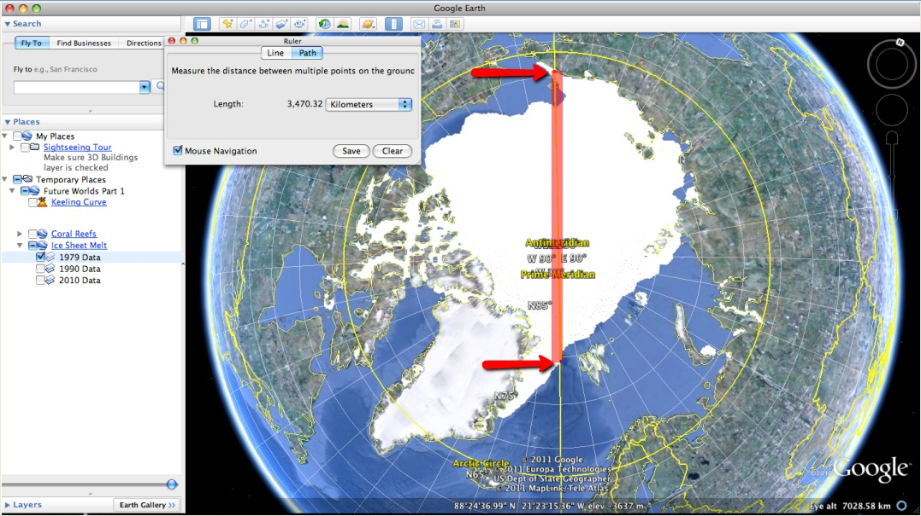
- Next, use the Ruler tool to draw a line that is perpendicular to the Prime Meridian along the middle of the continuous ice sheet as shown to the right.  - Record the measured width in the data table on the Investigation Sheet.  - The area of the continuous ice sheet can be calculated by multiplying the length and the width together. Record the final area of the continuous ice sheet in the provided space in the data table on the Investigation Sheet. | 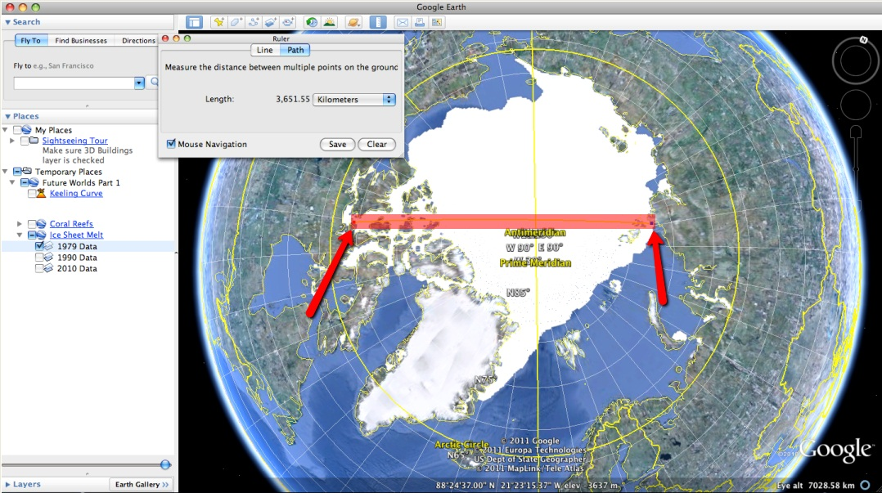
- After completing the measurements for the 1979 Ice Sheet, proceed to the 1990 Ice Sheet. Make sure that the 1990 Data box is the only selected box in the drop down list. Measure the length and width in a manner consistent with your measurements for the 1979 Ice Sheet. Record the measurements and calculate the area using the Investigation Sheet.

- After completing the measurements for the 1990 Ice Sheet, proceed to the 2010 Ice Sheet. Make sure that the 2010 Data box is the only selected box in the drop down list. Measure the length and width in a manner consistent with your measurements for the 1990 Ice Sheet. Record the measurements and calculate the area using the Investigation Sheet.

- Answer analysis questions #4-6 on the Investigation Sheet.

