Heat Capacity Demonstration

In this demonstration activity your students will:
- Understand that different Earth materials – water and sand – have different heat capacities. The heat capacity is a reflection of a material’s ability to heat up and cool down, and how well it conducts or holds heat.

Demonstration Overview

This teacher-led demonstration illustrates that different Earth materials have varying heat capacities. This demonstration highlights that the temperatures of water and sand increase at different rates when heated over a period of time. This demonstration activity should take approximately 15 minutes.

Background Information

Heat capacity can be defined in two ways:

- The amount of heat required to change an object’s temperature by a one degree Celsius.
or
- The ratio of the heat energy absorbed by a substance to the substance's increase in temperature.

Liquids, solids, and gases all have different heat capacities. These substances heat and cool at different rates when exposed to thermal energy. Heat is the transfer of thermal energy; it flows from regions of high temperatures to regions of low temperatures.

Each substance is able to store thermal energy as kinetic energy at different rates of retention. Materials cool (radiate) at different rates as well.

The specific heat of water is 4186 J/kgC.
The specific heat of sand is 835 J/kgC.

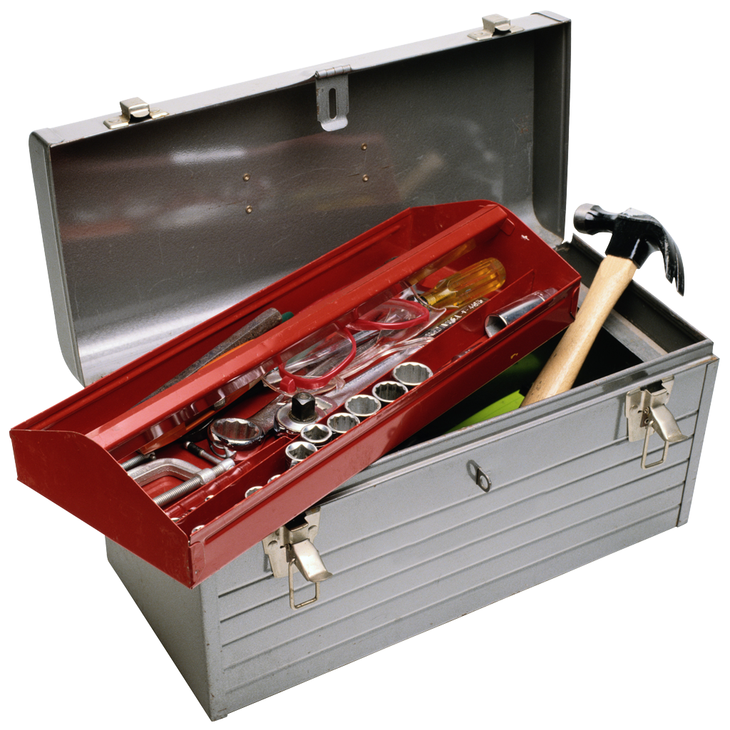 Equipment List

2 - 1000 ml heat-safe beakers
2 - ring stands
2 - temperature probes and handsets or thermometers on string
2 - hot plates
200 ml (approximate) of each of the following materials:
- water
- sand

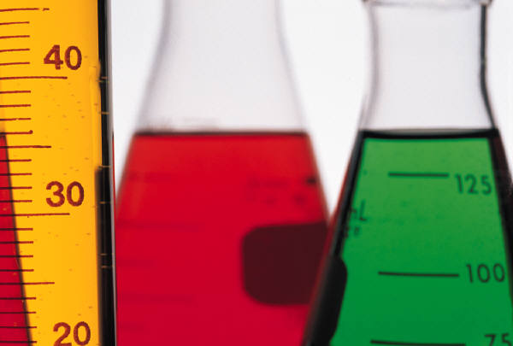 Step 1: Demonstration Preparation (set up prior to class)

- Fill beakers with the following materials:
  - Beaker 1 – water
  - Beaker 2 – sand

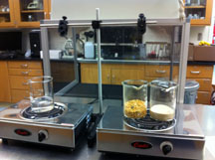
- Place beakers on hot plates. More than one beaker may be placed on a hot plate.

- Place ring stand behind hot plates.

- Place a temperature probe wire (or thermometer) through the ring stand apparatus, – suspending a temperature probe into the substance in the beaker. Make sure the temperature probe does not touch the bottom or side of the beaker. Make sure the temperature probe wire does not come in contact with the heating elements. See images below.

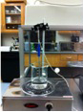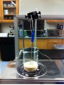

 Step 2: Conducting the Demonstration

- Ask a few students to assist with the demonstration. They will assist with gathering temperature readings at two different time intervals: an initial temperature and after 10 minutes of heating.

- Have students record an “Initial Temperature” reading.

- Turn on hot plates to high heat.

- Record temperature after 10-minutes of heating.

- Display the following data chart at the front of the classroom and place recorded readings into the chart.

Material/ Time | Initial Temperature  (0 minutes) | 10 minutes
Water
Fine Sand

 Step 3: Results and Group Discussions

Results sample (degrees Celsius):

Material/ Time | Initial Temperature  (0 minutes) | 10 minutes
Water | 20.2 | 106.7
Fine Sand | 20.5 | 55.0

- Discuss the following questions with your students:

  - Which material had the largest temperature increase during the 10-minute interval?
Water had the largest temperature increase during the 10-minute interval.

- Ask students to explain why they think different materials heat at different rates.
Explain to students that different Earth materials have different heat capacities. Water has a higher heat capacity than sand. Water initially heats up faster than many other Earth materials including sand.

