Geohazards and Me: What geologic hazards exist near me? Which plate boundary is closest to me?

Movement of the Earth’s plates creates great forces that push and reshape the rock in the crust. Sometimes the forces create hazards that are dangerous to humans. In this activity you will locate geologic hazards created by tectonic forces near you. You will:
- Discover where the most recent earthquake occurred near you and where the nearest volcano is located.
- Investigate how geologic hazards are distributed around the globe and infer how this is related to plate tectonics.

Read all instructions and answer each question on your investigation sheet.

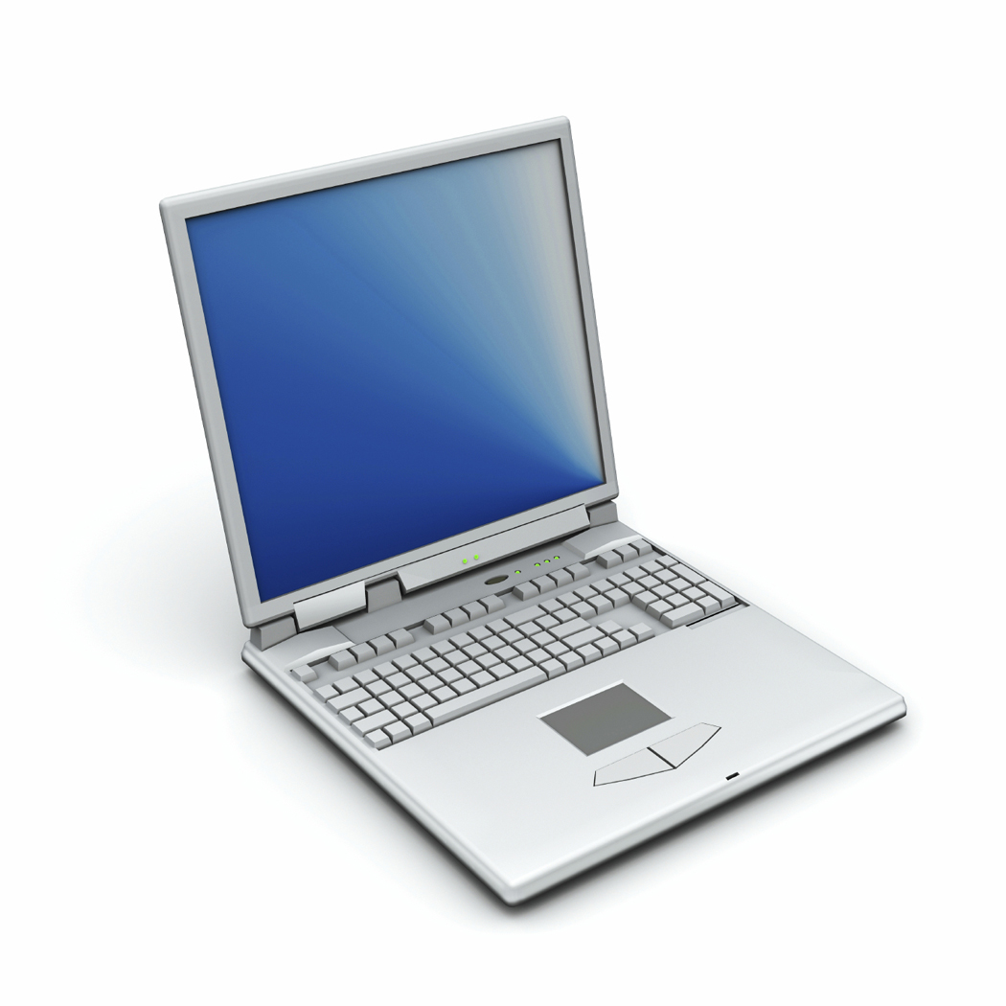 Step 1: Open Web GIS

- Open your Web browser. Go to www.ei.lehigh.edu/learners/tectonics/

- Click on: Investigation 1: Geohazards and Me: What geologic hazards exist near me? Which plate boundary is closest to me?

- When the Web GIS opens, a message will appear at the top that says “gis1.cc.lehigh.edu would like to know your location.”
  - Click on “Share Location.”

- The Web GIS will determine your location and zoom into a blue dot on your location.

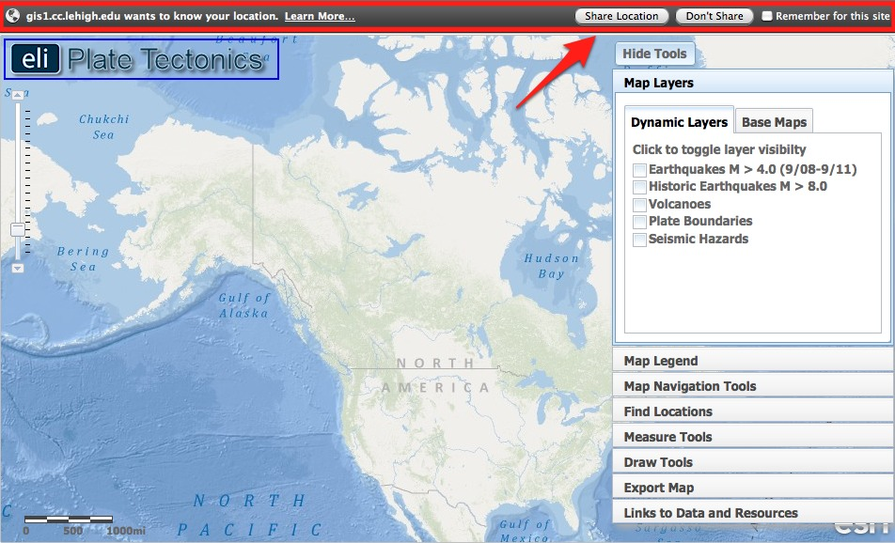

Step 2: Find the nearest earthquake to your location.

The forces of plate movement cause earthquakes. Plate movement produces stresses on faults until the rock breaks. An earthquake is the release of the elastic energy stored in the rock. This energy produces wave-like motion through the Earth’s interior and across the surface causing buildings to shake.

- Click on the Map Layers tab in the toolbars menu.  - Activate the Earthquakes M > 4.0 (9/08-9/11) layer in the Data Layers menu by clicking on the check box.  - Different shades of orange circles are displayed on your map. The location of each circle represents the epicenter of an earthquake with a magnitude greater than 4.0 that occurred between September 2008 and September 2011. The epicenter is the location on the map where the rocks first break on an earthquake fault.  - To view the map legend, click the Map Legend tab in the toolbars menu. The color indicates the focal depth of the earthquake.  - Go to the Map Navigation Tools tab and select Western U.S. or Eastern U.S. depending upon your location. This will help you see the earthquakes nearest to your location. | 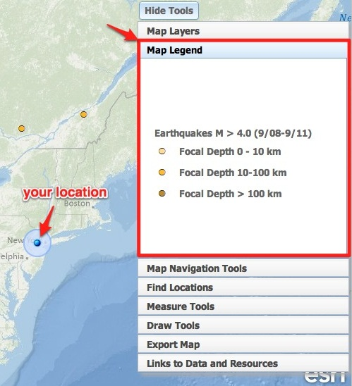
- Locate the nearest earthquake epicenter to your location. If needed, zoom in close so the epicenters can be seen separately.  - Use the Distance measure tool to measure the distance between your location and the location of the nearest earthquake.  (i) Go to the Measure Tools tab.  (ii) Click on the Distance measure tool.  (iii) Click on your location and drag your mouse to the closest earthquake.  (iv) Double click at the epicenter location to display the measurement result.  (v) Record the distance in kilometers on your investigation sheet. | 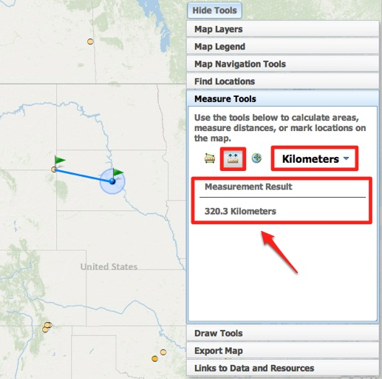
- Click on the Map Layers tab.  - Click once on the earthquake epicenter to learn more about the event. Record the latitude and longitude of the earthquake epicenter and other information about this event on your investigation sheet (# 1) and answer question 2.  - Turn off the Earthquakes M > 4.0 (9/08-9/11) layer. | 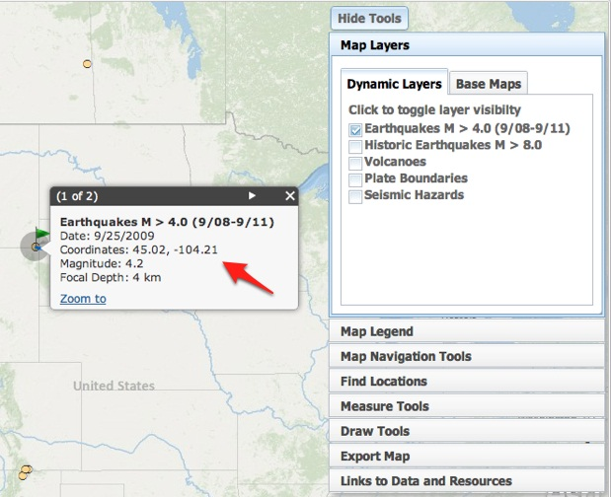
- Turn on the Historic Earthquakes M > 8.0 layer and locate the nearest earthquake of magnitude 8.0+ from your location. Notice that the map legend identifies these earthquakes as large red circles.  - Click on the earthquake epicenter to learn more about the event. Record the information on your investigation sheet (# 3). Note that historical earthquakes that precede the invention of seismographs (earthquake recording instruments) will only display the magnitude of that earthquake event. | 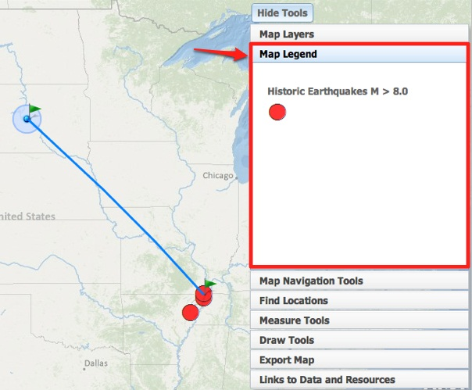

Step 3: Find the nearest volcano.

Volcanoes form along the boundaries of tectonic plates. Near some plate boundaries, conditions allow heat and molten material from the mantle to melt rock in the crust to form magma. The magma is less dense than the surrounding rock and rises to the surface to erupt as lava forming a volcano.

- Click on the Map Layers tab in the toolbars menu.  - Turn off all layers and then activate the Volcanoes layer by clicking on the check box.  - Use the navigational tools to locate blue, red, and purple triangles on your map. The location of each triangle represents the location of an active volcano. Click on the Map Legend tab to view the volcano types. | 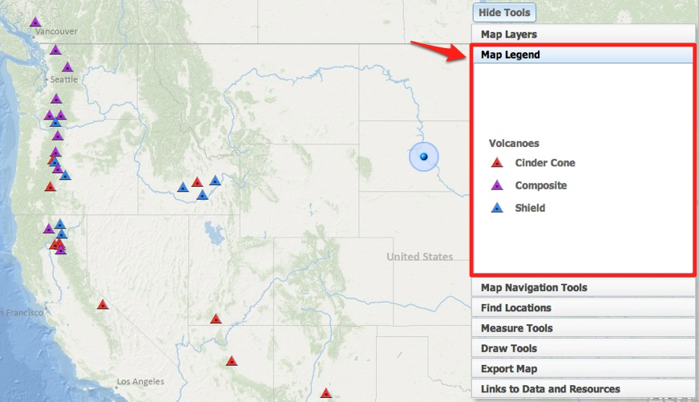
- Locate the volcano nearest to you. Select the North America bookmark in the Map Navigation Tools tab if you are unable to view the volcanoes.  - Using the Distance measure tool , measure the distance between you and the location of the nearest volcano.  - Click once on the volcano symbol to learn more about the event. Record the information about this event on your investigation sheet (#4) and answer question 5. Click on the Smithsonian Website link to learn the date of the last known eruption. | 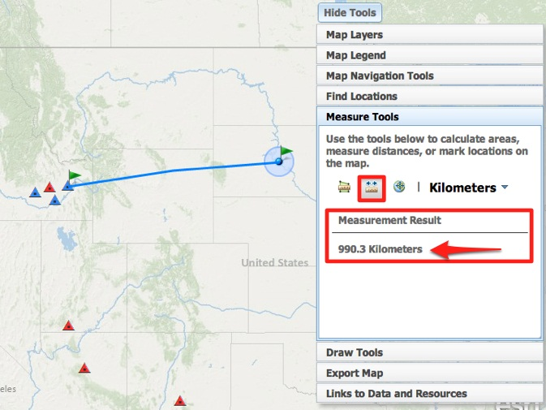

Step 4: Find the nearest plate boundary

- Click on the Map Layers tab in the toolbars menu.  - Turn off the Volcanoes layer and activate the Plate Boundaries layer by clicking the check box.  - Click on the Map Navigation Tools tab in the toolbars menu.  - Select North America from the list of bookmarked locations. | 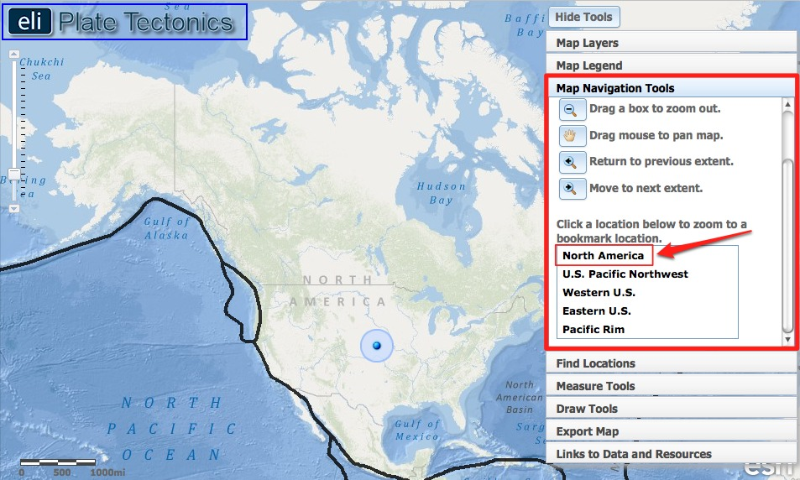
- Locate the plate boundary that is closest to you. Click on “Hide Tools” to remove the toolbars menu from the GIS if needed. You can click “Show Tools” to display it again.  - Using the Distance measure tool , measure the distance between your location and the nearest plate boundary.  - Record this distance in kilometers on your investigation sheet (#6). | 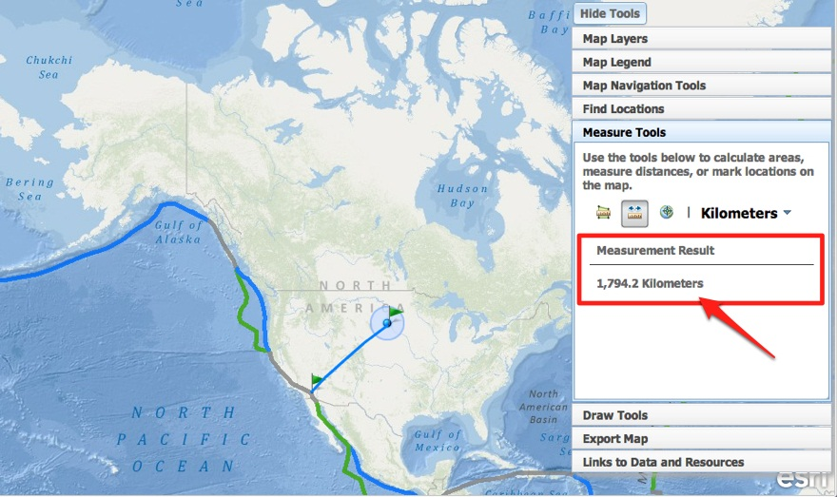
- Activate the Earthquakes > 4.0 layer and the Volcanoes layer.  - Answer questions # 7-9 on your investigation sheet. | 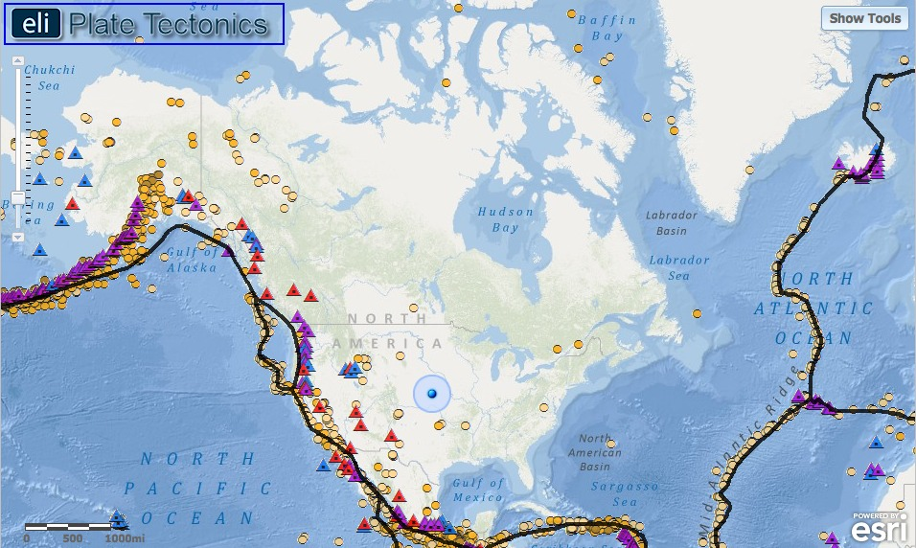
Step 5: Compare your findings to a seismic hazard map.

Geologists determine seismic hazards by studying the timing, location, and magnitude of past earthquake events. Using this information they make maps that show the hazards for citizens.

- Click on the Map Layers tab in toolbars menu.  - Turn off all layers. Activate the Seismic Hazards layer by clicking on the check box.  - Click on the Map Legend tab in the toolbars menu. The colors on this map represent the intensity of forces caused by shaking during an earthquake. Bigger earthquakes cause more shaking, so a larger value means these areas are more at-risk for higher magnitude earthquakes to occur. | 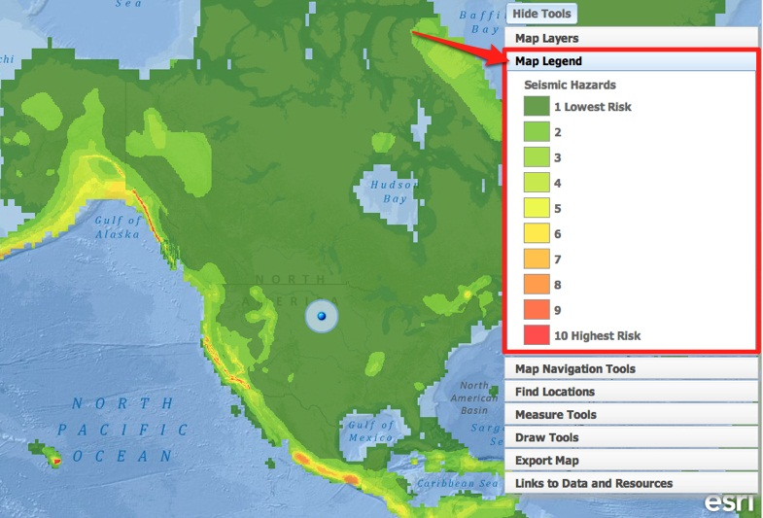
- Discover the seismic hazard in the Los Angeles, CA area.  - Click on the Find Locations tab in the toolbars menu.  - Click on the button that says  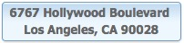  (iii) Zoom in close to explore this area.  Let’s compare the seismic hazard in the Los Angeles, CA area to the seismic hazard in Washington, D.C. area.  - Explore the seismic hazard in Washington, D.C.  - Click on the Find Locations tab in the toolbars menu.  - Click on the button that says  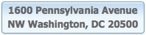  - Answer questions 10-12 on your investigation sheet. | 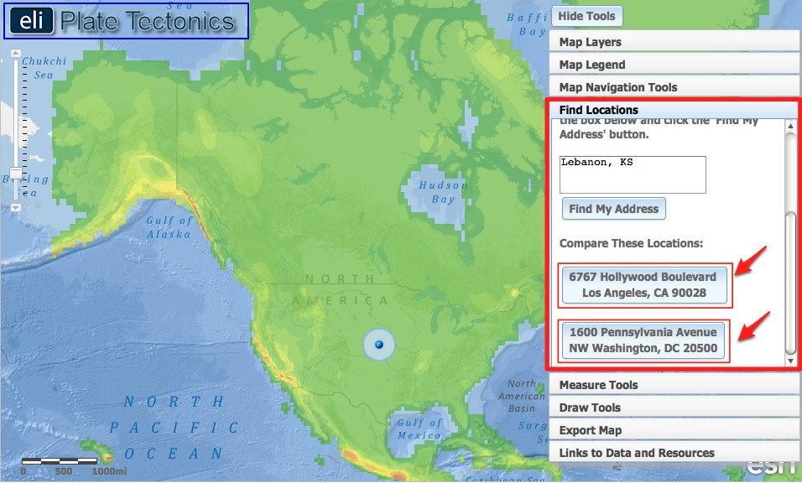
- Click on the Map Layers tab in toolbars menu. Activate the Plate Boundaries layer in the Data Layers menu by clicking on the check box.  - Navigate around the globe to see how earthquake hazards are distributed relative to plate boundaries. Answer questions 13-14 on your investigation sheet.  Helpful hint: Zoom-in to view the country names. | 