Geohazards and Me: What geologic hazards exist near me? Which plate boundary is closest to me?

Movement of the Earth’s plates creates great forces that push and reshape the rock in the crust. Sometimes the forces create hazards that are dangerous to humans. In this activity students will locate geologic hazards created by tectonic forces near your location. They will:
- Discover where the most recent earthquake occurred near your location and where the nearest volcano is located.
- Investigate how geologic hazards are distributed around the globe and infer how this is related to plate tectonics.

Model the following procedural instructions with your students. It is recommended that you display your computer image to the front of the classroom.

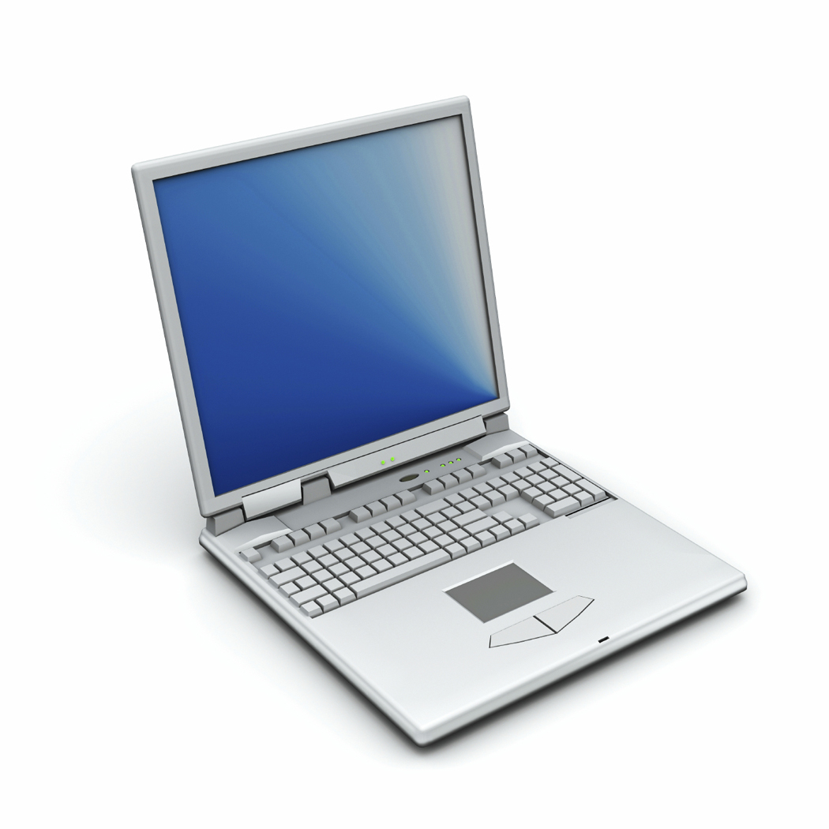 Step 1: Open Web GIS

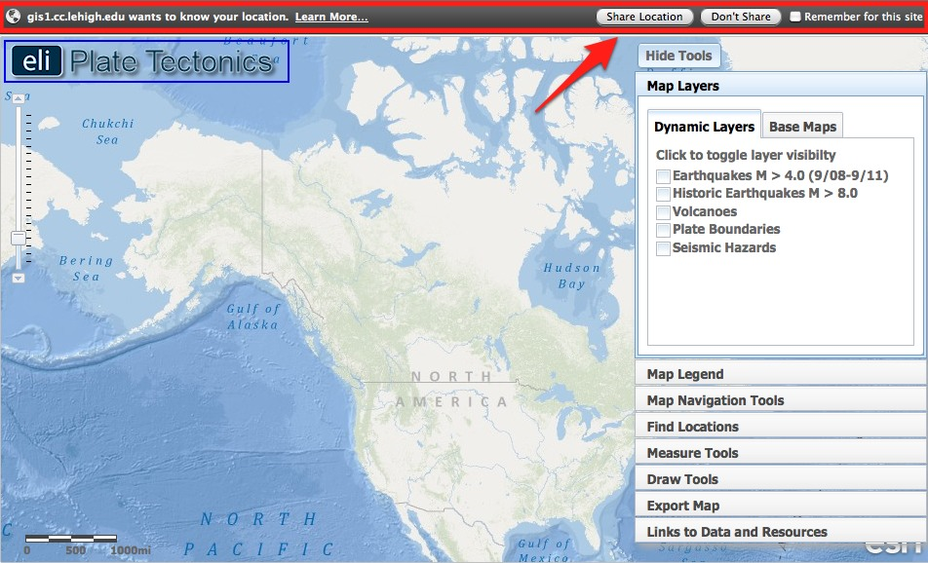

- Have students open their Web browser. Go to www.ei.lehigh.edu/learners/tectonics/

- Click on: Investigation 1: Geohazards and Me: What geologic hazards exist near me? Which plate boundary is closest to me?

- When the Web GIS opens, a message will appear at the top that says “gis1.cc.lehigh.edu would like to know your location.”
  - Click on “Share Location.”
Note: Your computer’s location is not being shared with anyone else. It only communicates with the secured Web server at Lehigh University to place a location point on your GIS.

- The Web GIS will determine your location and zoom into a blue dot on your location.

Troubleshooting:

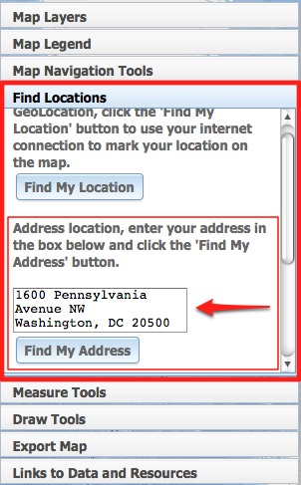 | - If the Web GIS cannot determine your location, click on the Find Locations tab in the toolbars menu.  - Type in your address, the name of your city, or a local zip code into the box and click “Find My Address”  - The Web GIS will create a blue dot and zoom to this location.

Step 2: Find the nearest earthquake to your location.

In this step, your students will learn about recent earthquakes (occurred between September, 2008 and September, 2011) and historic earthquakes (since 1800) that occurred near your location. The forces of plate movement cause earthquakes. Plate movement produces stresses on faults until the rock breaks. An earthquake is the release of the elastic energy stored in the rock. This energy produces wave-like motion through the Earth’s interior and across the surface causing buildings to shake.

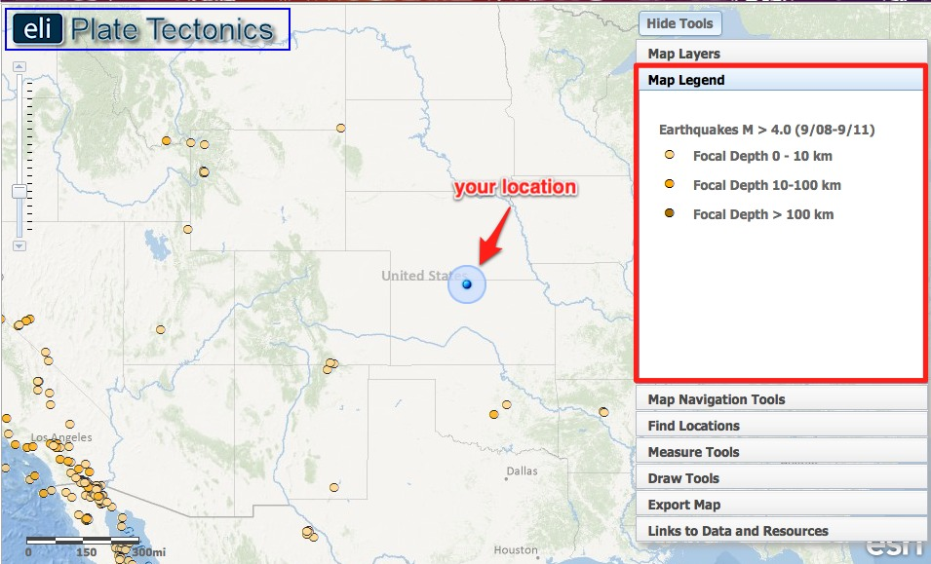

- In the Map Layers tab, have students activate the Earthquakes M > 4.0 (9/08-9/11) layer by clicking on the check box.

- Different shades of orange circles are displayed on the map. The location of each circle represents the epicenter of an earthquake with a magnitude greater than 4.0 that occurred between September 2008 and September 2011. The epicenter is the location on the map above where the rocks first break on an earthquake fault.

- Students should click on the Map Legend tab to view the map legend. The color indicates the focal depth of the earthquake. The focal depth is the depth of the focus, the point in the crust where a seismic rupture begins.

- In the Map Navigation Tools tab students should select Western U.S. or Eastern U.S. depending upon your location. This will zoom your GIS image and focus the map into your area to help students visualize the earthquakes that have occurred near your location. The size of the symbols and the number of earthquakes that are displayed in the Web GIS are dependent upon the extent of the navigational zoom. Fewer events are shown with broader navigational extents so the map is not too cluttered with overlapping data points.

- Have students locate the nearest earthquake epicenter to your location. If you live in an area with a lot of earthquakes, it is recommended that students zoom in closely to make sure the epicenters are separated so they can see all of the earthquakes in your area (for example – see Southern California in the image below). Inform students they can click on “Hide Tools” to remove the toolbars menu from the GIS. They can then click “Show Tools” to display the toolbars menu again.

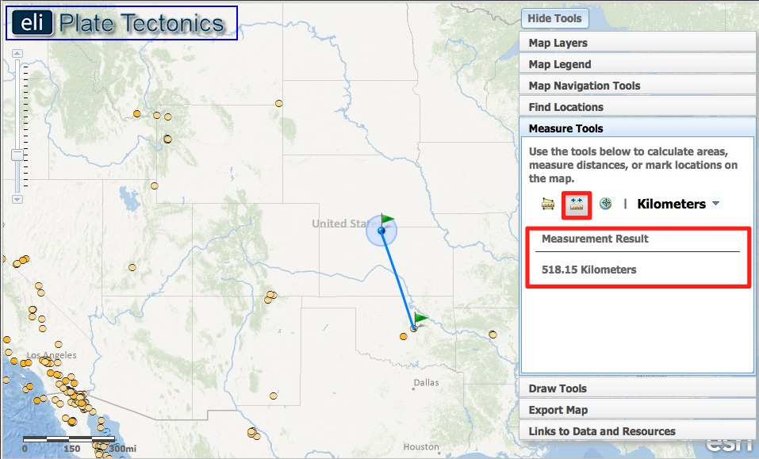
- Students will use the Distance measure tool to measure the distance between your location and the location of the nearest earthquake. To use the distance measure tool:

- Select the Measure Tools tab on the toolbars menu.
- Click on the Distance measure tool .
- Click on your location. A green flag will appear to mark the location.
- Drag your mouse to the closest earthquake epicenter.
- Double click at the epicenter location. A green flag will appear to mark the location. If you single click, the location will still be marked, but the line will be continued.
- The Measurement Result is displayed in the menu.

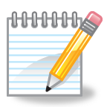 Instruct students to record the distance in kilometers on their investigation sheet.

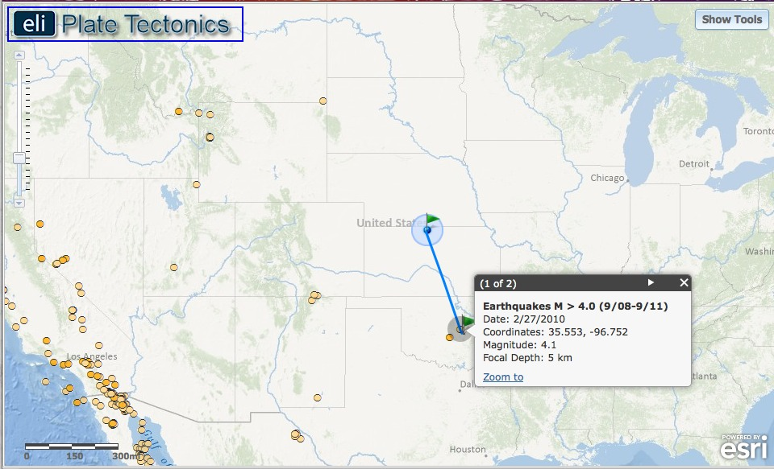

Instruct students to record the location, magnitude, depth of earthquake, and date of the earthquake on their investigation sheet (# 1) and answer question 2. Remind students that they only need to click once (not a double-click) to access this data. Double-clicking on the GIS will zoom-in on the map display.
Important Note: Historical earthquakes that preceded the invention of seismographs (earthquake recording instruments) will only display the magnitude of that earthquake event.
  - The latitude and longitude of the cursor location is displayed in the bottom left hand corner. Note that the Web GIS displays coordinates in decimal degrees. If needed, explain to students that negative latitude values correspond to locations south of the equator in the southern hemisphere and negative longitude values correspond to locations west of the prime meridian in the western hemisphere.
  - Instruct students to click on the Map Legend tab. Students can learn more about earthquake events by clicking on each earthquake epicenter. This action reveals a pop-up box with the details of the seismic event.
Turn off the Earthquakes M > 4.0 (9/08-9/11) layer.

Troubleshooting:
• To turn off the Distance measure tool, just click on the Map Layers tab.
• If the GIS Web viewer appears to have a resolution issue with the image display, reset your Web browser zoom. To do this in the recommended Firefox Web browser, select Zoom from the View drop-down menu and click Reset.
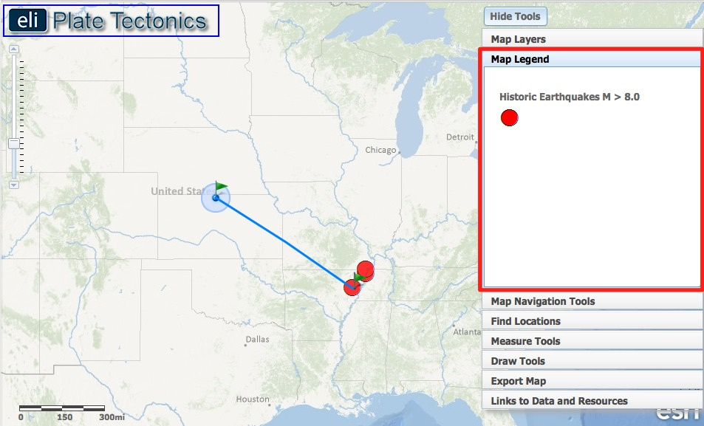

- Earthquakes with magnitude > 4.0 were likely all felt by humans, but may not have caused great damage to a geographical area. To locate earthquakes that caused great damage closest to your location, instruct students to turn on the Historic Earthquakes M > 8.0 layer and locate the nearest earthquake of magnitude 8.0+. Note the map legend that distinguishes these earthquakes as large red circles.

Instruct students to record the distance, location, magnitude, depth of earthquake, and date of the earthquake on their investigation sheet (#3).

Step 3: Find the nearest volcano to your location.

In this step, your students will locate and learn about the volcano nearest to your location. All of the volcanoes on the map are identified as “active” and could erupt in the future. Volcanoes form along the boundaries of tectonic plates. Near some plate boundaries, conditions allow heat and molten material from the mantle to melt rock in the crust to form magma. The magma is less dense than the surrounding rock and rises to the surface to erupt as lava forming a volcano.

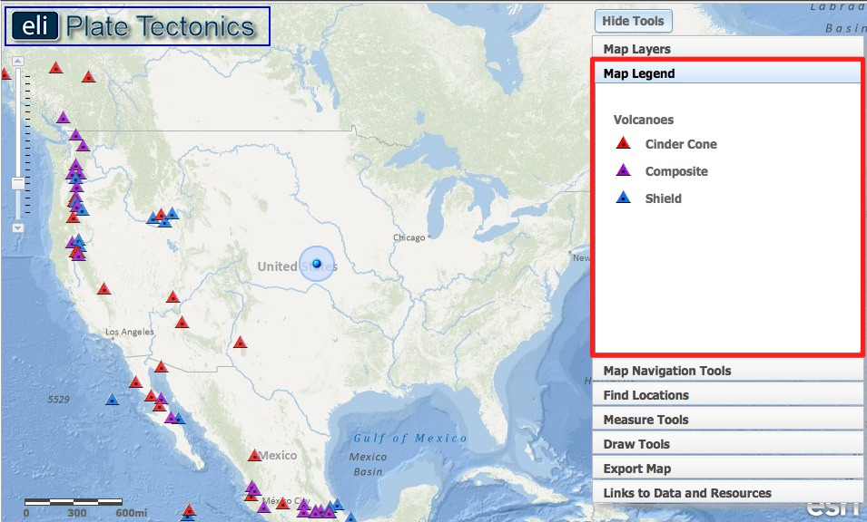

- Click on the Map Layers tab in the toolbars menu.

- Instruct students to turn-off all layers and then activate the Volcanoes layer by clicking on the check box. The location of each triangle represents the location of an active volcano. Instruct students to use the navigational tools to locate blue, red, and purple triangles on their map.

- Students should click on the Map Legend tab in the toolbars menu to view the volcano types. The color indicates the volcano type (cinder cone, composite, or shield).

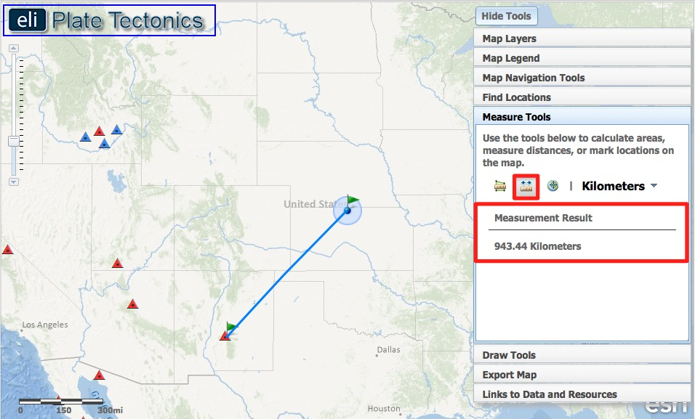
- Have students locate the volcano nearest your location, and use the Distance measure tool to measure the distance between your location and the location of that volcano. Students should click on the volcano symbol to learn more about that volcano. Depending on your location, you may need to have students select the North America bookmark in the Map Navigation Tools tab to view the volcanoes.
Instruct students to record the distance, location, type of volcano, date of last eruption, and summit elevation on their investigation sheet (#4) and answer question 5. Instruct students to click on the Smithsonian Website link to learn the date of the last known eruption.

Step 4: Find the nearest plate boundary

Earthquakes and volcanoes occur along plate boundaries. In this step, students will measure the distance from their location to the nearest plate boundary and analyze patterns between plate boundaries and the location of earthquake epicenters and volcanoes.

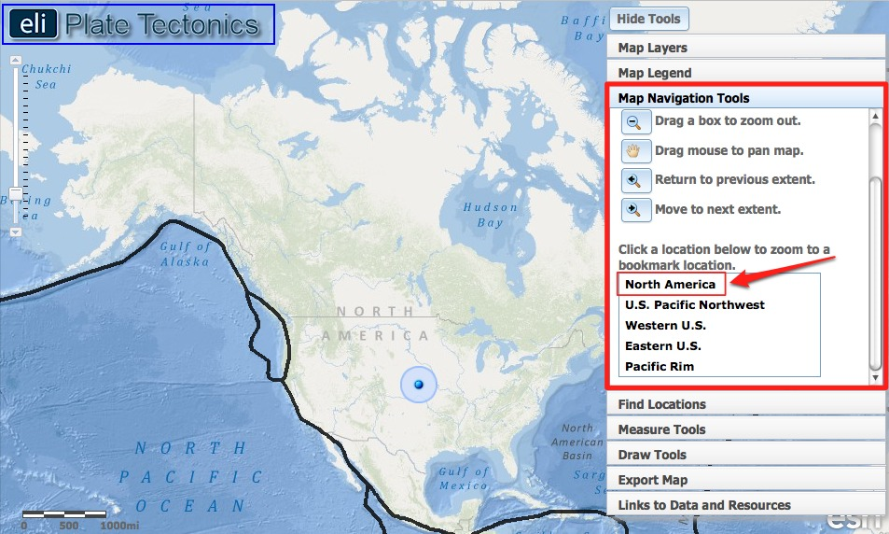

- Click on the Map Layers tab in the toolbars menu.

- Instruct students to turn-off the Volcanoes layer and activate the Plate Boundaries layer by clicking the check box. The black line represents a boundary between two tectonic plates.

- For this step, it is easier to see the plate boundaries from a distant perspective. Instruct students to click on the Map Navigation Tools tab in the toolbars menu, and select North America from the list of bookmarked locations.

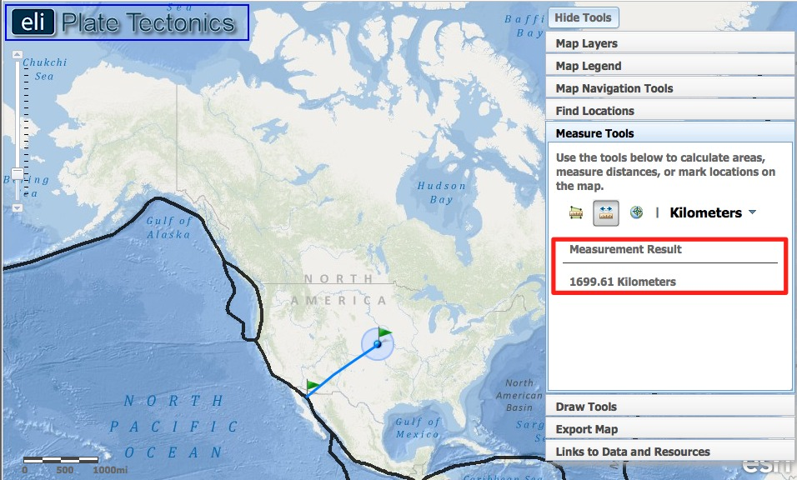

- Have students locate the plate boundary that is closest to your location and use the Distance measure tool to measure the distance between your location and the nearest plate boundary. If you live on the east coast, this boundary may be in the Atlantic Ocean, or in the Caribbean Sea.
Note: You may wish to tell students to click “Hide Tools” to display more of the map.
Instruct students to record the distance in kilometers on their investigation sheet (#6).

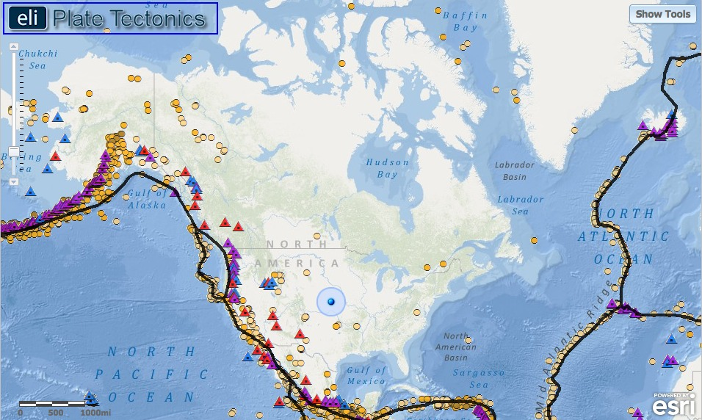

- Next, students should click on the Map Layers tab in the toolbars menu and turn on the Earthquakes M > 4.0 (9/08-9/11) layer and Volcanoes layer.

Instruct students to answer questions 7-9 on their investigation sheet.

Step 5: Compare your findings to a seismic hazard map.

In this last step, students will learn how scientists communicate information about seismic hazards to the public and assess hazards in different locations. Geologists determine seismic hazards by studying the timing, location, and magnitude of past earthquake events. Using this information they develop risk assessment maps that communicate the potential for seismic hazards to occur in a particular area and the worst case scenario should the hazardous event occur.

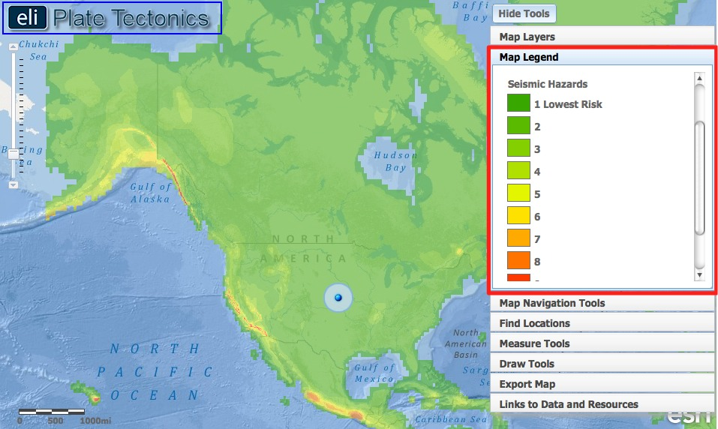

- Click on the Map Layers tab in the toolbars menu.

- Instruct students to turn-off all layers and then activate the Seismic Hazards layer by clicking on the check box. Instruct students to click on the Map Legend tab in the toolbars menu. The colors on this map represent the intensity of forces caused by shaking during an earthquake. Bigger earthquakes cause more shaking, so a larger value means these areas are more at-risk for higher magnitude earthquakes to occur.

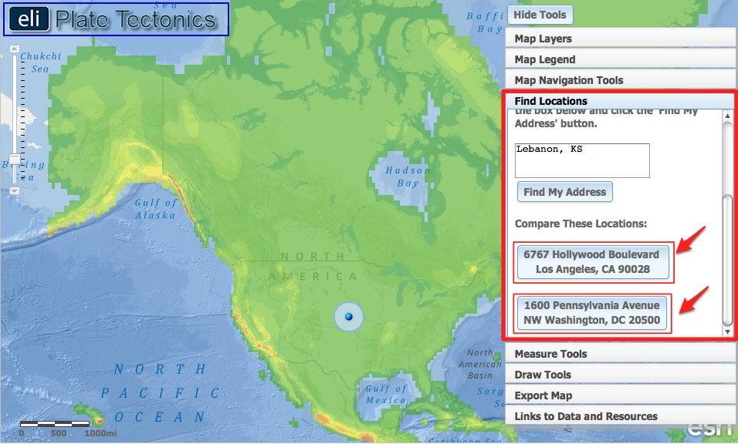

Instruct students to compare the seismic hazard between Los Angeles, CA and Washington, D.C.
Each location is bookmarked in the Find Locations tab on the toolbar menu.
- Instruct students to click on the Find Locations tab in the toolbars menu.
- First, instruct students to click on the button that says:
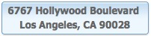
Instruct students to zoom in closely to explore this location.

- Second, instruct students to click on the button that says:
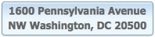
Instruct students to answer questions 10-12 on their investigation sheet.

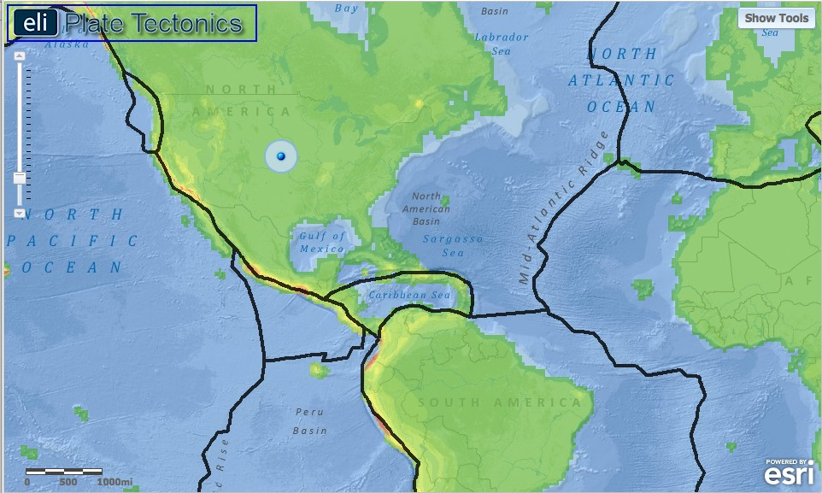

- Instruct students to click on the Map Layers tab in the toolbars menu and activate the Plate Boundaries layer by clicking on the check box. Instruct students to navigate around the globe to analyze how earthquake hazards are distributed relative to plate boundaries.
Instruct students to answer questions 13-14 on their investigation sheet. Note to students that they can zoom-in to view the country names.

