How do we recognize plate boundaries?

The Earth’s lithosphere is made-up of tectonic plates that pull apart, collide, and slide past each other. In this activity, you will use tectonics data in a Web GIS to identify the eastern and western boundaries of the North American plate. You will:
- Analyze earthquake epicenter and volcano data to determine the boundaries of the North American Plate.
- Analyze the movement of the surrounding plates to determine plate boundary types (divergent, convergent, or transform).

Read all instructions and answer each question on your investigation sheet.

Step 1: Open Web GIS

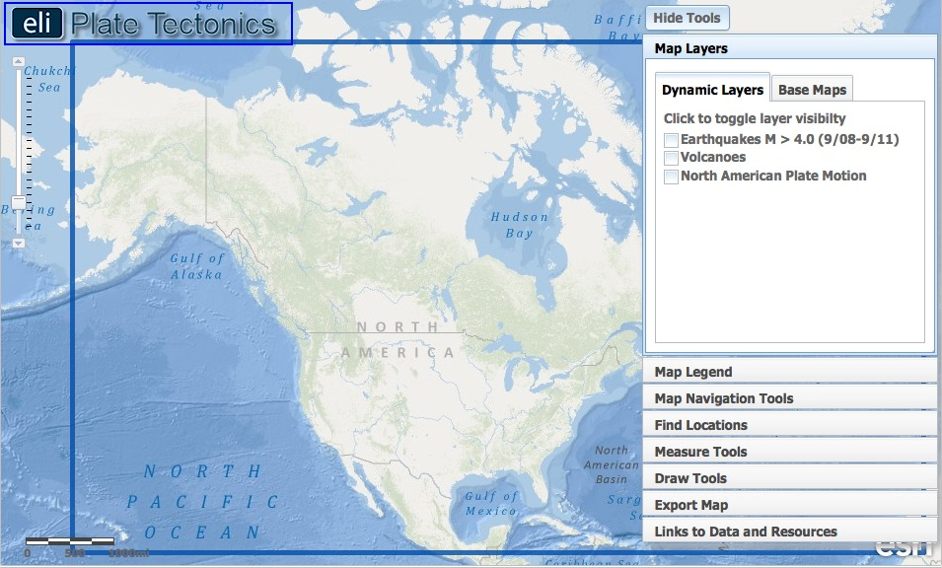

Open your Web browser. Go to www.ei.lehigh.edu/learners/tectonics/

Click on: Investigation 2: How do we recognize plate boundaries?
The Web GIS will open to a map focused on the United States with a blue box around the study area.

Step 2: Identify and trace the North American Plate boundary.

We live on the North American Plate, which includes the continent of North America and parts of the Atlantic and Arctic Ocean floors. Tectonic forces cause plates to collide, pull apart, and slide past each other causing earthquakes. We will identify areas that determine plate boundary locations.

- Click on the Map Layers tab in the toolbox menu.  - Activate the Earthquakes M > 4.0 (9/08-9/11) layer in the Dynamic Layers menu by clicking on the check box.  - Different shades of orange circles are displayed on your map. The location of each circle represents the epicenter – the point on the Earth’s surface above the origin of the earthquake -- of an earthquake with a magnitude > 4.0 that occurred between September 2008 and September 2011.  - To view the map legend, click the Map Legend tab in the toolbox menu. The color indicates the focal depth -- the point in the earth where an earthquake originates -- of the earthquake.  - Click on in the upper right hand corner to hide the toolbox menu. You should notice that earthquakes appear in some locations and not others. | 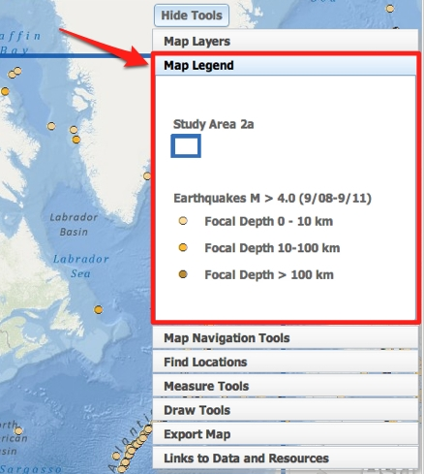
- You will use the Draw Tools to outline the North American plate boundary. This toolbox allows you to draw lines and place labels on your map.  - Click on in the upper right hand corner to show the toolbox menu. Select the Draw Tools tab in the toolbox menu.  - Use the tool to trace the path of the densely clustered earthquakes on the Pacific Coast of North America. First, click on a point at the western edge of the blue box to start drawing a line (see figure to the right). Next, hold your mouse down while you drag along the cluster of earthquakes. To finish your line, let go of your mouse at the southern edge of the blue box (see figure to the right). If you make a mistake, you can erase a line segment by clicking . | 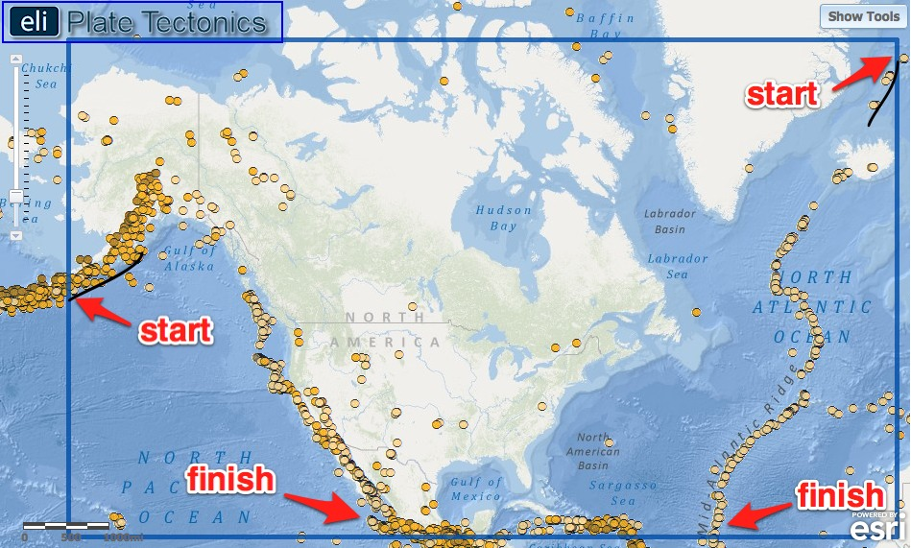
- The eastern edge of the North American plate is located in the Atlantic Ocean. Click on to hide the toolbox menu. Locate the clusters of earthquakes and use the polyline tool to trace the plate boundary in the North Atlantic Ocean.
- Two other plates are located on the eastern boundary of the North American Plate. Notice the line of earthquakes that runs east-west between Europe and Africa. This is another plate boundary that separates these two plates. Trace this line of earthquakes with the polyline tool within the blue box.
If needed, click on to hide the toolbox menu.

- When you are finished drawing the boundaries, click the button in the Draw Tools tab to deactivate the drawing tools.

- Submit your map image using the Export Map tool. (Note: Your teacher may ask you to take a screenshot instead).  First, click on the Export Map tab in the toolbox menu. Next, click . This will create an image of your GIS map to be exported to your computer. Next, follow directions in the toolbox for Macintosh or PC depending upon the computer you are using. Your teacher will instruct you with specific file naming instructions and location directions. When you are finished, clickto return to your map.  Make sure you keep your plate boundaries on your map. | 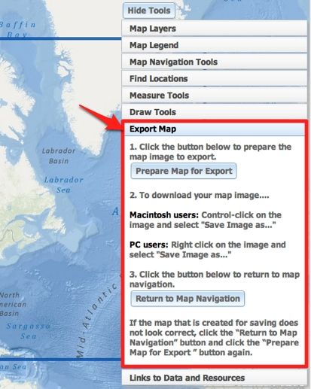

Step 3: Identify the plates surrounding the North American Plate.

There are three major plates that border the North American plate. Identify these adjacent plates and record the plate names on your investigation sheet.

- Click on the Map Layers tab in the toolbox menu. Hide the toolbox menu so you can see the whole map.  - To identify a plate name, click once on the GIS map. When you click on a location, a box will appear with that location’s plate name. Click on North America. A box will appear that says “Plate Name: North American Plate” will appear.  - One plate is located on the western plate boundary of the North American plate. Click on a point in the Pacific located near latitude 35º and longitude -132º.  Reminder: the latitude and longitude of your cursor is displayed on the bottom left corner of your GIS map.  Answer Question #1-3 on your investigation sheet. | 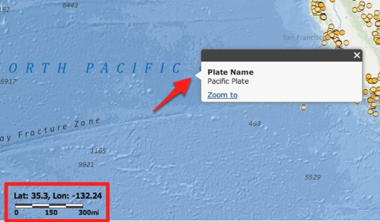
- Identify the name of the plates south of the North American plate. Remember, you just learned earthquake epicenter clusters identify plate boundaries.  - Click on the Map Layers tab in the toolbox menu. Hide the toolbox menu so you can see the whole map.  - Click different locations south of the North American plate, below the blue study box, where you think there may be a different plate. When you click on a location, a box will appear with that location’s plate name. Click until you have identified 3 different plates.  Answer Question #4 on your investigation sheet. | 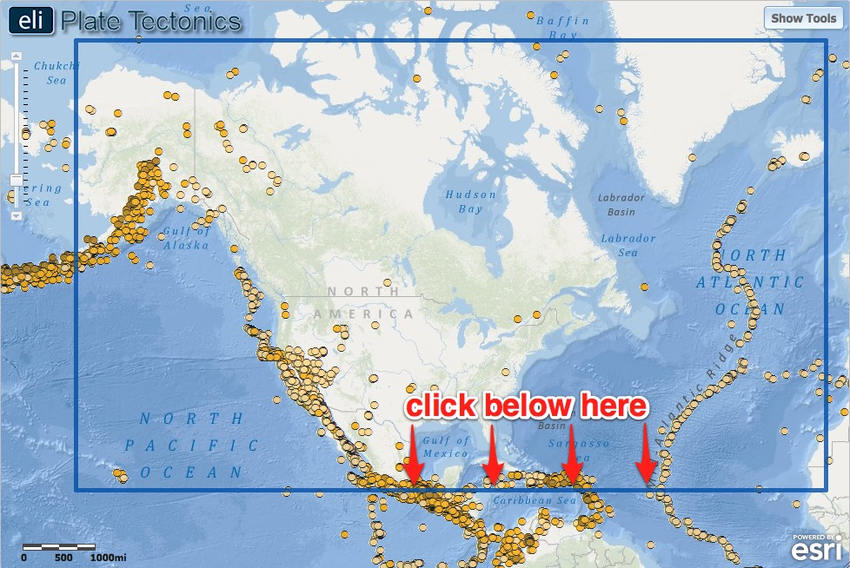

Step 4: Revisit the western plate boundary and investigate volcano locations.

Sometimes when plates collide, subduction related to volcanoes occurs on one side of the plate boundary.

Click on the Map Layers tab in the toolbox menu.  - Activate the Volcanoes layer in the Dynamic Layers menu by clicking on the check box. The displayed triangles represent the location of 3 different types of volcanoes.  - To view the map legend, click the Map Legend tab in the toolbox menu.  - Click on the Map Navigation Tools tab in the toolbox menu.  - Select U.S. Pacific Northwest from the list of bookmark locations. Your map will zoom to this area and a new blue study area box will appear. | 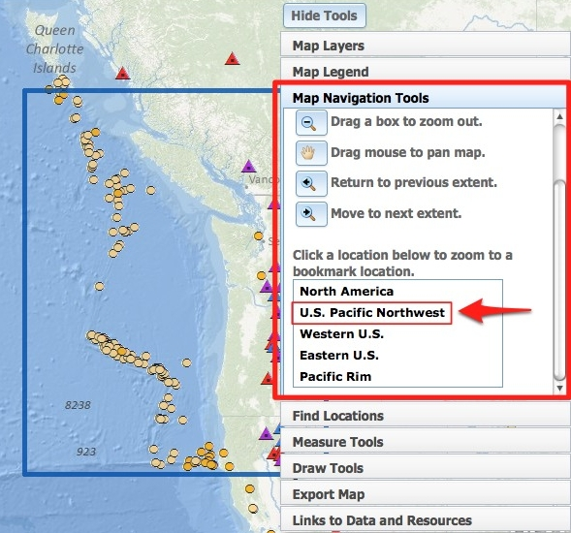
- There is another small plate located on the western edge of the United States. Click the Draw Tools tab. Use the tool to trace a line to the west of the volcanoes near the coast (See image to the right). Make sure your line does not extend into the Pacific Ocean.  - Click the button, then, click to another toolbox menu tab. Next, click the middle of the plate (latitude 46º and longitude  -127º) to find out its name. Your map should now display a newly drawn plate with its name displayed.  Answer Question #5-6 on your investigation sheet. | 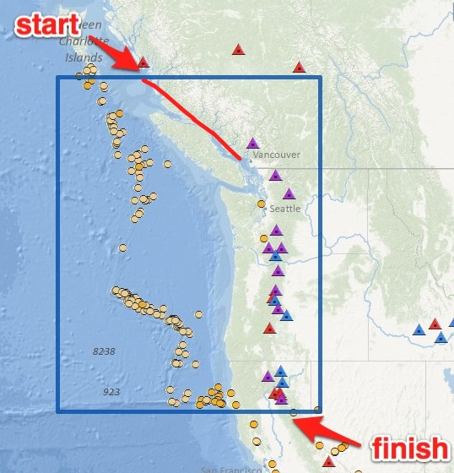
- Click on the Map Navigation Tools tab in the toolbox menu.

- Select North America from the list of bookmark locations.

- Submit your map using the Export Map tool. First, click on the Export Map tab in the toolbox menu. Then, click . This will create an image of your work that is ready to be exported. Next, follow directions in the toolbox for Macintosh or PC depending upon the computer you are using. Your teacher will instruct you with specific file naming instructions and location directions. When you are finished, clickto return to your map.

Step 5: Identify the types of plate boundaries.

There are three types of plate boundaries that are defined by the relative plate motion across the plate boundary. The three types of boundaries are:
1. Divergent boundary for plates moving apart.
2. Convergent boundary for plates moving towards one another.
3. Transform boundary for plates moving parallel to their boundary.

- Click on the Map Navigation Tools in the toolbox menu.  - Select North America from the bookmark locations list.  - Click on the Map Layers tab in the toolbox menu.  - Turn off the Volcanoes and Earthquakes M > 4.0 (9/08-9/11) layers. Activate the North American Plate Motion layer.  - These arrows show how the plates are moving relative to the boundary. Click on the Plate Motion Image icon at each arrow pair to view what is occurring at these plate boundaries. | 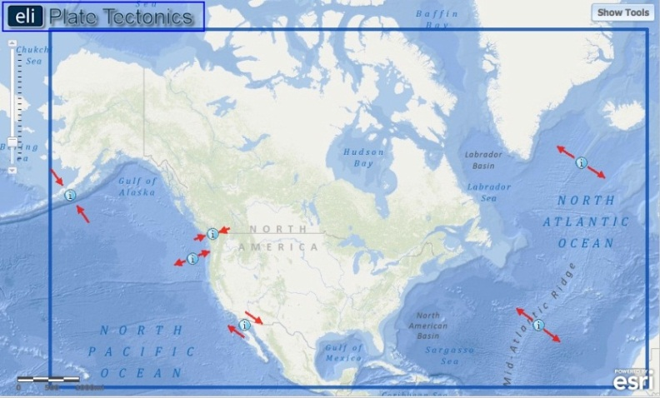
- Arrows perpendicular to the boundary and pointing towards each other are located at convergent boundaries.  - Arrows perpendicular to the boundary and pointing away from each other are located at divergent boundaries.  - Arrows parallel to the boundary and pointing in opposite directions are located at transform boundaries.  Answer Questions #7-11 on your investigation sheet. | 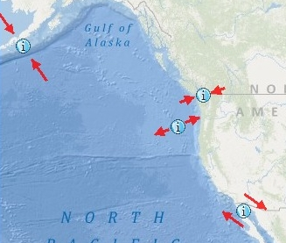

Step 6: Identify the different types of lithosphere

The lithosphere is the layer of the Earth that is broken into plates. It is made-up of the crust and the uppermost part of the mantle. There are two types of lithosphere:
- Oceanic lithosphere, which is associated with oceanic crust and exists beneath ocean basins
- Continental lithosphere, which is associated with continental crust and exists beneath continents

Look at your map. Examine the relationship between the plate boundaries you traced and the edge of the continents. Answer Questions #12 on your investigation sheet.

