How does thermal energy move around in the Earth?

Movement of the Earth’s tectonic plates is driven by heat flow in the Earth’s interior. Plumes of mantle rock rise slowly from the bottom of the mantle to the top and create convective currents. In this activity you will locate areas where heat escapes from the Earth’s interior and provide evidence for a hot mantle. You will:
- Investigate how surface heat flow (loss) is distributed around the Earth and it’s relationship to plate boundaries.
- Discover geologic features on the Earth’s surface that are associated with heat loss.

Read all instructions and answer each question on your investigation sheet.

Step 1: Open Web GIS

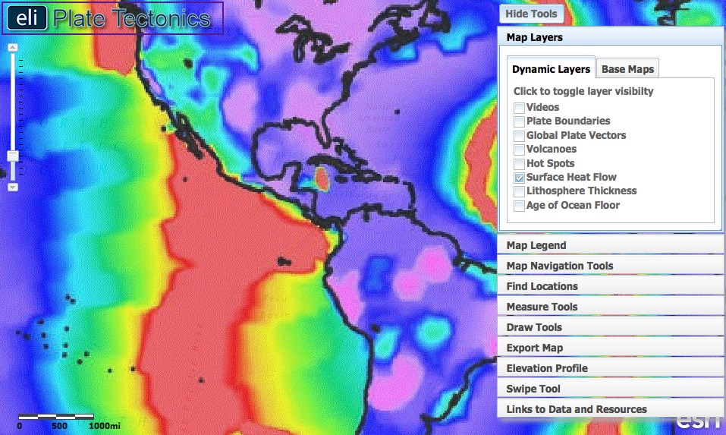

- Open your Web browser. Go to www.ei.lehigh.edu/learners/tectonics/

- Click on: Investigation 3: How does thermal energy move around in the Earth?

- The WebGIS will open to a global view with the Surface Heat Flow layer turned on.

Step 2: Discover the relationship between heat flow and plate boundaries.

Heat from the Earth’s core and mantle causes convection currents to form in the mantle. Although mainly solid, over millions of years the immense heat and pressure in the Earth causes the mantle to gradually flow and drive plate tectonics.

- The different colors on the Surface Heat Flow layer represent the heat released from the Earth’s interior at that location.  - To view the map legend, click the Map Legend tab in the toolbox menu. The color indicates the amount of heat released from the interior of the Earth in mW/m², a unit of heat flow of milliWatts per square meter at the Earth’s surface. | 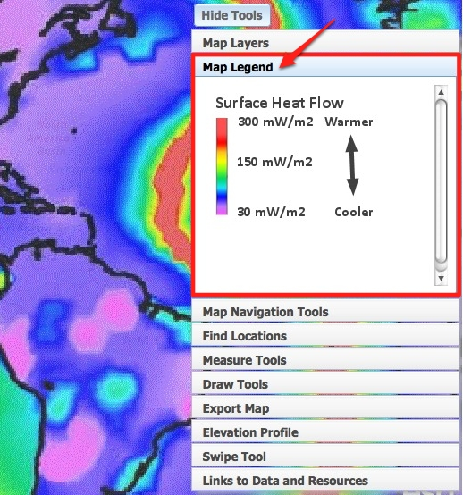
- Explore the map using the Map Navigation Tools located on the toolbox menu.  - To move around the map, select the hand tool and click and drag the map to a new location.  - Click on in the upper right hand corner to hide the toolbox menu when needed.  - Compare the surface heat flow on the continents to the oceans.  Answer Question #1 on your investigation sheet. | 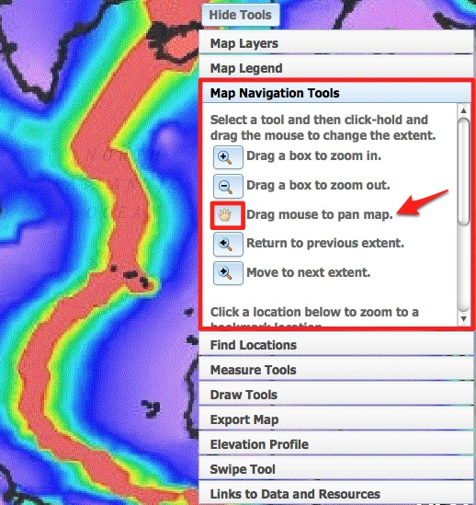
- Click on in the upper right hand corner to show the toolbox menu.  - Click on the Map Layers tab.  - Turn-on the Plate Boundaries layer by clicking on the check box.  - Click the Legend tab to view the map legend. The color of the boundary indicates the type of plate boundary.  - Examine the patterns of the Surface Heat Flow layer to the location of the plate boundaries.  Answer Questions #2-4 on your investigation sheet. | 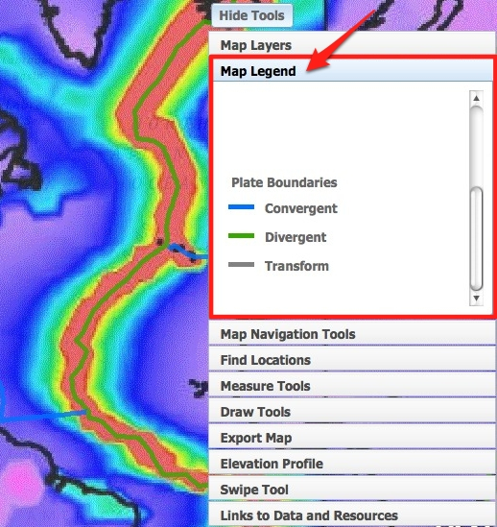

Step 3: Discover the relationship between surface heat flow and the age of the ocean floor.

As heat is released at divergent boundaries, the sea floor spreads apart along both sides of the mid-ocean ridges and new crust is added. This creates symmetry of ocean age on each side of the divergent boundary.

- Click on the Map Layers tab in the toolbox menu.  - Turn-off the Surface Heat Flow layer and activate the Age of the Ocean Floor layer by clicking on the check boxes.  - To view the map legend, click the Map Legend tab in the toolbox menu. The color indicates the age of the ocean floor at the location. Use the scroll bar on the right to see the legend to 280 m.y.  - Click on the Map Navigation Tools tab in the toolbox menu. Select Mid-Atlantic Ridge from the list of bookmark locations.  Answer Question #5 on your investigation sheet. | 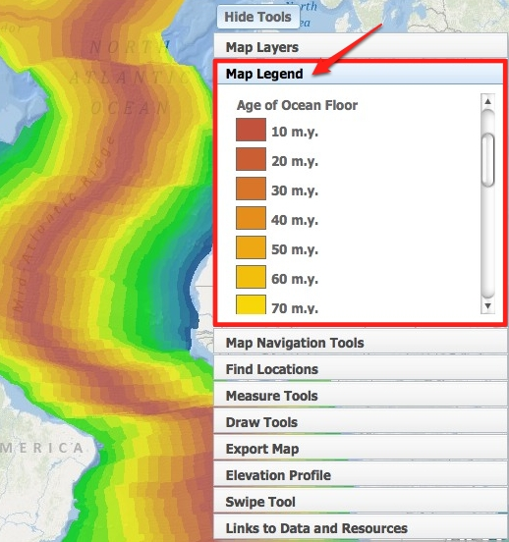
- Next, compare the age of the ocean floor with the surface heat flow.  - Click on the Map Layers tab in the toolbox menu. Activate the Surface Heat Flow layer by clicking on the check box.  - Click on the Swipe Tool tab in the toolbox menu.  - From the “Choose Layer to Swipe” drop down menu, select Surface Heat Flow.  - Click on to activate the swipe tool.  - Click on in the upper right hand corner to hide the toolbox menu.  - Use the mouse to click and drag the divider across the map. As you drag the swipe tool, the surface heat flow layer is removed, revealing the age of the ocean floor underneath that layer.  Answer Question #6 on your investigation sheet.  - When you are finished, click on in the upper right hand corner to show the toolbox menu and click in the Swipe Tool tab to turn the tool off. | 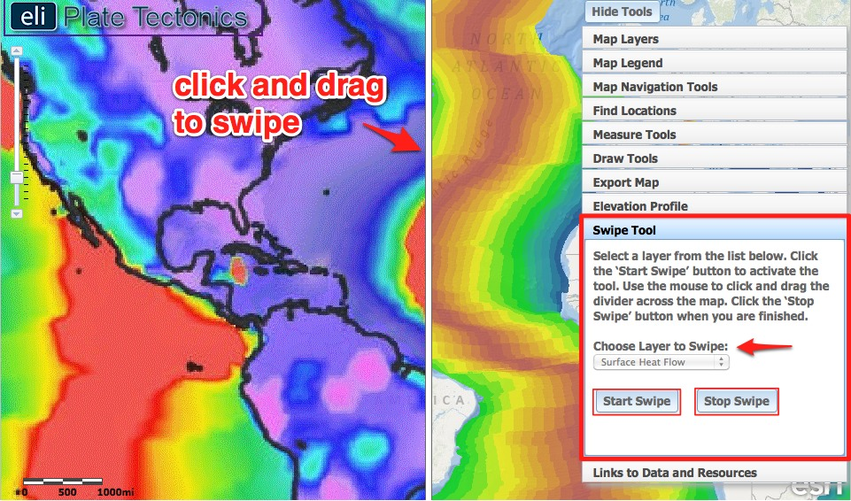
- The elevation of the seafloor is also related to surface heat flow and the age of the ocean floor.  Reading an Elevation Profile: All elevations below sea level will be negative numbers, while elevations above sea level will be positive numbers. Sea level is at 0 meters elevation. A deeper sea floor elevation corresponds to a higher negative number. A shallower sea floor elevation corresponds to a lower negative number.  A point on an elevation profile at  – 3000 meters means that the elevation of the sea floor at that point is 3000 meters below sea level. Likewise, a point on an elevation profile at – 1000 meters means that the sea floor elevation at that point is 1000 meters below sea level. -3000 meters is deeper than -1000 meters.  - Click on the Map Layers tab in the toolbox menu.  - Turn-off the Surface Heat Flow and Age of the Ocean floor layers.  - Look at the relief shading in the oceans on the base map. Darker shades of blue represent lower elevations and lighter shades of blue represent higher elevations.  - Click on the Elevation Profile tab in the toolbox menu.  - To help see the ocean bathymetry, draw a few elevation profiles across the Atlantic Ocean. Profile areas of rough and smooth ocean floor.  - Click on . On your map, click once to start drawing a profile, and double-click to finish. An elevation profile of the line you drew will appear in the Map Layers tab. You can place your cursor on the elevation profile to view corresponding points on the profile line your map. | 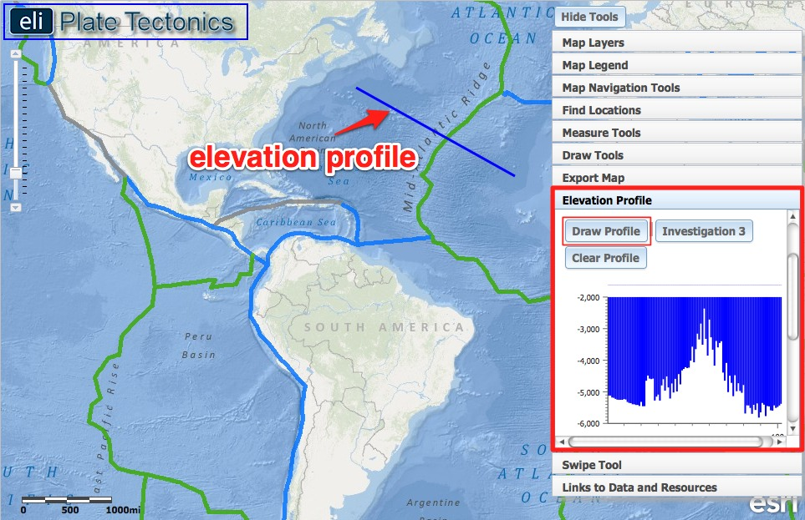
- After drawing a few profiles, click on in the Elevation Profile tab. This will draw a profile in the North Atlantic that you will use to answer questions on your investigation sheet.  - Click on the Map Layers tab in the toolbox menu. Turn-on the Age of the Ocean Floor layer.  Answer Questions #7-9 on your investigation sheet.  When you are finished, click on in the Elevation Profile tab to turn the tool off. | 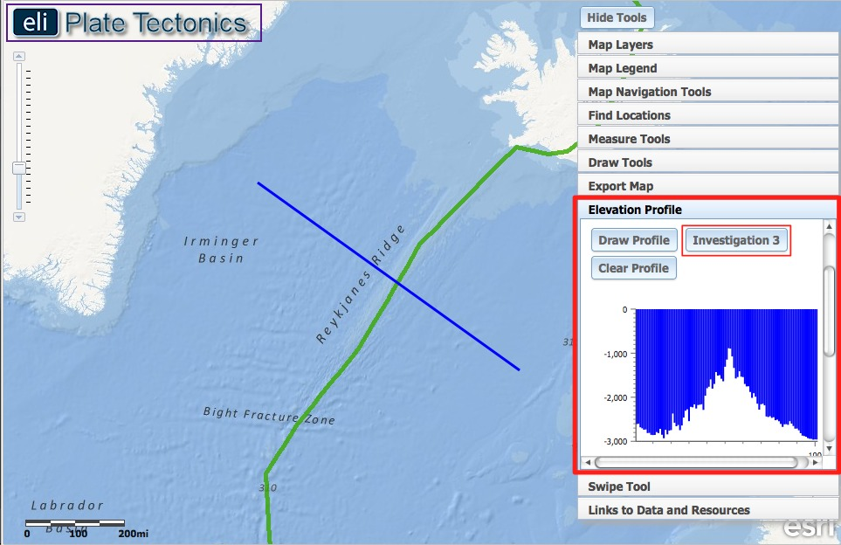

Step 4: Learn about surface heat flow near hotspots.

Most of the Earth’s heat is released at plate boundaries, but some volcanoes form at hotspots. A hotspot is an area where material from deep within the mantle rises and melts through a lithospheric plate. Hotspot volcanoes can occur in the middle of a plate far away from boundaries. They can also occur on or near the plate boundary (e.g. Iceland).

- Click on the Map Layers tab in the toolbox menu.  - Turn-off the Age of the Ocean Floor layer. Activate the Hot Spots and Plate Boundary layer by clicking on the check boxes.  - Use the zoom tool on the left side of your map to zoom out so you can see the entire map.  Answer Questions #10-11 on your investigation sheet. | 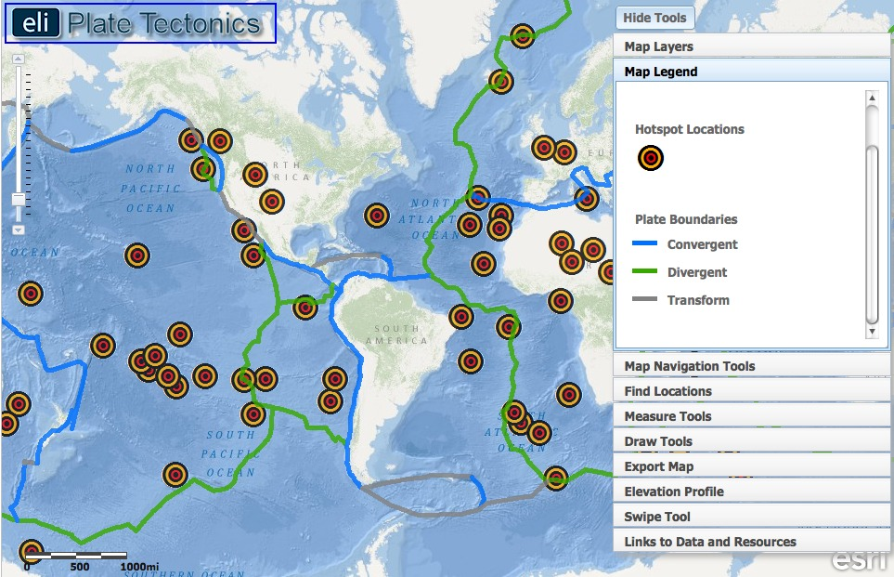
- Click on the Map Layers tab in the toolbox menu.  - Turn-on the Global Plate Vectors layer.  - The arrow head points in the direction the plate is moving. The length of the tail represents how fast the plate is moving. A longer tail means the plate is moving faster.  Answer Questions #12 on your investigation sheet. | 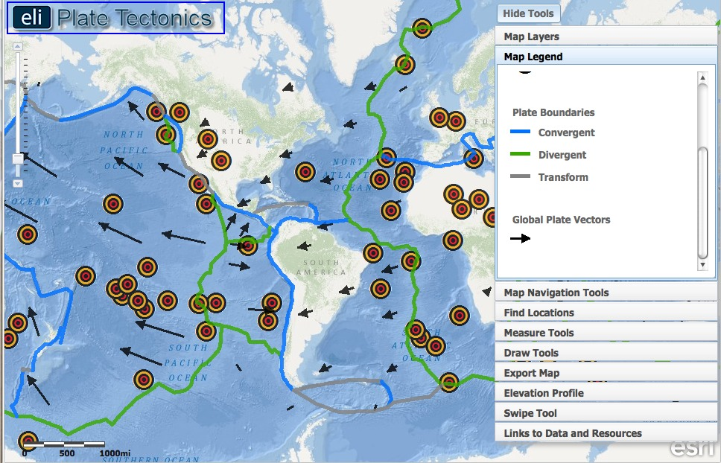
- Click on the Map Layers tab.
- Turn on the Lithosphere Thickness layer.
- Look at the Legend.
Answer Questions #13 on your investigation sheet.

