Name____________________________
Investigation 3: How does thermal energy move around in the Earth? Investigation Sheet
http://www.ei.lehigh.edu/learners/tectonics
Read all instructions on your handout and answer each question in complete sentences where appropriate.
- Do continents or oceans have higher surface heat flow?

- Which kind of plate boundary has the highest surface heat flow?
- What is occurring at these boundaries?

- Why do oceans have high surface heat flow?

- In the Atlantic Ocean, where is the youngest ocean floor located?

- How does heat flow relate to age of the ocean floor?

- Use your map to fill in the age of the ocean floor in the spaces below the profile

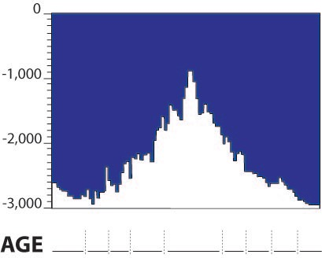

- How does ocean depth relate to age of ocean floor?

- What is the relationship between ocean age, ocean depth, and surface heat flow?

- How is hotspot volcanism different from other volcanoes?

- Which two plates have the most hotspots? Reminder: click on the map to learn the name of the plate.

- Why are there more hot spots on the African Plate than on the South American Plate? Hint: look at the length of the plate vectors.

- The Pacific Plate is moving fast! Why are there more hot spots in the Pacific Ocean?
Hint: Think about what happens as hot spot travels from the mantle to the surface. Is it faster or easier to go through something thick or thin?

