What happens when plates diverge?

Plates spread apart, or diverge, from each other at divergent boundaries. At these boundaries new ocean crust is added to the Earth’s surface and ocean basins are created. In this investigation, you will locate different divergent boundaries and study their history. You will:
- Investigate how tectonic stresses are accommodated at the plate boundary by examining earthquake and fault data and calculating the half-spreading rate of a plate boundary.
- Investigate features of passive margins, areas along divergent boundaries where continental crust becomes oceanic crust.
- Compare a young divergent boundary to an old divergent boundary.

Read all instructions and answer each question on your investigation sheet.

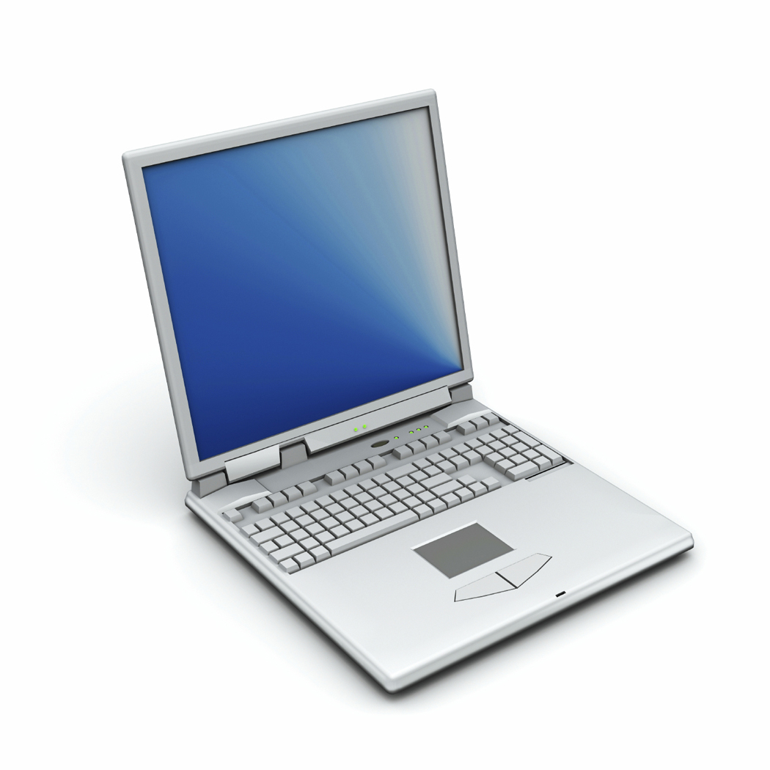 Step 1: Open Web GIS

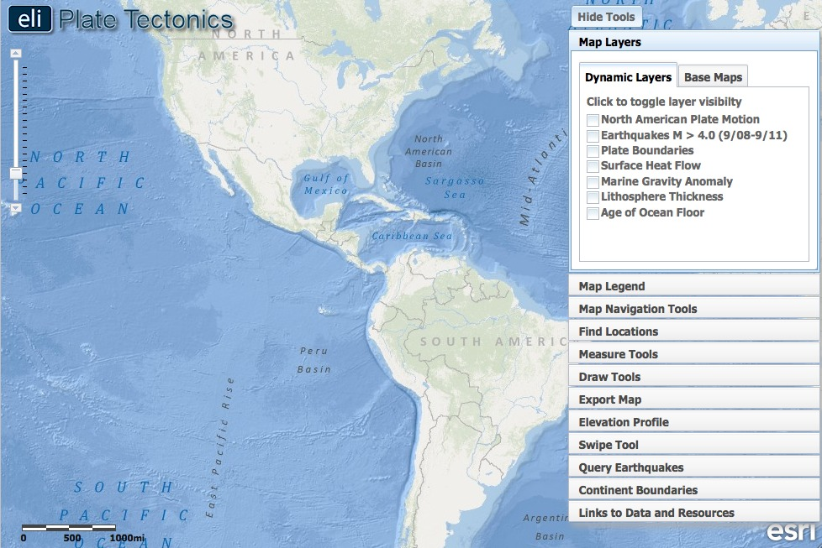

- Open your Web browser. Go to www.ei.lehigh.edu/learners/tectonics/

- Click on: What happens when plates diverge?

- The Web GIS will open to a global view.

Step 2: Learn where the nearest divergent boundaries are located.

Divergent boundaries are located all over the globe; they define the longest mountain ranges on earth. Some are small and span only about 1,500 km, such as those located off the coast of the U.S. Pacific Northwest. Others extend for more than 10,000 km. There are two major divergent boundaries located near North America.

- Click on the Map Layers tab in the toolbox menu.  - Turn on the Enhanced Bathymetry / Topography layer.  - Let’s find a divergent boundary in the Atlantic Ocean. To do this, locate latitude 31º and longitude -41º on the map. At this location, you will find the name of the feature that lets you know there is a divergent boundary.  Answer Question #1 on your investigation sheet.  - Before moving on, look at the ocean bathymetry along this boundary.  - On the map, darker shades of blue represent lower elevations (deeper water) and lighter shades of blue represent higher elevations (shallower water). See if you can trace this feature to the north and south. | 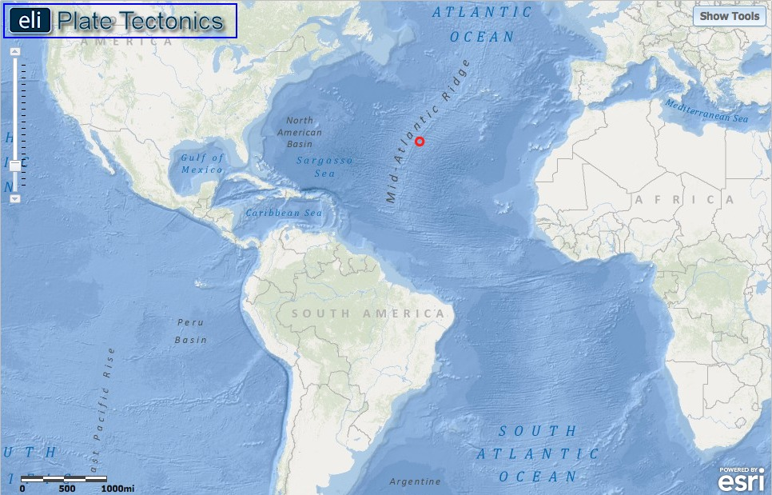  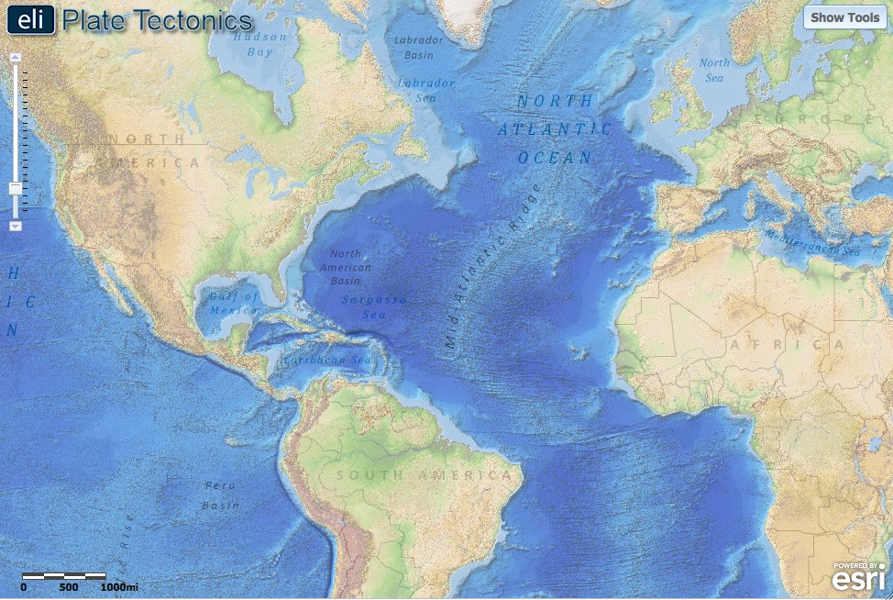
- Let’s find a divergent boundary in the Pacific Ocean.  - Use the navigation tools to locate and zoom to latitude -29º and longitude -112º. At this location, you will find the name of the feature that lets you know there is a divergent boundary.  Answer Questions #2 and #3 on your investigation sheet. | 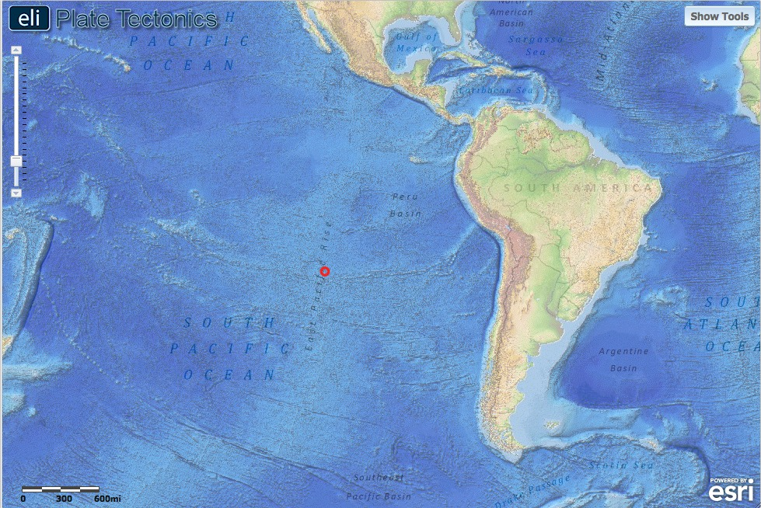

Step 3: Discover the relationship between earthquakes and divergent boundaries.

Earthquakes along divergent boundaries result from movement on extensional faults also known as “normal faults”. These faults form because a force called “tension” pulls the rocks away from each other.

- Click on the Map Layers tab in the toolbox menu.  - Turn-off the Enhanced Bathymetry/Topography layer. Activate the Earthquakes M > 4.0 (9/08-9/11) and Plate Boundaries layers.  - Click on the Map Legend tab to interpret the data displayed on your map. | 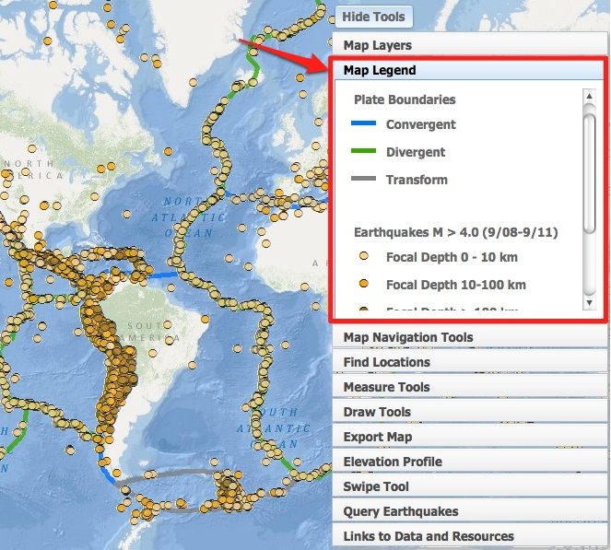
- Use the Query Earthquakes tab to investigate the locations of extensional (normal) faults.  - Click on the Query Earthquakes tab in the toolbox menu.  - Make sure the “All Depths” option is selected from the Select Earthquake Depth drop down menu (B).  - Make sure “extensional” from the Select Primary Fault Type drop down menu (A).  - Click to observe the plate boundary earthquakes that occurred on extensional faults.  Answer Question #4 on your investigation sheet. | 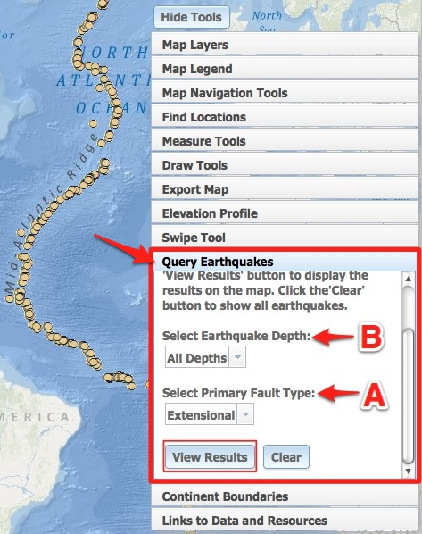
- Click on the Map Layers tab in the toolbox menu.  - Turn on the North American Plate Motion layer.  Answer Question #5 on your investigation sheet. Then, turn off the North American Plate Motion layer. | 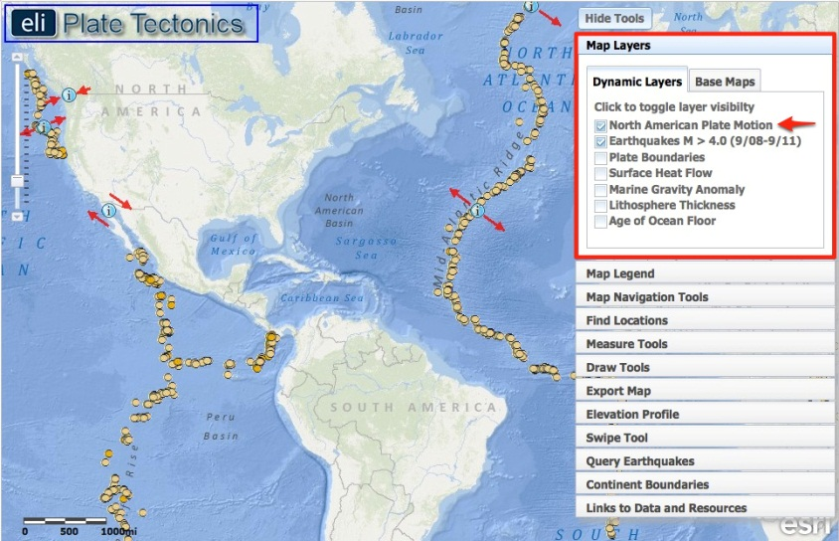
- Use the Query Earthquakes tab to investigate the depth of earthquakes on extensional faults.  - Click on the Query Earthquakes tab in the toolbox menu.  - Select “>=100 km” from the Select Earthquake Depth drop down menu (B).  - Click to see the plate boundary earthquakes that occurred on extensional faults.  - Explore the different earthquake depth ranges. Try all the other options from the Select Earthquake Depth drop down menu.  Answer Question #6 on your investigation sheet. | 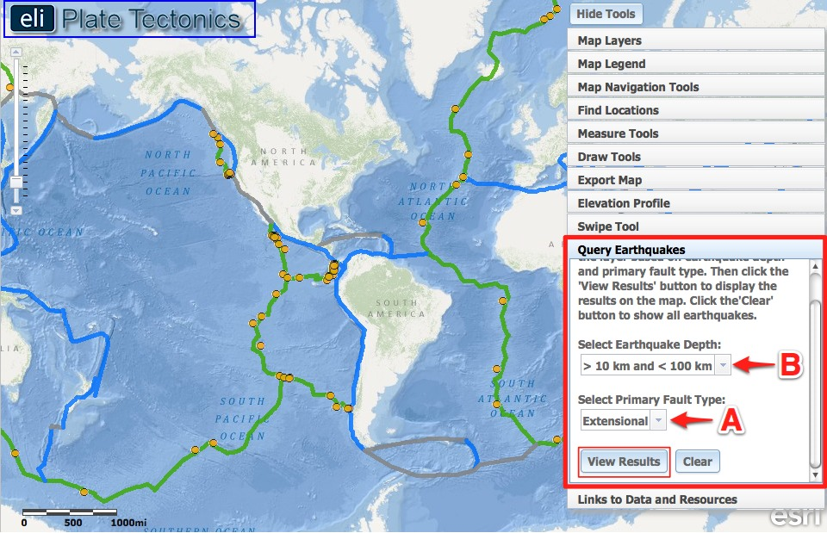

Step 4: Calculate divergent boundary spreading rates.

At divergent boundaries, the sea floor spreads apart on both sides of the mid-ocean ridges, and magma wells up from the mantle to add new crust to fill the gap. As a result, the ocean floor moves like a conveyor belt, carrying the continents along with it. The spreading rate is the speed that the plate is moving away from the boundary. The half-spreading rate can be calculated by dividing the distance between the crust and the plate boundary by the age of the crust. The bordering continents are separating at twice the spreading rate.

Half-Spreading Rate = Distance between crust and plate boundary ÷ Age of the crust (Time)

- Click on the Map Layers tab in the toolbox menu.  - Turn-off the Earthquakes M > 4.0 (9/08-9/11), Lithosphere Thickness, and Surface Heat Flow layers. Activate the Age of the Ocean Floor layer by clicking on the check box.  - To view the map legend, click the Map Legend tab in the toolbox menu. The color indicates the age of the ocean floor at a location. Scroll down with the scroll bar to view the entire legend to 280 m.y. (See image to the right.) | 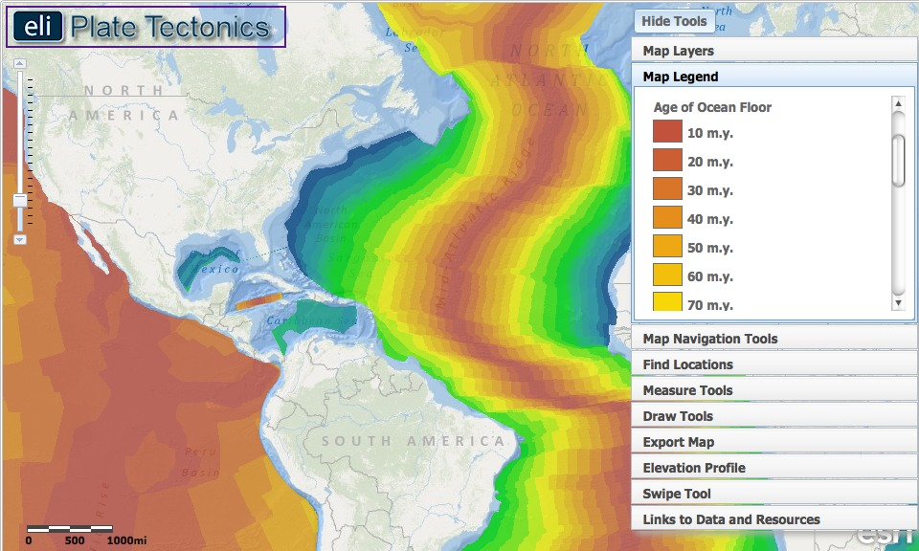
- To calculate the half-spreading rate of the North American plate at the divergent boundary in the Atlantic Ocean, you will divide the distance the plate has traveled by the time it took to travel that distance.  Half-Spreading Rate =  Distance ÷ Time  - Click on the Map Navigation Tools tab in the toolbox menu. Select Mid-Atlantic Ridge from the list of bookmark locations.  - Use the Distance measure tool to measure the distance of the oldest ocean floor from the divergent plate boundary.  (i) Go to the Measure Tools tab.  (ii) Click on the Distance measure tool.  (iii) Click on a point on the Mid-Atlantic Ridge near latitude 30º and longitude -41º.  (iv) Drag your mouse perpendicular to the oldest ocean floor near latitude 39º and longitude -72º.  (v) Double click at the left edge of the oldest ocean floor to display the measurement result. (See image to the right.)  Important note: Double-clicking on the distance measure will complete your measurement for your line. Click anywhere on the map to begin a new line with the distance measure tool. Your previous line will disappear.  Record this distance on the chart in #7 on your investigation sheet. Be sure to include the measurement units.  - Click the Map Legend tab in the toolbox menu. Determine the age of the oldest ocean floor you measured to.  Record this age of the ocean floor (from the step above) on the chart in #7 on your investigation sheet. Calculate the half-spreading rate (Distance ÷ Time) to complete your chart. Don’t forget units! | 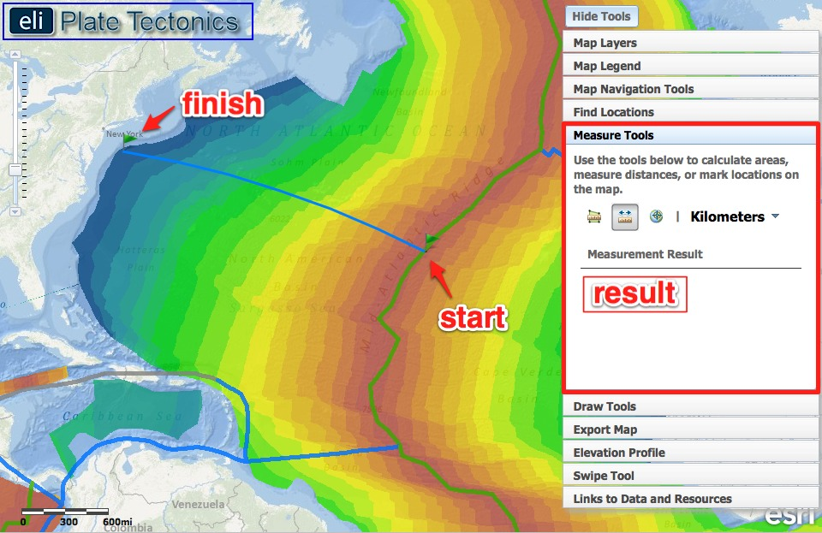
- Next, calculate the half-spreading rate of the Nazca Plate at the East Pacific Rise. You will divide the distance the plate has traveled by the time it took to travel that distance.  - Click on the Map Navigation Tools tab in the toolbox menu. Select East Pacific Rise from the list of bookmark locations.  - Use the Distance measure tool to measure the distance of the oldest ocean floor from the divergent plate boundary.  (i) Go to the Measure Tools tab.  (ii) Click on the Distance measure tool.  (iii) Click on a point on the East Pacific Rise near latitude -20º and longitude -114º.  (iv) Drag your mouse perpendicular to the oldest ocean floor near latitude -20º and longitude -71º off the west coast of South America.  (v) Double click at the right edge of the oldest ocean floor to display the measurement result.  Record this distance on the chart in #8 on your investigation sheet. Be sure to include the measurement units.  - Click the Map Legend tab in the toolbox menu. Determine the age of the oldest ocean floor you measured to.  Record this age of the ocean floor (from the step above) on the chart in #8 on your investigation sheet. Calculate the half-spreading rate (Distance ÷ Time) to complete your chart. Don’t forget units! Then, answer Question #9 on your investigation sheet. | 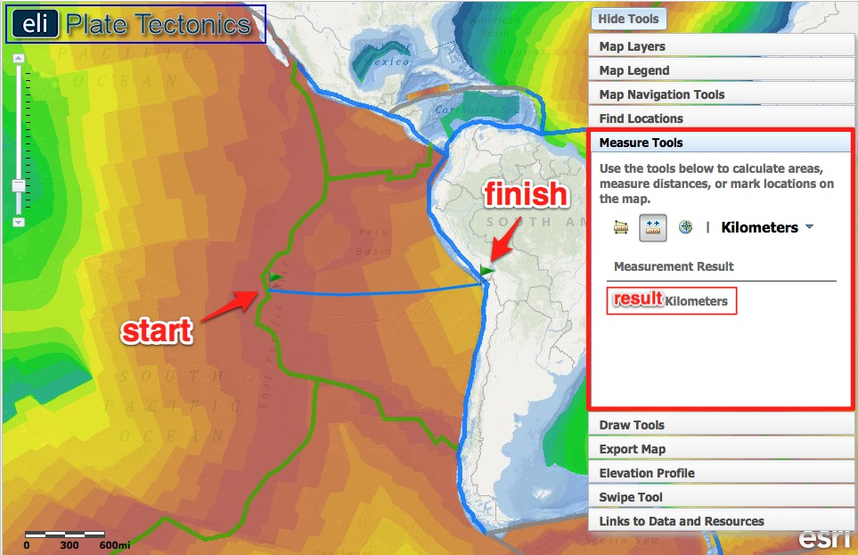
Step 5: Discover transform faults along the divergent boundary.

Transform boundaries are located all over the globe. In ocean basins, transform boundaries form perpendicular to divergent boundaries and offset the mid-ocean ridges. Transform faults at ridges allow for the symmetrical opening of the ocean basin.

- Click on the Elevation Profile tab in the toolbox menu.  Reading an Elevation Profile: All elevations below sea level will be negative numbers, while elevations above sea level will be positive numbers. Sea level is at 0 meters elevation. A deeper sea floor elevation corresponds to a higher negative number. A shallower sea floor elevation corresponds to a lower negative number.  A point on an elevation profile at  – 3000 meters means that the elevation of the sea floor at that point is 3000 meters below sea level. Likewise, a point on an elevation profile at – 1000 meters means that the sea floor elevation at that point is 1000 meters below sea level. -3000 meters is deeper than -1000 meters.  - Click on . This will draw a profile in the North Atlantic that you will use to answer questions on your investigation sheet.  Note: The left side of the elevation profile graph corresponds to the bottom of the profile line.  - This profile crosses a transform fault. Notice how the age of the ocean floor changes as you move across the elevation profile line.  Answer Questions #10-11 on your investigation sheet.  Turn off the Age of the Ocean Floor layer when finished. | 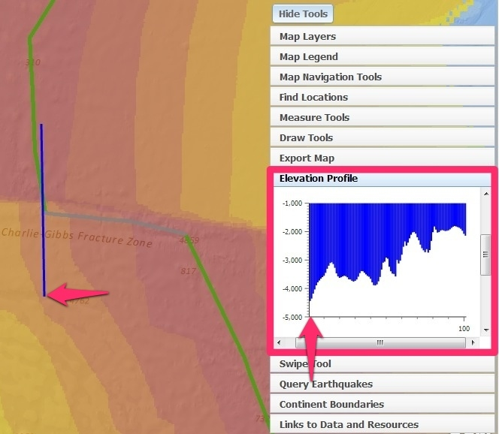  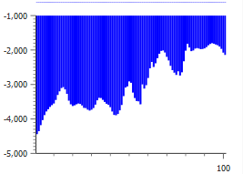

Step 6: Discover how passive margins form.
A continental margin is the area of the ocean floor along the coast that separates oceanic crust from continental crust. When the area does not occur along an active plate boundary, it is called a passive margin.

- Click on the Map Navigation Tools tab in the toolbox menu. Select Eastern U.S. from the list of bookmark locations.  - Click on the Map Layers tab in the toolbox menu.  - Activate the North American Plate Motion and Enhanced Bathymetry/Topography layers by clicking on the check box.  - Click on the Image icon located off the east coast of North America to see a diagram of a passive continental margin.  In the pop-up image on your map, notice that there is continental crust beneath the continental shelf (left side of the image) and oceanic crust in the ocean basin (right side of the image). | 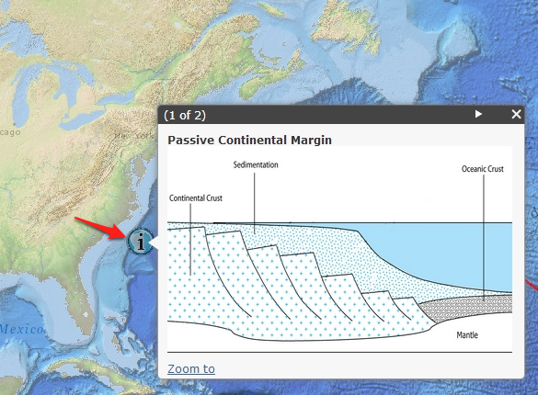
- Geologists use a “Marine Gravity Anomaly” map, which shows changes in gravitational force, to identify the transition (or change) from continental to oceanic crust.  - Click on the Map Layers tab in the toolbox menu.  - Activate the Marine Gravity Anomaly layer by clicking on the check box.  - To view the map legend, click the Map Legend tab in the toolbox menu. An eotvos is a measure of the gravitational force at that location.  Stronger gravitational forces are represented by red-yellow color on your map.  Weaker gravitational forces are represented by blue-green color.  Differences in gravitational forces occur because continental crust and oceanic crust have different compositions and different densities. Oceanic crust in more dense than continental crust. Oceanic crust is composed mainly of basalt and continental crust is mainly composed of granite. | 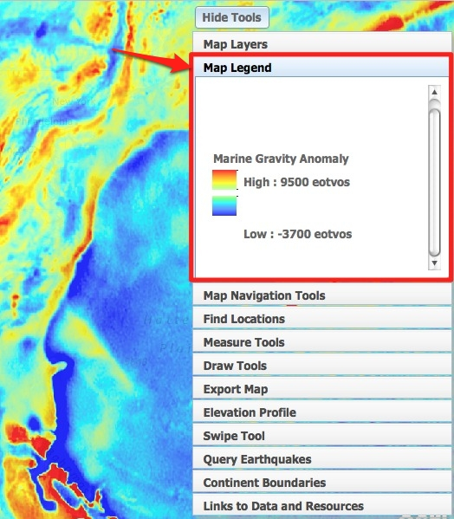
- A change in gravity occurs across the continental margin because the density changes at the transition boundary between continental crust and oceanic crust. This is indicated by locations on the map where red/yellow colors appear next to blue/green colors when the marine gravity anomaly layer is displayed.  - Click on the Continent Boundaries tab in the toolbox menu.  - Click “Add Boundaries”. This button will trace the continental margin around North America and Africa. On the east side of the North America continent boundary (and continental margin), you should see more blue colors (dense oceanic crust). On the west side, you should see more yellow-red colors (less dense continental crust).  - Use the swipe tool to compare what you see on the Marine Gravity Anomaly layer to the continent-ocean boundary on your base map.  - Click on the Swipe Tool tab in the toolbox menu.  - From the “Choose Layer to Swipe” drop down menu, select Marine Gravity Anomaly.  - Next, click on to activate the swipe tool. Then in the upper right hand corner to hide the toolbox menu so you can see the whole map.  - Using the mouse, click and drag the divider across the map. As you drag the swipe tool, the marine gravity anomaly layer is on the left, and the base map layer is on the right.  Answer Question #12 on your investigation sheet. Click | 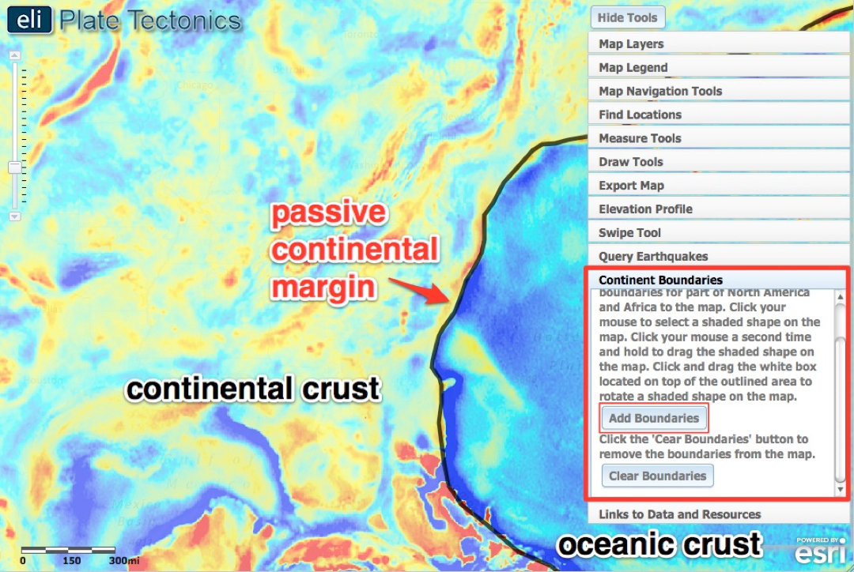  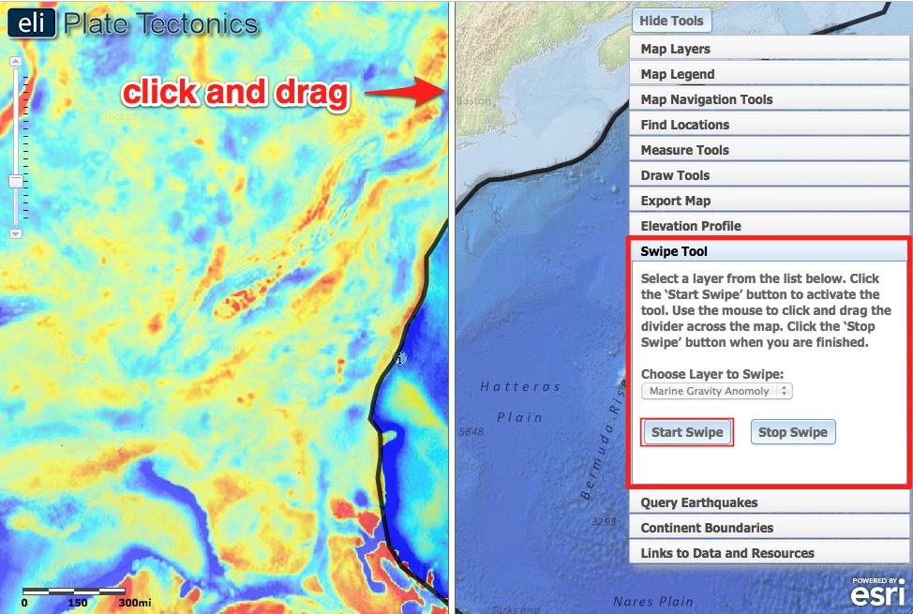
- The continents that border the Atlantic Ocean have spread over millions of years away from the Mid-Atlantic Ridge and formed passive margins along the coast. Let’s discover where the continents were once located.  - You are going to move the North America and Africa continent boundaries to an area where they were located 90 million years ago.  - Click on the Map Layers tab in the toolbox menu.  - Turn-off the Marine Gravity Anomaly and Enhanced Bathymetry/Topography layers and activate the Age of the Ocean Floor layer by clicking on the check box.  - Use the navigation tools to zoom out so you can see the boundary around both North America and Africa.  - Click the Map Legend tab in the toolbox menu.  (i). Determine the age of the oldest ocean floor in the Atlantic.  (ii). Subtract 90 million from that age.  (iii). Look at the Map Legend tab to determine the color that represents the location of the continents 90 million years ago.  - You will now move the continents to the location on the map that represents their location 90 million years ago.  Click on the Continent Boundaries tab.  Click .  Place the part of the continent boundaries highlighted in red (see 2nd picture to the right) to the location of the continents from 90 million years ago.  Click your mouse to select a shaded shape on the map. Click your mouse a second time and hold to move the continent.  To rotate a selected shaded continent, click the white box located on top of the outlined area and then move your mouse to rotate it on the map. | 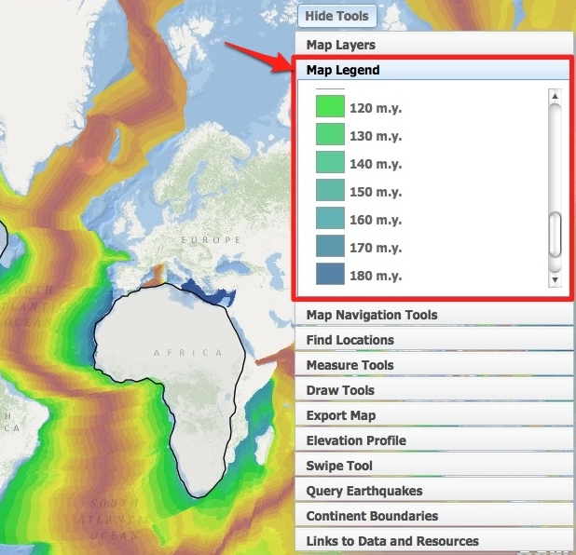  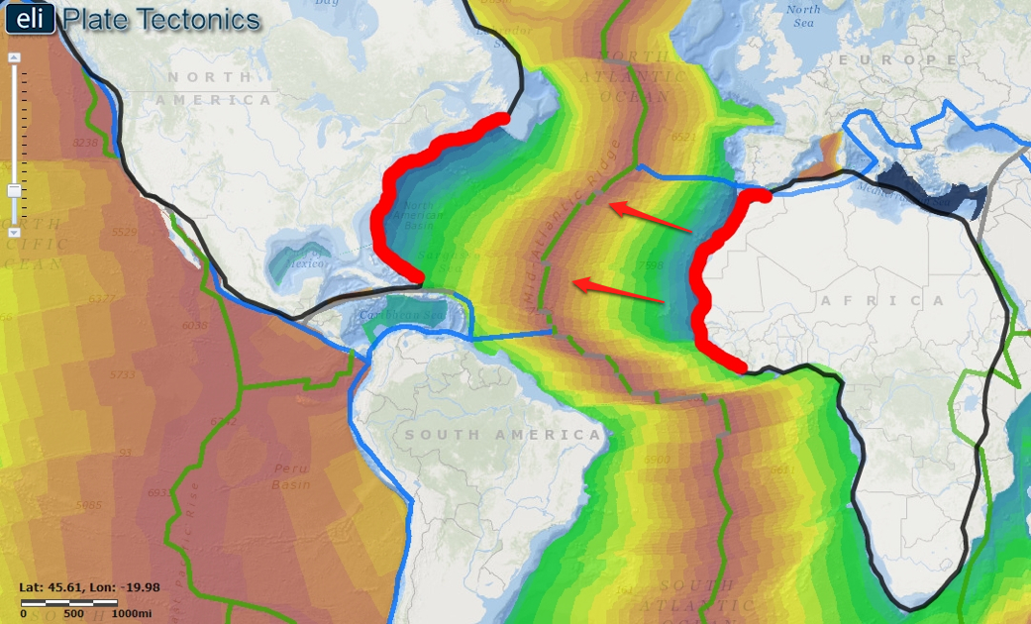
- Submit your map using the Export Map tool. (Note: Your teacher may ask you to take a screenshot instead).  - First, click on the Export Map tab in the toolbox menu.  - Click . This will create an image of your work that is ready to be exported.  - Next, follow directions in the toolbox for Macintosh or PC depending upon the computer you are using. Your teacher will instruct you with specific file naming instructions and with a computer or network location to save your image.  When you are finished, click to return to your map. | 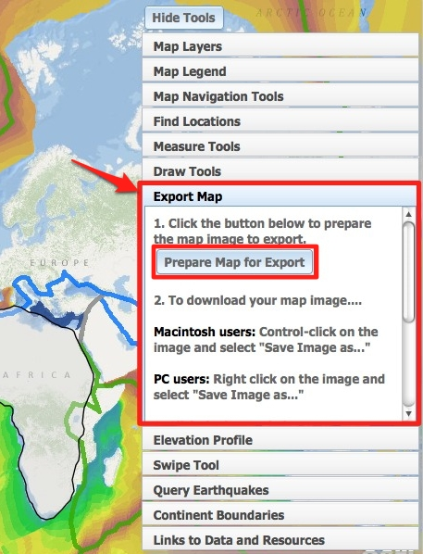
- Next, place the joined continents where they were located when rifting (spreading apart) first started, along the divergent boundary.  - Submit your map using the Export Map tool. See instructions above if needed. (Note: Your teacher may ask you to take a screenshot instead).  - Answer Questions #13-14 on your investigation sheet. | 