What happens when plates diverge?

Plates spread apart, or diverge, from each other at divergent boundaries. At these boundaries new ocean crust is added to the Earth’s surface and ocean basins are created. In this investigation, students will locate different divergent boundaries and study their history. They will
- Investigate how tectonic stresses are accommodated at the plate boundary by examining earthquake and fault data and calculating the half-spreading rate of a plate boundary.
- Investigate features of passive margins, areas along divergent boundaries where continental crust becomes oceanic crust.
- Compare a young divergent boundary to an old divergent boundary.

Prior to implementing this learning activity, make sure that students have prerequisite knowledge that plates are composed of both continental crust and oceanic crust. This concept is explored in more detail in this investigation. Model the following procedural instructions with your students. It is recommended that you display your computer image to the front of the classroom.

Step 1: Open Web GIS

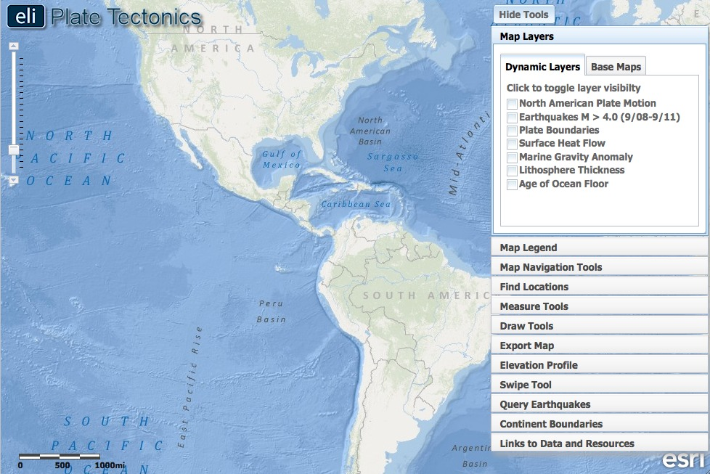

- Have students open their Web browser. Go to www.ei.lehigh.edu/learners/tectonics/

- Click on: What happens when plates diverge?

- The Web GIS will open to a global view.

Step 2: Learn where the nearest divergent boundaries are located.

Divergent boundaries are located all over the globe; they define the longest mountain ranges on earth. Some are small and span only about 1,500 km, such as those located off the coast of the U.S. Pacific Northwest. Others extend for more than 10,000 km. There are two major divergent boundaries located near North America. In this step, students will locate the Mid-Atlantic Ridge (divergent boundary opening the Atlantic Ocean) and the East Pacific Rise (divergent boundary opening the Pacific Ocean).

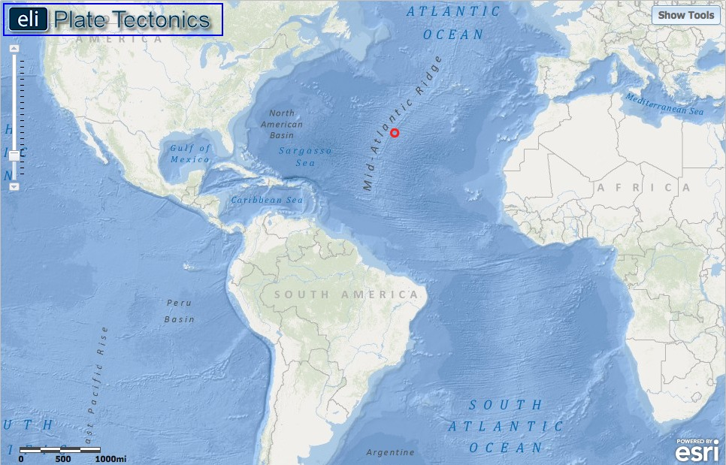

- Instruct student to turn on the Enhanced Bathymetry/Topography layer. This layer is displayed to help students visualize bathymetric changes away from the ridge. Click on the Map Layers tab in the toolbox menu. Turn on the Enhanced Bathymetry/Topography layer.

- First, students will find the divergent boundary in the Atlantic Ocean.

- Instruct students to locate latitude 31º and longitude -41º on the map. At this location, they will find the Mid-Atlantic Ridge labeled on their map.
Instruct student to answer Question #1 on their investigation sheet.

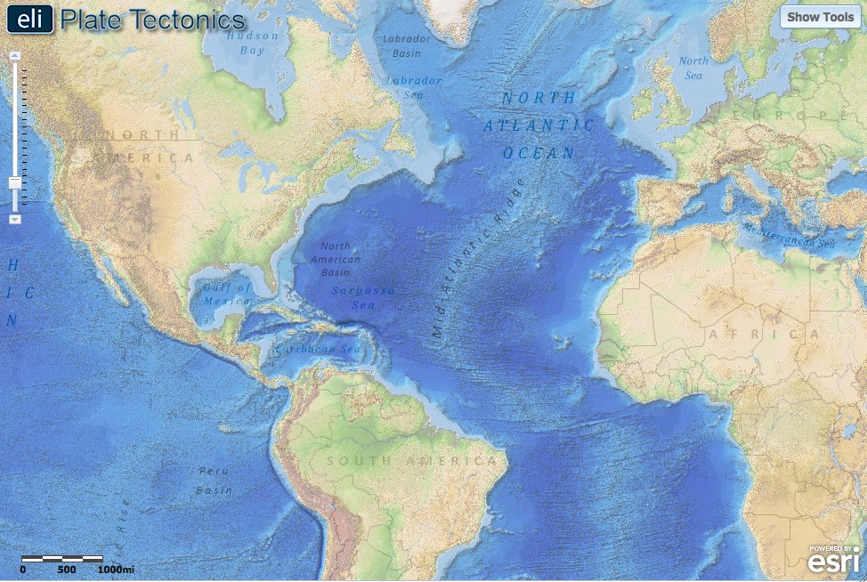

- Before moving on, ask students to look at the ocean bathymetry along this boundary.

- On the map, darker shades of blue represent lower elevations (deeper water) and lighter shades of blue represent higher elevations (shallower water). Make sure students can trace the Mid-Atlantic Ridge to the north and south.

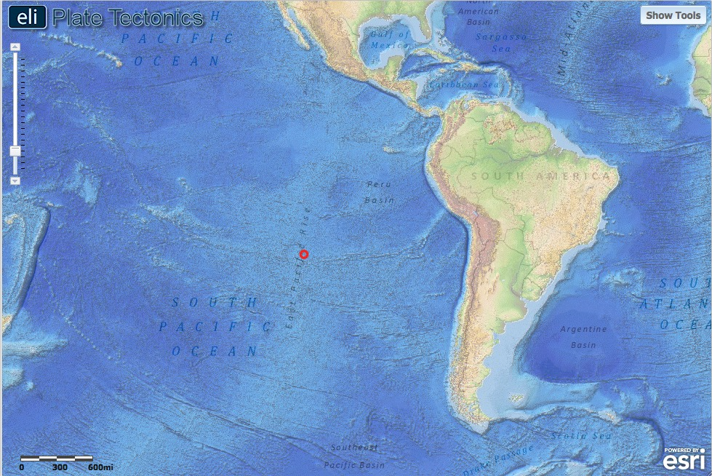

- Next, students will locate a second divergent boundary in the Pacific Ocean.

- Instruct students to use the navigation tools to locate and zoom to latitude -29º and longitude -112º. At this location, students will find the name of the feature that lets you know there is a divergent boundary.

- Again, ask students to look at the bathymetry around the ridge.

Instruct students to answer Questions #2 and #3 on their investigation sheet.

Step 3: Discover the relationship between earthquakes and divergent boundaries.

Earthquakes along divergent boundaries result from movement on extensional faults also known as “normal faults”. These faults form because a force called “tension” pulls the rocks away from each other. In this step, students will learn that earthquakes occur at shallow depths on normal faults along divergent boundaries. For more information on the different types of faults, see the content support materials on the Web site.
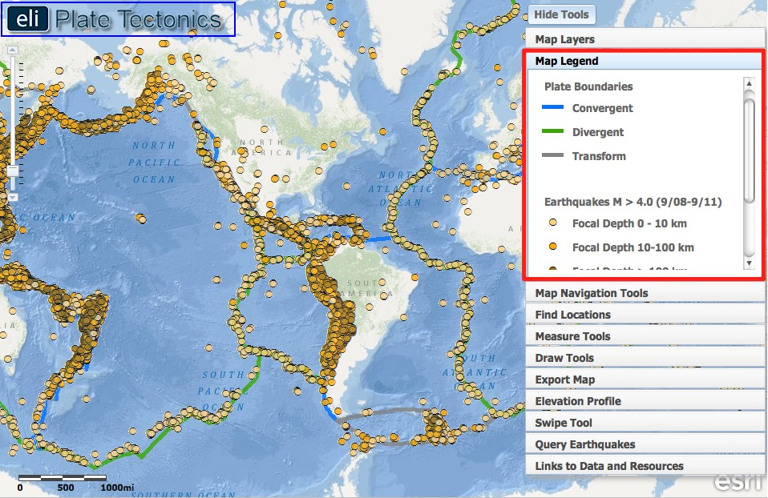

- Instruct students to click on the Map Layers tab in the toolbox menu. They will turn-off the Enhanced Bathymetry/Topography layer and activate the Earthquakes M > 4.0 (9/08-9/11) and Plate Boundaries layers.

- Students should click on the Map Legend tab to interpret the data displayed on their map and learn that different colors represent different earthquake focal depths.

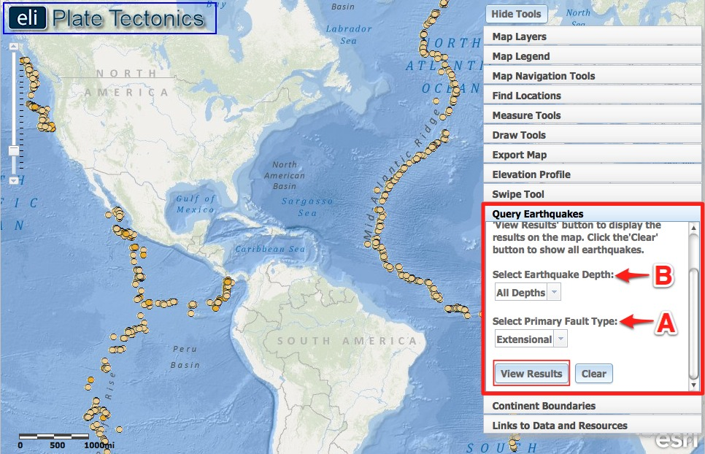

- Students will use the Query Earthquakes tab to investigate the locations of extensional (normal) faults.
Implementation Suggestion: Before students use the query earthquakes tool, we recommend that you explicitly model how to use the tool to display different query results in the GIS.

- Instruct students to click on the Query Earthquakes tab in the toolbox menu.

- They should first select “extensional” from the Select Primary Fault Type drop down menu (A). Make sure the “All Depths” option is selected from the Select Earthquake Depth drop down menu (B). If it is not, it will only query earthquakes from a certain depth range (<10 km, 10-100 km, or >100 km).

- Students should click to observe the plate boundary earthquakes that occurred on extensional faults.

Instruct students to answer Question #4 on their investigation sheet.

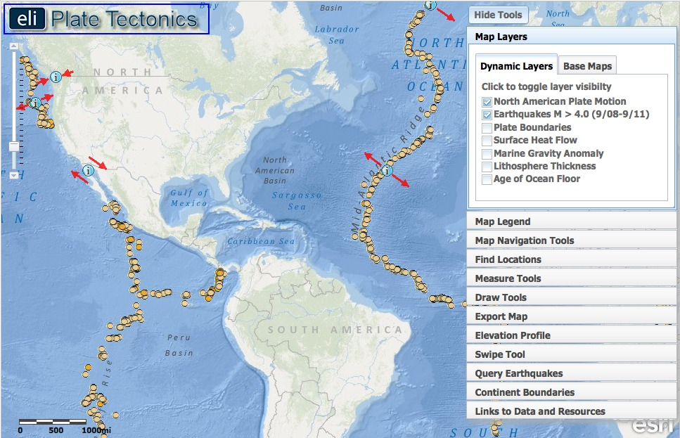

- Next, students will turn on the North American Plate Motion layer. This will help them visualize the queried earthquakes that occurred along the North American Plate boundary with the Eurasian and African plates. Since the arrows point away from one another at these plate boundaries, the queried earthquakes are located on a divergent plate boundary.

- Instruct students to click on the Map Layers tab in the toolbox menu, and turn on the North American Plate Motion layer.

Instruct student to answer Question #5 on their investigation sheet. After they answer the question, they can turn off the North American Plate Motion layer.
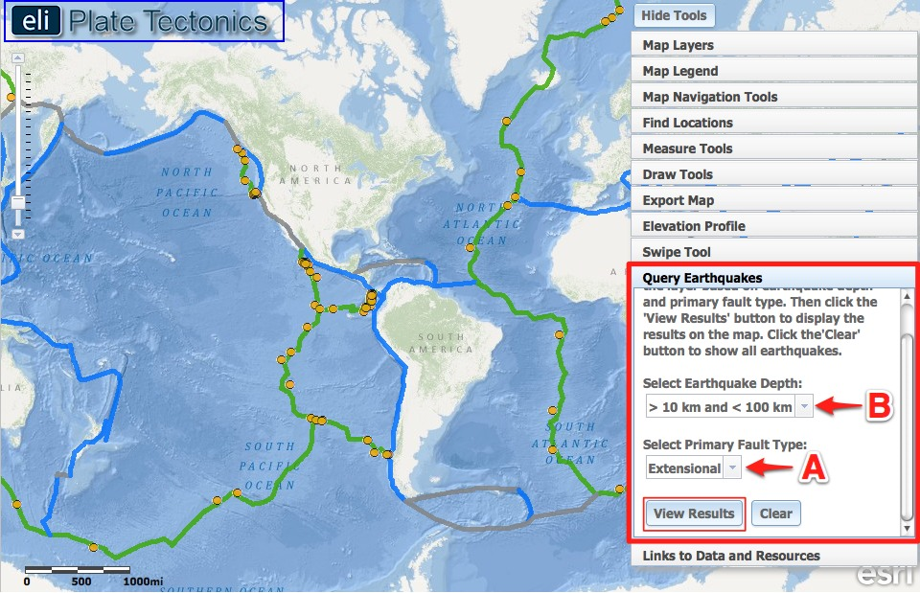

- The students will use the Query Earthquakes tab to investigate different ranges of earthquake depths on extensional faults, and discover that they mostly occur at shallow depths, less than <10 km.

- Students will click on the Query Earthquakes tab in the toolbox menu, and select “>=100 km” from the Select Earthquake Depth drop down menu (B).

- When they click to see the earthquakes that occurred on extensional faults at those depths, there will be no earthquakes displayed on the students’ maps. This is because the lithosphere along the divergent boundary is too thin and hot for earthquakes to occur at these depths.

- Instruct students to explore the different earthquake depth ranges, and to select all the other options from the Select Earthquake Depth drop down menu.

Instruct student to answer Question #6 on their investigation sheet. In part “b.”, students have been given a hint to turn on the Lithosphere Thickness and Surface Heat Flow layers to discover that earthquakes do not occur at great depths because the lithosphere is too thin and it is too hot for earthquakes to occur at great depth. If needed, show students how to interpret the map legend to assist them with understanding this spatial concept.

Step 4: Calculate divergent boundary spreading rates.

At divergent boundaries, the sea floor spreads apart on both sides of the mid-ocean ridges, and magma wells up from the mantle to add new crust to fill the gap. As a result, the ocean floor moves like a conveyor belt, carrying the continents along with it. The spreading rate is the speed that the plate is moving away from the boundary. The spreading rate can be calculated by dividing the distance between the crust and the plate boundary by the age of the crust. Spreading rates vary at different locations along a plate boundary. Additionally, spreading rates can be presented as a “half spreading rate” -- the rate at which 1 continent is moving away from the divergent plate boundary, or a “full spreading rate” -- the rate at which the ocean basin is opening and 2 continents are spreading away from each other. In this step, students will calculate the half-spreading rate at a location that is representative of rates for the Mid-Atlantic Ridge and the East Pacific Rise.

Half-spreading rate = Distance between crust and plate boundary ÷ Age of the crust (Time)

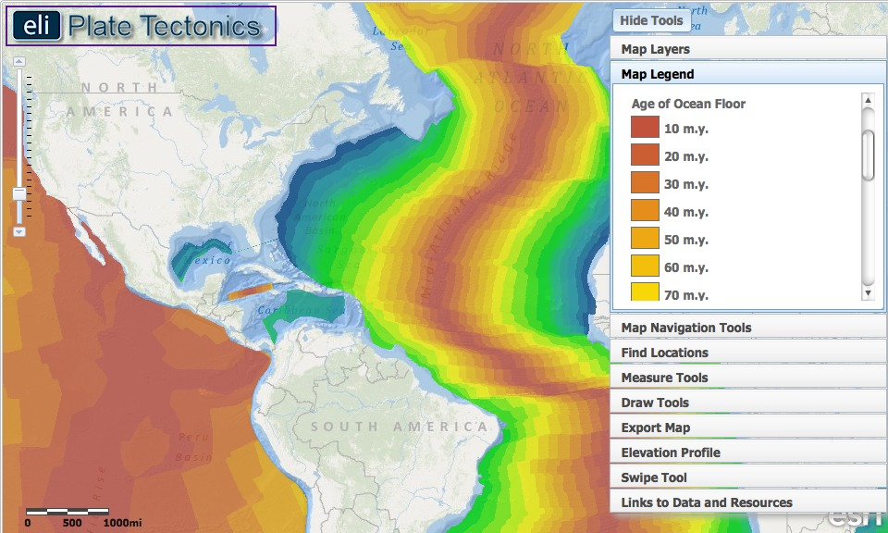

- Instruct students to click on the Map Layers tab in the toolbox menu. They should turn-off the Earthquakes M > 4.0 (9/08-9/11), Lithosphere Thickness, and Surface Heat Flow layers and activate the Age of the Ocean Floor layer by clicking on the check box.

- Students should click the Map Legend tab in the toolbox menu to view the map legend. The color indicates the age of the ocean floor at a location. Scroll down with the scroll bar to view the entire legend to 280 m.y. (See image above.). Note that the age of the ocean floor is 180 m.y. in the North Atlantic Basin near the continental edge of North America and Africa. The oldest ocean floor age in the world of 280 m.y. is located in the Mediterranean Basin.

- To calculate the half-spreading rate of the North American plate at the divergent boundary in the Atlantic Ocean, students will divide the distance the plate has traveled by the time it took to travel that distance.
Half-Spreading Rate = Distance ÷ Time

- Instruct students to click on the Map Navigation Tools tab in the toolbox menu, and select Mid-Atlantic Ridge from the list of bookmark locations. The map will zoom in on this study area.
- Students will use the Distance measure tool to measure the distance of the oldest ocean floor from the divergent plate boundary. They will:
(i) Go to the Measure Tools tab.
(ii) Click on the Distance measure tool.
(iii) Click on a point on the Mid-Atlantic Ridge located near latitude 30º and longitude -41º.
(iv) Drag the mouse perpendicular to the divergent boundary to the oldest ocean floor near latitude 39º and longitude -72º.
(v) Double click at the left edge of the oldest ocean floor to display the measurement result (see image above).
Important note: Double-clicking on the distance measure will complete the measurement of the line and a green flag will be placed at that location. Clicking anywhere on the map will begin a new line with the distance measure tool. The previous line will disappear.
Show students what happens when they do not double-click to complete their measured distance. Their line will continue and the measured distance will be inaccurate.
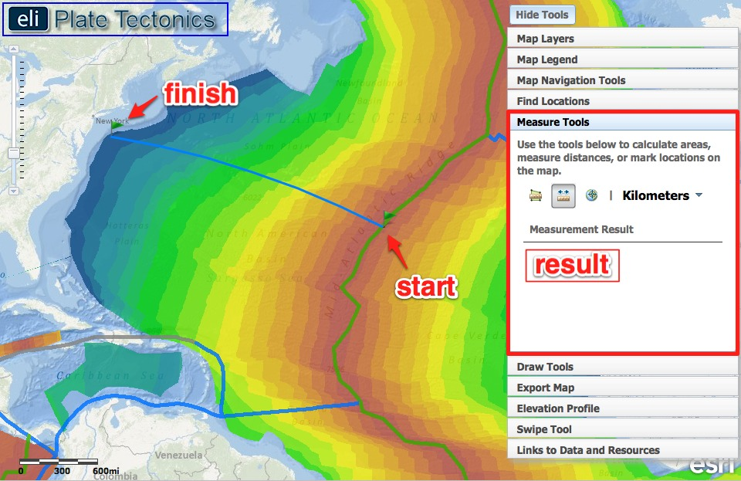
Instruct student to record the distance they measured using the chart in #7 on their investigation sheet. Be sure they include the measurement units – kilometers (km).

- Next, have students click the Map Legend tab in the toolbox menu. They should look at the legend to determine the age of the oldest ocean floor they measured to.

Instruct students to (1) record this age of the ocean floor (from the step above) using the chart in #7 on their investigation sheet, and (2) calculate the half-spreading rate to complete the chart. Be sure they include the measurement units – km/m.y.

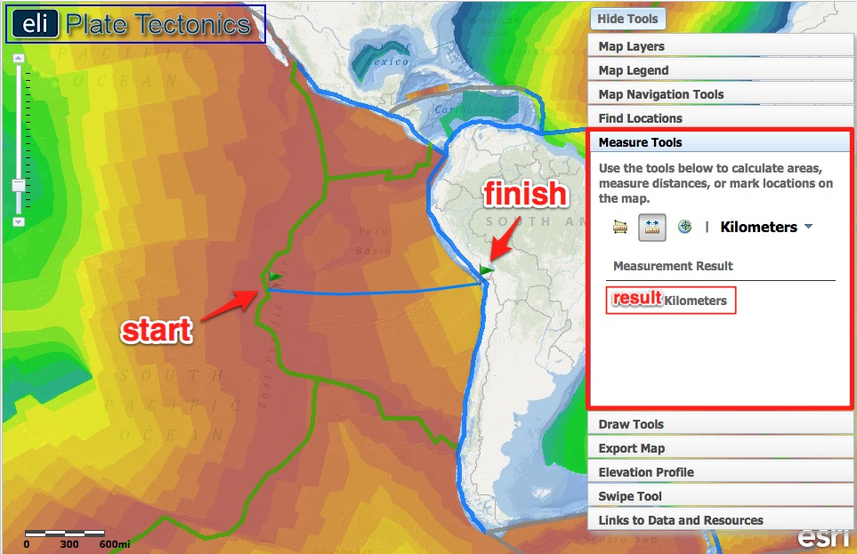

- Next, students will calculate the half-spreading rate of the Nazca Plate at the East Pacific Rise to compare it to the rate of the Mid-Atlantic Ridge. They will divide the distance the plate has traveled by the time it took to travel that distance.

- Instruct students to click on the Map Navigation Tools tab in the toolbox menu, and select East Pacific Rise from the list of bookmark locations. The map will zoom in on this study area.

- Students will use the Distance measure tool to measure the distance of the oldest ocean floor from the divergent plate boundary. They will:
(i) Go to the Measure Tools tab.
(ii) Click on the Distance measure tool.
(iii) Click on a point on the East Pacific Rise located near latitude -20º and longitude -114º.
(iv) Drag the mouse perpendicular to the divergent boundary to the oldest ocean floor near latitude -20º and longitude -71º off the west coast of South America.
(v) Double click at the left edge of the oldest ocean floor to display the measurement result (see image above).
Important note: Double-clicking on the distance measure will complete the measurement of the line and a green flag will be placed at that location. Clicking anywhere on the map will begin a new line with the distance measure tool. The previous line will disappear.

Instruct student to record the distance they measured using the chart in #8 on their investigation sheet. Be sure they include the measurement units – kilometers (km).

- Next, have students click the Map Legend tab in the toolbox menu. They should look at the legend to determine the age of the oldest ocean floor they measured to.

Instruct student to (1) record this age of the ocean floor (from the step above) using the chart in #8 on their investigation sheet, and (2) calculate the half-spreading rate to complete the chart. Be sure they include the measurement units – km/m.y. Then, answer Question #9 on your investigation sheet.

Step 5: Discover transform faults along the divergent boundary.

Transform boundaries are located all over the globe. In ocean basins, transform boundaries form perpendicular to divergent boundaries and offset the mid-ocean ridges. Transform faults at ridges allow for the symmetrical opening of the ocean basin. In this step, students will locate a transform fault and study the ocean floor properties across it. Also, they will use the Elevation Profile tool to examine elevation changes across a transform fault.
Implementation suggestion: Before you begin this step, we recommend that you explicitly model how to interpret an elevation profile graph from a profile line drawn on the map.

Reading an Elevation Profile: All elevations below sea level will be negative numbers, while elevations above sea level will be positive numbers. Sea level is at 0 meters elevation. A deeper sea floor elevation corresponds to a higher negative number. A shallower sea floor elevation corresponds to a lower negative number.
A point on an elevation profile at – 3000 meters means that the elevation of the sea floor at that point is 3000 meters below sea level. Likewise, a point on an elevation profile at – 1000 meters means that the sea floor elevation at that point is 1000 meters below sea level. -3000 meters is deeper than -1000 meters.

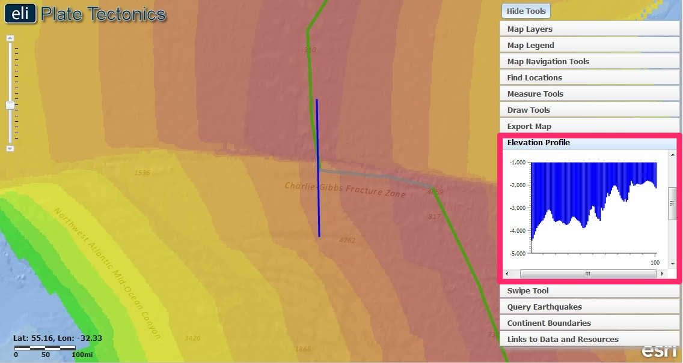

- Instruct students to click on the Elevation Profile tab in the toolbox menu.

- Next, have them click on . This will draw a profile in the North Atlantic that they will use to answer questions on their investigation sheet.

Note: The left side of the elevation profile graph corresponds to the bottom of the profile line.

- This profile crosses a transform fault. Ensure that students notice how the age of the ocean floor changes as you move across the elevation profile line.
Instruct student to answer Questions #10-11 on their investigation sheet.

Students should turn off the Age of the Ocean Floor layer when finished.

Step 6: Discover how passive margins form.

A continental margin is the area of the ocean floor along the coast that separates oceanic crust from continental crust. When the area does not occur along an active plate boundary, it is called a passive margin. In this step, students will use a marine gravity anomaly map to see the transition from continental to oceanic crust. Then, they will place the North American and African plates at their paleo-geographic locations to see how the Atlantic Ocean passive margin has grown and spread from the divergent boundary.

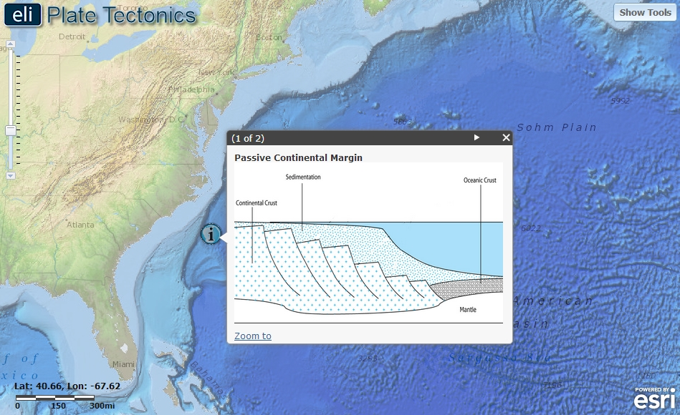

- First, instruct students to click on the Map Navigation Tools tab in the toolbox menu. They should select Eastern U.S. from the list of bookmark locations.

- Next, instruct student to click on the Map Layers tab in the toolbox menu and activate the North American Plate Motion and Enhanced Bathymetry/Topography layers by clicking on the check box.

- Students will click on the Image icon located off the east coast of North America to see a diagram of a continental passive margin. The image below will be displayed in the GIS. We recommend that you explicitly point out to students that there is continental crust beneath the continental shelf (left side of the image below) and oceanic crust in the ocean basin (the right side of the image below).

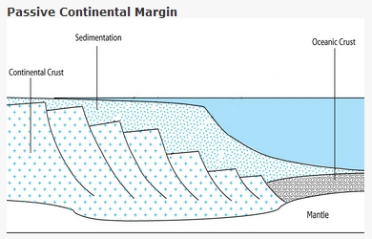

- Next, students should click on the Map Layers tab in the toolbox menu, and activate the Marine Gravity Anomaly layer by clicking on the check box. Explain to students that this layer displays changes in gravity (a result of the properties that define continental vs. oceanic crust) as you move across the continental margin and transition from continental crust to oceanic crust. An eotvos is a measure of the gravitational force at that location. Stronger gravitational forces are represented by red-yellow color on the GIS. Weaker gravitational forces are represented by blue-green color.
Differences in gravitational forces occur because continental crust and oceanic crust have different compositions and different densities. Oceanic crust in more dense than continental crust. Oceanic crust is composed mainly of basalt and continental crust is mainly composed of granite.
A change in gravity occurs across the continental margin because the density changes at the transition boundary between continental crust and oceanic crust. This is indicated by locations on the map where red/yellow colors appear next to blue/green colors when the marine gravity anomaly layer is displayed.

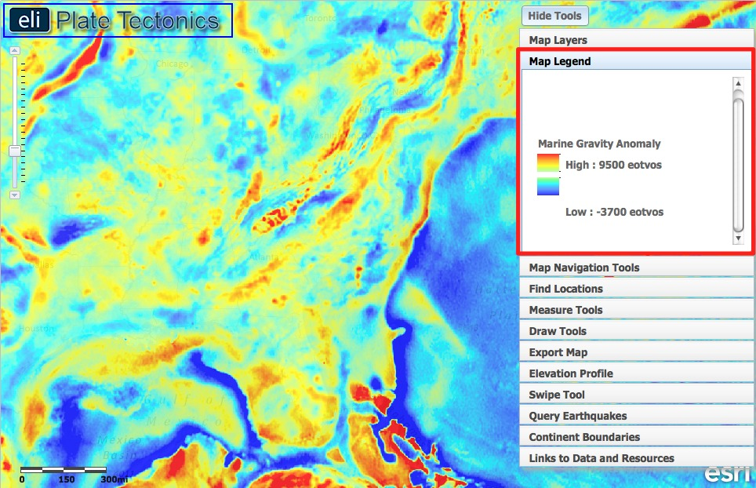

- A change in gravity occurs across the continental margin because oceanic crust is composed of “mafic” minerals (such as basalt) that are denser than the “felsic” continental crust (such as granite). This is indicated by the color change on the map when the marine gravity anomaly layer is displayed. The biggest gravity anomaly occurs where there are transitions in crust type. This is along continental margins.

- To help see the boundary, instruct students to click on the Continent Boundaries tab in the toolbox menu. Click “Add Boundaries”. This button will trace the continental margin around North America and Africa with a thick black line. Students should clearly see the red-yellow color on the left side of the boundary and the blue color to the right of the boundary.

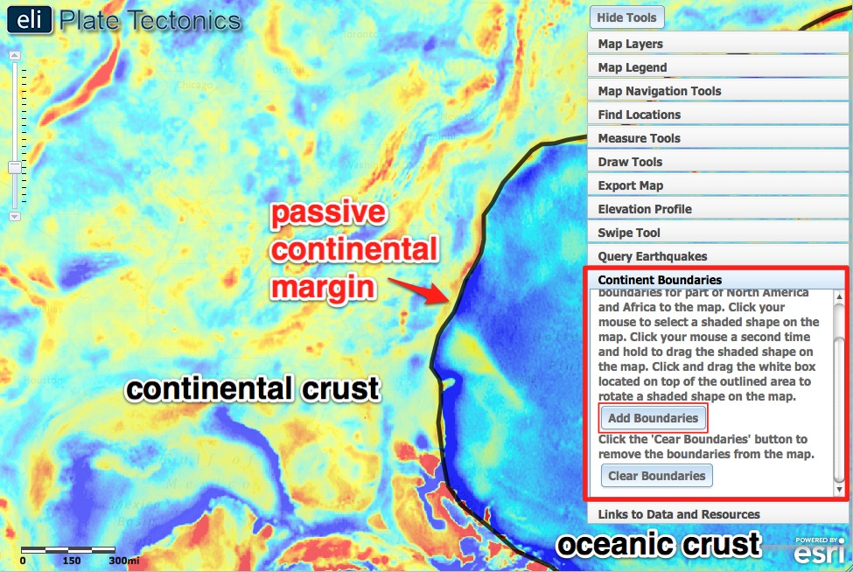

- Next, students will use the swipe too to help them visualize the transition from continent to oceanic lithosphere and answer Question 12.

  - Click on the Swipe Tool tab in the toolbox menu.

  - From the “Choose Layer to Swipe” drop down menu, select Marine Gravity Anomaly.

  - Next, click on to activate the swipe tool. Then in the upper right hand corner to hide the toolbox menu so they can see the whole map.

  - Using the mouse, click and drag the divider across the map. As you drag the swipe tool, the Marine Gravity Anomaly layer is on the left, and the base map layer is on the right.
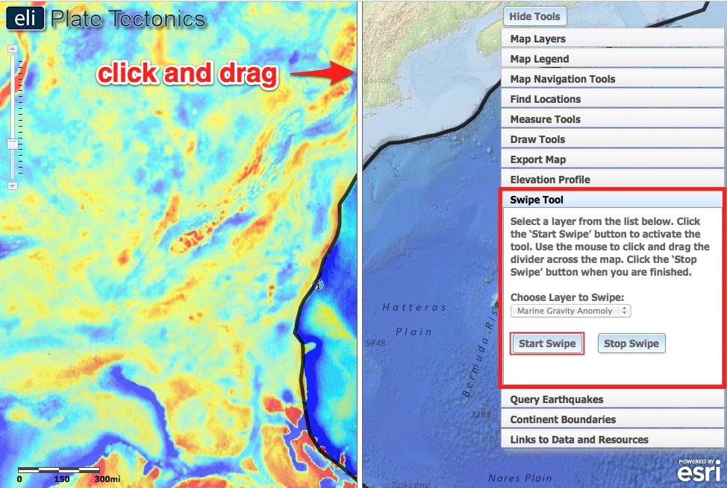

Instruct student to answer Question #12 on their investigation sheet.

- Next, students will discover how North America and Africa have moved away from the Mid-Atlantic Ridge over millions of years. They will observe how the continents that border the Atlantic Ocean have spread and formed passive margins along the coast. First, students are going to determine and place North America and Africa to the area where they were located 90 million years ago and submit a screenshot to you. Next, they will move these continents to the divergent boundary along the Mid-Atlantic Ridge where rifting (spreading apart) of these continents first occurred. They will take a second screenshot at this location and submit it to you.

- Instruct students to click on the Map Layers tab in the toolbox menu and turn-off all the layers and then activate the Age of the Ocean Floor layer by clicking on the check box.

- Have students use the navigation tools to zoom out so they can see the boundary around both North America and Africa. See image on next page.

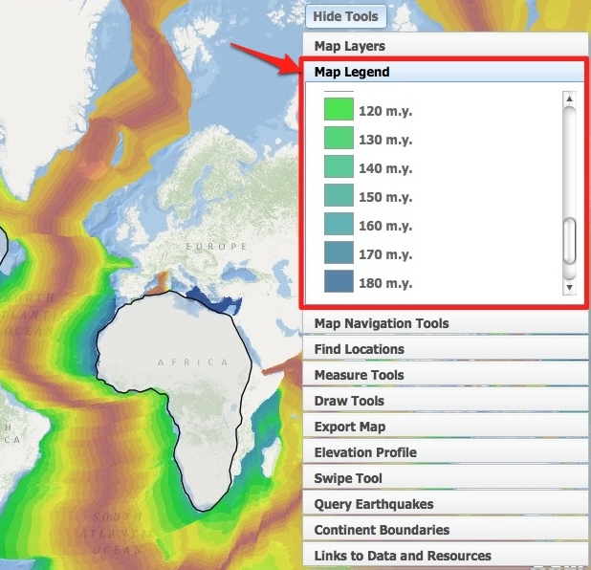

- To determine where the continents were located 90 million years ago, students will need to click the Map Legend tab in the toolbox menu to determine the age of the oldest ocean floor in the Atlantic Ocean (180 million years). They will need to subtract 90 million from the oldest ocean floor age (180 m.y.) to determine the age of this location = 90 million years. They should use the map legend to determine that 90 m.y. is represented by the yellow-green color on the map.

- Next, students will move the continents to the location on the map that represents the location of 90 million years ago. We recommend that you explicitly model how to select, move, and rotate shaded shapes on the map as described below. Review the video on the Web site for additional support with using the Continent Boundaries tool.

- Instruct students to place the part of the continent boundaries highlighted in red (see picture on next page) to the location of the continents from 90 million years ago.

  - Click on the Continent Boundaries tab. Click . Click the mouse to select a shaded shape on the map. Click the mouse a second time and hold to move the continent on the map.

  - To rotate a selected shaded continent, click the white box located on top of the outlined area and then move the mouse to rotate it on the map.

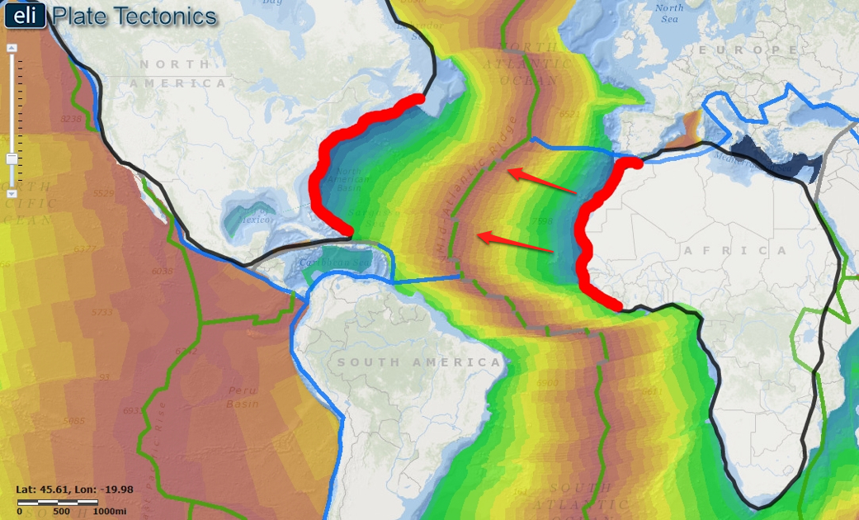

- At this point, students should submit their map images for assessment using the Export Map tool or by taking a screenshot on their computer.
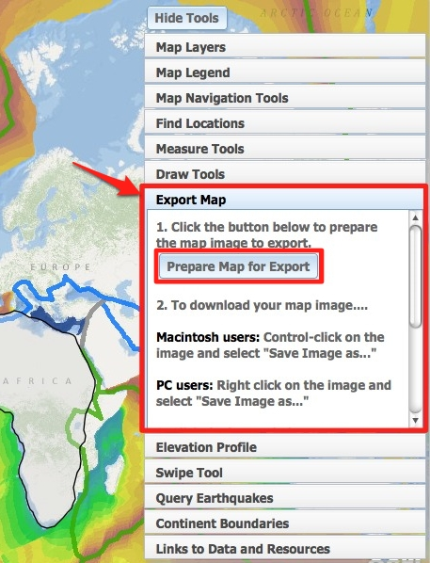

- Instruct students to click on the Export Map tab in the toolbox menu. Next, click . This will create an image of the GIS map to be exported to a location on the computer.

- Follow directions in the toolbox for Macintosh or PC depending upon the computers that are used in your classroom.

- Provide specific file naming instructions and a computer or network location for students to save their images to.
- When they are finished, students can click to return to their maps.

- Next, students should place the continents where they were located when rifting first started, along the divergent boundary.

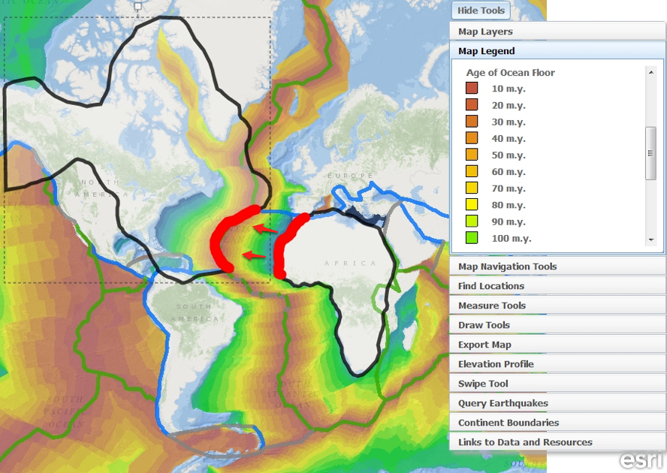

- Students should again submit their map images for assessment using the Export Map tool or by taking a screenshot on their computers.

Instruct student to answer Questions #13-14 on their investigation sheet.

