Name____________________________
Investigation 4:What happens when plates diverge? Investigation Sheet
http://www.ei.lehigh.edu/learners/tectonics
Read all instructions on your handout and answer each question in complete sentences where appropriate.
- What is the name of the feature located at latitude 31º and longitude -41º?

- What is the name of the feature located at latitude -29º and longitude -112º?

- Describe the color pattern that occurs as you look from the divergent boundaries towards the continents. What does this tell you about the elevation at divergent boundaries?

- Where are the extensional (normal) earthquake epicenters located?
Helpful Hint: Look at your Map Legend.

- a. What is the relative motion between the Eurasian and North American Plate?
Helpful Hint: Click anywhere on the map to locate the plate names.
b. What is occurring as a result of this motion?

- a. At what range of depths do most earthquakes occur along divergent boundaries?

b. Why does this happen?
Helpful Hint: Turn on the Lithosphere Thickness layer and the Surface Heat Flow layer and look at the Map Legend to investigate ‘why?’

- Calculate the half-spreading rate of the Mid-Atlantic Ridge. The half-spreading rate is the measurement from the divergent plate boundary in one direction towards the continent.

Distance from the Mid-Atlantic Ridge to oldest Atlantic Ocean floor off the east coast of North America
Age of the oldest Atlantic Ocean floor off the east coast of North America
Half-Spreading Rate of the Mid-Atlantic Ridge
(Distance ÷ Time)

- Calculate the half-spreading rate of the East Pacific Rise.

Distance from the East Pacific Rise to the oldest Pacific Ocean floor off the west coast of South America
Age of the oldest Pacific Ocean floor off the west coast of South America
Half-Rate of the East Pacific Rise
(Distance ÷ Time)

- How many times faster is the East Pacific Rise spreading than the Mid-Atlantic Ridge?
Hint: Divide the rate of the East Pacific Rise spreading by the rate of spreading calculated for the Mid-Atlantic Ridge.

- Use your map to fill in the age of the ocean floor in the spaces below the profile. Then, look at the dashed lines on the profile below. The dashed lines mark the average elevation of that part of the ocean floor. Record the average elevations in the spaces below the profile.

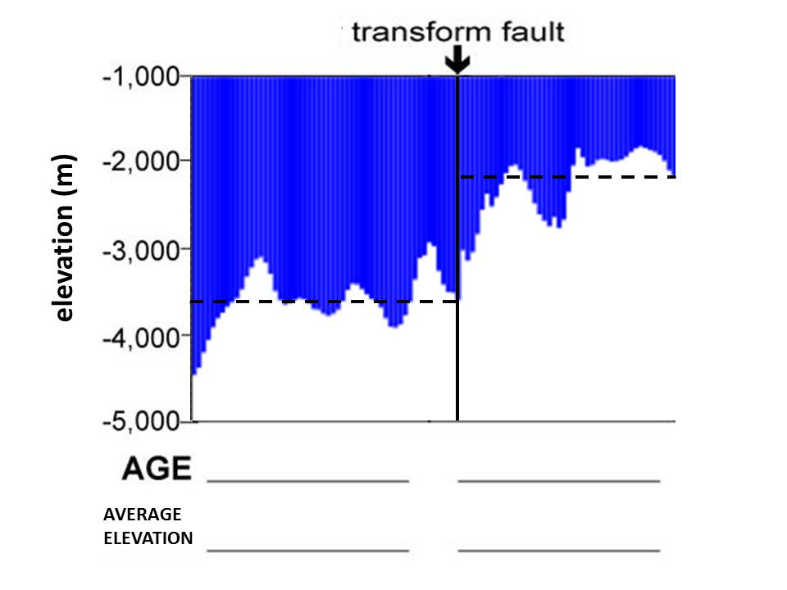

- Why does the elevation change across the transform fault?

- Is the eastern edge of the continental shelf of North America on land or under water?

- What continent rifted away and separated from the East Coast of the United States?

- When did North America separate from Africa?

