Investigation 5: What happens when plates move sideways past each other?

Plates move sideways past each other at transform boundaries. At these boundaries, the lithosphere is neither created nor destroyed. In this investigation, students will locate oceanic and continental transform boundaries and study their history. They will:
- Investigate an oceanic transform boundary, the Charlie-Gibbs Fracture zone, using earthquake and age of the ocean floor data.
- Investigate a continental transform boundary, the San Andreas Fault zone, and the seismic hazards associated with living in this area using earthquake data and historical photographs.

Model the following procedural instructions with your students. It is recommended that you display your computer image to the front of the classroom.

 Step 1: Open Web GIS

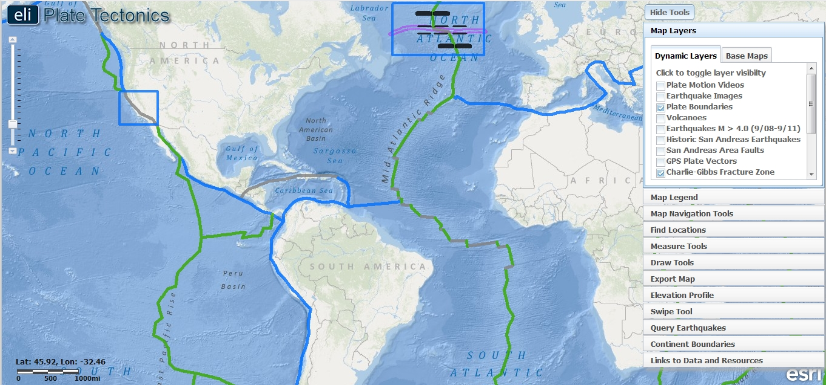

- Have students open their Web browser. Go to www.ei.lehigh.edu/learners/tectonics/

- Click on: Investigation 5: What happens when plates move sideways past each other?

- The Web GIS will open to a global view with the Plate Boundary layer turned on displaying two blue investigation boxes on the GIS: the Charlie-Gibbs Fracture zone and the San Andreas Fault zone.

Step 2: Explore oceanic transform boundaries.

Transform boundaries are located all over the globe. In ocean basins, transform boundaries form perpendicular to divergent boundaries and offset the mid-ocean ridges. Transform faults at ridges allow for the symmetrical opening of the ocean basin. In this step, students will learn that transform boundaries form perpendicular to divergent boundaries and are seismically active.
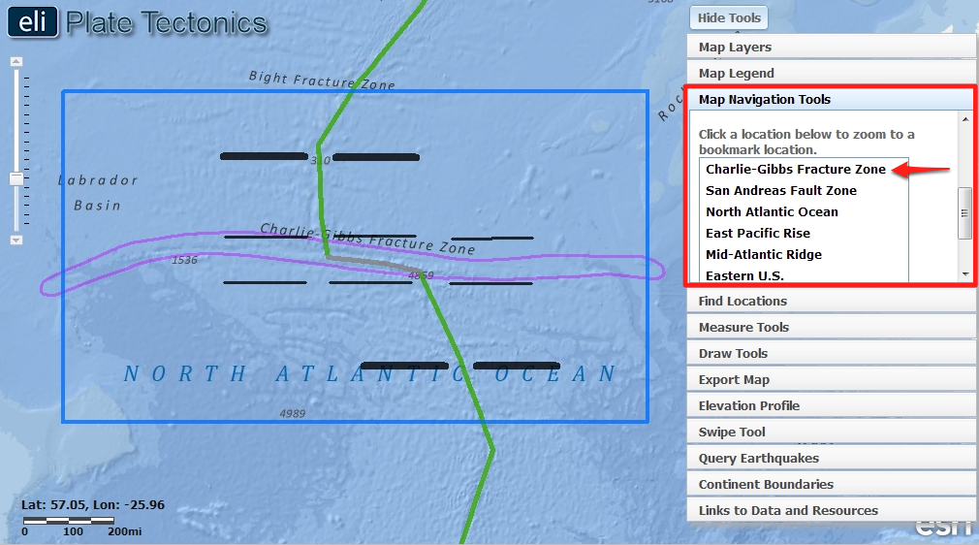

- First, students will investigate the Charlie-Gibbs Fracture zone in the North Atlantic Ocean. Instruct students to click on the Map Navigation Tools tab in the toolbox menu, and select Charlie-Gibbs Fracture Zone from the list of bookmark locations.

- The students’ map will zoom into the Charlie-Gibbs Fracture Zone. They will see 6 black lines that will be used later to explore the motion of the plates in this tectonic area.

- Students will identify the types of plate boundaries in the blue investigation box. To do this, instruct students to click on the Map Legend tab and interpret the data displayed on their map.

 Instruct students to answer Questions #1 and #2 on their investigation sheet.

INTERESTING FACT: The Charlie-Gibbs Fracture Zone is a system of two parallel fracture zones. It is the most prominent interruption of the Mid-Atlantic Ridge between the Azores and Iceland. It can be traced over more than 2,000 kilometers, all the way from north-east of Newfoundland to south-west of Ireland. It took 90 million years for the fault to grow to this length.
The fault was named Charlie Fracture Zone after the USCG Ocean Weather Station Charlie at 52°45′N 35°30′W, located at the fault. In July 1968, the USNS Josiah Willard Gibbs (T-AGOR-1) conducted a more extended survey. It was proposed that the fracture zone be renamed Gibbs Fracture Zone, as fracture zones are generally named for research vessels. The proposal was accepted only in part, and currently the official name is Charlie-Gibbs Fracture Zone. Note that the double name refers to the two parallel fracture zones together. The individual fracture zones have to be referred to as Charlie-Gibbs North and South.

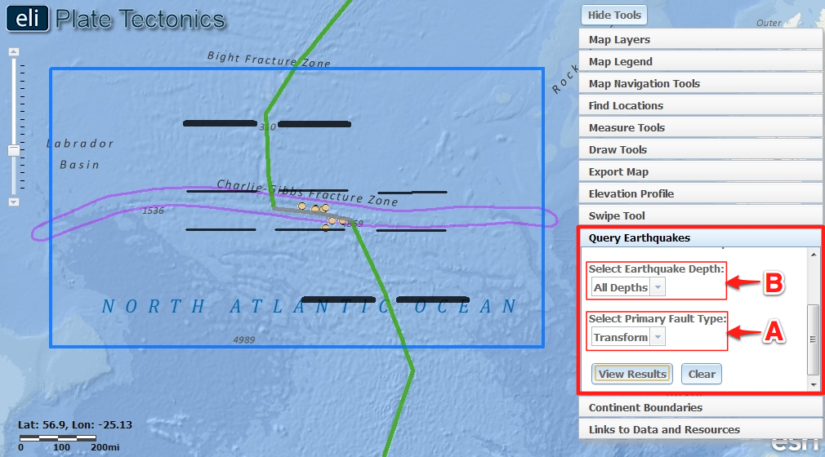

- Earthquakes along transform boundaries record the Earth’s fracture between ridge segments. This fracturing is known as a transform fault, or “strike-slip fault”. The plates move past one another at these locations. Inactive transform faults are fossilized as fracture zones outside the seismically active central transform fault.

- Instruct students to click on the Map Layers tab in the toolbox menu and turn on the Earthquakes M > 4.0 (9/08-9/11) layer.

- Next, instruct students to click on the Query Earthquakes tab in the toolbox menu.

- From this menu, students should select “Transform” from the Select Primary Fault Type drop down menu (A) to query earthquakes that occur along transform plate boundaries.
- Make sure the “All Depths” option is selected from the Select Earthquake Depth drop down menu (B).
- Instruct students to click to observe the plate boundary earthquakes that occurred on the transform plate boundary.
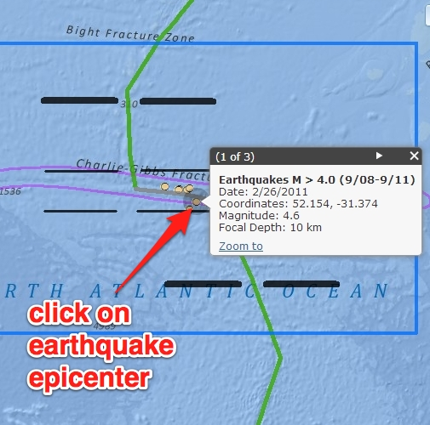

- There are not many earthquakes greater than magnitude 5.0 along oceanic transform boundaries.

- Instruct students to click on an earthquake to identify its magnitude. This magnitude is similar to the other earthquakes along the transform boundary. Magnitude results are between 4.2 - 4.7.

Instruct students to answer Questions #3-4 on their investigation sheet.

Step 3: Explore a transform plate boundary and fracture zone to learn about seismicity.

Transform faults leave scars on the ocean floor called fracture zones. The motions of the plates can be traced by following these fracture zones. In this step, students will explore the lithosphere on both sides of the Charlie-Gibbs Fracture zone to learn how a transform plate boundary differs from the rest of the fracture zone.

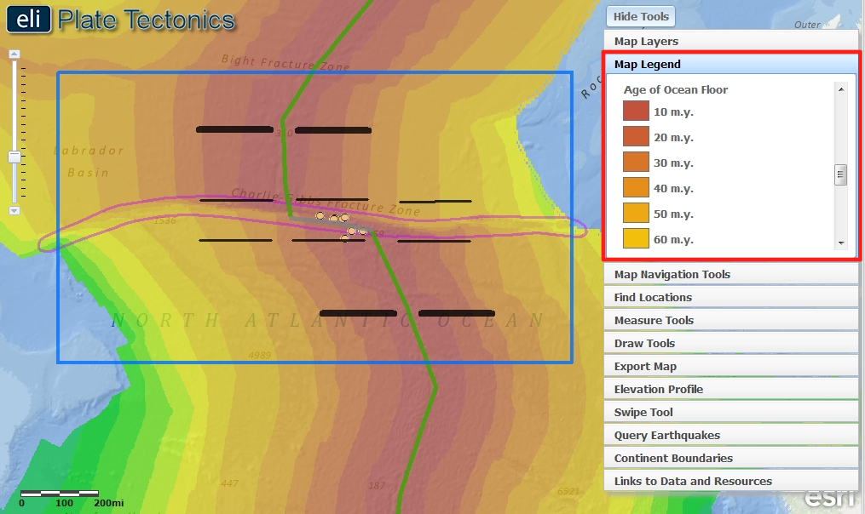

- Instruct students to click on the Map Layers tab in the toolbox menu and turn on the Age of the Ocean Floor layer. To view the map legend, instruct students to click the Map Legend tab in the toolbox menu. The color indicates the age of the ocean floor at the location.

- Show students that the color bands that represent the age are “offset”, and do not line up on opposite sides of the fracture zone. The plates are actively moving past each other between the ridge segments, along the transform plate boundary in the Charlie-Gibbs Fracture zone. In the area outside of the transform boundary, the offset ocean floor preserves the inactive fault or “scar” where the ocean floor now moves in the same direction at the same rate across the fracture zone.

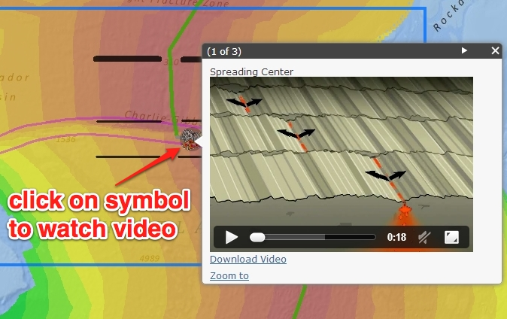

- Next, students will watch a video embedded in the GIS to see the difference between the active transform fault and the inactive fracture.

- Instruct student to click on the Map Layers tab in the toolbox menu and turn on the Plate Motion Videos layer.

- Instruct students to click on the icon located on the transform plate boundary to watch the video.

- The toolbox menu may obstruct the view of the pop-up box. If this is the case, instruct students to click on 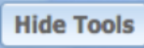, located in the upper right hand corner, so you can see the whole pop-up window.

- Watch the video with your students. Show students that in between the divergent boundaries the plates slide past one another (see image above), along the transform boundaries. Next, highlight how the crust moves in opposite directions at the transform boundary. To the left and the right of the transform boundary you can see that the crust is “fractured”.

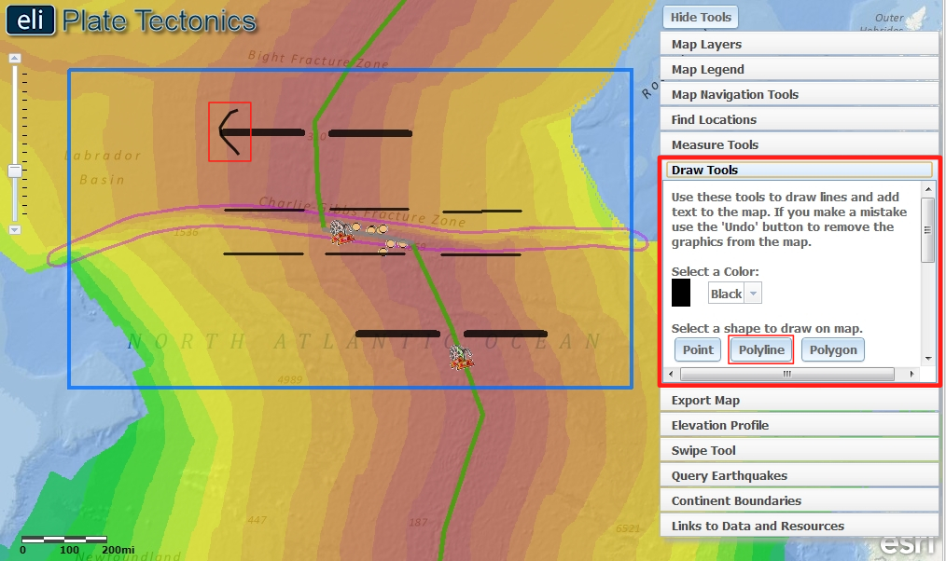

- Next, students will use the Draw Tools to draw the plate motions they observed in the video onto their GIS map.

- Instruct students to click on 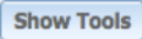 to open the toolbox menu and select the Draw Tools tab in the toolbox menu.

- First, students will draw arrowheads on each of the four bold line segments that point in the direction that the crust is spreading away from the divergent boundaries (see figure above).

- Instruct students to click on the tool and then click a point on their map to start drawing. Students are given a hint that the arrows should be pointing towards the oldest crust. Arrows on the eastern side of the divergent boundary (right), should be pointing to the east (right). Arrows on the western side of the divergent boundary (left) should be pointing towards the west (left).

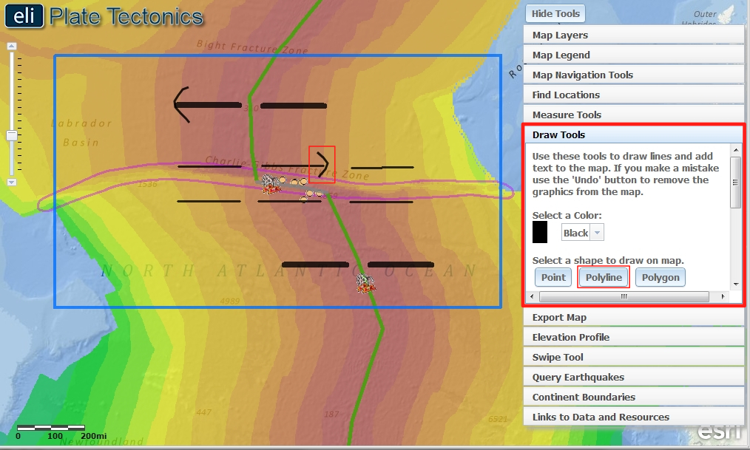

- Next, students will draw arrowheads on each of the six thin line segments that point in the direction that the crust is spreading away from the divergent boundaries on each side of the Charlie Gibbs Fracture Zone (see figure above).

Instruct students to answer Questions #5-9 on their investigation sheet.
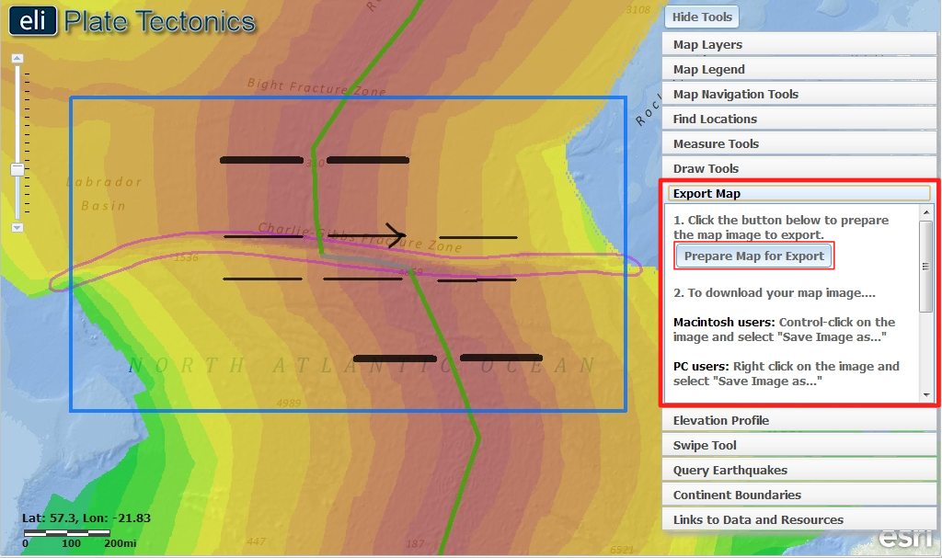

- At this point, students should submit their map images for assessment using the Export Map tool or by taking a screenshot.

- The Export Map tool runs much quicker if students have turned off the Earthquakes M > 4.0 (9/08-9/11) layer and the Plate Motion Videos layer. Instruct students to click on the Query Earthquakes tab in the toolbox menu. Click “Clear”. Next, Click on the Map Layers tab in the toolbox menu and turn-off off the Earthquakes M > 4.0 (9/08-9/11) layer.

- Instruct students to click on the Export Map tab in the toolbox menu. Next, they should click . This will create an image of the GIS map to be exported to a location on the computer.

- Next, follow directions in the toolbox for Macintosh or PC depending upon the computers that are used in your classroom.

- Provide specific file naming instructions and a computer or network location for students to save their images to.

- When they are finished, students can click to return to their maps.

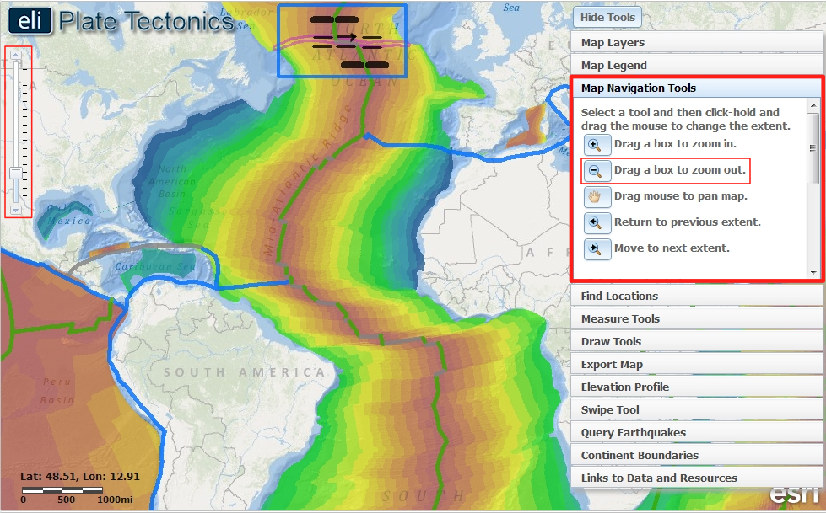

- Next, students will trace more fracture zones in the Atlantic Ocean by looking for patterns of offset ocean floor ages.

- Make sure students zoom out so they can see the entire Atlantic Ocean. To zoom, students can use the vertical bar on the left side of the screen.

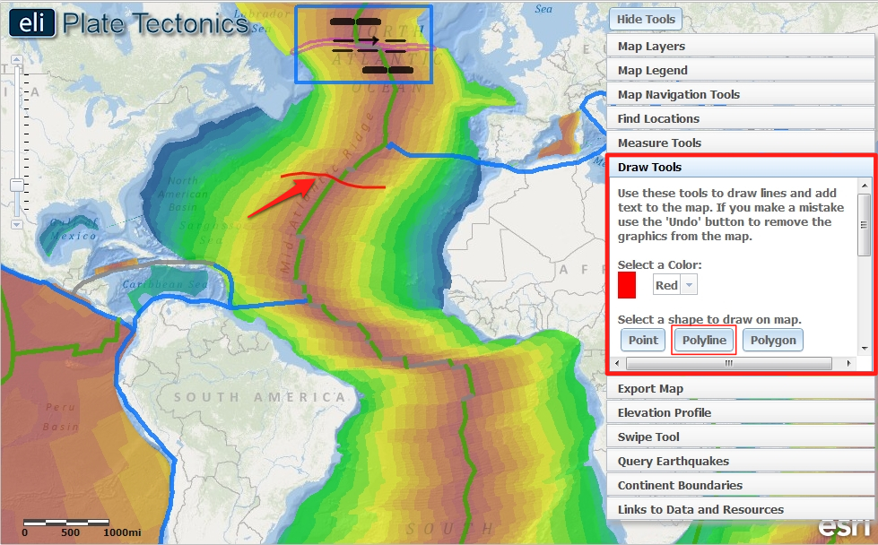

- Students will use the Draw Tools to trace five (5) more fracture zones in the Atlantic Ocean.

- Instruct students to click on the Draw Tools tab in the toolbox menu, and use the tool to trace a location where they see a fracture zone.
Implementation Suggestion: If students have difficulty identifying areas to draw the fracture zones, show them how to zoom-in closely in the GIS viewer to identify the offsets in the age of the ocean floor that identify fracture zones.

- First, instruct students to click on a point at the western edge of fracture to start drawing a line (see figure above). Next, they should hold their mouse down while they drag along the fracture. To finish their line, instruct students to let go of their mouse at the eastern edge of fracture (see figure above). If they make a mistake, students can erase a line segment by clicking .

- Instruct students to find and trace four (4) more fracture zones.

Instruct students to answer Question #10 on their investigation sheet.

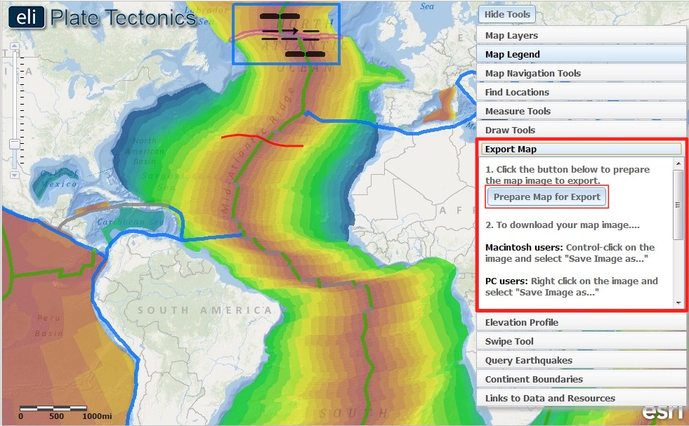

- At this point, students should submit their map images for assessment using the Export Map tool.

Step 4: Locate a continental transform boundary, the San Andreas Fault Zone.

Transform boundaries are also found on land and occur between divergent boundaries. They have more impact on humans. In this part of the Investigation, students will learn about the San Andreas Fault zone and the hazards people face when they live along the plate boundary.

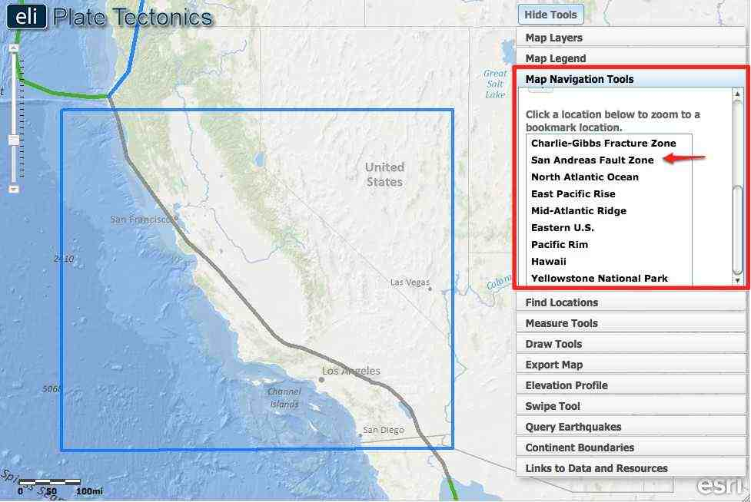

- Instruct students to click on the Map Navigation Tools tab in the toolbox menu and select San Andreas Fault Zone from the list of bookmark locations. Their map will zoom to the transform plate boundary located in western California.

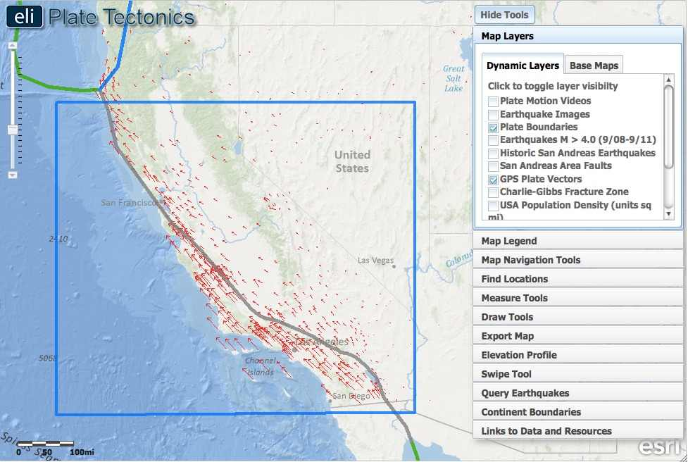

- First students will click on the Map Layers tab in the toolbox menu and turn off Age of the Ocean Floor and activate GPS Plate Vectors layers.
- The red arrows on the map represent “vectors” of the plate motion at that location. A vector consists of a direction and a magnitude.
- The arrow points in the direction the plate is moving at that location.
- The arrow’s size represents the magnitude of motion, or how much that location moves. Bigger arrows represent faster motion. The biggest arrows on the map represent speeds of ~30 mm/yr, and the smallest ~5 mm/yr.

Instruct students to answer Question #11 on their investigation sheet.

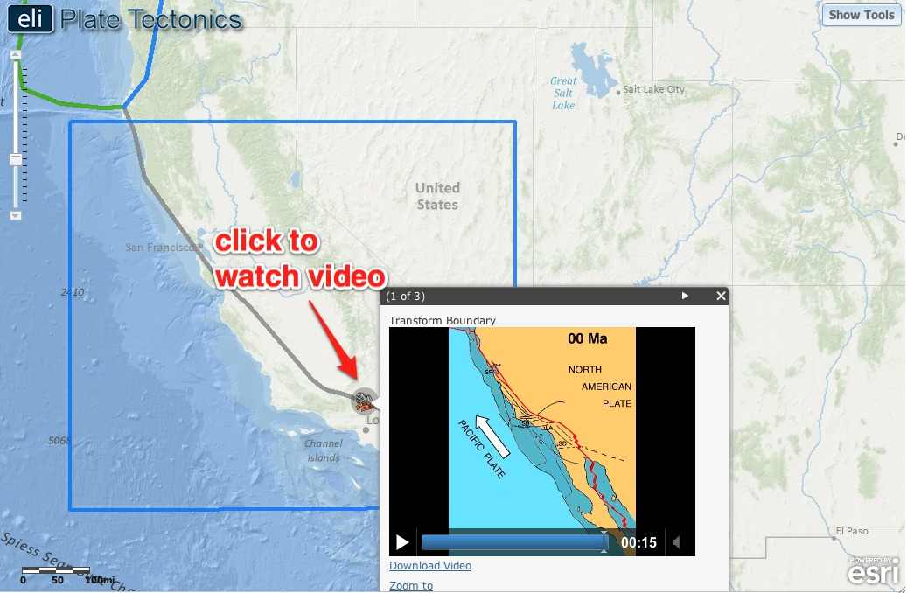

- Next students will watch a video to observe how the San Andreas Fault zone has evolved over the past 20 million years.

- Click on the Map Layers tab in the toolbox menu.

- Turn on the Plate Motion Videos layer.

- Click on the icon located on the transform plate boundary to watch the video.

- Turn off the Plate Motion Videos layer.

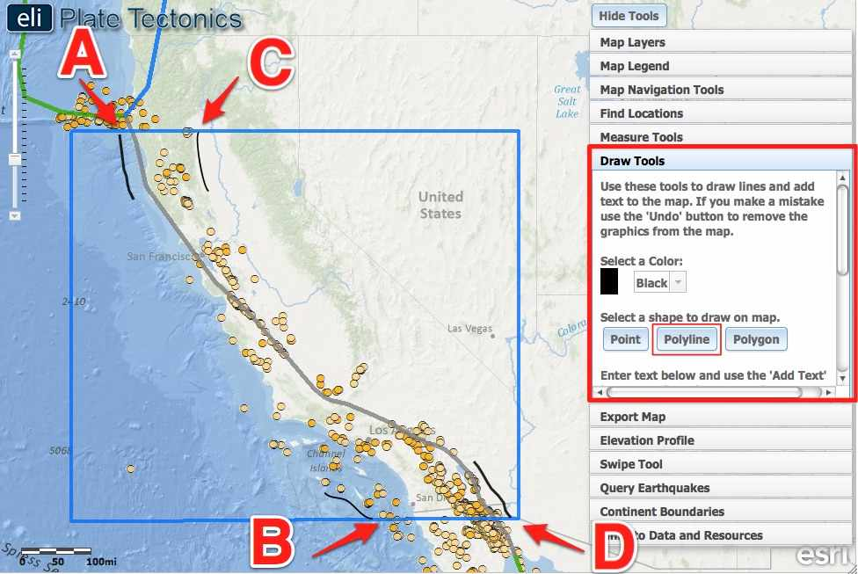

- In the next learning task, students will examine data layers in order to outline the San Andreas Fault zone.

- Instruct students to click on the Map Layers tab in the toolbox menu and turn off the GPS Plate Vectors layer and activate the Earthquakes M > 4.0 (9/08-9/11) layer.

- Students will use the Query Earthquake tool to display only the Transform fault earthquakes. Have students review Step 2 h-k if they need assistance.

- Have students examine the San Andreas Fault zone to observe the spatial patterns of the transform earthquake epicenters and the transform boundary.

- Prompt students to click on the Draw Tools tab in the toolbox menu. Students should select “Black” from the Select a Color drop down menu and then use the tool to draw a line on each side of the transform earthquakes and the plate boundary.

- Refer to the image above: First, instruct students to click on a point at the northwest end of the transform plate boundary on the western edge of the investigation box to start drawing a line (A). Next, students should hold their mouse down while they draw a line to the left of the plate boundary and include all the transform earthquakes. To finish their line, instruct students to release their mouse at the southern edge of the investigation box (B).

- Then, instruct students to draw a line on the eastern edge of the San Andreas Fault zone. Instruct students to start at the northeast end of the transform plate boundary on the edge of the investigation box to start drawing a line (C). Next, students should hold their mouse down while they draw a line to the right of the plate boundary and include all the transform earthquakes. To finish their line, instruct students to release their mouse at the southern edge of the investigation box (D).

- 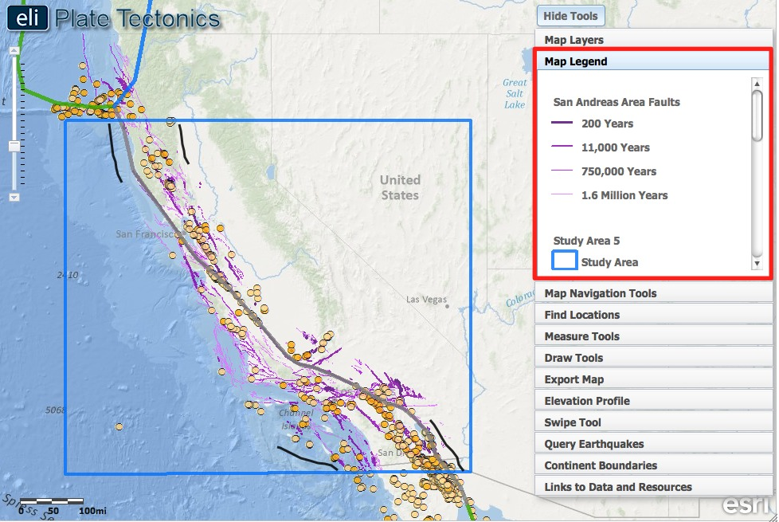

- The area the students outlined represents the San Andreas Fault zone. It is made up of many faults that accommodate the tectonic stresses.

- To view all the faults, instruct students to click on the Map Layers tab in the toolbox menu, and turn on the San Andreas Area Faults layer.

- Instruct student to click on the Map Legend tab to interpret the data displayed on their map. Note the ages of the displayed faults.

- At this point, students should submit their map images for assessment using the Export Map tool.

Step 5: Learn about seismic hazard along the San Andreas Fault Zone.

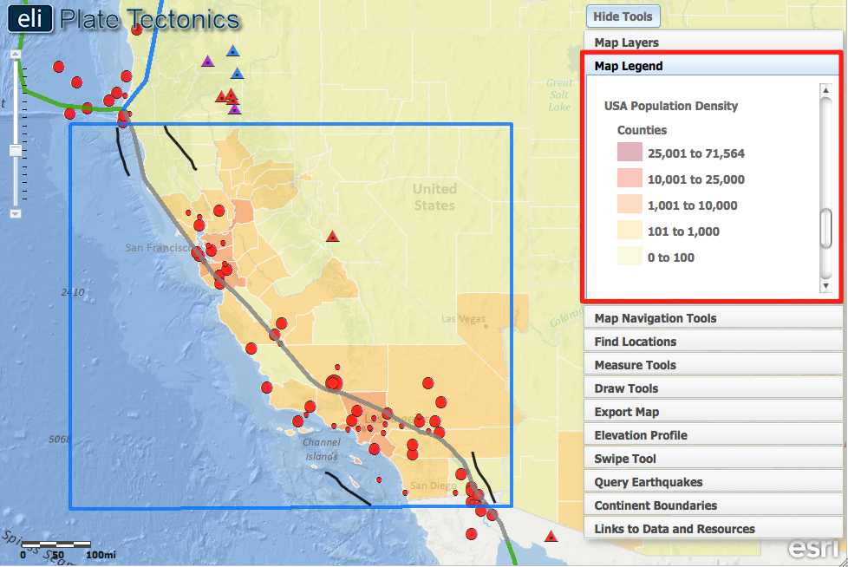

- Instruct students to click on the Map Layers tab in the toolbox menu and turn off the Earthquakes M > 4.0 (9/08-9/11) and San Andreas Area Faults layers and activate the USA Population Density, the Historic San Andreas Earthquakes, and the Volcanoes layer.

Instruct students to answer Questions #12 and #13 on their investigation sheet.

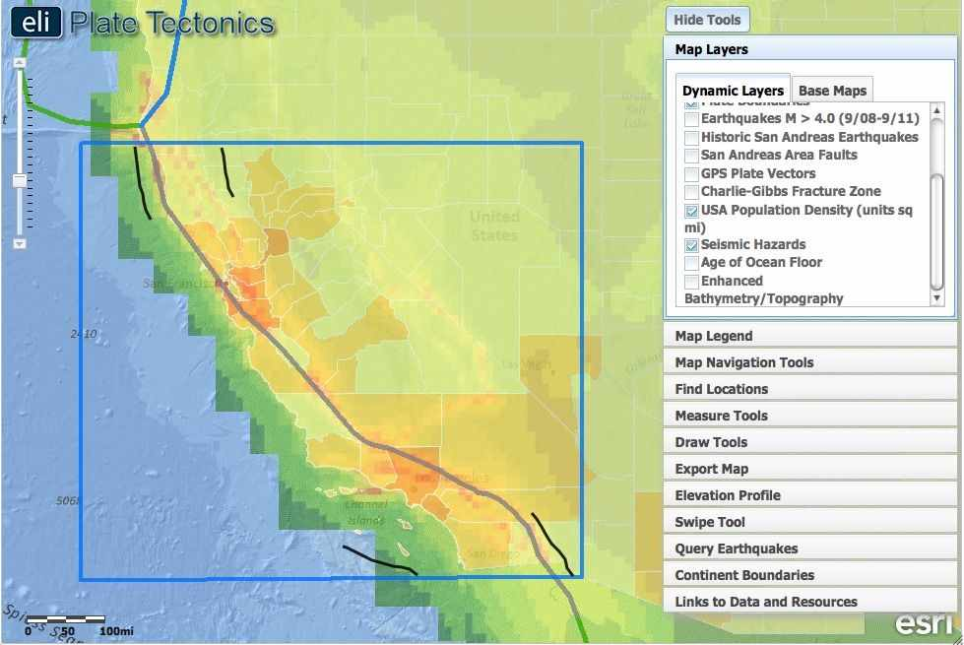

- Next, students will compare the seismic hazard along the San Andreas Fault zone with the population density.

Important note: For the population density layer, the units change based on the scale of the map. It is a relative density based on scale so the map may look different at different zoom levels.
- Instruct students to click on the Map Layers tab in the toolbox menu. Students will turn-off the Historic San Andreas Earthquakes and Volcanoes layer and activate the Seismic Hazards layer by clicking on the check box.
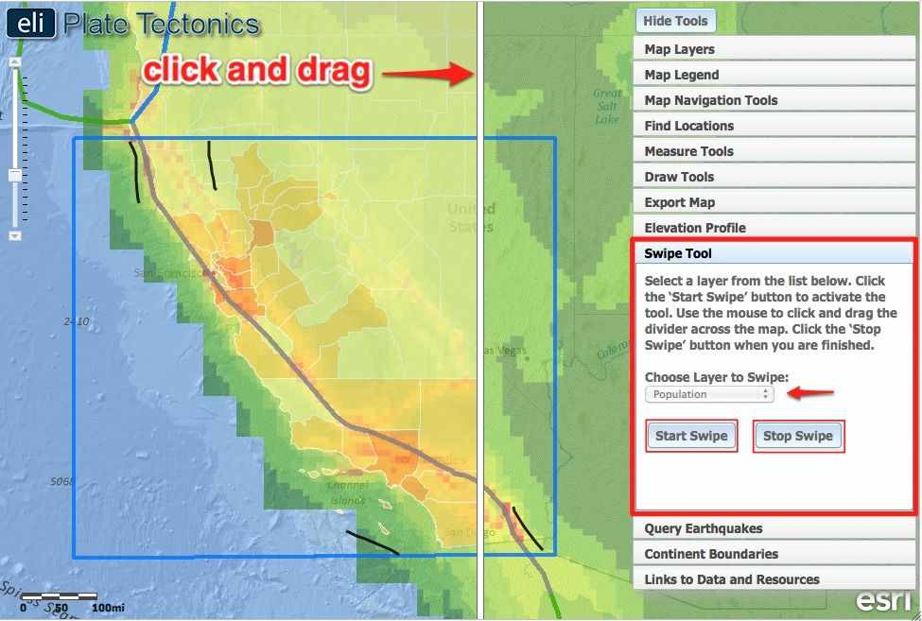

- Students will use the Swipe Tool to compare the Population Density and Seismic Hazard.

- Instruct students to click on the Swipe Tool tab in the toolbox menu.

- From the “Choose Layer to Swipe” drop down menu, select Population.

- Click on to activate the swipe tool.

- Click on in the upper right hand corner to hide the toolbox menu.

- Instruct students to use the mouse to click and drag the divider across the map. As they drag the swipe tool to the left, the USA Population Density layer is removed, revealing the seismic hazard layer underneath.
Instruct students to answer Question #14 on their investigation sheet.

j. When students are finished, instruct them to click on in the upper right hand corner to show the toolbox menu and click in the Swipe Tool tab to turn the tool off.

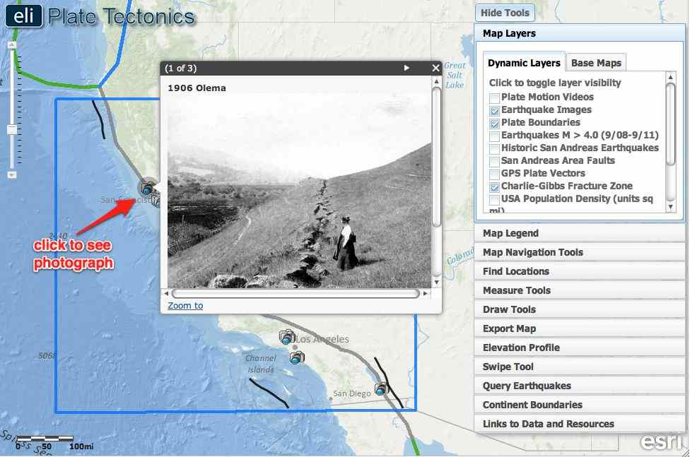

k. In the final activity, students will explore seismic hazards by looking at historic photographs.

l. Instruct student to click on the Map Layers tab in the toolbox menu. Students should turn off the USA Population Density and Seismic Hazards layers and activate the Historic San Andreas Earthquakes and Earthquake Images layers.

Instruct students to click on each image to see a picture of damage caused by earthquakes in the San Andreas Fault zone, and answer Question #15 on their investigation sheet. Make sure the students see the arrow in the grey bar above the image; this means there are more images to view.

