Investigation 6: What happens when plates collide?

In this activity, students will use the distribution of earthquakes and volcanoes in a Web GIS to learn about plate collision at an ocean-ocean subduction zone and ocean-continent subduction zone. They will also recreate a continent collision to learn about convergent zones. They will:
1) Discover the relationship between the subduction zones and volcanoes.
2) Determine the slope of subduction along a convergent plate boundary.
3) Learn the types of landforms created by continents colliding at convergent zones.

Model the following procedural instructions with your students. It is recommended that you display your computer image to the front of the classroom.
Part 1: Subduction Zones
Step 1: Open Web GIS
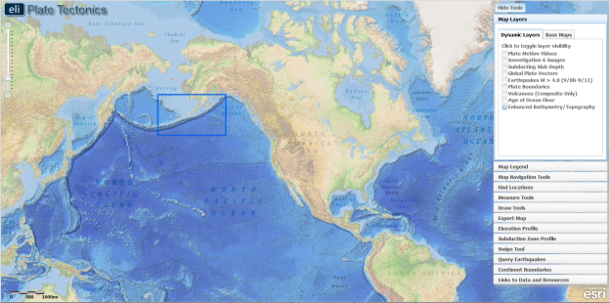
Have students open their Web browser. Go to http://gisweb.cc.lehigh.edu/tectonics/investigation6/

Click on: Investigation 6: What happens when plates collide?

The Web GIS will open to a map focused on North America with a blue box around the study area.

Step 2: Identify and trace the plate boundary.

Tectonic forces cause plates to collide, pull apart, and slide past each other causing earthquakes. Also, volcanoes tend to form where plates are colliding or pulling apart. Because of this, we can identify areas with many earthquakes and volcanoes as a boundary where plates are either colliding or pulling apart. A subduction zone is an area where two tectonic plates move towards one another and one plate sinks beneath the other. Aging and cooling ocean lithosphere becomes denser than the mantle and becomes a subducting slab when it collides with another plate.

- On the students’ GIS, the map opens with a view of North America and a box around the study area in the Aleutian Islands. Ask students where the blue study area box is located geographically. Prompt students to identify which ocean, which part of the ocean, and which state the study area includes. This will help the students orient themselves to where the Aleutian Islands are located and what is around them. The Enhanced Bathymetry/Topography layer will already be activated. This layer will make it easier for students to identify deeper areas of the ocean floor: darker blue colors indicate deeper water.

- Have students explore the map using the Map Navigation Tools located on the toolbars menu. Select the “Aleutian Islands” bookmark.

  - To move around the map, select the hand tool and click and drag the map to a new location.

- To help students observe the depth of the trench formed at the ocean-ocean subduction zone, instruct students to draw a few elevation profiles across the Atlantic Ocean.

- Instruct students to click on the Elevation Profile tab in the toolbars menu.

- Next, students should click on 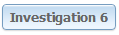. On their map, a pre-drawn profile will appear that crosses the Aleutian Trench. An elevation profile of this line will appear in the Elevation Profile tab. They can place their cursor on the elevation profile to view corresponding points along the profile line on their maps. We recommend that you explicitly model how to use the elevation profile tool with your students.
Instruct students to answer Question #1 on their investigation sheets.

f Instruct students to activate the Volcanoes (Composite Only) layer. To learn more about an individual volcano, they will click on it and a box will appear with the elevation, type, and location of that volcano.

- Students will also identify the names of the plates subducting and overriding at the Aleutian Trench. To identify a plate name, click on the GIS map. When they click on a location, a box will appear with that location’s plate name. For example, when they click on North America, a box that says “Plate Name: North American Plate” will appear.

- When they are finished, students should click on in the Elevation Profile tab to turn the tool off.

Instruct students to answer Questions 2-4 on their investigation sheets.
- Students should now turn off the Volcanoes (Composite Only) layer. Students will now use Draw Tools to outline the subduction zone boundary. These tools allow you to draw lines and place labels on your map.

- Select the Draw Tools tab in the toolbars menu.

- Use the tool to trace the path of the deepest water (dark blue). First, click on a point at the western edge of the trench to start drawing a line. Press and hold your mouse down while you drag it along. To finish the line, instruct students to let go of their mouse at the eastern edge of the Aleutian Trench (see figure below). If students make a mistake, they can erase a line segment by clicking .

- Have students use the Draw Tools tab to ‘Add Text’ to label their map with their name and a descriptive title about the map. Students should submit their maps by taking a screenshot or by using the Export Map tool. To use the Export Map Tool, first click on the Export Map tab in the toolbars menu. Next, click . This will create an image of your work that is ready to be exported. Next, follow directions for Macintosh or PC depending upon the computer you are using. Give students instructions with specific file naming instructions and with a computer or network location to save their images to. When you are finished, click to return to your map.

Assessing the exported image:
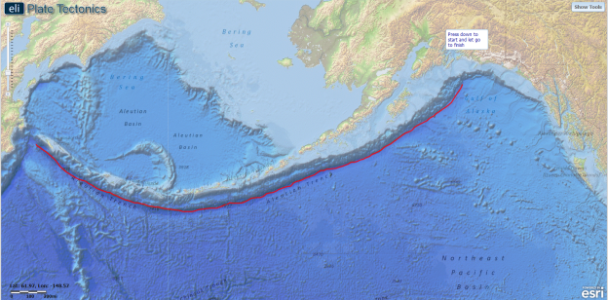
The exported image should include a continuous line that follows the Aleutian Trench at its deepest point indicated by the darkest blue color on the GIS map display.
- Instruct students to activate the Global Plate Vectors, and Volcanoes (Composite Only) layers by clicking the check boxes.

- Using the Volcanoes (Composite Only) and Global Plate Vectors layers, students will determine what types of plate boundaries lie on the line they just drew. Transform plate boundaries occur where plates are sliding past one another, and do not produce volcanoes. Convergent plate boundaries occur when a plate is being subducted underneath another plate. This type of boundary does produce volcanoes.

Instruct students to answer Questions 5-7 on their investigation sheets.
- Students will now view a video on plate subduction at the Aleutian Trench. Instruct students to activate the Plate Motion Videos layer and click to play. The video shows a subduction zone where ocean crust is subducting underneath lithospheric crust. The downgoing slab at the subduction zone heats up and partially melts causing magma to rise up through the overriding plate resulting in the formation of volcanoes. This heat rises through the surface going through the overarching plate and results in the formation of volcanoes.
Implementation Suggestion: We recommend that you display the video to the front of the room and explicitly describe the tectonics processes that are described above.

Step 3: Determine the slope of the subducting slab.

The slope of the subducting slab usually varies along the plate boundary. In this step, students will formulate a hypothesis about which plate is subducting underneath the other at the Aleutian Trench. After analyzing two different subduction zone profiles, they will revisit their hypothesis to modify it based on evidence learned in the GIS.
Use the Subduction Zone Profile tab to investigate the subducting slab at two locations along the subduction zone.

        - Instruct students to turn off the Global Plate Vectors and Plate Motion Videos layers. They should now click on the Subduction Zone Profile tab and click on O\O (Atka Island) to investigate a profile across the western part of the subduction zone. The names on the subduction zone profiles indicate whether there is ocean subducting under ocean (O\O), or ocean subducting under continent (O\C).

        - The Subduction Zone Profile tab shows a profile view of the subducting slab. Surface elevation is represented by the blue filled circles, composite volcanoes are shown as purple triangles, earthquake foci are shown as red circles, and top of the subducting slab depth is shown as gray connected circles. All units are in kilometers.
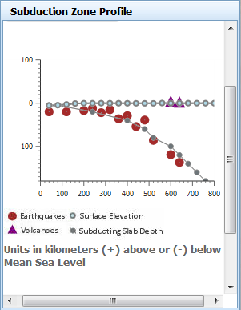
O\C (Kodiak Island)
Pacific Plate (Ocean)
North American Plate (Ocean)
Pacific Plate (Ocean)
North American Plate (Crust)
O\O (Atka Island)
Subduction Zone Profile tool with plate labels. Students will see these images in their student guide.
Implementation Suggestion: Some students may require explicit modeling in order to interpret the subduction zone profiles. We suggest that you use guiding questions to note the locations of the volcanoes, the deepest earthquakes, and prompts to help students identify which plate is the subducting plate (Pacific Plate) and which plate is the overriding plate (North American Plate).
        - Students will use the Distance measure tool to measure the distance of the volcanoes to the convergent plate boundary.

i. Instruct students to go to the Measure Tools tab.
ii. Click on the Distance measure tool.
iii. Click on a volcano on the eastern profile.
iv. Students should drag their mouse perpendicular to the convergent boundary until they reach the trench.
v. Double click at the left edge of the oldest ocean floor to display the measurement result (see image below).
- Click on the Subduction Zone Profile tab and click on O\C (Kodiak Island) to investigate a profile across the eastern part of the subduction zone.

Important note: Double-clicking on the distance measure will complete the measurement for the line. Click anywhere on the map to begin a new line with the distance measure tool. The previous line will disappear. Click the Distance Measure tool to make the line disappear.
Instruct students to record this distance for both the O\O (Atka Island) and O\C (Kodiak Island) profiles on the chart in Question 8 on the investigation sheets. Remind students to include the measurement units.
- Students should now examine the focal depths of the earthquakes in the O\O (Atka Island) subduction zone. The focal depth of each earthquake in the Subduction Zone Profile will appear when you hold your mouse over each earthquake.

- Click on the Subduction Zone Profile tab and click on O\C (Kodiak Island) to investigate a profile across the eastern part of the subduction zone.

Instruct students to record this depth for both the O\O (Atka Island) and O\C (Kodiak Island) profiles on the chart in Question 8 on the investigation sheets. Remind students to include the measurement units. Instruct students to answer Questions 9-11 on their investigation sheets.
- Have students turn off the Subduction Zone Profile tool by clicking and activate the Slab Depth layer. To view the map legend, students should click the Map Legend tab in the toolbars menu. Red lines mean a greater depth to the slab while green lines represent a shallower slab depth.

- Students will use the Slab Depth layer to determine which direction the subduction slab is dipping.

Instruct students to answer Questions 12-13 on their investigation sheets.

- Students should now turn off the Subducting Slab Depth layer and activate the Age of the Ocean Floor layer. To view the map legend, students should click the Map Legend tab in the toolbars menu. Red indicates younger ages while blue indicates older ages. Younger crust is warm and shallow. At the Aleutian Trench, there is warmer, more buoyant ocean being subducted on one side.

Instruct students to answer Question 14 on their investigation sheets.

Part 2: Colliding Creates Landforms
Step 4: Exploring plate subduction

Students will explore the landforms created by volcanoes at different subduction zones in the Aleutian Islands and the Northwestern United States.

- Using the Aleutian Islands bookmark, students will re-focus their view on the Aleutian Trench. Turn off the Age of the Ocean Floor layer. Activate the Plate Boundaries layer, the Volcanoes (Composite Only) layer, and the Investigation 6 Images layer.
- Students should recall the plate names on either side of the Aleutian Trench. If they have difficulties, refer them to Step 2f. Students should pay particular attention to the types of lithospheric crusts at this location and the location of the volcanoes in relation to the plate boundary. In the previous sections they will have learned that the downgoing (subducting) slab at the subduction zone heats up and partially melts causing magma to rise up through the overriding plate resulting in the formation of volcanoes. The volcanoes appear on the surface of the overriding plate.
- Instruct students to click on the three icons to view photos of some volcanoes along the Aleutian Trench. To view the elevation of each volcano, instruct students to click on the arrow at the top of the volcano image box. The elevation units are in meters.
Ocean-ocean subduction in the Aleutian Trench created volcanic islands.
Instruct students to answer Questions 15-17 on their investigation sheets.
- Students will now use the Map Navigation Tools to zoom to Cascadia with the bookmark. Students will identify the names of plates in Cascadia. They should pay attention to the location of the volcanoes to identify which plate is subducting and which plate is overriding at this subduction zone. Volcanoes form on the overriding plate.

- Instruct students to click on the three icons to view photos of some volcanoes in the Cascadia region. To view the elevation of each volcano, instruct students to click on the arrow at the top of the volcano image box. The elevation units are in meters.

Ocean-continent subduction in Cascadia creates volcanic mountains. It may be helpful to point out to students that while the elevation of volcanoes in Cascadia is greater than those in the Aleutian Islands, elevation is relative to sea level and the Aleutian Island volcanoes originate from under the ocean.

Instruct students to answer Questions 18-24 on their investigation sheets.
- Have students turn off the Investigation 6 Images layer and activate the Earthquakes M > 4.0 (9/08-9/11) layer. They should zoom out to see the entire western coast of the United States.

Implementation Suggestion: It may be helpful to remind students to think about what types of plate boundaries form different types of geologic hazards. Volcanoes are formed on the overriding plate at a convergent boundary, as seen in the Northern Pacific U.S. Volcanoes do not occur on transform plates, as seen in the Southern Pacific U.S.
Instruct students to answer Questions 25-27 on their investigation sheets.
Step 5: Exploring continent collisions

Continental plates do not subduct underneath one another because they have similar densities and are buoyant. Instead, continental plates collide at continent-continent convergent boundaries. In this step, students will explore what happens when continents collide and learn how mountains are created.

- Have students turn off the Plate Boundaries, Volcanoes (Composite Only), Earthquakes M > 4.0 (9/08-9/11), and Enhanced Bathymetry/Topography layers. Students should click on the Map Layers tab and select base maps. Turn on the Topography base map. Click on Map Navigation Tools tab in the toolbars menu and select Atlantic Ocean.

- The continents that bordered the Atlantic Ocean collided approximately 300 million years ago. Students will virtually collide the continent boundaries North America and Africa. Instruct students to turn on the Investigation 6 Images layer. Click on the on the eastern coast of the United States. This image illustrates a continent-continent convergent boundary creating mountains. Have students pay attention to what landforms are on the surface of the continental crust.
- Have students click on the Map Layers tab in the toolbars menu and click on the Continent Boundaries tab and select “Add Boundaries”. This will add dark boundaries to the outlines of Africa and North America.

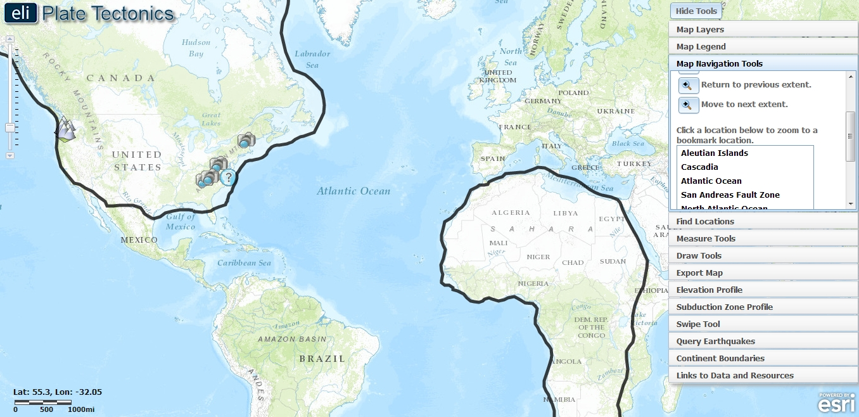

- Students will now move Africa to simulate the collision of the continents 300 million years ago.
Implementation Suggestion: We recommend that you model how to use the Continent Boundaries tool to select, move, and rotate the continents on the GIS.
To begin, instruct students to click on Africa once. After Africa is selected, students can drag the outlined west coast of Africa to the outlined east coast of North America. To rotate Africa, click the white box located on top of the outlined area and then move your mouse to rotate it on the map.

Assessing the exported image:
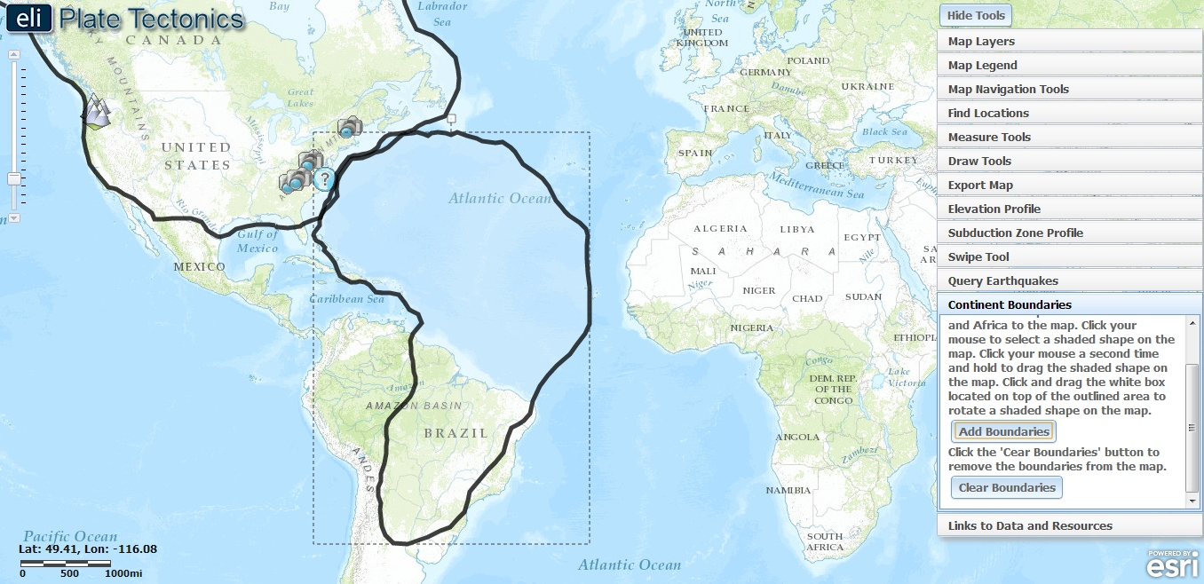
The exported image should show Africa moved and rotated so it fits in with the eastern coast of North America.
- Students will now focus on the results of this continent-continent collision. Have students click on the Map Navigation Tools tab and select Eastern U.S. At this point, students should look for any major landforms along the eastern coast of North America. It may help to remind students of what they saw in the continent-continent collision image. Continent-continent collision does not result in subduction because continental crust is lighter than the underlying mantle and floats on top. Continent-continent collision creates new landforms.

- Instruct the students to draw an Elevation Profile across the Appalachian Mountains. Click on the Elevation Profile tab in the toolbars menu. The Elevation Profile tool will not work if the Continent Boundaries tab is selected.

- Locate the Appalachian Mountain range (see image below). Begin your elevation profile line by clicking on the map on the western side of the Appalachian Mountains. Continue your line east to the coast of the U.S. (see image below).
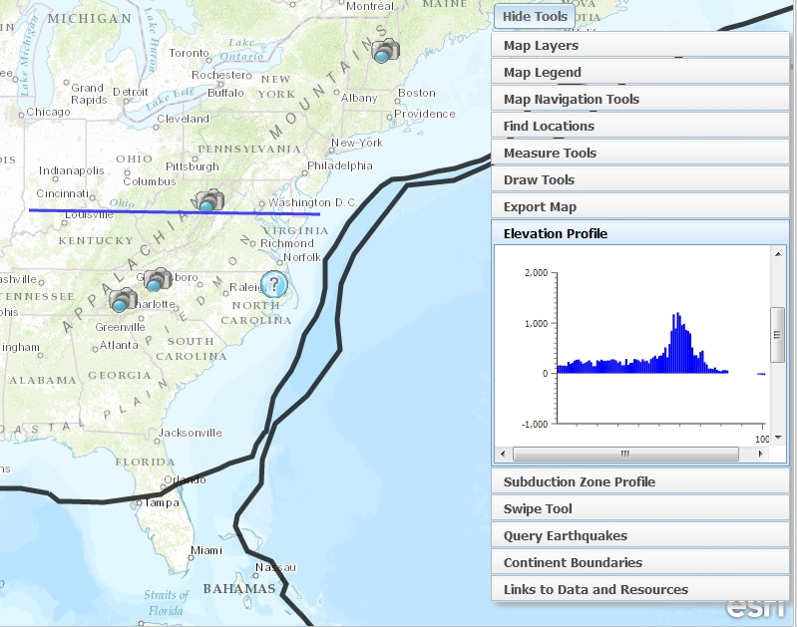
- The elevation profile along that line will appear in Elevation Profile tab on the right. The highest point corresponds to the highest elevation in the Appalachian Mountain range along that profile line.
- Instruct students to click on the Map Layers tab. Have students click on the icons to view pictures of mountains in the Appalachian range. The images will not be accessible if the Map Layers tab is not selected. Tell students to notice how these are still tall mountains even though they have been eroding for 300 million years.
- Students will calculate the height of the Appalachian Mountains when they formed. The current height of the Appalachians and the erosion rate are given on the student worksheet.
Instruct students to answer Questions 28-30 on their investigation sheets.

