Investigating Solar Energy

INVESTIGATIVE QUESTION: What is the effect of using different light sources to power simple appliances with a solar cell?

In this activity you will:
- Observe the transfer of solar energy (light energy) to different appliances with a solar cell.
- Investigate the effect of using different solar sources to supply energy to appliances.

You will work in groups of 4. Each group will be given two solar panel kits. In your group, you will work in teams of two. Each team using one solar panel for 1/2 the session; switching panels at the midway point.

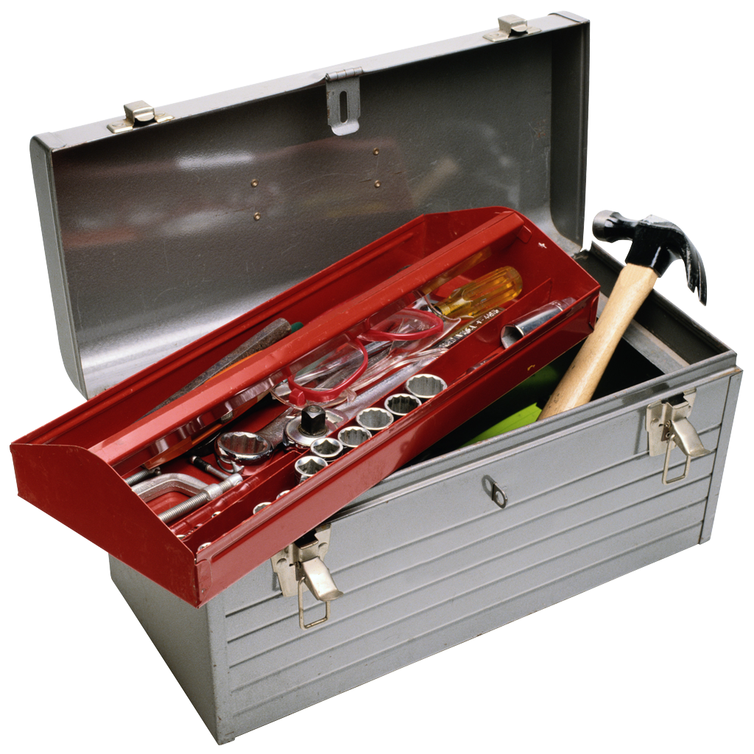Step 1: Tools to Capture Solar Energy

Inside your Solar Kit you will find many pieces. Read the descriptions of each component below.

Component Description |  | Picture
Solar Cell (also called Photovoltaic Cell): Made of several layers of silicon crystals encased in a plastic and metal structure. As sunshine passes through the layers, it creates a flow of electrons throughout the silicon crystals. Gaps in the layers allow electrons to move between the layers. As electrons move back and forth through the gaps, it produces electricity. |  | 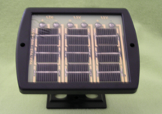
Back of Solar Cell Component: Small wire nuts hold the wires to negative and positive connection points. You may need to move the wires to increase the voltage or current (amps). | Parallel Circuit: This connection pattern increases the current (amps). | 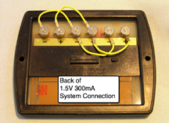
 | Series Circuit: This connection pattern increases voltage. | 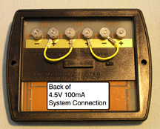

Appliances: An appliance is a piece of equipment, usually operated from an electrical source.

The appliances in your solar kit include:
Light Bulb:  This is a LED light encased in plastic. It needs approximately 1.5 volts (V) of electricity to light.  This light source requires a 1.5V 300 milliAmps (mA) power source.  The connection terminals on this appliance can be hooked to either positive (+) or negative (-) poles. |  | 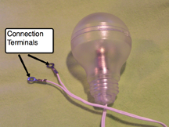
Music Unit:  This unit requires a 4.5V 100mA power source.  The connection terminals on this appliance must be placed on to the correctly charged poll. Note the + label on the terminal. This connection terminal would be placed on to a positive (+) charged poll.  A red marked connection terminal would be placed on to a negative (-) charged poll. |  | 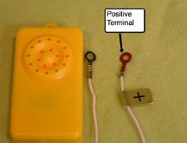
Assembled Fan/ Motor Unit:  The motor should always remain in the stand for safety purposes. |  | 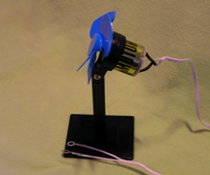
Goose Neck Light and 100 Watt Bulb  This is your artificial light source. |  | 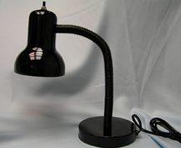

Step 2: Setting up your equipment:
- Your group has two solar cells. In teams of 2 you will experiment first with one solar cell set up and switch after all observations are made for the first series of experiments.

- One solar cell is prewired to power the light bulb and fan motor appliance. The other solar cell is prewired to power the music unit. Use the pictures below to select the correct solar cell set up.

  - Light Bulb and Fan Motor Wiring (1.5V 300mA system):

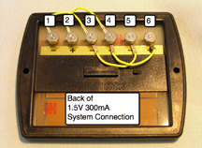

- Turn your solar cell panel over. Be sure it is wired as shown in the picture above. This is a parallel connection. This pattern increases the electrical current (Amperes) to the appliance.

  - Positive poles are connected to positive poles. Positive (+) pole 2 is connected to the next positive (+) pole 4 with a connecting wire. Positive (+) pole 4 is connected to positive (+) pole 6.

  - Negative poles are connected to negative poles. Negative (-) pole (1) is connected to negative (-) pole 3. Negative (-) pole 3 is connected to negative (-) pole (5).

- Connect your appliance.

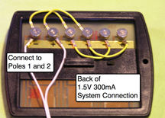

  - Look at the appliance you will be using. The wire splits in two. There are two separate connection terminals.

  - Unscrew the screw nuts at points 1 and 2.

  - Place a connection terminal on the end of the wire over pole 1.

  - Place a connection terminal on the end of the wire over pole 2.

  - Replace and tighten the screw nut. Be sure it is just tight enough to make a connection. If you make it too tight it will break the solar panel.

- Continue to Step 3: Conducting The Experiment.

b. Music Box Wiring (4.5V 100mA system):

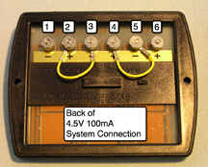

- Turn your solar cell panel over. Be sure it is wired as shown above. This is a series connection. This pattern increases Voltage.

  - The positive (+) pole 2 is connected to negative (-) pole 3 with a connecting wire. Positive (+) pole 4 is connected to negative (+) pole 5.

- Connect the Music Box.

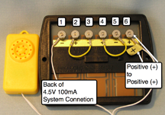

  - The Music box requires special wiring. The wire splits into two connection terminals. One connection terminal is marked with a + label or is colored red. The other connection terminal is unmarked.
The wire with a + label and is colored red attaches to a positive (+) pole.
The unmarked wire to a negative (-) pole.

  - Unscrew the screw nuts at points 1 and 6.

  - Place the (+) and red connection terminal on the end of the wire over positive (+) pole 6.

  - Place the unmarked connection terminal over negative (-) pole 1.

  - Replace and tighten the screw nuts. Be sure it is just tight enough to make a connection. If you make it too tight it will break the solar panel.

- Continue to Step 3: Conducting the experiment.

Step 3: Conducting the experiment:

Basic Set Up:
- For the first half of the class work with solar kit 1. At midway point switch to solar kit 2.
- You will be using 3 different light sources in this experiment.
  - Direct artificial light (gooseneck Lamp with 100 watt bulb)
  - Sunlight (direct sunlight or near a bright window using natural light)
  - Normal room lighting

- Place your solar panel near your light source.
  - When using the direct artificial light it is important to start with the light 5 inches away from the solar panel. Closer positioning could damage the panel. See below.

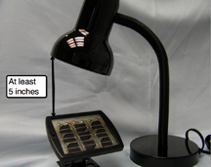

- Change your light source conditions.
  - As you change your light source think about the following questions: What happens? How does the appliance’s performance change? Does it slow down or speed up? Is it louder or quieter? When does your appliance stop working?
  - Try using each appliance under different light sources.
  - Increase and decrease the distance between your light source and your solar panel.
  - Block the light source completely.

- Complete the Investigating Solar Energy: Observations Sheet.

